**LOOPS**

**What are Loops?**

In our everyday lives, we tend to repeat a lot of processes without noticing.

For instance, if we want to cook a delicious recipe, we might have to prepare our ingredients by chopping them up. We chop and chop and chop until all of our ingredients are the right size. At this point, we stop chopping.

If we break down our chopping task into a series of three smaller steps, we have:

1. An initialization: We’re ready to cook and have a collection of ingredients we want to chop. We will start at the first ingredient.
2. A repetition: We’re chopping away. We are performing the action of chopping over and over on each of our ingredients, one ingredient at a time.
3. An end condition: We see that we have run out of ingredients to chop and so we stop.

In programming, this process of using an initialization, repetitions, and an ending condition is called a [*loop*](https://www.codecademy.com/resources/docs/python/loops?page_ref=catalog). In a loop, we perform a process of *iteration* (repeating tasks).

Programming languages like Python implement two types of iteration:

1. *Indefinite iteration*, where the number of times the loop is executed depends on how many times a condition is met.
2. *Definite iteration*, where the number of times the loop will be executed is defined in advance (usually based on the collection size).

Typically we will find loops being used to iterate a collection of items. In the above example, we can think of our ingredients we want to chop as our collection. This is a form of definite iteration since we know how long our collection is in advance and thus know how many times we need to iterate over the collection of ingredients.

Some collections might be small — like a short string, while other collections might be massive like a range of numbers from 1 to 10,000,000! But don’t worry, loops give us the ability to masterfully handle both ends of the spectrum. This simple, but powerful, concept saves us a lot of time and makes it easier for us to work with large amounts of data.

In this lesson, we’ll learn how to use Python to implement both definite and indefinite iteration in our own programs.

**Instructions**

Look over (and over) the provided diagram. Then, go to the next exercise to get looped in!

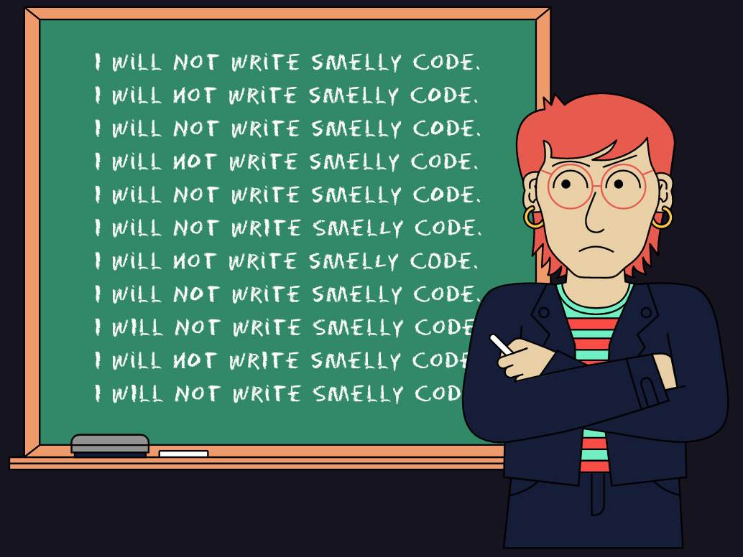

**Why Loops?**

Before we get to writing our own loops, let’s explore what programming would be like if we couldn’t use loops.

Let’s say we have a list of ingredients and we want to print every element in the list:

ingredients = ["milk", "sugar", "vanilla extract", "dough", "chocolate"]

If we only use print(), our program might look like this:

print(ingredients[0])  
print(ingredients[1])  
print(ingredients[2])  
print(ingredients[3])  
print(ingredients[4])

The output would be:

milk  
sugar  
vanilla extract  
dough  
chocolate

That’s still manageable, We’re writing 5 print() statements (or copying and pasting a few times). Now imagine if we come back to this program and our list had 10, or 24601, or … 100,000,000 elements? It would take an extremely long time and by the end, we could still end up with inconsistencies and mistakes.

Don’t dwell too long on this tedious scenario — we’ll learn how loops can help us out in the next exercise. For now, let’s gain an appreciation for loops.

**Instructions**

**1.**

Using 10 print() statements, print out: "This can be so much easier with loops!".

Checkpoint 2 Passed

Hint

If you already have an idea of how to use loops (or have searched up how to do it) we’re still expecting 10 individual print() statements.

If for some reason you still are not passing the tests, make sure all your print() statements have the same text "This can be so much easier with loops!".

Copy and paste is your best friend here 😉

**script.py**

# Write 10 print() statements below!

print("This can be so much easier with loops!")

print("This can be so much easier with loops!")

print("This can be so much easier with loops!")

print("This can be so much easier with loops!")

print("This can be so much easier with loops!")

print("This can be so much easier with loops!")

print("This can be so much easier with loops!")

print("This can be so much easier with loops!")

print("This can be so much easier with loops!")

print("This can be so much easier with loops!")

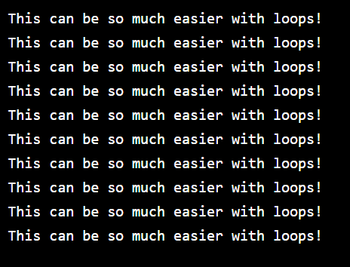

**For Loops: Introduction**

Now that we can appreciate what loops do for us, let’s start with your first type of loop, a for loop, a type of definite iteration.

In a for loop, we will know in advance how many times the loop will need to iterate because we will be working on a collection with a predefined length. In our examples, we will be using Python lists as our collection of elements.

With for loops, on each iteration, we will be able to perform an action on each element of the collection.

Before we work with any collection, let’s examine the general structure of a for loop:

for <temporary variable> in <collection>:  
  <action>

Let’s break down each of these components:

1. A for keyword indicates the start of a for loop.
2. A <temporary variable> that is used to represent the value of the element in the collection the loop is currently on.
3. An in keyword separates the temporary variable from the collection used for iteration.
4. A <collection> to loop over. In our examples, we will be using a list.
5. An <action> to do anything on each iteration of the loop.

Let’s link these concepts back to our ingredients example. This for loop prints each ingredient in ingredients:

ingredients = ["milk", "sugar", "vanilla extract", "dough", "chocolate"]  
   
for ingredient in ingredients:  
  print(ingredient)

In this example:

1. ingredient is the <temporary variable>.
2. ingredients is our <collection>.
3. print(ingredient) was the <action> performed on every iteration using the temporary variable of ingredient.

This code outputs:

milk  
sugar  
vanilla extract  
dough  
chocolate

Some things to note about for loops:

* **Temporary Variables:**

A temporary variable’s name is arbitrary and does not need to be defined beforehand. Both of the following code snippets do the exact same thing as our above example:

for i in ingredients:  
  print(i)

for item in ingredients:  
 print(item)

Programming best practices suggest we make our temporary variables as descriptive as possible. Since each iteration (step) of our loop is accessing an ingredient it makes more sense to call our temporary variable ingredient rather than i or item.

* **Indentation:**

Notice that in all of these examples the print statement is indented. Everything at the same level of indentation after the for loop declaration is included in the loop body and is run on every iteration of the loop.

for ingredient in ingredients:  
  # Any code at this level of indentation   
  # will run on each iteration of the loop  
  print(ingredient)

If we ever forget to indent, we’ll get an IndentationError or unexpected behavior.

* **Elegant loops:**

Python loves to help us write elegant code so it allows us to write simple for loops in one-line. In order to see the below example as one line, you may need to expand your narrative window. Here is the previous example in a single line:

for ingredient in ingredients: print(ingredient)

**Note**: One-line for loops are useful for simple programs. It is not recommended you write one-line loops for any loop that has to perform multiple complex actions on each iteration. Doing so will hurt the readability of your code and may ultimately lead to buggier code.

Let’s practice writing our own for loop!

**Instructions**

**1.**

Run the code.

We should get an IndentationError because the print(game) line is not indented.

Checkpoint 2 Passed

Hint

You should see the following error indicating that we forgot to indent our code:

File "script.py", line 6

print(game)

^

IndentationError: expected an indented block

**2.**

Indent (2 spaces or tab) line 6 so that we don’t get an IndentationError when you run the code.

Run the code again!

Checkpoint 3 Passed

Hint

Your code should look like this:

for game in board_games:  
  print(game)

**3.**

Write a for loop that prints each sport in the list sport_games.

Checkpoint 4 Passed

Hint

The general structure of a for loop is:

for <temporary variable> in <collection>:  
  <action>

In our case here are each of our components:

1. Our <temporary variable> is anything we want. Since we are accessing individual sports, it might make sense to call it sport (the singular of the word sports).
2. Our <collection> is the list sport_games.
3. Take a stab at figuring out the action. Think about what we are trying to do on each iteration (step) of the loop.

**script.py**

board_games = ["Settlers of Catan", "Carcassone", "Power Grid", "Agricola", "Scrabble"]

sport_games = ["football", "hockey", "baseball", "cricket"]

for game in board_games:

  print(game)

for sport in sport_games:

  print(sport)

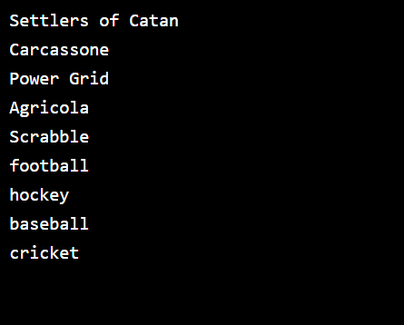

**For Loops: Using Range**

Often we won’t be iterating through a specific list (or any collection), but rather only want to perform a certain action multiple times.

For example, if we wanted to print out a "Learning Loops!" message six times using a for loop, we would follow this structure:

for <temporary variable> in <list of length 6>:

print("Learning Loops!")

Notice that we need to iterate through a list with a length of six, but we don’t necessarily care what is inside of the list.

To create arbitrary collections of any length, we can pair our for loops with the trusty [Python built-in function range()](https://www.codecademy.com/resources/docs/python/built-in-functions/range?page_ref=catalog).

An example of how the range() function works, this code generates a collection of 6 integer elements from 0 to 5:

six_steps = range(6)  
   
# six_steps is now a collection with 6 elements:  
# 0, 1, 2, 3, 4, 5

We can then use the range directly in our for loops as the collection to perform a six-step iteration:

for temp in range(6):  
  print("Learning Loops!")

Would output:

Learning Loops!  
Learning Loops!  
Learning Loops!  
Learning Loops!  
Learning Loops!  
Learning Loops!

Something to note is we are not using temp anywhere inside of the loop body. If we are curious about which loop iteration (step) we are on, we can use temp to track it. Since our range starts at 0, we will add + 1 to our temp to represent how many iterations (steps) our loop takes more accurately.

for temp in range(6):  
  print("Loop is on iteration number " + str(temp + 1))

Would output:

Loop is on iteration number 1  
Loop is on iteration number 2  
Loop is on iteration number 3  
Loop is on iteration number 4  
Loop is on iteration number 5  
Loop is on iteration number 6

Let’s try out using a range in a for loop!

**Instructions**

**1.**

Use the range() function in a for loop to print() out the provided promise variable five times.

Checkpoint 2 Passed

Hint

We will need to generate a list with a length of five.

What value will we need to provide to the range() function where <length> is?

for <temporary variable> in range(<length>):   
  <action>

**script.py**

promise = "I will finish the python loops module!"

for temp in range(5):

  print(promise)

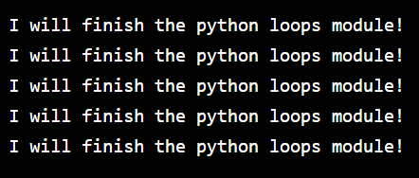

**While Loops: Introduction**

In Python, for loops are not the only type of loops we can use. Another type of loop is called a while loop and is a form of indefinite iteration.

A while loop performs a set of instructions as long as a given condition is true.

The structure follows this pattern:

while <conditional statement>:  
  <action>

Let’s examine this example, where we print the integers 0 through 3:

count = 0  
while count <= 3:  
  # Loop Body  
  print(count)  
  count += 1

Let’s break the loop down:

1. count is initially defined with the value of 0. The conditional statement in the while loop is count <= 3, which is true at the initial iteration of the loop, so the loop body executes.

Inside the loop body, count is printed and then incremented by 1.

1. When the first iteration of the loop has finished, Python returns to the top of the loop and checks the conditional again. After the first iteration, count would be equal to 1 so the conditional still evaluates to True and so the loop continues.
2. This continues until the count variable becomes 4. At that point, when the conditional is tested it will no longer be True and the loop will stop.

The output would be:

0  
1  
2  
3

Note the following about while loops before we write our own:

* **Indentation:**

Notice that in our example the code under the loop declaration is indented. Similar to a for loop, everything at the same level of indentation after the while loop declaration is run on every iteration of the loop while the condition is true.

while count <= 3:  
  # Loop Body  
  print(count)  
  count += 1  
  # Any other code at this level of indentation will  
  # run on each iteration

If we ever forget to indent, we’ll get an IndentationError or unexpected behavior.

* **Elegant loops:**

Similar to for loops, Python allows us to write elegant one-line while loops. Here is our previous example in a single line:

count = 0  
while count <= 3: print(count); count += 1

**Note**: Here we separate each statement with a ; to denote a separate line of code.

Let’s practice writing a while loop!

**Instructions**

**1.**

Examine the while loop from the narrative in your code editor. There are additional print() statements to help visualize the iterations.

Run the code to see what happens on each iteration of the loop. When you are finished, comment out the example to make space for the rest of the checkpoints.

To quickly comment out the code, use your cursor or mouse to highlight all the code and press command ⌘ + / on a Mac or CTRL + / on a Windows machine.

Checkpoint 2 Passed

**2.**

Let’s write a while loop that counts down from 10 to 0(inclusive). Once our loop is finished we will commemorate our accomplishment by printing "We have liftoff!".

As we saw in the narrative, our key components will be:

1. A variable to keep track of the count, and also help our loop eventually stop.
2. A condition that our while loop will check on each iteration.
3. Several code statements to execute on each iteration of the loop.

Let’s tackle the first component!

Create a variable named countdown and set the value to 10.

Checkpoint 3 Passed

**3.**

Now let’s tackle the actual while loop. Define a while loop that will run while our countdown variable is greater than or equal to zero.

On each iteration:

1. We should print() the value of the countdown variable.
2. We should decrease the value of the countdown variable by 1

Make sure to *only* print the value of countdown.

If you notice the **Run** button spinning continuously or a “Lost connection to Codecademy” message in an exercise, you may have an infinite loop! If the stop condition for our loop is never met, we will create an infinite loop which stops our program from running anything else. To exit out of an infinite loop in an exercise, refresh the page — then fix the code for your loop.

Checkpoint 4 Passed

Hint

Let’s remember the structure of a while loop:

while <conditional statement>:  
  <action>

Let’s see how this breaks down for our loop:

* Our <conditional statement> is that our countdown variable is greater than or equal to zero.
* We have two actions we want to execute on each iteration of the loop:
  + First, we want to print the value of the countdown variable.
  + Lastly, we want to decrease the value of the countdown variable. We can do so using -=.

**4.**

Now that we have built our loop, let’s commemorate our success by printing "We have liftoff!" after the while loop.

Checkpoint 5 Passed

Hint

Make sure your print() is not indented, otherwise it will run on every iteration of the loop.

**script.py**

# While Loop Walkthrough

# count = 0

# print("Starting While Loop")

# while count <= 3:

#   # Loop Body

#   # Print if the condition is still true

#   print("Loop Iteration - count <= 3 is still true")

#   # Print the current value of count

#   print("Count is currently " + str(count))

#   # Increment count

#   count += 1

#   print(" ----- ")

# print("While Loop ended")

# Your code below:

countdown = 10

while countdown >= 0:

  print(str(countdown))

  countdown -= 1

print("We have liftoff!")

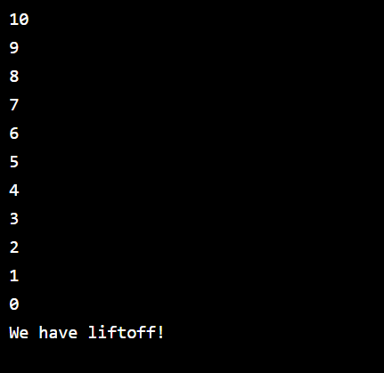

**While Loops: Lists**

A while loop isn’t only good for counting! Similar to how we saw for loops working with lists, we can use while loops to iterate through a [list](https://www.codecademy.com/resources/docs/python/lists?page_ref=catalog) as well.

Let’s return to our ingredient list:

ingredients = ["milk", "sugar", "vanilla extract", "dough", "chocolate"]

We know that while loops require some form of a variable to track the condition of the loop to start and stop.

Take some time to think about what we would use to track whether we need to start/stop the loop if we want to iterate through ingredients and print every element.

Click here to find out!

We know that a list has a predetermined length. If we use the length of the list as the basis for how long our while loop needs to run, we can iterate the exact length of the list.

We can use the [built-in Python len() function](https://www.codecademy.com/resources/docs/python/built-in-functions/len?page_ref=catalog) to accomplish this:

# Length would be equal to 5  
length = len(ingredients)

We can then use this length in addition to another variable to construct the while loop:

length = len(ingredients)  
index = 0  
   
while index < length:  
  print(ingredients[index])  
  index += 1

Let’s break this down:

# Length will be 5 in this case  
length = len(ingredients)

Explanation

As mentioned, we need a way to know how many times we need our loop to iterate based on the size of the collection.  
  
This comes in the form of our length variable which stores the value of the length of the list.

# Index starts at zero  
index = 0

Explanation

We still need an additional variable that will be used to compare against our length.

while index < length:

Explanation

In our while loop conditional, we will compare the index variable to the length of our list stored inside of the length variable.

On the first iteration, we will be comparing the equivalent of 0 < 5 which will evaluate to True, and start the execution of our loop body.

# The first iteration will print ingredients[0]  
print(ingredients[index])

Explanation

Inside of our loop body, we can use the index variable to access our ingredients list and print the value at the current iteration.  
  
Since our index starts at zero, our first iteration will print the value of the element at the zeroth index of our ingredients list, then the next iteration will print the value of the element at the first index, and so on.

# Increment index to access the next element in ingredients  
# Each iteration gets closer to making the conditional no longer true  
index += 1

Explanation

On each iteration of our while loop, we need to also increment the value of index to make sure our loop can stop once the index value is no longer smaller than the length value.  
  
This increment also helps us access the next value of the ingredients list on the next iteration.

Our final output would be:

milk  
sugar  
vanilla extract  
dough  
chocolate

Let’s use a while loop to iterate through some lists!

**Instructions**

**1.**

We are going to write a while loop to iterate over the provided list python_topics.

First, we will need a variable to represent the length of the list. This will help us know how many times our while loop needs to iterate.

Create a variable length and set its value to be the length of the list of python_topics.

Checkpoint 2 Passed

Hint

You can use the len() built-in function to acquire the length of a list.

my_list = [1, 2, 3, 4]  
print(len(my_list))

Would output:

4

**2.**

Next, we will require a variable to compare to our length variable to make sure we are able to implement a condition that eventually allows the loop to stop.

Create a variable called index and initialize the value to be 0.

Checkpoint 3 Passed

**3.**

Let’s now build our loop. We want our loop to iterate over the list of python_topics and on each iteration print "I am learning about <element from python_topics>". For this loop we will need the following components:

1. A condition for our while loop
2. A statement in the loop body to print from our condition
3. A statement in the loop body to increment our index forward.

The end result should output:

I am learning about variables  
I am learning about control flow  
I am learning about loops  
I am learning about modules  
I am learning about classes

If you notice the **Run** button spinning continuously or a “Lost connection to Codecademy” message in an exercise, you may have an infinite loop! If the stop condition for our loop is never met, we will create an infinite loop which stops our program from running anything else. To exit out of an infinite loop in an exercise, refresh the page — then fix the code for your loop.

Checkpoint 4 Passed

Hint

Let’s take a look at our three components:

1. A condition for our while loop

Our condition should compare our length variable and index variable. What comparison operator should we use?

1. A statement in the loop body to print from our condition. To combine the required print statement with the element from the list, use + inside of your print statement. For example:

hello_string = "Hello"  
print(hello_string + " World")

Would output:

Hello World

In this case, we would also use the index variable to print the corresponding item from the list. For example:

print("The cookies need " + ingredients[index])

1. A statement in the loop body to increment our index forward.

Since our index value starts at 0, we want to create a statement that increments the index so that it will eventually be larger than the length of the list.

**script.py**

python_topics = ["variables", "control flow", "loops", "modules", "classes"]

#Your code below:

length = len(python_topics)

index = 0

while index < length:

  print("I am learning about " + python_topics[index])

  index += 1

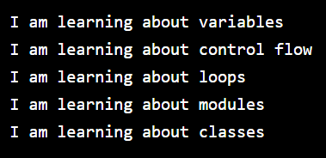

**Infinite Loops**

We’ve iterated through lists that have a discrete beginning and end. However, let’s consider this example:

my_favorite_numbers = [4, 8, 15, 16, 42]  
   
for number in my_favorite_numbers:  
  my_favorite_numbers.append(1)

Take some time to ponder what happens with this code.

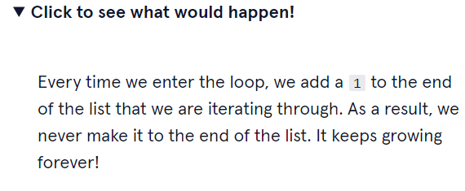

A loop that never terminates is called an infinite loop. These are very dangerous for our code because they will make our program run forever and thus consume all of your computer’s resources.

A program that hits an infinite loop often becomes completely unusable. The best course of action is to avoid writing an infinite loop.

**Note**: If you accidentally stumble into an infinite loop while developing on your own machine, you can end the loop by using control + c to terminate the program. If you’re writing code in our online editor, you’ll need to **refresh the page** to get out of an infinite loop.

Let’s fix an infinite loop to see it in action.

### Instructions

Suppose we have two lists of students, students_period_A and students_period_B. We want to combine all students into students_period_B.

In your code editor, we have provided you a loop. Go ahead and uncomment line 5 and **before you run the code** ponder why this code would cause an infinite loop.

When you are ready, run this code. What do you notice happens? Over the run button, notice the loading circle is continuing without anything happening.

This is an infinite loop! To end this program we must **refresh the page**. (Note: The reason this loop is infinite is that we’re adding each student in students_period_A to students_period_A which would create a never-ending list of all the student names.)

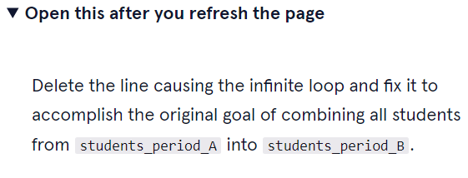

**script.py**

students_period_A = ["Alex", "Briana", "Cheri", "Daniele"]

students_period_B = ["Dora", "Minerva", "Alexa", "Obie"]

for student in students_period_A:

  students_period_B.append(student)

  #print(student)

  students_period_B.sort()

print(students_period_B)

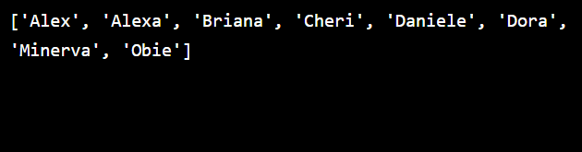

**Loop Control: Break**

Loops in Python are very versatile. Python provides a set of control statements that we can use to get even more control out of our loops.

Let’s take a look at a common scenario that we may encounter to see a use case for *loop control statements*.

Take the following list items_on_sale as our example:

items_on_sale = ["blue shirt", "striped socks", "knit dress", "red headband", "dinosaur onesie"]

It’s often the case that we want to search a list to check if a specific value exists. What does our loop look like if we want to search for the value of "knit dress" and print out "Found it" if it did exist?

It would look something like this:

for item in items_on_sale:  
  if item == "knit dress":  
    print("Found it")

This code goes through each item in items_on_sale and checks for a match. This is all fine and dandy but what’s the downside?

Once "knit_dress" is found in the list items_on_sale, we don’t need to go through the rest of the items_on_sale list. Unfortunately, our loop will keep running until we reach the end of the list.

Since it’s only 5 elements long, iterating through the entire list is not a big deal in this case but what if items_on_sale had 1000 items? What if it had 100,000 items? This would be a huge waste of time for our program!

Thankfully you can stop iteration from inside the loop by using break loop control statement.

When the program hits a break statement it immediately terminates a loop. For example:

items_on_sale = ["blue shirt", "striped socks", "knit dress", "red headband", "dinosaur onesie"]  
   
print("Checking the sale list!")  
   
for item in items_on_sale:  
  print(item)  
  if item == "knit dress":  
    break  
   
print("End of search!")

This would produce the output:

Checking the sale list!  
blue shirt  
striped socks  
knit dress  
End of search!

When the loop entered the if statement and saw the break it immediately ended the loop. We didn’t need to check the elements of "red headband" or "dinosaur onesie" at all.

Now let’s break some loops!

**Instructions**

**1.**

You have a list of dog breeds you can adopt, dog_breeds_available_for_adoption.

Using a for loop, iterate through the dog_breeds_available_for_adoption list and print() out each dog breed.

Use the <temporary variable> name of dog_breed in your loop declaration.

Checkpoint 2 Passed

Hint

Remember the structure of a for loop:

for <temporary variable> in <list>:  
  <action>

For our loop:

for dog_breed in dog_breeds_available_for_adoption:  
  <action>

What action do we want to perform on each iteration of the loop?

**2.**

Inside your for loop, after you print each dog breed, check if the current element inside dog_breed is equal to dog_breed_I_want. If so, print "They have the dog I want!"

Checkpoint 3 Passed

Hint

We can put conditional logic in our loops.

num_list = [1, 2, 3, 4]  
for num in num_list:  
  if num == 2:   
    print("We have a 2!")

What might the condition in our loop be to determine if dog_breed_I_want is inside of our list dog_breeds_available_for_adoption?

**3.**

Add a break statement when your loop has found dog_breed_I_want so that the rest of the list does not need to be checked once we have found our breed.

Checkpoint 4 Passed

Hint

Think about at what point we want our loop to break. Will it be before or after our print("They have the dog I want!")

**script.py**

dog_breeds_available_for_adoption = ["french_bulldog", "dalmatian", "shihtzu", "poodle", "collie"]

dog_breed_I_want = "dalmatian"

for dog_breed in dog_breeds_available_for_adoption:

  print(dog_breed)

  if dog_breed == dog_breed_I_want:

    print("They have the dog I want!")

    break

