ClimPACTv2
Indices and software
Lisa Alexander and Nicholas Herold
28/5/2015

A document prepared on behalf of The Commission for Climatology (CCl) Expert Team on Sector-Specific Climate Indices (ET-SCI)
Acknowledgements
This document and the body of work it represents was made possible through the efforts of The World Meteorological Organisation (WMO) Commission for Climatology (CCl) Open Panel of CCl Experts on Climate Information for Adaptation and Risk Management (OPACE 4) under the guidance of OPACE-4 co-chairs (Rodney Martinez and Andrew Tait); the CCl OPACE 4 Expert Team on Sector-specific Climate Indices (ET-SCI) members: Lisa Alexander (Chair, Australia), Toshiyuki Nakaegawa (co-Chair, Japan), Fatima Zohra El Guelai (Morocco), Amelia Diaz Pablo (Peru), Adam Kalkstein (USA) and Gé Verver (The Netherlands) and the WMO World Climate Applications and Services Programme (Rupa Kumar Kolli and Anahit Hovsepyan). It draws heavily on the input of the Expert Team on Climate Risk and Sector-specific Climate Indices (ET-CRSCI), the predecessor of the ET-SCI and including additional ET-CRSCI members Elena Akentyeva, Alexis Nimubona, G. Srinivasan, Philip Thornton, and Peiqun Zhang. Significant contributions to the development of the ET-SCI indices, software and technical manual also came from Enric Aguilar, Andrew King, Brad Rippey, Sarah Perkins, Sergio M. Vicente-Serrano, Juan Jose Nieto, Sandra Schuster and Hongang Yang. We are also grateful to the other experts and sector representatives who have contributed to the development of indices: Manola Brunet, Albert Klein Tank, Christina Koppe, Sari Kovats, Glenn McGregor, Xuebin Zhang, Javier Sigro, Peter Domonkos, Dimitrios Efthymiadis.

Lisa Alexander and Nicholas Herold contributed significantly to development of this document, the indices and the ClimPACTv2 software.

The application of climate indices to the Agriculture sector was undertaken in full cooperation with the WMO Commission for Agricultural Meteorology, through which Brad Rippey and Sergio Vicente Serrano supported the work.

Commission for Climatology experts Glenn McGregor, Christina Koppe and Sari Kovats supported the applications of indices for Climate and Health, in particular for heat waves and health.

The ClimPACTv2 software updates ClimPACT which was based on the RClimDEX software developed by the WMO CCl/WCRP/JCOMM Expert Team on Climate Change Detection and Indices (ETCCDI). The CCl Co Chair for the CCl OPACE on Climate Monitoring and Assessment (Manola Brunet), ETCCDI members, Albert Klein Tank and Xuebin Zhang, along with Enric Aguilar, Juan Jose Nieto, Javier Sigro, Peter Domonkos, and Dimitrios Efthymiadis, contributed to development of the indices and software in the previous version of the technical manual.

ClimPACT is written in R, a language and environment for statistical computing and graphics and makes use of several R subroutines, including spi and spei. R is available as Free Software under the terms of the Free Software Foundation's GNU General Public License in source code form (see http://www.r-project.org/).

This work is also supported by WMO grant SSA 3876-12/REM/CNS and the Australian Research Council grant CE110001028 specifically through funding from the New South Wales Office of the Environment and Heritage.

Background Material
1. INTRODUCTION
This document was prepared on behalf of the World Meteorological Organization (WMO) Commission for Climatology (CCl) Expert Team on Sector-specific Climate Indices Indices (ET-SCI). It outlines the background and goals of the ET-SCI and describes indices and software that were developed on their behalf.
The ET-SCI, formerly known as the Expert Team on Climate Risk and Sector-specific Indices (ET-CRSCI) was set up by the Fifteenth session of the WMO Technical Commission for Climatology (CCl-XV, Antalya, Turkey, February 2010), with terms of reference established to support eventual implementation of the Global Framework for Climate Services (GFCS) (for background on GFCS see http://www.wmo.int/hlt-gfcs/downloads/HLT_book_full.pdf). Following the sixteenth World Meteorological Congress in May 2011 where a decision was made by WMO members to implement the GFCS, the ET-ICS held their first meeting in Tarragona, Spain (13-15 July, 2011). See http://www.wmo.int/pages/prog/wcp/ccl/opace/opace4/expertteam.php for more details.

1.1 Role of ET-SCI in GFCS
The ET-SCI sits within CCl under the Open Panel of CCl Experts (OPACE) on Climate Information for Adaptation and Risk Management (OPACE-4). The objective of OPACE-4 is to improve decision-making for planning, operations, risk management and for adaptation to both climate change and variability (covering time scales from seasonal to centennial) and will be achieved through a higher level of climate knowledge, as well as by access to and use of actionable information and products, tailored to meet their needs. Activities primarily focus on the development of tailored climate information, products and services for user application in adaptation and risk management, and build interface with user groups to facilitate GFCS implementation.
The work of OPACE-4 is multidisciplinary, and requires close collaboration with experts from various socio-economic sectors. In keeping with the priorities agreed for initial implementation of the GFCS, the core priority sectors for consideration by the OPACE in this present intersessional period are agriculture/food security, water and health. This requires close collaboration with relevant experts in these sectors including seeking guidance and aid from the WMO Technical Commissions for Agricultural Meteorology (CAgM) and Hydrology (CHy) and with the World Health Organisation (WHO).
The ET-SCI Terms of Reference (ToR) and expected deliverables are shown in Appendix A. The deliverables include the collection and analysis of existing sector-relevant climate indices in addition to developing the tools required to produce them. At a meeting in Tarragona in 2011, members of the former ET-CRSCI invited sector and Commission representatives to help define a suite of indices that would represent a “core set” that would meet the ToR and deliverables. This manual outlines the rationale behind the creation of those indices and the ClimPACTv2 software developed for their calculation. In the next section the development of climate indices and their uses are outlined, followed by a description of ClimPACTv2 and instructions on how to run it.

ET-SCI INDICES

2. THE ‘VALUE’ OF CLIMATE INDICES
Monthly averages of climate data smooth over a lot of important information that is relevant for sectoral impacts. For this reason indices derived from daily data are an attempt to objectively extract information from daily weather observations that answers questions concerning aspects of the climate system that affect many human and natural systems with particular emphasis on extremes. Such indices might reflect the duration or amplitude of heat waves, extreme rainfall intensity and frequency or measures of extremely wet or dry/hot or cold periods that have socio-economic impacts. Climate indices provide valuable information contained in daily data, without the need to transmit the daily data itself.

Much progress has been made in recent decades through internationally agreed indices derived from daily temperature and precipitation that represent more extreme aspects of the climate, overseen by the CCl/WCRP/JCOMM Expert Team on Climate Change Detection and Indices (ETCCDI). Development and analyses of these indices has made a significant contribution to the Intergovernmental Panel on Climate Change (IPCC) Assessment Reports.

2.1 Background to ETCCDI, Indices and Software

The ETCCDI started in 1999 and is co-sponsored by the World Climate Research Program (WCRP) and JCOMM. They developed an internationally coordinated set of core climate indices consisting of 27 descriptive indices for moderate extremes (Alexander et al. 2006; Zhang et al. 2011; Table A4). These indices were developed with the ‘detection and attribution’ research community in mind. In order to detect changes in climate extremes, it was important to develop a set of indices that were statistically robust, covered a wide range of climates, and had a high signal-to-noise ratio. In addition, internationally agreed indices derived from daily temperature and precipitation allowed results to be compared consistently across different countries and also had the advantage of overcoming most of the restrictions on the dissemination of daily data that are applied in many countries.

ETCCDI recognized that a two-pronged approach was needed to promote further work on the monitoring and analysis of daily climate records to identify trends in extreme climate events (Peterson and Manton, 2008). In addition to the formulation of indices described above, a second prong was to promote the analysis of extremes around the world, particularly in less developed countries, by organizing regional climate change workshops that provided training for the local experts and conducted data analysis. The goals of these workshops are to: contribute to worldwide indices database; build capacity to analyse observed changes in extremes; improve information services on extremes in the region; and publish peer-reviewed journal articles. Most of these articles were directly as a result of the regional workshops and included all of the workshop participants as authors (e.g. Peterson et al. 2002; Vincent et al. 2005; Zhang et al. 2005; Haylock et al. 2006; Klein Tank et al. 2006; New et al. 2006; Aguilar et al, 2006, Aguilar et al. 2009; Caesar et al. 2011; Vincent et al. 2011).

As part of the workshop development, software called RClimDEX was also developed that could be used at the workshops (thus providing consistent definitions from each workshop and region). Environment Canada provides, maintains, and further develops the R-based software used for the workshops (freely available from http://etccdi.pacificclimate.org).

2.2 Background to Development of ET-SCI Indices

Most ETCCDI indices focus is on counts of days crossing a threshold; either absolute/fixed thresholds or percentile/variable thresholds relative to local climate. Others focus on absolute extreme values such as the warmest, coldest or wettest day of the year. The indices are used for both observations and models, globally as well as regionally, and can be coupled with simple trend analysis techniques, and standard detection and attribution methods in addition to complementing the analysis of more rare extremes using Extreme Value Theory (EVT).

One current disadvantage of the ETCCDI indices is that few of them are specifically sector-relevant. While some of these indices may be useful for sector applications (e.g. number of days with frost for agricultural applications, heat waves for health applications) it was realised that it was important to get sectors involved in the development of the ET-SCI indices so that more application-relevant indices could be developed to better support adaptation.

The core set of indices agreed by the ET-SCI (as the ET-CRSCI) at their meeting in Tarragona, Spain in July 2011 were developed in part from the core set of indices that are developed and maintained by ETCCDI (Table A4). The meeting included technical experts in climate and health and climate and agriculture from CCl and CAgM representing the health representatives from the health, water and agriculture sectors and it was agreed that the initial effort should consider requirements for climate indices relevant to heat waves and droughts. A core set of 34 indices was agreed at that meeting and are shown in Table A1 and Table A2. In some cases these indices are already part of the core set defined by the ETCCDI (Table A4) – it is indicated in Table A1 and Table A2 where this is the case. Additional indices developed after the agreed core indices are shown in Table A3.

It should be noted that indices development is an ongoing activity as additional sector-needs arise and other sectors are considered (see Section 2.5) within the Terms of Reference and deliverables of the ET-ICS. This should therefore be seen only as the initial step in the continuing work of the ET-ICS.

2.3 Background to Development of ET-SCI Workshops

Given the success of the ETCCDI regional workshops (see Section 2.1 and Peterson and Manton 2008), ET-ICS aims to adapt and further develop this regional workshop model with participants from both National Meteorological and Hydrological Services (NMHSs) and sector groups. ET-SCI will work with sector-based agencies and experts, including those of relevant WMO Technical Commissions, particularly the Commission for Climatology for health, the Commission for Hydrology (CHy) for water and the Commission for Agricultural Meteorology (CAgM) for agriculture and food security, to facilitate the use of climate information in users’ decision-support systems for climate risk management and adaptation strategies. As part of this development, ET-SCI has commissioned the development of software, ClimPACTv2, with the aim of producing an easy and consistent way of calculating indices for each user. The development and use of standardized software for generating sector-specific climate indices is described in Section 3.

2.4 Requirements for data quality when computing indices
Before indices can be computed, it is important that any daily input data are checked for quality and homogeneity. Homogeneity implies consistency of a series through time and is an obvious requirement for the robust analysis of climate time series. While many of the time series that are used for indices calculations have been adjusted to improve homogeneity, some aspects of these records may remain inhomogeneous, and this should be borne in mind when interpreting changes in indices. For example, most methods for assessing homogeneity do not consider changes in day-to-day variability or changes in how the series has been derived. It is possible for a change of variance to occur without a change in mean temperature. Two examples of ways in which this could occur are where a station moves from an exposed coastal location to a location further inland, increasing maximum temperatures and decreasing minimum temperatures, or where the number of stations contributing to a composite series changes.
Homogeneity adjustment of daily data is difficult because of high variability in the daily data when compared with monthly or annual data, and also because an inhomogeneity due to a change in station location or instrument may alter behaviour differently under different weather conditions. Homogeneity adjustment of daily data is a very active field of research and there are many methods which could be used. Although many different methods exists, the ETCCDI promote the use of the RHTest software* because it is free and easy to use, making it ideal for demonstration in regional workshops. The software method is based on the penalized maximal t (PMT) or F test (PMF) and can identify, and adjust for, multiple change points in a time series (see Wang, 2008 and ETCCDI website for more details). PMT requires the use of reference stations for the homogeneity analysis but PMF can be used as an absolute method (i.e. in isolation or when there are no neighbouring stations to use for comparison). In ClimPACT, apart from basic quality control, there is currently no means to homogenise data. We therefore assume that the required level of homogeneity testing and/or adjustment has already been applied.
*NB Daily adjustments, especially with absolute methods, must be applied with extreme care as – if incorrectly applied – they can damage the statistical distribution of the series. Therefore, data require careful post-workshop analysis in concert with metadata (where available) and as such ET-ICS recommend that any homogeneity software used at regional workshops is for demonstration purposes only.
2.5 Future prospects for the Indices
At present the core set of indices are defined using only daily maximum temperature (TX), daily minimum temperature (TN) and daily precipitation (P), and each index relies on a single parameter apart from a few which consider both TX and TN. It is acknowledged that for sector applications, these variables (and the related indices) are all required, but users have also indicated a need for additional variables including: humidity (important for both agricultural and health indices); wind speed and direction (important for health indices, building design, energy, transportation, etc.); Sea Surface Temperatures (SSTs; useful for marine applications and in relation to the onset and variability of the El Niño-Southern Oscillation (ENSO)); onset and cessation dates for monsoon; rain periods, snow fall, snow depth, snow-water equivalent, days with snowfall and hydrological parameters (particularly important for mid-and high latitude applications). Some of these (e.g. onset dates) may require considerable study and available systematic long-term data. Furthermore, in a subsequent phase of the work of the Team, addition of ‘event statistics’ such as days with thunderstorms, hail, tornados, number of consecutive days with snowfall, etc., for expanded studies of hazards could be considered. The ET-SCI will consider (at a later date) whether to add these new variables to the dataset as a second level priority.
ET-SCI also feels that it is important to add several complex indices to this initial effort (for example for (heat waves), but recognized that more could be demanded by (or may be in current use by) sectors, once they are consulted on the process and through training. The development of indices to assess multi-day temperature extremes (e.g., prolonged heat waves) has been particularly challenging, as the occurrence of such events depends not just on the frequency distribution of daily temperatures, but also on their persistence from day to day. The existing ETCCDI indices measure the maximum number of consecutive days during events with six or more consecutive days above a specified percentile value or anomaly, vary widely in frequency across climates, describe events that occur rarely or not at all in many climates, and are poor discriminators of very extreme events. The ET-SCI are therefore recommending some new heat wave indices (see Table A3; Perkins and Alexander, 2013 and Perkins et al. 2012) that have been added as a supplement to the core set in this initial phase of the software. This range of indices is defined for most climates and has a number of other desirable statistical properties, such as being approximately normally distributed in many climates.

Also drought indices have been included following ET-SCI recommendations. Since drought severity is difficult to quantify and is identified by its effects or impacts on different types of systems (e.g. agriculture, water resources, ecology, forestry, economy), different proxies have been developed based on climatic information. These are assumed to adequately quantify the degree of drought hazard exerted on sensitive systems. Recent studies have reviewed the development of drought indices and compared their advantages and disadvantages (Heim, 2002; Mishra and Singh, 2010; Sivakumar et al., 2010). Currently ClimPACTv2 includes the Standardized Precipitation Index (SPI), proposed by McKee et al. (1993), and accepted by the WMO as the reference drought index for more effective drought monitoring and climate risk management (World Meteorological Organization, 2012), and the Standardized Precipitation Evapotranspiration Index (SPEI), proposed by Vicente-Serrano et al. (2010), which combines the sensitivity to changes in evaporative demand, caused by temperature fluctuations and trends, with the simplicity of calculation and the multi-temporal nature of the SPI.
In a subsequent phase, ET-SCI will investigate additional complex indices combining meteorological variables (e.g. temperature and humidity for physiological comfort), and could consider indices that combine meteorological/hydrological parameters with sector-based information including measures of vulnerability.

It is also acknowledged that updating indices is problematic for many regions and some regions would need specific indices to cope with their particular needs to provide climate services. As GFCS stresses the importance of the global, regional and local scales, ET-SCI acknowledges that support for this could come from Regional Climate Centers (RCCs) or Regional Climate Outlook Forums (RCOFs) etc. In addition, there are constraints on access to daily data. It is a considerable challenge to assemble worldwide datasets which are integrated, quality controlled, and openly and easily accessible. There is tension between traceability (access to the primary sources) and data completeness (use whatever available). Also a problem arises through the use of specified climatological periods which vary from group to group and which are used for base period calculations for percentile-based indices. In the first iteration of the software we use the base period of 1971-2000 but recognise that this will need to be amended for countries that do not have records covering this period. The software has been written in such a way that the user can specify the climatological base period which is most suitable for their data.
Users are invited to view ClimPACTv2 as ‘living software’ in that it can and will be amended easily as additional user needs arise.
2.6 Differences between ClimPACT and ClimPACTv2
The main difference between ClimPACT and ClimPACTv2 is that the R package climdex.pcic is used as the base for the software rather than RClimDex. The advantages of this are that the software is faster and cleaner and also it is designed to work with model data in addition to point-based station measurements. Several bug fixes have been included and the software is now being updated within a version control environment. Apart from changes to some indices due to the bug fixes, the indices remain essentially unchanged.
The next section describes the development of the software and instructions on how to use it.

CLIMPACTv2 SOFTWARE
3. DEVELOPMENT OF THE ClimPACTv2 SOFTWARE
ClimPACTv2 is an R software packages for calculating the 34 core ET-SCI indices (Appendix C), additional indices defined on top of the core set (Appendix C), and indices defined by ETCCDI (Appendix D) that are not part of the core ET-SCI group. It provides two methods for calculating these indices. The first is through a Graphical User Interface (GUI) which allows the user to calculate the indices for time-series data stored in ASCII format for a specific location in space (e.g. a weather station). Through this GUI a limited number of parameters relating to the indices can be adjusted and various plots and quality control diagnostics are produced for the user. The second method for calculating the ClimPACTv2 indices is through the climpact.loader function and is meant for advanced users familiar with the R programming language. The climpact.loader function has no GUI and does not produce plots or diagnostics. However, it offers significant flexibility in adjusting index parameters and is designed to calculate the ClimPACTv2 indices on gridded netCDF datasets. Thus, users who have three dimensional datasets (time x latitude x longitude) are able to have all of the indices included in this software package calculated with minimal effort.
ClimPACTv2 has been developed under R version 3.1.1 and should be run with version 3.0.2 or later.
Users familiar with the RClimDEX software will notice many similarities between that and the ClimPACTv2 GUI. This is because ClimPACTv2 was developed using the basic code from climdex.pcic which was modelled after RClimDEX. This means that the same simple data quality control procedure is implemented (see Section 2.4 for details on the importance of QC) along with a bootstrapping procedure to determine climatological percentile thresholds (see Appendix F). At present there is no facility to homogenise data, so it is assumed that the daily weather information provided by users will be of a high standard and free from artificial inconsistencies (i.e. non-climatic inhomogeneities).
This section provides step-by-step instructions on the installation of R, setting up the user environment, and running the ClimPACTv2 GUI. Section 4 presents a brief introduction to the climpact.loader function.
3.1 Requirements for running ClimPACTv2
To run the ClimPACTv2 GUI the R software package needs to be installed (see APPENDIX E for details). If you do not have the ClimPACTv2 code, download the latest version from github (https://github.com/heroldn/ClimPACTv2/archive/master.zip) and extract the files to a new directory. Input files intended for ClimPACTv2 must be in the format described in Appendix G.
Once R is installed, you have the ClimPACTv2 software, and your data files are in the correct format, the software can be run.
3.2 Opening ClimPACTv2
We first need to open the R environment. In a Microsoft Windows operating system, select the ‘R’ icon that was created during the installation process. Once in R, from the drop down menu click on “File>Change dir…” and choose the location where you have downloaded and extracted the ClimPACTv2 software (where the climpact2.GUI.r file resides). Then, within the R console prompt “>”, enter source(“climpact2.GUI.r”).
In a Unix-based operating system (e.g. Linux systems such as Debian, Ubuntu, Red Hat etc.), open a terminal window, navigate to the directory where you have downloaded the ClimPACTv2 software (where the climpact2.GUI.r file resides). Then type source(“climpact2.GUI.r”).
ClimPACTv2 will now be loaded into the R environment. If this is being done for the first time on the current computer, certain R packages may need to be installed that ClimPACTv2 relies upon. ClimPACTv2 will check for these packages and install them as required. If this process occurs you may be asked to select the geographical location of the closest “mirror” to download these packages from (see figure below), you may select any location, though the closest location will offer the fastest download speed.
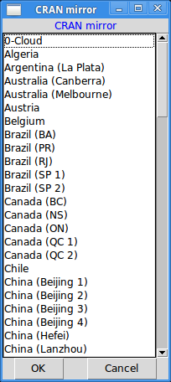

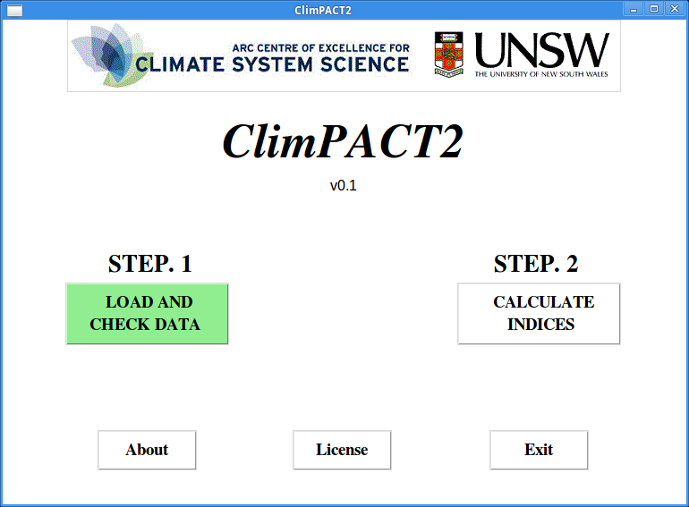
3.3 The ClimPACTv2 home screen
Once ClimPACTv2 has determined that the required packages are installed, the user will be presented with the ClimPACTv2 home screen. Here, two main options are presented, with the labels “STEP. 1” and “STEP. 2”, indicating the order in which the user should proceed to calculate the climate indices, using their data. The green highlighting of the “STEP. 1” button indicates which step the user currently needs to complete and thus which option they should select.
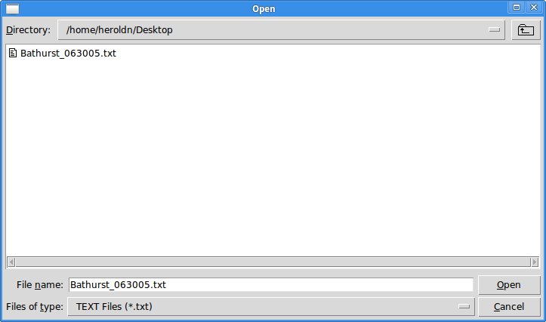
3.4 Select climate data file
Selecting “STEP. 1” presents a prompt where the user can locate an ASCII file containing their climate data (refer to Appendix G for the required format of this file) and which is subsequently checked for formatting. The filename should be of the form “stationname.txt”. For this manual the file Bathurst_063005.txt will be used as an example. Once a file is selected a progress bar may briefly appear indicating progress in scanning for comma delimiters and replacing any with white space, checking that years are in the correct order, and substituting missing values of -99.9 with NA (the R nomenclature for a missing value). If any errors occur in reading the chosen file ClimPACTv2 will display the error message and the user must check their file for the correct formatting.
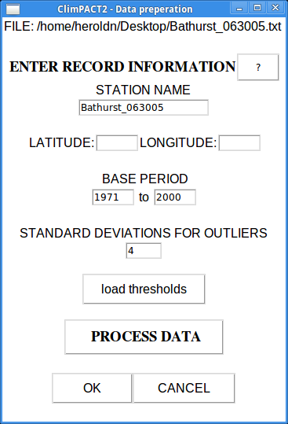
3.5 Load and check data
Once the chosen climate data file has been successfully read by ClimPACTv2 the above screen will appear, displaying the chosen file across the top (in this case Bathurst_063005.txt) and a series of input text boxes and buttons below. This is the window where data from the chosen climate data file is prepared for the calculation of the indices. Selecting the ‘?’ icon at the top of the screen will provide a summary of each input on this screen.
The first input text box allows the user to customise the station name of the record (the default being the filename). This should be informative and will be used to name files produced by ClimPACTv2 (these include output index .csv files, plots and diagnostic files).
Below this the user must specify the latitude and longitude of the station. This is required for some indices to approximate radiation balance for the site. Use decimal format for latitudes and longitudes (i.e. full degrees and 1/100 of degrees, instead of hexagesimal format). The valid latitude range is -90 to +90 and the valid longitude range is -180 to + 180.
The base period input text boxes refer to the years that the user wishes percentile indices to be measured against. For example, in a record from 1950 to 2010, the user may wish percentiles to be calculated for the years 1960 to 1990.
The last input text box allows the user to specify the number of standard deviations that ClimPACTv2 will define as outliers in the user’s temperature data. The outliers are daily values outside a number of standard deviations specified by the user. Currently, this range is defined as the mean plus or minus n times the standard deviation of the value for the day, that is, [mean – n*std, mean+n*std]. Here std represents the standard deviation for the day, n is an input from the user and mean is computed from the climatology of the day (input at next step).
Below the input text boxes is a button ‘load thresholds’ which allows the user to optionally load climate thresholds that have been previously calculated by ClimPACTv2. Selecting this button will present a prompt allowing the user to select a *_thres.csv file that has been previously created. This option may be desired when a reference period is outside of the time period of the chosen data. For example, the Bathurst_063005.txt station record contains data from 1901 to 2014, however, if thresholds were previously calculated for this station for the period 1880 to 1900, then these thresholds can be loaded here. ClimPACTv2 automatically calculates thresholds for each dataset every time the ‘PROCESS DATA’ button is selected. If a separate threshold file is desired it must be selected before selecting ‘PROCESS DATA’. Lastly, when a threshold file is loaded, the specified base period is ignored, since no new thresholds will be calculated.
After all input text boxes have been filled out and previous thresholds have been loaded (if desired), select ‘PROCESS DATA’. This step takes time and a progress bar will appear. This step is mandatory and the user will not be allowed to select ‘OK’ at the bottom of the screen (and thus be prevented from proceeding to ‘STEP. 2’ of the ClimPACTv2 process) until their data has been processed. During this step ClimPACTv2 may stop if it detects errors in the data or the user’s preferences. Specifically, ClimPACTv2 will stop if the latitude and longitude values are not valid, if the base period years are not valid or compatible with the data or if negative precipitation values are found. A warning will be shown if a series of 4 or more zero values are found in any of the temperature data (given that such a number of precisely zero temperatures likely indicates erroneous data) along with the dates between which they were found, however, processing will still continue. Upon completion, a message stating “PROCESSING COMPLETE” will be shown, along with an indication of whether outliers (defined by the number of standard deviations entered by the user) were detected.
Selecting ‘PROCESS DATA’ produces three .csv files which are placed in a subdirectory called log, which is automatically created by ClimPACTv2. Using our example of Bathurst_063005 the files would be named:
- “Bathurst_063005_tempQC.csv”,
- “Bathurst_063005_prcpQC.csv”,
- “Bathurst_063005_tepstdQC.csv”
The first two files contain information about unreasonable temperature and precipitation values, i.e. any cases where TN is greater than TX, TN or TX are above or below 70°C and -70°C, respectively, or P is negative. The third file flags all possible outliers in daily temperature with the dates on which those outliers occur. For an easy visualization, 4 PDF files containing time series plots (missing values are plotted as red dots) of daily precipitation amount, daily maximum, minimum temperatures and daily temperature range are also stored in log. See below for an example of a maximum temperature diagnostic plot showing missing values.
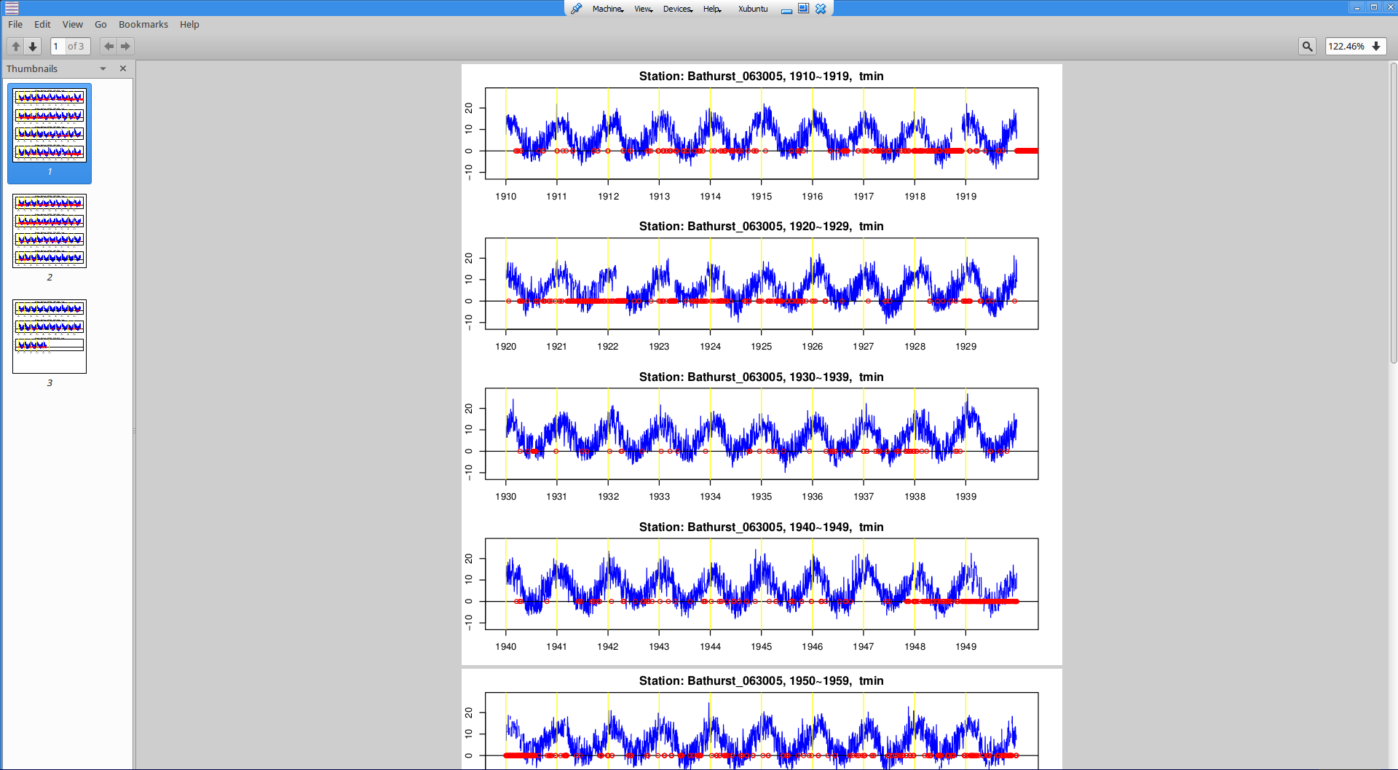
At this point, the user would check the data in the file “Bathurst_063005_tepstdQC.csv” to determine if any value marked as an outlier is really an outlier. The user should also check any data in their original .txt file (Bathurst_063005.txt in this example) that has been flagged by ClimPACTv2 (for example, negative precipitation or series of zero temperatures). If data is corrected by the user they will need to select the “STEP. 1 LOAD AND CHECK DATA” process again to ensure all data has been corrected.
ClimPACTv2 will display and error or warning message if any data appears erroneous or suspicious.
If the user’s data has been processed successfully, the ‘OK’ button at the bottom of the screen may be selected. At this point the user will be returned to the ClimPACTv2 home screen.

3.6 Calculating the indices
ClimPACTv2 is capable of computing the 34 ET-SCI core indices (see Table A1 and Table A2 in Appendix B; definitions in Appendix C), additional sector-specific indices (see Table A3), and the ETCCDI indices (see Table A4 and definitions in Appendix D). Users may, however, compute only those indices they require.
After STEP. 1 has been completed successfully, the “STEP. 2” button on the ClimPACTv2 home screen will be highlighted green to indicate that the user is now able to calculate the indices, as shown below. Select the “CALCULATE INDICES” button.
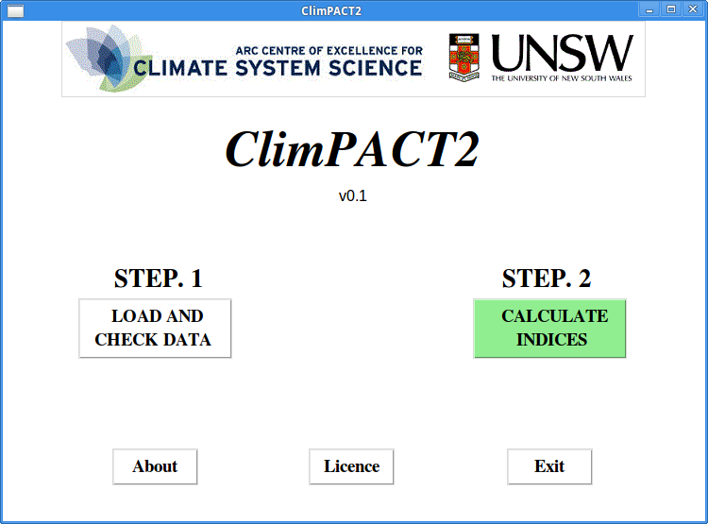

3.7 Parameter values for indices
This screen allows users to set parameters relevant to some of the indices. Some indices can be calculated over months or years (e.g. the number of frost days ‘FD’ can be summed monthly or annually) and this can be specified with the radio buttons at the top of the screen.
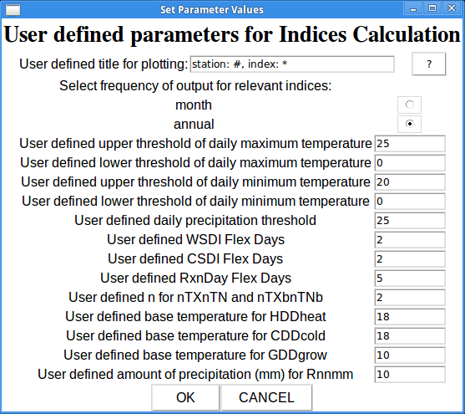
The “User defined upper threshold of daily maximum temperature” allows the calculation of the number of days when daily maximum temperature has exceeded this threshold.
The “User defined lower threshold of daily maximum temperature” allows the calculation of the number of days when daily maximum temperature is below this value.
The “User defined upper threshold of daily minimum temperature” allows the calculation of the number of days when daily minimum temperature has exceeded this threshold.
The “User defined lower threshold of daily minimum temperature” allows the calculation of the number of days when daily minimum temperature is below this limit.
The “User defined daily precipitation threshold” computes the number of days when daily precipitation amounts exceed this threshold.
The “Flex” parameters (see Table A1) are the consecutive days over which you want to calculate relevant indices e.g. heat waves. As an example, if you choose 2 for the WSDIflex index, this will create an index called WSDI2, if you choose 3 this will create an index called WSDI3 etc. These values can be a minimum of 2 and a maximum of 10.
The “User defined n for nTXnTN and nTXbnTNb” sets the number of consecutive days required for the nTXnTN and nTXbnTNb indices.
The “User defined base temperature” for HDDheat, CDDcold and GDDgrow set the temperature to be used in the subtraction in these indices.
The “User defined amount of precipitation (mm) for Rnnmm” sets the value of nn in Rnnmm.
Once this step is completed, click “OK”.
3.8 Select indices to calculate
A window is now presented that allows users to select their desired indices for calculation. The abbreviation for each index as well as its definition are printed.
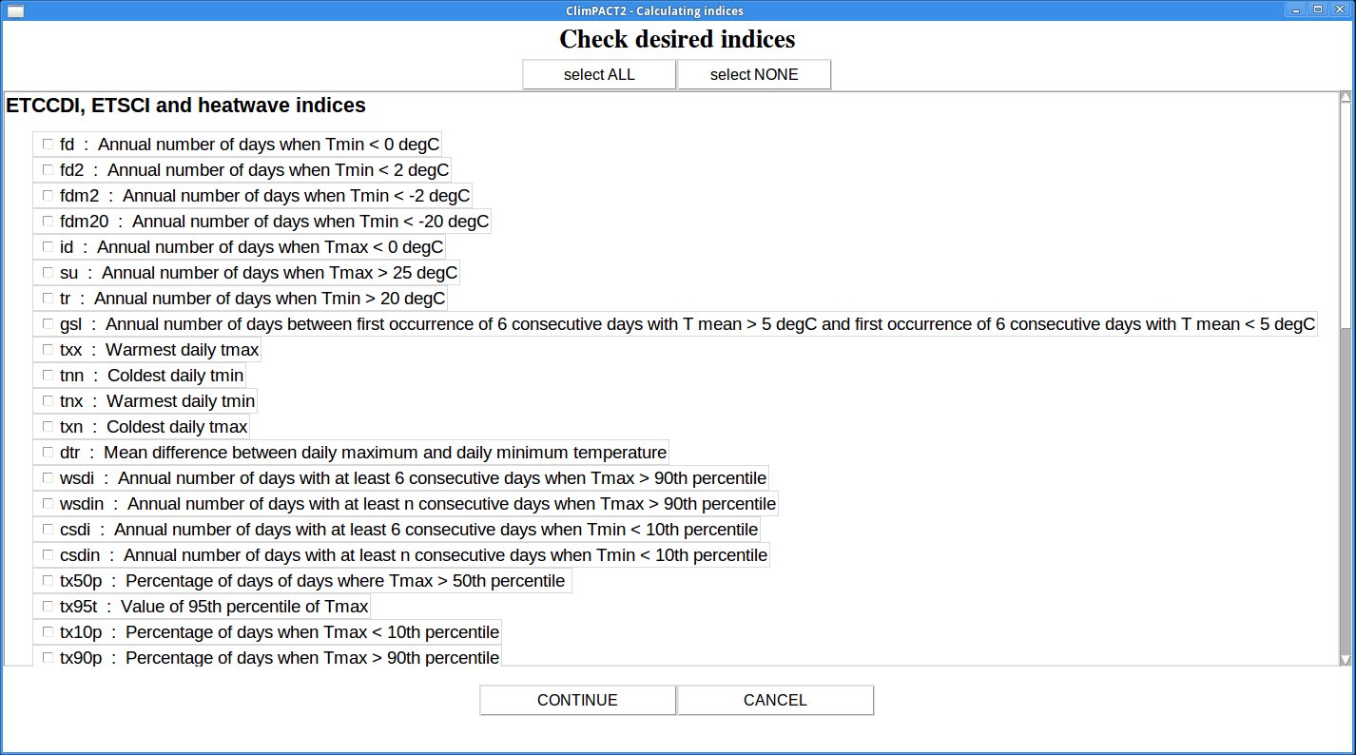
Tick the indices that are desired, or choose “select ALL”. Click “CONTINUE” to perform the computation. In most cases this process should not take very long, a progress bar will appear to indicate the time remaining. A pop-up window will appear once the indices are computed.
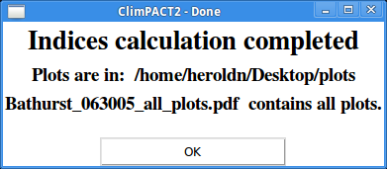
3.9 Accessing ClimPACTv2 output
Calculated indices series are stored in sub-directory indices in .csv format. Data columns are separated by a comma (“,”). These files can be opened in Excel or using a text editor. The indices files have names “Bathurst_063005_XXX.csv” where XXX represents the name of the index. A sample csv file for tm5a is shown below.
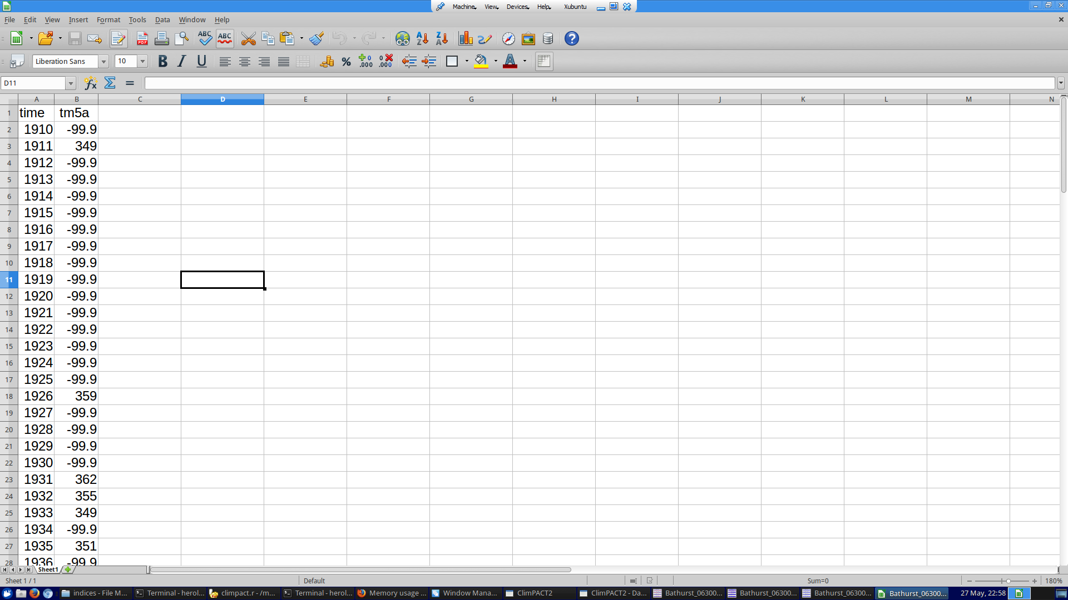
Note here there is one value per year for tm5a. Some indices have monthly output.
Resulting trends for all indices are stored in sub-directory trend in csv format. There is one file for all indices per station with the name “Bathurst_063005_trend.csv”. Columns represent latitude, longitude, start year for trend calculation, end year for trend calculation, trend per year, standard error on trend calculation and the significance of the trend (< 0.05 indicates significance at the 5% level). See below for an example.
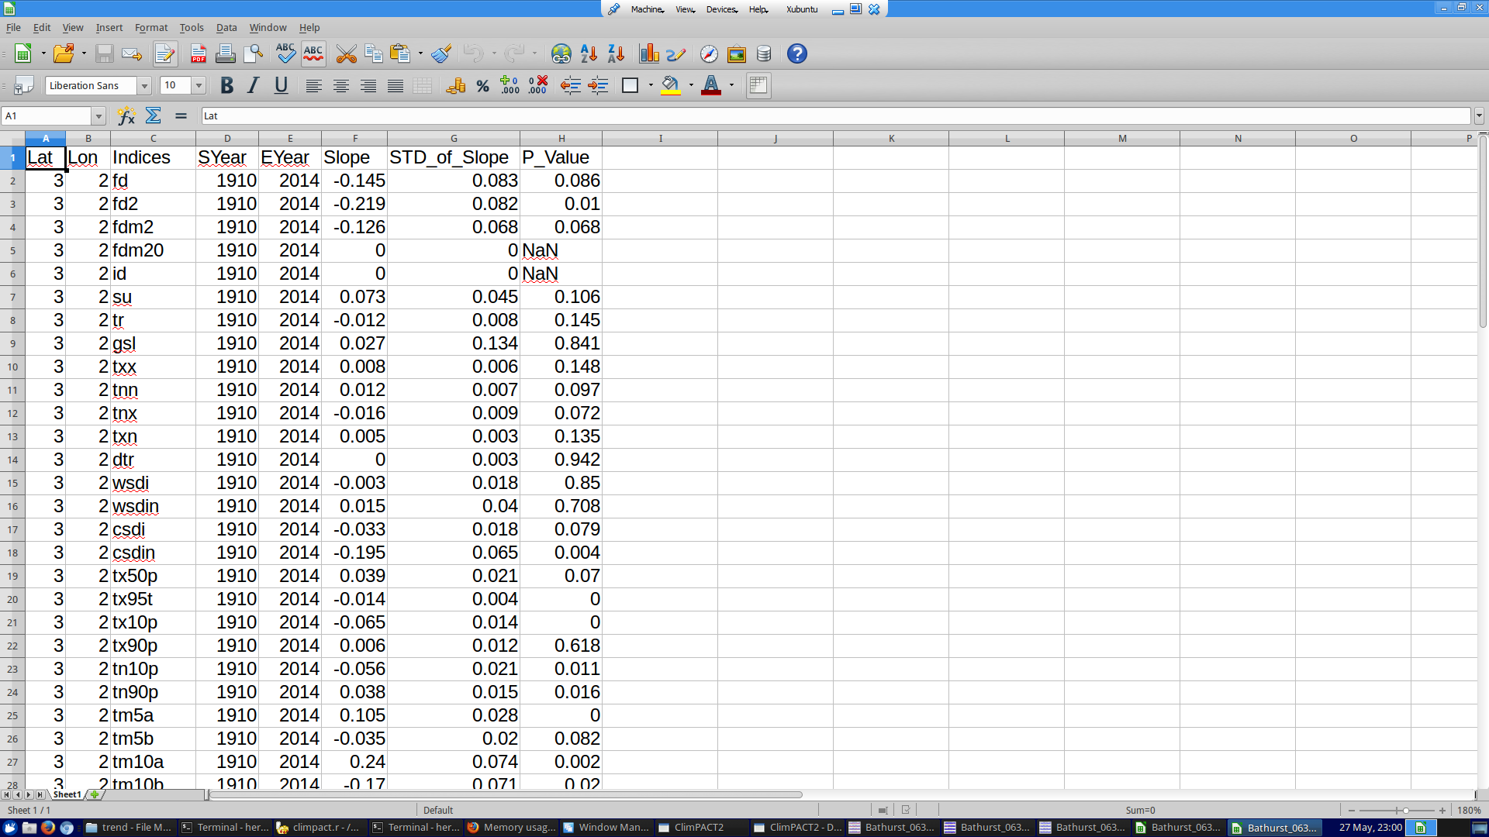
Select “CALCULATE INDICES” from the main menu if you want to compute additional indices or trends for the same station (NB: if you use the same station name you will write over the existing trend file). For additional stations, select “LOAD AND CHECK DATA” and repeat the above process. Select “Exit” if all required calculations are completed.
3.10 Visualising the indices output
For the purpose of visualization time series are plotted, along with a locally weighted linear regression (dashed line) to try and give an indication of longer-term variations. Statistics of the linear trend fitting are displayed on the plots (see below for an example of tn90p the percentage of days below the 90th percentile of minimum temperature, for our station “Bathurst_063005”). These plots are stored in the sub-directory plots in JPEG format. The filenames for plots follow the same rule as the csv file in the indices directory except that “csv” is changed to “jpg”. In addition one pdf file, *_all_plots.pdf (Bathurst_063005_all_plots.pdf in our case), containing all plots is also produced in the sub-directory plots. This file will be overwritten each time you run the software.
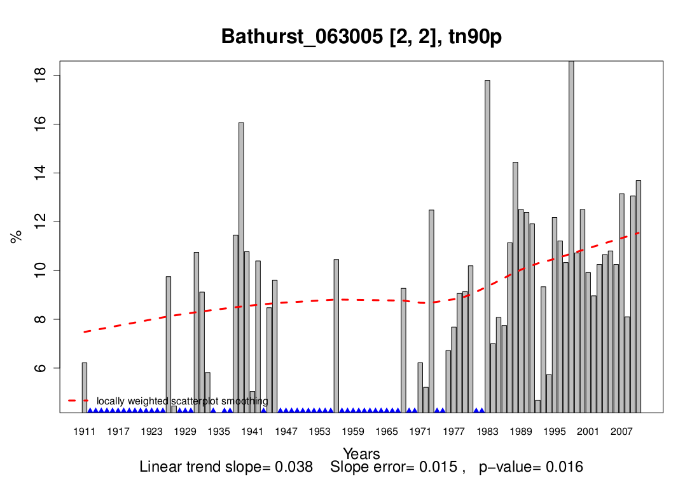
Title includes station metadata and index information
Linear trend Error on trend calculation Statistical significance

4. CALCULATING THE CLIMPACTV2 INDICES ON THREE DIMENSIONAL DATASETS WITH THE climpact.loader FUNCTION
Users who have three-dimensional datasets (time x latitude x longitude) of daily temperature and precipitation may utilise the climpact.loader function contained in climpact2.r to calculate the ClimPACTv2 indices. This functionality is intended for users familiar with R. This section provides a brief overview of this functionality.
If you do not have the ClimPACTv2 code, you can download the latest version from github (https://github.com/heroldn/ClimPACTv2/archive/master.zip). The file climpact2.wrapper.r provides an example R script that calls the climpact.loader function in climpact2.r. Users are encouraged to modify this script to their needs.
climpact.loader takes three dimensional netCDF files in CF (Climate and Forecast) format as its input. The list of parameters that can be specified when calling climpact.loader are shown below and can be found in the climpact2.r source code.
- tsminfile: min temperature netCDF file. Must be gridded daily data.
- tsmaxfile: max temperature netCDF file. Must be gridded daily data.
- precfile: daily precipitation netCDF file. Must be gridded daily data.
- tsminname: name of min temperature variable in tsminfile
- tsmaxname: name of max temperature variable in tsmaxfile
- precname: name of daily precipitation variable in precfile
- timename: name of time variable in input files
- indices: a list specifying which indices to calculate. See index.master.list for a list of supported indices. Specify "all" to calculate all indices.
- identifier: an optional string to aid identifying output files (e.g. this may be the particular model/dataset the indices are being calculated on).
- lonname: name of longitude dimension.
- latname: name of latitude dimension.
- baserange: reference period for calculating percentile indices.
- freq: frequency at which to calculate relevant indices.
- write_quantiles: boolean specifying whether to write percentiles to a file for later use.
- quantile_file: netCDF file created from a previous execution of climpact.loader with write_quantiles set to TRUE.
- cores: specify the number of cores to use for processing. Default is to use one core.
- tempqtiles: temperature percentiles to calculate.
- precqtiles: precipitation percentiles to calculate.
- max.missing.days: maximum missing days under which indices will still be calculated.
- min.base.data.fraction.present: minimum fraction of data required for a quantile to be calculated for a particular day.
- outputdir: directory where index files will be created.
- ... additional parameters: any parameters that are defined for specific indices (see the manual) can be specified by prefixing the index name followed by an underscore. For example, the spells.can.span.years parameter for the climdex index wsdi can be specified by passing wsdi_spells.can.span.years.

A strength of ClimPACTv2 is that given it is built upon climdex.pcic functionality, any parameters that can be passed to index functions in climdex.pcic can be also passed to climpact.loader. This function can also be executed on multiple cores to increase performance. This is achieved by setting cores to some value greater than 1. It is important that the user knows the limits of their hardware. Currently, operating on two cores, calculating all 51 indices on a 20 year, 144 x 215 grid takes approximately 12 hours.
It is also important to note that if the user wishes to record quantiles for later use they must set write_quantiles to “TRUE”. When doing this the user must ensure that tempqtiles and precqtiles have all of the percentiles that will be required for later calculations. In other words, the percentiles specified in tempqtiles and precqtiles are the percentiles that will be recorded when write_quantiles is set to “TRUE”. If not specified these parameters will be set to their default values (which can be found in ClimPACTv2.r). The percentiles specified in ClimPACTv2.wrapper.r are all that are required for calculating all 51 indices in ClimPACTv2.
An example output of the Standardised Precipitation-Evapotranspiration Index (SPEI) calculated for a gridded dataset is shown below. We recommend using Ncview (http://meteora.ucsd.edu/~pierce/ncview_home_page.html) or Panoply (http://www.giss.nasa.gov/tools/panoply/) for viewing netCDF output.
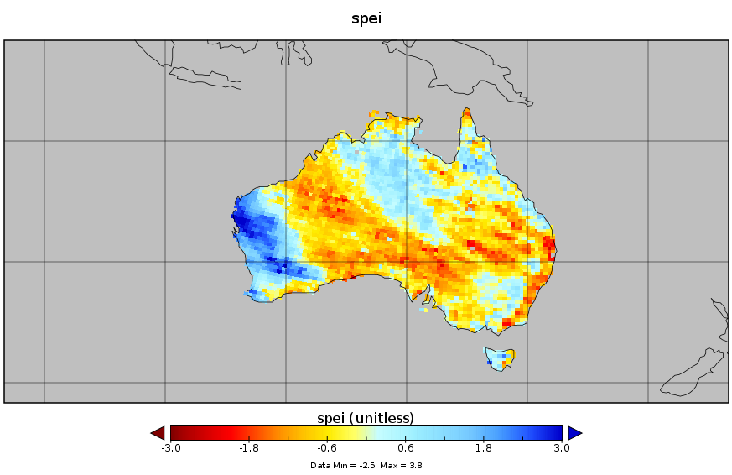

APPENDICES
APPENDIX A: Goals and terms of reference of the ET-SCI

At the first meeting of the ET-SCI in Tarragona, Spain in July 2011, the following Terms of Reference (ToR) and deliverables were agreed as follows are:

- Develop methods and tools including standardized software for, and to generate, sector-specific climate indices, including their time series based on historical data, and methodologies to define simple and complex climate risks;

- Promote the use of sector-specific climate indices to bring out variability and trends in climate of particular interest to socio-economic sectors (e.g., droughts), with global consistency and to help characterize the susceptibility of various sectors to climate;

- Develop the training materials needed to raise capacity and promote uniform approaches around the world in applying these techniques;

- Work with sector-based agencies and experts, including those of relevant WMO Technical Commissions, particularly the Commission for Hydrology (CHy) and the Commission for Agricultural Meteorology (CAgM), to facilitate the use of climate information in users’ decision-support systems for climate risk management and adaptation strategies;

- Submit reports in accordance with timetables established by the OPACE 4 co-chairs.

In addition various deliverables were proposed for consideration by the Team. These included:

- A collection and analysis of existing climate indices with particular specific sectoral (agriculture, water, health and Disaster Risk Reduction (DRR)) applications at national and regional scales;

- Technical publication on climate indices for sectoral application in risk assessment and adaptation;

- Methods and tools, standardized software and associated training materials required to produce sector-specific climate indices for systematic assessment of the impact of climate variability and change and to facilitate climate risk management and adaptation (to be done in collaboration with WMO Technical Commissions, particularly CCl OPACE-2 and with relevant agencies and organizations if required;

- Pilot training workshop (at least one region) on development of the indices;

- Workshop Report/Publication.

APPENDIX B: TABLES OF ET-SCI INDICES

Table A1: List Temperature-BAsed indices of ET-SCI core sector-specific indices (AS AGREED JULY 2011) where TM = mean temperature, TN = minimum temperature and TX = maximum temperature

 | ID | Indicator  name | Definitions | UNITS | ETCCDI index | Sector
1 | FD0 | Frost days 0 | Annual count when TN < 0ºC | days | Y | H, AFS
2 | FD2 | Frost days 2 | Annual count when TN < 2ºC | days | N | AFS
3 | FDm2 | Hard freeze | Annual count when TN < -2ºC | days | N | AFS
4 | FDm20 | Very Hard freeze | Annual count when TN < -20ºC | days | N | H, AFS
5 | ID0 | Ice days | Annual count when TX < 0ºC | days | Y | H, AFS
6 | SU25 | Summer days | Annual count when TX > 25ºC | days | Y | H
7 | TR20 | Tropical nights | Annual count when TN > 20ºC | days | Y | H, AFS
8 | GSL | Growing season  Length | Annual (1st Jan to 31st Dec in NH, 1st July to 30th June in SH) count between first span of at least 6 days with TM>5ºC and first span after July 1 (January 1 in SH) of 6 days with TM<5ºC | days | Y | AFS
9 | TXx | Max TX | Monthly maximum value of daily TX | ºC | Y | AFS
10 | TNn | Min TN | Monthly minimum value of daily TN | ºC | Y | AFS
11 | WSDI | Warm spell duration  indicator | Annual count of days with at least 6 consecutive days when TX>90th percentile | days | Y | H, AFS,  WRH
12 | WSDIn | User-defined WSDI | Annual count of days with at least n consecutive days when TX>90th percentile where n>= 2 (and max 10) | days | N | H, AFS,  WRH
13 | CSDI | Cold spell duration  indicator | Annual count of days with at least 6 consecutive days when TN<10th percentile | days | Y | H, AFS
14 | CSDIn | User-defined CSDI | Annual count of days with at least n consecutive days when TN<10th percentile where n>= 2 (and max 10) | days | N | H, AFS,  WRH
15 | TX50p | Above average  Days | Percentage of days of days where TX>50th percentile | % | N | H, AFS,  WRH
16 | TX95t | Very warm day  threshold | Value of 95th percentile of TX | ºC | N | H, AFS
17 | TM5a | TM above 5°C | Annual count when TM >= 5ºC | days | N | AFS
18 | TM5b | TM below 5°C | Annual count when TM < 5ºC | days | N | AFS
19 | TM10a | TM above 10°C | Annual count when TM >= 10ºC | days | N | AFS
20 | TM10b | TM below 10°C | Annual count when TM < 10ºC | days | N | AFS
21 | SU30 | Hot days | Annual count when TX >= 30ºC | days | N | H, AFS
22 | SU35 | Very hot days | Annual count when TX > = 35ºC | days | N | H, AFS
23 | nTXnTN | User-defined  consecutive number  of hot days and  nights | Annual count of n consecutive days where both TX > 95th percentile and TN > 95th percentile, where n >= 2 (and max of 10) | Number of events | N | H, AFS,  WRH
24 | HDDheat | Heating degree  Days | Annual sum of T_{b}- TM (where T_{b} is a user-defined location-specific base temperature and TM < T_{b}) | ºC | N | H
25 | CDDcold | Cooling degree  Days | Annual sum of TM - T_{b} (where T_{b} is a user-defined location-specific base temperature and TM > T_{b}) | ºC | N | H
26 | GDDgrow | Growing degree  Days | Annual sum of TM - T_{b} (where T_{b} is a user-defined location-specific base temperature and TM >T_{b}) | ºC | N | H, AFS
H=Health, AFS=Agriculture and Food Security, WRH=Water Resources and Hydrology
Table A2: List PRECIPITATION-BAsed indices of ET-SCI core sector-specific indices (AS AGREED JULY 2011) where P = daily precipitation and prcp = annual total precipitation
 | ID | Indicator  Name | Definitions | UNITS | ETCCDI index | Sector
27 | R20mm | Number of very heavy precipitation days | Annual count of days when P>=20mm | days | Y | AFS,  WRH
28 | CDD | Consecutive dry Days | Maximum number of consecutive days with P<1mm | days | Y | H, AFS,  WRH
29 | PRCPTOT | Annual total wet-day precipitation | PRCP from wet days (P>=1mm) | mm | Y | AFS,  WRH
30 | R95pTOT | Contribution from very wet days | Annual percentage of RR>95th percentile / PRCPTOT | % | Y | AFS,  WRH
31 | R99pTOT | Contribution from extremely wet days | Annual percentage of P>99th percentile / PRCPTOT | % | Y | AFS,  WRH
32 | RXnday | User-defined consecutive days precipitation amount | Monthly maximum consecutive n-day precipitation (up to a maximum of 10) | mm | N | H, AFS,  WRH
33 | SPIflex | Standardised Precipitation Index | Measure of “drought” using the Standardised Precipitation Index on time scales of 3, 6 and 12 months. No missing data are allowed to calculate SPIflex. | Dimension less index | N | H, AFS,  WRH
34 | SPEIflex | Standardised Precipitation Evapotranspiration Index | Measure of “drought” using the Standardised Precipitation Evapotranspiration Index on time scales of 3, 6 and 12 months. No missing data are allowed to calculate SPEIflex. | Dimension less index | N | H, AFS,  WRH
H=Health, AFS=Agriculture and Food Security, WRH=Water Resources and Hydrology
Table A3:List Temperature-BAsed indices of ET-SCI ADDITIONAL sector-specific indices
 | ID | Indicator  name | Definitions | UNITS | ETCCDI index | Sector
35 | HWN (EHF/CTN90pct/CTX90pct) | Heat wave number | The annual number of summer (Nov-Mar in SH and May-Sep in NH) heat waves where conditions persist for at least 3 consecutive days per the definitions of EHF/CTN90pct/CTX90pct in Appendix B | Number of events | N | H, AFS, WRH
36 | HWD (EHF/CTN90pct/CTX90pct) | Heat wave duration | The length of the longest summer (Nov-Mar in SH and May-Sep in NH) heat wave where conditions persist for at least 3 consecutive days per definitions per the definitions of EHF/CTN90pct/CTX90pct in Appendix B | days | N | H, AFS,  WRH
37 | HWF (EHF/CTN90pct/CTX90pct) | Heat wave day frequency | The total number of days each summer (Nov-Mar in SH and May-Sep in NH) that contribute to all heat waves where conditions persist for at least 3 consecutive days per definitions per the definitions of EHF/CTN90pct/CTX90pct in Appendix B | days | N | H, AFS,  WRH
38 | HWA (EHF/CTN90pct/CTX90pct) | Heat wave amplitude | The hottest day of the hottest summer (Nov-Mar in SH and May-Sep in NH) heat wave where conditions persist for at least 3 consecutive days per definitions per the definitions of EHF/CTN90pct/CTX90pct in Appendix B | ºC  ( ºC² EHF) | N | H, AFS,  WRH
39 | HWM (EHF/CTN90pct/CTX90pct) | Heat wave mean | Average magnitude of all heat wave days (Nov-Mar in SH and May-Sep in NH) heat wave where conditions persist for at least 3 consecutive days per definitions per the definitions of EHF/CTN90pct/CTX90pct in Appendix B | ºC  ( ºC² EHF) | N | H, AFS,  WRH
40 | nTX_{b}nTN_{b} | User-defined consecutive number of cold days and nights | Annual count of n consecutive days where both TX < 5th percentile and TN < 5th percentile where n >=2 and n <=10? | Number of events | N | H, AFS
H=Health, AFS=Agriculture and Food Security, WRH=Water Resources and Hydrology
Appendix C: Definitions of CoRE and NON-CORE ET-SCI Indices
The definitions for a core set of 34 core descriptive sector-specific indices defined by the World Meteorological Organization (WMO) Commission for Climatology (CCl) Expert Team on Climate Risk and Sector-specific Indices (ET-SCI, see http://www.wmo.int/pages/prog/wcp/ccl/opace/opace4/expertteam.php) and 9 additional descriptive sector-specific indices are provided below. User-friendly R-based software (ClimPACT) is provided to calculate the indices from the ET-SCI website.
Missing data criteria: Monthly indices are calculated if no more than 3 days are missing in a month, while annual values are calculated if no more than 15 days are missing in a year. No annual value will be calculated if any one month’s data are missing. For threshold indices, a threshold is calculated if at least 70% of data are present. For spell duration indicators (marked with a *), a spell can continue into the next year and is counted against the year in which the spell ends e.g. a cold spell (CSDI) in the Northern Hemisphere beginning on 31st December 2000 and ending on 6th January 2001 is counted towards the total number of cold spells in 2001.
CORE INDICES:
Temperature indices:
1. FD0, frost days 0: count of days where TN (daily minimum temperature) < 0°C
Let TNij be the daily minimum temperature on day i in period j. Count the number of days where TNij <0°C.
2. FD2, frost days 2: count of days where TN (daily minimum temperature) < 2°C
Let TNij be the daily minimum temperature on day i in period j. Count the number of days where TNij <2°C.
3. FDm2, frost days -2: count of days where TN (daily minimum temperature) < -2°C
Let TNij be the daily minimum temperature on day i in period j. Count the number of days where TNij <-2°C.
4. FDm20, frost days -20: count of days where TN (daily minimum temperature) < -20°C
Let TNij be the daily minimum temperature on day i in period j. Count the number of days where TNij <-20°C.
5. SU25, summer days: count of days where TX (daily maximum temperature) > 25°C
Let TXij be the daily maximum temperature on day i in period j. Count the number of days where TXij >25°C.
6. ID0, ice days: count of days where TX < 0°C
Let TXij be the daily maximum temperature on day i in period j. Count the number of days where TXij <0°C.
7. TR20, tropical nights: count of days where TN > 20°C
Let TNij be the daily minimum temperature on day i in period j. Count the number of days where TNij >20°C.
8. GSL, growing season length: annual count of days between first span of at least six days where TM (daily mean temperature) > 5°C and first span in second half of the year of at least six days where TM< 5°C.
Let TMij be the daily mean temperature on day i in period j. Count the annual (1 Jan to 31 Dec in Northern Hemisphere, 1 July to 30 June in Southern Hemisphere) number of days between the first occurrence of at least six consecutive days where TMij > 5°C and the first occurrence after 1 July (1 Jan in Southern Hemisphere) of at least six consecutive days where TMij < 5°C.
9. TXx: monthly maximum value of daily maximum temperature:
Let TXik be the daily maximum temperature on day i in month k. The maximum daily maximum temperature in month k is then TXx = max (TXik).
10. TNn: monthly minimum value of daily minimum temperature:
Let TNik be the daily minimum temperature on day i in month k. The minimum daily minimum temperature in month k is then TNn = min (TNik).
11. WSDI*, warm spell duration index: count of days in a span of at least six days where TX > 90th percentile.
Let TXij be the daily maximum temperature on day i in period j and let TXib90 be the calendar day 90th percentile of daily maximum temperature calculated for a five-day window centred on each calendar day in the base period b (e.g. 1971-2000). Count the number of days where, in intervals of at least six consecutive days TXij > TXib90.
12. WSDIn*, user-defined warm spell duration index: count of days in a span of at least n days where TX > 90th percentile.
Let TXij be the daily maximum temperature on day i in period j and let TXib90 be the calendar day 90th percentile of daily maximum temperature calculated for a five-day window centred on each calendar day in the base period b (e.g. 1971-2000). Count the number of days where, in intervals of at least n consecutive days TXij > TXib90 where n<= 10.
13. CSDI*, cold spell duration index: count of days in a span of at least six days where TN < 10th percentile.
Let TNij be the daily minimum temperature on day i in period j and let TNib10 be the calendar day 10th percentile of daily minimum temperature calculated for a five-day window centred on each calendar day in the base period b (e.g. 1971-2000). Count the number of days where, in intervals of at least six consecutive days TNij < TNib10.
14. CSDIn*, user-defined cold spell duration index: count of days in a span of at least n days where TN < 10th percentile.
Let TNij be the daily minimum temperature on day i in period j and let TNib10 be the calendar day 10th percentile of daily minimum temperature calculated for a five-day window centred on each calendar day in the base period b (e.g. 1971-2000). Count the number of days where, in intervals of at least n consecutive days TNij < TNib10 where n<= 10.
15. TX50p, above average days: count of days where TX > 50th percentile.
Let TXij be the daily maximum temperature on day i in period j and let TXib50 be the calendar day 50th percentile of daily maximum temperature calculated for a five-day window centred on each calendar day in the base period b (e.g. 1971-2000). Count the number of days where TXij > TXib50.
16. TX95t, very warm day threshold: value of the 95th percentile of TX.
Let TXij be the daily maximum temperature on day i in period j. Calculate TXib95p as the calendar day 95th percentile of daily maximum temperature calculated for a five-day window centred on each calendar day in the base period b (e.g. 1971-2000).
17. TM5a, growing days 5: count of days where TM (daily average temperature) >= 5°C
Let TMij be the daily average temperature on day i in period j. Count the number of days where TMij >=5°C.
18. TM5b, non-growing days 5: count of days where TM (daily average temperature) < 5°C
Let TMij be the daily average temperature on day i in period j. Count the number of days where TMij <5°C.
19. TM10a, growing days 10: count of days where TM (daily average temperature) >=10°C
Let TMij be the daily average temperature on day i in period j. Count the number of days where TMij >10°C.
20. TM10b, non-growing days 10: count of days where TM (daily average temperature) < 10°C
Let TMij be the daily average temperature on day i in period j. Count the number of days where TMij <10°C.
21. TX30, hot days: count of days where TX > 30°C
Let TXij be the daily maximum temperature on day i in period j. Count the number of days where TXij >30°C.
22. TX35, very hot days: count of days where TX > 35°C
Let TXij be the daily maximum temperature on day i in period j. Count the number of days where TXij >35°C.
23. nTXnTN, user-defined consecutive hot days and hot nights: count of events with at least n consecutive days of TX > 95th percentile followed by at least n consecutive nights TN > 95th percentile and where TX and TN must occur in the same 24-hour period.
Let TNij (TXij) be the daily minimum (maximum) temperature on day i in period j and let TNib95 (TXib95) be the calendar day 95th percentile of daily minimum (maximum) temperature calculated for a five-day window centred on each calendar day in the base period b (e.g. 1971-2000). Count the number of times where, at least n consecutive days TXij > TXib95 are followed by at least n consecutive nights TNij > TNib95.
24. HDDheat, user-defined heating degree days: annual sum of T_{b} – TM where T_{b} is a user-defined location-specific base temperature.
Let TMij be the daily mean temperature on day i in period j and let T_{b} be a user-defined location-specific base temperature (e.g. needed to heat a building). Then,
HDDheat= 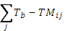 where TM_{ij}< T_{b}
25. CDDcold, user-defined cooling degree days: annual sum of TM – T_{b} where T_{b} is a user-defined location-specific base temperature.
Let TMij be the daily mean temperature on day i in period j and let T_{b} be a user-defined location-specific base temperature (e.g. needed to cool a building). Then,
CDDcold =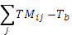 where TM_{ij}> T_{b}
26. GDDgrow, user-defined growing degree days: annual sum of TM – T_{b} where T_{b} is a user-defined location-specific base temperature.
Let TMij be the daily mean temperature on day i in period j and let T_{b} be a user-defined location-specific base temperature (e.g. needed for plant growth). Then,
GDDgrow = where TM_{ij}> T_{b}

Precipitation indices:
27. R20mm, very heavy precipitation days: count of days where RR ≥ 20 mm
Let RRij be the daily precipitation amount on day i in period j. Count the number of days where RRij ≥ 20 mm.
28. CDD*, consecutive dry days: maximum length of dry spell (RR < 1 mm)
Let RRij be the daily precipitation amount on day i in period j. Count the largest number of consecutive days where RRij < 1 mm.
29. PRCPTOT: annual total wet-day precipitation: total precipitation from wet days (> 1 mm)
Let RRwj be the daily precipitation amount on a wet day w (RR ≥ 1 mm) in period j. Then PRCPTOTj = sum (RRwj).
30. R95pTOT: contribution from very wet-days: precipitation due to very wet days (> 95th percentile)
Let RRwj be the daily precipitation amount on a wet day w (RR ≥ 1 mm) in period j and let RRwb95 be the 95th percentile of precipitation on wet days in the base period b (e.g. 1971-2000). Then R95pTOTj = (sum (RRwj)/PRCPTOT)*100, where RRwj > RRwb95.
31. R99pTOT: contribution from extremely wet days: precipitation due to extremely wet days (> 99th percentile)
Let RRwj be the daily precipitation amount on a wet day w (RR ≥ 1 mm) in period j and let RRwb99 be the 99th percentile of precipitation on wet days in the base period b (e.g. 1971-2000). Then R99pTOTj = (sum (RRwj)/PRCPTOT)*100, where RRwj > RRwb99.
32. RXnday: maximum n-day precipitation: highest precipitation amount in an n-day period
Let RRkj be the precipitation amount for the n-day interval k in period j, where k is defined by the last day. The maximum n-day values for period j are RXndayj = max (RRkj).

Drought indices:
33. SPIflex, user-defined Standardised Precipitation Index:
SPIflex corresponds to the user-defined Standardized Precipitation Index, which is the conversion of monthly precipitation data to probabilities based on long-term precipitation records computed on different time scales. Probabilities are transformed to standardized series with an average of 0 and a standard deviation of 1 (see details in World Meteorological Organization, 2012). SPI time scales of 3, 6 and 12 months are currently included in ClimPACT.
34. SPEIflex, user-defined Standardised Precipitation Evapotranspiration Index:
SPEIflex is a variation of the SPIflex. It corresponds to the user-defined Standardized Precipitation Evapotranspiration Index, which address the Potential Evapotranspiration (PET) influence on drought severity. PET is calculated following Hargreaves formulation since the Food and Agricultural Organization (FAO) recommends this method as the best alternative where data are scarce. SPEIflex is the conversion of monthly climatic water balance to probabilities also computed on different time scales and transformed to standardized series. SPEI time scales of 3, 6 and 12 months are currently included in ClimPACT. No missing data is allowed to calculate SPEIflex.

Additional (non-core) indices:
For the following 5 heat wave indices:
Let TXij be the daily maximum temperature on day i in period j. Calculate TXib90p as the calendar day 90th percentile of daily maximum temperature calculated for a five-day window centred on each calendar day in the base period b (e.g. 1971-2000).
Let TNij be the daily minimum temperature on day i in period j. Calculate TNib90p as the calendar day 90th percentile of daily minimum temperature calculated for a five-day window centred on each calendar day in the base period b (e.g. 1971-2000).
Let TMij be the daily mean temperature (i.e. (Txij+Tnij)/2) on day i in period j. Calculate TMib90p as the calendar day 90th percentile of daily mean temperature calculated for a five-day window centred on each calendar day in the base period b (e.g. 1971-2000).
35.HWN (EHF/CTN90pct/CTX90pct), heat wave number: number of heat waves
If conditions persist for at least 3 days then count the number of summer (Nov-Mar in SH and May-Sep in NH) heat waves where:
HWN_TX90 > TXib90p
HWN_TN90 >TNib90p
EHF > 0
where EHF = max [1,EHI_{accl}] x EHI_{sig}
and EHI_{accl} = (TMi + TMi−1 + TMi−2)/3 − (TMi−3 + …+ TMi−32)/30
and EHI_{sig} = (TMi + TMi−1 + TMi−2)/3 – TMij
36. HWD (EHF/CTN90pct/CTX90pct), heat wave duration: duration of longest heat wave
If conditions persist for at least 3 days then count the duration of the longest summer (Nov-Mar in SH and May-Sep in NH) heat wave where:
HWN_TX90 > TXib90p
HWN_TN90 >TNib90p
EHF > 0
where EHF = max [1,EHI_{accl}] x EHI_{sig}
and EHI_{accl} = (TMi + TMi−1 + TMi−2)/3 − (TMi−3 + …+ TMi−32)/30
and EHI_{sig} = (TMi + TMi−1 + TMi−2)/3 – TMij
37.HWF (EHF/CTN90pct/CTX90pct), heat wave frequency: total days contributing to all heat waves
If conditions persist for at least 3 days then count the total number of days contributing to summer (Nov-Mar in SH and May-Sep in NH) heat waves where:
HWN_TX90 > TXib90p
HWN_TN90 >TNib90p
EHF > 0
where EHF = max [1,EHI_{accl}] x EHI_{sig}
and EHI_{accl} = (TMi + TMi−1 + TMi−2)/3 − (TMi−3 + …+ TMi−32)/30
and EHI_{sig} = (TMi + TMi−1 + TMi−2)/3 – TMij
38. HWA (EHF/CTN90pct/CTX90pct), heat wave amplitude: hottest day of hottest heat wave
If conditions persist for at least 3 days then calculate the hottest day of the hottest summer (Nov-Mar in SH and May-Sep in NH) heat wave where:
HWN_TX90 > TXib90p
HWN_TN90 >TNib90p
EHF > 0
where EHF = max [1,EHI_{accl}] x EHI_{sig}
and EHI_{accl} = (TMi + TMi−1 + TMi−2)/3 − (TMi−3 + …+ TMi−32)/30
and EHI_{sig} = (TMi + TMi−1 + TMi−2)/3 – TMij
39. HWM (EHF/CTN90pct/CTX90pct), heat wave mean magnitude: hottest day of hottest heat wave
If conditions persist for at least 3 days then calculate the mean magnitude across all days in summer (Nov-Mar in SH and May-Sep in NH) heat waves where:
HWN_TX90 > TXib90p
HWN_TN90 >TNib90p
EHF > 0
where EHF = max [1,EHI_{accl}] x EHI_{sig}
and EHI_{accl} = (TMi + TMi−1 + TMi−2)/3 − (TMi−3 + …+ TMi−32)/30
and EHI_{sig} = (TMi + TMi−1 + TMi−2)/3 – TMij
40. nTX_{b}nTN_{b}, user-defined consecutive cold days and cold nights: count of events with at least n consecutive days of TX < 5th percentile followed by at least n consecutive nights TN < 5th percentile, and where TX and TN must occur in the same 24-hour period
Let TNij (TXij) be the daily minimum (maximum) temperature on day i in period j and let TNib5 (TXib5) be the calendar day 5th percentile of daily minimum (maximum) temperature calculated for a five-day window centred on each calendar day in the base period b (e.g. 1971-2000). Count the number of times where, at least n consecutive days TXij < TXib5 are followed by at least n consecutive nights TNij < TNib5.
41. TN95t, very warm night threshold: value of the 95th percentile of TN.
Let TNij be the daily minimum temperature on day i in period j. Calculate TNib95p as the calendar day 95th percentile of daily minimum temperature calculated for a five-day window centred on each calendar day in the base period b (e.g. 1971-2000).
42. TR30, hot nights: count of days where TN > 30°C
Let TNij be the daily minimum temperature on day i in period j. Count the number of days where TNij >30°C.
43. TR25, very hot nights: count of days where TN > 25°C
Let TNij be the daily minimum temperature on day i in period j. Count the number of days where TNij >25°C.
Appendix D: Additional ETCCDI Indices THAT Appear in ClimPACT
Table A4: The extreme temperature and precipitation indices recommended by the ETCCDI that are not core-ET-SCI indices but are included in ClimPACT software (some user defined ETCCDI indices are not included).
ID | Indicator name | Indicator definitions | UNITS
TNx | Max Tmin | Monthly maximum value of daily min temperature | ºC
TXn | Min Tmax | Monthly minimum value of daily max temperature | ºC
TN10p | Cool nights | Percentage of time when daily min temperature < 10th percentile | %
TX10p | Cool days | Percentage of time when daily max temperature < 10th percentile | %
TN90p | Warm nights | Percentage of time when daily min temperature > 90th percentile | %
TX90p | Warm days | Percentage of time when daily max temperature > 90th percentile | %
DTR | Diurnal temperature range | Monthly mean difference between daily max and min temperature | ºC
RX1day | Max 1-day precipitation amount | Monthly maximum 1-day precipitation | mm
RX5day | Max 5-day precipitation amount | Monthly maximum consecutive 5-day precipitation | mm
SDII | Simple daily intensity index | The ratio of annual total precipitation to the number of wet days (> 1 mm) | mm/day
R10mm | Number of heavy precipitation days | Annual count when precipitation > 10 mm | days
CWD | Consecutive wet days | Maximum number of consecutive days when precipitation ≥ 1 mm | days
R95p | Very wet days | Annual total precipitation from days > 95th percentile | mm
R99p | Extremely wet days | Annual total precipitation from days > 99th percentile | mm

The definitions of the descriptive indices in Table A4 for extremes defined by the Joint CCl/CLIVAR/JCOMM Expert Team on Climate Change Detection and Indices (ETCCDI, see http://www.clivar.org/organization/etccdi/etccdi.php) are provided below. User-friendly R-based software (RClimDEX) to calculate these indices is available from http://etccdi.pacificclimate.org. Note that these indices are calculated by ClimPACT but are not part of the core set of indices recommended by the ET-SCI.

Temperature indices:
TNx: monthly maximum value of daily minimum temperature:
Let TNik be the daily minimum temperature on day i in month k. The maximum daily minimum temperature is then TNx = max (TNik).
TXn: monthly minimum value of daily maximum temperature:
Let TXik be the daily maximum temperature on day i in month k. The minimum daily maximum temperature is then TXn = min (TXik).
TN10p, cold nights: count of days where TN < 10th percentile
Let TNij be the daily minimum temperature on day i in period j and let TNin10 be the calendar day 10th percentile of daily minimum temperature calculated for a five-day window centred on each calendar day in the base period n (e.g. 1971-2000). Count the number of days where TNij < TNin10.
TX10p, cold days: count of days where TX < 10th percentile
Let TXij be the daily maximum temperature on day i in period j and let TXin10 be the calendar day 10th percentile of daily maximum temperature calculated for a five-day window centred on each calendar day in the base period n (e.g. 1971-2000). Count the number of days where TXij < TXin10.
TN90p, warm nights: count of days where TN > 90th percentile
Let TNij be the daily minimum temperature on day i in period j and let TNin90 be the calendar day 90th percentile of daily minimum temperature calculated for a five-day window centred on each calendar day in the base period n (e.g. 1971-2000). Count the number of days where TNij > TNin90.
TX90p, warm days: count of days where TX > 90th percentile
Let TXij be the daily maximum temperature on day i in period j and let TXin90 be the calendar day 90th percentile of daily maximum temperature calculated for a five-day window centred on each calendar day in the base period n (e.g. 1971-2000). Count the number of days where TXij > TXin90.
DTR, diurnal temperature range: mean difference between TX and TN (°C)
Let TXij and TNij be the daily maximum and minimum temperature on day i in period j. If I represents the total number of days in j then the mean diurnal temperature range in period j DTRj = sum (TXij - TNij) / I.

Precipitation indices:
RX1day, maximum one-day precipitation: highest precipitation amount in one-day period
Let RRij be the daily precipitation amount on day i in period j. The maximum one-day value for period j is RX1dayj = max (RRij).
RX5day, maximum five-day precipitation: highest precipitation amount in five-day period
Let RRkj be the precipitation amount for the five-day interval k in period j, where k is defined by the last day. The maximum five-day values for period j are RX5dayj = max (RRkj).
SDII, simple daily intensity index: mean precipitation amount on a wet day
Let RRij be the daily precipitation amount on wet day w (RR ≥ 1 mm) in period j. If W represents the number of wet days in j then the simple precipitation intensity index SDIIj = sum (RRwj) / W.
R10mm, heavy precipitation days: count of days where RR (daily precipitation amount) ≥ 10 mm
Let RRij be the daily precipitation amount on day i in period j. Count the number of days where RRij ≥ 10 mm.
CWD, consecutive wet days: maximum length of wet spell (RR ≥ 1 mm)
Let RRij be the daily precipitation amount on day i in period j. Count the largest number of consecutive days where RRij ≥ 1 mm.
R95p: precipitation due to very wet days (> 95th percentile)
Let RRwj be the daily precipitation amount on a wet day w (RR ≥ 1 mm) in period j and let RRwn95 be the 95th percentile of precipitation on wet days in the base period n (e.g. 1971-2000). Then R95pj = sum (RRwj), where RRwj > RRwn95.
R99p: precipitation due to extremely wet days (> 99th percentile)
Let RRwj be the daily precipitation amount on a wet day w (RR ≥ 1 mm) in period j and let RRwn99 be the 99th percentile of precipitation on wet days in the base period n (e.g. 1971-2000). Then R99pj = sum (RRwj), where RRwj > RRwn99.
APPENDIX E: Installation and running of R
R is a language and environment for statistical computing and graphics. It is a GNU implementation of the S language developed by John Chambers and colleagues at Bell Laboratories (formerly AT&T, now Lucent Technologies). S-plus provides a commercial implementation of the S language.
F.1 How to install R
ClimPACT requires the base package of R and graphic user interface TclTk. The installation of R involves a very simple procedure. 1) Connect to the R project website at http://www.r-project.org, 2) Follow the links to download the most recent version of R for your computer operating system from any mirror site of CRAN.
For Microsoft Windows (95, 98, 2000, and XP), download the Windows setup program. Run that program and R will be automatically installed in your computer, with a short cut to R on your desktop. The TclTk is included in the default installation of R 2.15.2 or later versions. It may need to be installed separately if you are running an earlier version of R.
For Linux, download proper precompiled binaries and follow the instruction to install R. For other unix systems, you many need to download source code and compile it yourself.

F.2 How to run R
Under the Windows environment, double click the R icon on your desktop, or launch it through Windows “start” menu. This usually gets you into the R user interface. For some computers, you may need to first setup an environment variable called “HOME”. See R for Windows FAQ for details if you have any problems.
Under a unix and mac environment, just run R to give you the R console.
Exit from R by entering q() in the R console under both Windows and unix. Under Windows, you may also click “File” menu and then “Exit”.

APPENDIX F: Threshold estimation and base period temperature indices calculation
Empirical quantile estimation:
The quantile of a distribution is defined as
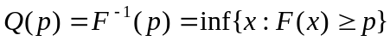, 1<p<1,
where F(x) is the distribution function. Let 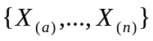denote the order statistics of 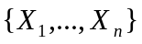(i.e. sorted values of {X}), and let 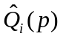denote the ith sample quantile definition. The sample quantiles can be generally written as:
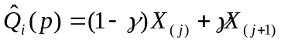.
Hyndman and Fan (1996) suggest a formula to obtain medium un-biased estimate of the quantile by letting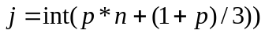 and letting 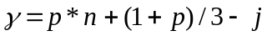, where int(u) is the largest integer not greater than u. The empirical quantile is set to the smallest or largest value in the sample when j<1 or j> n respectively. That is, quantile estimates corresponding to p<1/(n+1) are set to the smallest value in the sample, and those corresponding to p>n/(n+1) are set to the largest value in the sample.
Bootstrap procedure for the estimation of exceedance rate for the base period:
It is not possible to make an exact estimate of the thresholds due to sampling uncertainty. To provide temporally consistent estimate of exceedance rate throughout the base period and out-of-base period, we adapt the following procedure (Zhang et al. 2005) to estimate exceedance rate for the base period.
- The 30-year base period is divided into one “out-of-base” year, the year for which exceedance is to be estimated, and a “base-period” consisting the remaining of 29 years from which the thresholds would be estimated.
- A 30-year block of data is constructed by using the 29 year “base-period” data set and adding an additional year of data from the “base-period" (i.e., one of the years in the “base-period” is repeated). This constructed 30-year block is used to estimate thresholds.
- The “out-of-base” year is then compared with these thresholds and the exceedance rate for the “out-of-base” year is obtained.
- Steps (b) and (c) are repeated for an additional 28 times, by repeating each of the remaining 28 in-base years in turn to construct the 30-year block.
- The final index for the “out-of-base” year is obtained by averaging the 29 estimates obtained from steps (b), (c) and (d).

APPENDIX G: Input Data Format for RClimDEX/ClimPACT
All of the data files that are read or written are in list formatted format. The exception is the very first data file that is processed in the “Quality Control” step. This input data file has several requirements:
- ASCII text file
- Columns as following sequences: Year, Month, Day, P, TX, TN (NOTE: P units = millimeters and Temperature units= degrees Celsius)
- The format as described above must be space delimited (e.g. each element separated by one or more spaces).
- For data records, missing data must be coded as -99.9; data records must be in calendar date order. Missing dates allowed.

Example data Format for the initial data file (e.g. used in the ‘Quality Control’ step):
1901 1 1 -99.9 -3.1 -6.8
1901 1 2 -99.9 -1.3 -3.6
1901 1 3 -99.9 -0.5 -7.9
1901 1 4 -99.9 -1 -9.1
1901 1 7 -99.9 -1.8 -8.4
APPENDIX H: Troubleshooting
Limitations of the software
You will receive a warning message if the first year or last year of the available data is the same as the first year or last year of the base period. This is caused by some computations that require data beyond the boundary of the base period. The calculation of percentile based temperature indices is an example. One way to avoid this problem is to add an extra record for the day (with values marked as missing just before the beginning of the base period. For example, if base period is 1961-1990 and the data also starts in 1961, one may add “1960 12 31 -99.9 -99.9 -99.9” as the first line for the input data file. Otherwise change the period to one that does not contain the first and last years of available data.
--------------------------------------------------------------------------------------------------------------------------
If the code stops suddenly, you will not be able to open the *_all_plots.pdf file in the “plots” directory. If this should happen, input the following command in the R console:
graphics.off()
If you do this then you can still open the .pdf file.
--------------------------------------------------------------------------------------------------------------------------
Currently the software requires three gif files (UNSW.gif, coecss.gif, WMOlogo.gif) containing logos and it is assumed that these files are in your working directory of R. However if you do not have these files loaded into your directory, you can choose “cancel”, and the software still runs normally but without the logos attached.
--------------------------------------------------------------------------------------------------------------------------
Currently SPEI and SPI functions are hard-coded to 3, 6, and 12-month periods. In later versions of the code this will be amended so that users can select other periods. In addition SPEI and SPI will not work if missing data are present in the monthly values.
--------------------------------------------------------------------------------------------------------------------------

APPENDIX I: FAQs
- What should be the length of the baseline period?
The answer to this question depends on your application and the length of data you have. At the moment the default period is 1971 – 2000 but this can easily be amended within the software (see Section 3.1) to shorter or longer periods.
- How are missing data handled by ClimPACT?
Missing data need to be stored as -99.9 in the input data files (see APPENDIX G) but are converted to an internal format that R recognises (NA, not available). At the moment SPI and SPEI calculations are not able to handle missing data but the other indices can handle a modest amount of missing data (see Appendix C).
- How can ClimPACT results be analysed further or used to produce customised graphics using other popular packages?
ClimPACT produces its own plots of each index (in the “plots” folder) once the software has completed running (see Section 3.1). However all of the indices output data are stored in the “indices” directory in csv format. Many graphics packages are able to handle this file format so you can produce your own customised packages easily with your favourite software package.
- Can I add additional indices to ClimPACT myself?
At the moment there is no easy method to do this but if you are familiar with the R programming language you can amend the code to add additional indices if you require. This is a good solution if you have very specific sector requirements that are not covered by the current suite of indices.
- Can I recommend additional indices to be added to the ET-SCI core set?
Yes, but any indices added to the core set have to be agreed by the members of the ET-SCI.

APPENDIX J: Software licence agreement
ClimPACT Software Licence

All source code developed by this project is provided under the following licence:
Copyright (c) 2013 The World Meteorological Organisation (WMO).
All rights reserved.
Redistribution and use in source and binary forms, with or without
modification, are permitted provided that the following conditions are met:
* Redistributions of source code must retain the above copyright notice, this list of conditions and the following disclaimer.
* Redistributions in binary form must reproduce the above copyright notice, this list of conditions and the following disclaimer in the documentation and/or other materials provided with the distribution.
* The WMO, the Commission for Climatology (CCl), the CCl Expert Team on Climate Risk and Sector Specific Climate Indices (CCl ET-SCI), or the names of any contributors to the ClimPACT software and the related technical manual may be used to endorse or promote products derived from this software without specific prior written permission.
THIS SOFTWARE IS PROVIDED BY THE COPYRIGHT HOLDER AND CONTRIBUTORS "AS IS" AND ANY EXPRESS OR IMPLIED WARRANTIES, INCLUDING, BUT NOT LIMITED TO, THE IMPLIED WARRANTIES OF MERCHANTABILITY AND FITNESS FOR A PARTICULAR PURPOSE ARE DISCLAIMED. IN NO EVENT SHALL THE COPYRIGHT HOLDER OR CONTRIBUTORS BE LIABLE FOR ANY DIRECT, INDIRECT, INCIDENTAL, SPECIAL, EXEMPLARY, OR CONSEQUENTIAL DAMAGES (INCLUDING, BUT NOT LIMITED TO, PROCUREMENT OF SUBSTITUTE GOODS OR SERVICES; LOSS OF USE, DATA, OR PROFITS; OR BUSINESS INTERRUPTION) HOWEVER CAUSED AND ON ANY THEORY OF LIABILITY, WHETHER IN CONTRACT, STRICT LIABILITY, OR TORT (INCLUDING NEGLIGENCE OR OTHERWISE) ARISING IN ANY WAY OUT OF THE USE OF THIS SOFTWARE, EVEN IF ADVISED OF THE POSSIBILITY OF SUCH DAMAGE.
In addition to the licence, if you redistribute or create derived works from this software, it is requested that you acknowledge the WMO and the ET-SCI and we would be very grateful if you would notify us of any publications resulting from the use of this software.
References
Aguilar E, Barry A, Brunet M, Ekang L, Fernandes A, Massoukina M, Mbah J, Mhanda A, Nascimento D, Peterson TC, et al. Changes in temperature and precipitation extremes in western Central Africa, Guinea Conakry and Zimbabwe, 1955–2006. 2009. J Geophys Res, 114:D02115. doi:10.1029/2008JD011010.
Aguilar E, et al. Changes in precipitation and temperature extremes in Central America and northern South America, 1961–2003. 2006. J Geophy, 110:D23107. doi:10.1029/2005JD006119
Alexander LV, Zhang X, Peterson TC, Caesar J, Gleason B, Klein Tank AMG, Haylock M, Collins D, Trewin B, Rahimzadeh F, Tagipour A, Kumar Kolli R, Revadekar JV, Griffiths G, Vincent L, Stephenson DB, Burn J, Aguilar E, Brunet M, Taylor M, New M, Zhai P, Rusticucci M, Vazquez Aguirre JL. 2006. Global observed changes in daily climate extremes of temperature and precipitation. Journal of Geophysical Research-Atmospheres 111: D05109, doi:10.1029/2005JD006290
Caesar J, Alexander LV, Trewin B, Tse-ring K, Sorany L, Vuniyayawa V, Keosavang N, Shimana A, Htay MM, Karmacharya J, et al. Changes in temperature and precipitation extremes over the Indo-Pacific region from 1971 to 2005. Int J Climatol 2011, 31:791–801. doi:10.1002/joc.2118.
Haylock MR, et al. Trends in total and extreme South American rainfall 1960–2000 and links with sea surface temperature. J Climate 2006, 19:1490–1512.
Heim, R.R., (2002): A review of twentieth-century drought indices used in the United States. Bulletin of the American Meteorological Society, 83, 1149-1165. Hyndman, R.J., and Y. Fan, 1996: Sample quantiles in statistical packages. The American Statistician, 50, 361-367.
Klein Tank AMG, et al. Changes in daily temperature and precipitation extremes in central and south Asia. J Geophys Res 2006. doi:10.1029/2005JD006316.
McKee, T.B.N., J. Doesken, and J. Kleist, (1993): The relationship of drought frecuency and duration to time scales. Eight Conf. On Applied Climatology. Anaheim, CA, Amer. Meteor. Soc. 179-184.
Mishra, A. K., and V. P. Singh (2010), A review of drought concepts, J. Hydrol., 391, 202–216.
New M, et al. Evidence of trends in daily climate extremes over southern and west Africa. J Geophys Res 2006, 111:D14102. doi:10.1029/2005JD006289.
Perkins SE, Alexander LV. 2013. On the measurement of heat waves. Journal of Climate, in press
Perkins SE, Alexander LV. Nairn J. 2012. Increasing frequency, intensity and duration of observed global heat waves and warm spells. Geophysical Research Letters, 39, 20, doi:10.1029/2012GL053361
Peterson TC, et al. Recent changes in climate extremes in the Caribbean region. J Geophys Res 2002, 107:D214601. doi:10.1029/2002JD002251.
Peterson TC, Manton MJ. Monitoring changes in climate extremes: a tale of international collaboration. Bull Am Meteorol Soc 2008, 89:1266–1271.
Sivakumar, M. V. K., R. P. Motha, D. A. Wilhite, and D. A. Wood (Eds.) (2010): Agricultural Drought Indices: Proceedings of an Expert Meeting, 2–4 June 2010, Murcia, Spain, 219 pp., World Meteorol. Org., Geneva, Switzerland.
Vicente-Serrano S.M., Santiago Beguería, Juan I. López-Moreno, (2010) A Multi-scalar drought index sensitive to global warming: The Standardized Precipitation Evapotranspiration Index – SPEI. Journal of Climate 23: 1696-1718.Vincent LA, et al. Observed trends in indices of daily temperature extremes in South America 1960–2000. J Climate 2005, 18:5011–5023.
Vincent LA, Anguilar E, Saindou M, Hassane AF, Jumaux G, Roy D, Booneeady P, Virasami R, Randriamarolaza LYA, Faniriantsoa FR, et al. Observed trends in indices of daily and extreme temperature and precipitation for the conutries of the western Indian Ocean, 1961–2008. J Geophys Res 2011, in press.
Wang, X. L. L., 2008: Accounting for autocorrelation in detecting mean-shifts in climate data series using the penalized maximal t or F test. J. App. Met. Climatol., 47, 2423-2444.
World Meteorological Organization (2012): Standardized Precipitation Index User Guide (M. Svoboda, M. Hayes and D. Wood). (WMO-No. 1090), Geneva.
Zhang X, Alexander L, Hegerl GC, Jones P, Klein Tank A, Peterson TC, Trewin, B, Zwiers FW. 2011. Indices for monitoring changes in extremes based on daily temperature and precipitation data. WIREs Climate Change doi:10.1002/wcc.147.
Zhang X, G Hegerl, FW Zwiers and J Kenyon 2005. Avoiding inhomogeneity in percentile-based indices of temperature extremes. J. Climate, 18, 1641-1651
Zhang X, Aguilar E, Sensoy S, Melkonyan H, Tagiyeva U, Ahmed N, Kutaladze N, Rahimzadeh F, Taghipour A, Hantosh TH, et al. Trends in Middle East climate extremes indices during 1930–2003. J Geophys Res 2005, 110:D22104.
Meeting reports
Final report of the Meeting of the Commission for Climatology (CCl) Expert Team on Climate Risk and SectorSpecific Climate Indices (ETCRSCI) (Tarragona, Spain 1315 July 2011):
http://www.wmo.int/pages/prog/wcp/ccl/opace/opace4/meetings/documents/ET_CRSCI_FinalReport_Tarragona.pdf

Final report of the High Level Task Force on the Global Framework for Climate Services:
http://www.wmo.int/hlt-gfcs/downloads/HLT_book_full.pdf

The Abridged final report with resolutions of the Sixteenth World Meteorological Congress (WMO-No. 1077):
ftp://ftp.wmo.int/Documents/PublicWeb/mainweb/meetings/cbodies/governance/congress_reports/english/pdf/1077_en.pdf

The Abridged final report with resolutions and recommendations of the Fifteenth session of the WMO Commission for Climatology (WMO-No. 1054):
ftp://ftp.wmo.int/Documents/PublicWeb/mainweb/meetings/cbodies/governance/tc_reports/english/pdf/1054_en.pdf

