Npm I xss

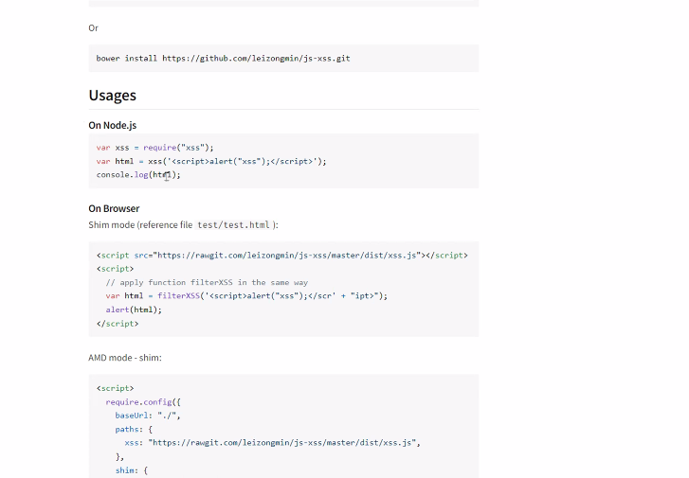

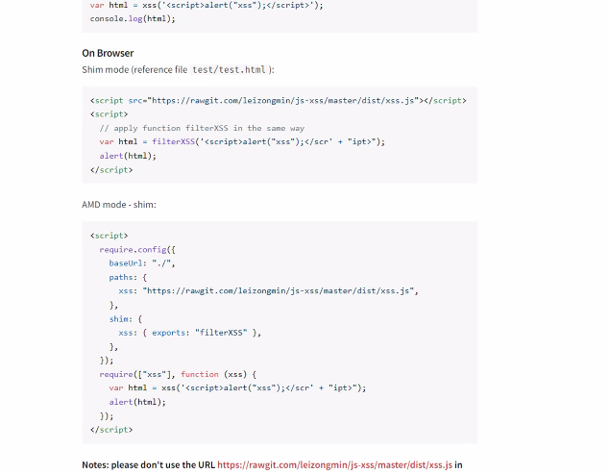

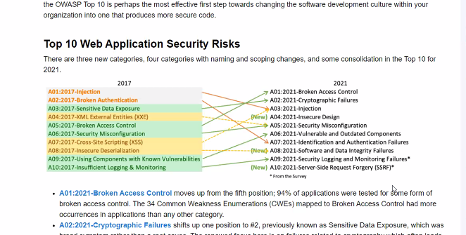

<https://www.npmjs.com/package/xss>

<https://owasp.org/www-project-top-ten/>

Security games

<https://overthewire.org/wargames/>

Security problems

https://github.com/digininja/DVWA