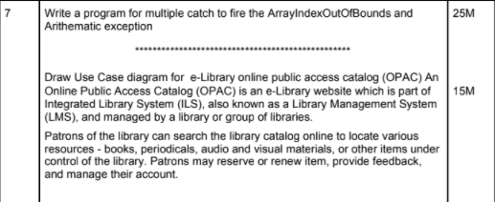

**Program 1:** Write a program for multiple catch to fire the ArrayIndexOutOfBounds and Arithematic exception.

**Program:**

package multicatchpractical;

import java.util.ArrayList;

public class MultiCatch {

public static void main(String[] args) {

try{

ArrayList<Integer> list = new ArrayList<>();

list.add(123);

list.add(0);

System.out.println(list.get(2));

System.out.println(list.get(0)/list.get(1));

}

catch(IndexOutOfBoundsException | ArithmeticException e){

System.out.println("Exception occured:" + e);

}

}

}

**Output:** 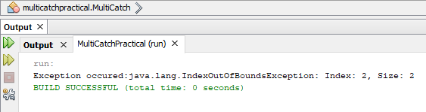

**Explanation:** Array out of bound exception occurs when we try to access an array element which is not present. Arithmetic exception occurs when we a user makes an arithmetic mistake, which can be like if a user is trying to add two string values which not possible or like if the user is trying to divide a number by 0 which result not in a number. As the above program is an implementation of multi catch, the exception which occurs first will be hit and that exception detail will be outputted.

**Usecase**

Draw Use Case diagram for e-Library online public access catalog (OPAC) An Online Public Access Catalog (OPAC) is an e-Library website which is part of Integrated Library System (ILS), also known as a Library Management System (LMS), and managed by a library or group of libraries. Patrons of the library can search the library catalog online to locate various resources - books, periodicals, audio and visual materials, or other items under control of the library. Patrons may reserve or renew item, provide feedback, and manage their account.

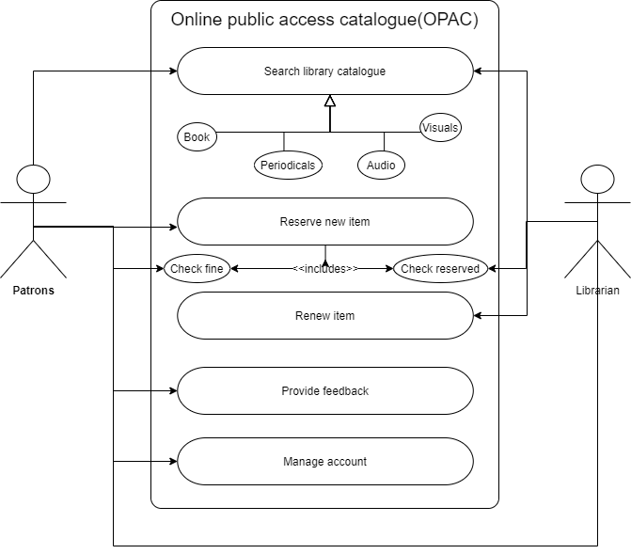

**Explanation:**

Use case diagram depicts the association (straight lines) between the actors (stick figures) and the use cases (ovals) in the system (rectangle). We have 2 actors above which interact with the system and person certain actions(use cases).

Like for example, patrons can search the library, reserve items (books, audio/ video resources), renew items, provide feedback to the system, manage their account. Whereas a librarian records and handles the system by maintaining the search records in the catalogue.

We have certain attributes such as the ‘arrow’ which depicts generalization, meaning they are the subset of the parent, here, the patron can search the library for book, periodicals, audio, and video resources. Also, there is <<includes>> which indicated that the underline condition must be met in order for that use case to function for example, the librarian can check if the patron has reserved books or has an undue fine which will affect the result of the usecase.