**Round 1: I See Dead People**

Question 01 Where do the remains of R. A Fisher lie? ## [1] "St Peter’s Cathedral, Adelaide, Adelaide City, South Australia, Australia"

Question 02 What deceased statistician said “All models are wrong but some are useful”? ## [1] "George Box"

Question 03 What deceased person is credited with first using the term “regression” to describe the relationship between two variables? ## [1] "Francis Galton"

Question 04 What well-known company hired the pseudonymous “Student” (a.k.a. William Sealy Gosset) in 1899? ## [1] "Guinness"

Question 05 What famous female historical figure is credited with innovative use of information graphics, like the polar area diagram? ## [1] "Florence Nightingale"

**Round 2: Science and Technology R** 

Question 06 Which scientist designed the ink blot test? Hermann Rorschach

Question 07 What is the name of one of the Economics Nobel laureates whose surname starts with R? ## [1] "Paul Romer"

Question 8 What is the name of the English inventor and son of John Kay, best known for designing a drop box to improve the capability of weaving looms? ## [1] "Robert Kay"

Question 9 What is the English name for the widespread species *Corvus corax*, often associated with death? (Common) Raven

Question 10 What would your job title be if you worked with positron emission tomography? Radiologist

**Round 3: Double R**

Question 11 Which actor is married to Blake Lively? Ryan Reynolds

Question 12: Name two science fiction authors with RR as their middle initials? JRR Tolkien, George RR Martin

Question 13: Which company produced the ‘Silver Ghost’ and the ‘Wraith’? Rolls Royce

Question 14 Which actor appeared in ‘A bridge too far’, ‘All the President’s Men’ and ‘Indecent Proposal’? Robert Redford

Question 15: Which football team in the Scottish first division plays at Stark’s Park in Kirkcaldy, Fife? Raith Rovers

**Round 4: Halloween and Horror**

Question 16: The Simpsons Halloween Episodes are an annual tradition in which there are three separate, self-contained pieces. By which title are these episodes known? Treehouse of Horror

Question 17 On the TV show “Buffy, the Vampire Slayer”, which run between 1996 and 2003, what is the name of Buffy Summers’ teacher and mentor? ## [1] "Rupert Giles"

Question 18 What is the name of the captain of the boat which picked up Victor in Mary Shelley’s famous book “The Modern Prometheus”, also know as “Frankenstein”? ## [1] "Captain Robert Walton"

Question 19: Plus or minus 100 pounds (lb), how much did the world's largest recorded pumpkin weigh? 1,524 lb

Question 20: **Who was the female lead of 'An American Werewolf in London'?** Jenny Agutter

**R-related questions**

Question 21 Which one of these data sets is not in the R datasets package:

-ldeaths (Monthly Deaths from Lung Diseases in the UK)

-USArrests (Violent Crime Rates by US State)

-gapminder (Excerpt of the Gapminder data on life expectancy, GDP per capita, and population by country)

-HairEyeColor (Hair and Eye Color of Statistics Students)

Question 22 If you get the error Error in rcorr() : could not find function "rcorr" which package have you forgotten to load?

Question 23 What colour is your chart background if you use theme_excel() from the ggthemes package?

Question 24

Question 25 

**Coding questions** 

Question 26 Write code to reproduce the graphic below.

Question 27 Match the following codes with their result.

4. 1:10 * 2 %% 2 5. 1:(10 * 2) 6. 11 %% 2 D. 0, 0, 0, 0, 0, 0, 0, 0, 0, 0 E. 1, 2, 3, 4, 5, 6, 7, 8, 9, 10, 11, 12, 13, 14, 15, 16, 17, 18, 19, 20 F. 1

Question 28

Question 29

Question 30

Tie breaker  Make the best coloured version of plot 4b

**Picture Round**

**1: Authors of guides to R** – 1 point for authors name, 1 point for name of a book they’ve published

 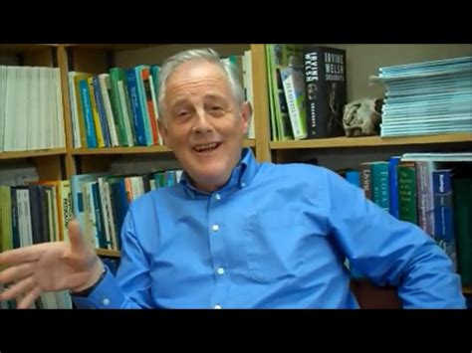  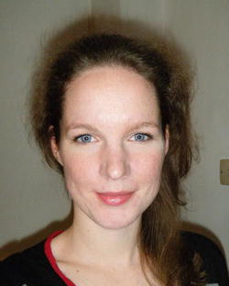

1 2 3 4

**2: Musicians vaguely connected with the letter R** – 0.5 point for the musicians name, 0.5 point for the band name

 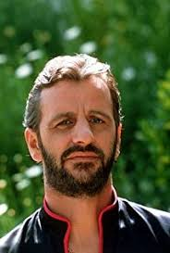 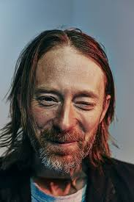 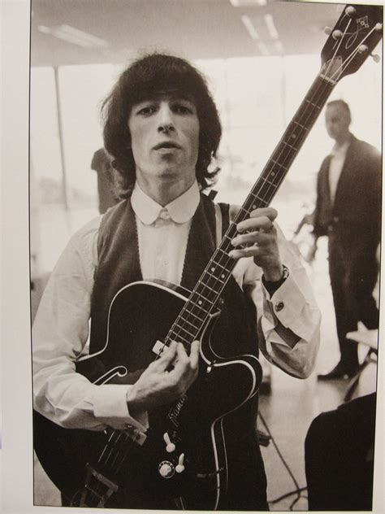

5 6 7 8

**3: Halloween Films** -0.5 point for character name, 0.5 point for film name

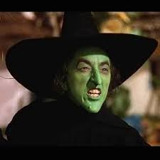  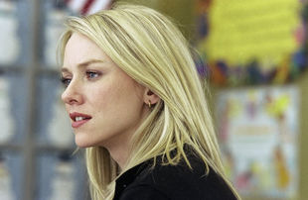 

9 10 11 12

Answers:

1.Hadley Wickham (R for Data Science, ggplot2: elegant graphics for data science, Advanced R, R packages

2.Michael J.Crawley (The R Book etc)

3.Joseph Schmuller (various R for Dummies titles)

4. Sarah Stowell (Using R for Statistics)

5. Kelly Rowland (Destiny’s Child)

6.Ringo Starr (The Beatles)

7.Thom Yorke (Radiohead)

8. Bill Wyman (Rolling Stones)

9.Wicked Witch of the West (The Wizard of Oz)

10.Jigsaw (Saw)

11.Rachel Keller (The Ring)

12.Cole Sear (The Sixth sense)