**OBJECTIVE**

The main object of this project is to manage the flow of information between students ,Faculty and management send an email to multiple users by selecting a particular group.Email can be send personally as well as in the group.The feature of adding attachment is also available.E-Mail address can be easily modify and delete.There is no need to write an individual email address repeatedly. It is very cost effective and less time consuming.It has user friendly interface having quick authenticated access to emails.It is based on the concept of intents in android. In Android, when you navigate between activities through,is known as an intent.

**INTRUDUCTION TO TECHNOLOGY**

World is contracting with the growth of mobile phone technology. As the number of users is increasing day by day, facilities are also increasing. Starting with simple regular handsets which were used just for making phone calls, mobiles have changed our lives and have become part of it. Now they are not used just for making calls but they have innumerable uses and can be used as a Camera , Music player, Tablet PC, T.V. , Web browser etc . And with the new technologies, new software and operating systems are required.

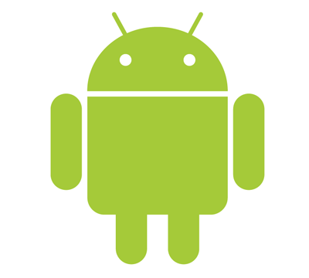

**What is Android**

[Operating Systems](http://www.engineersgarage.com/articles/operating-systems-tutorial) have developed a lot in last 15 years. Starting from black and white phones to recent smart phones or mini computers, mobile OS has come far away. Especially for smart phones, Mobile OS has greatly evolved from Palm OS in 1996 to Windows pocket PC in 2000 then to Blackberry OS and Android.

One of the most widely used mobile OS these days is **ANDROID**. **Android** is a software bunch comprising not only operating system but also middleware and key applications. Android Inc was founded in Palo Alto of California, U.S. by Andy Rubin, Rich miner, Nick sears and Chris White in 2003. Later Android Inc. was acquired by Google in 2005. After original release there have been number of updates in the original version of Android.

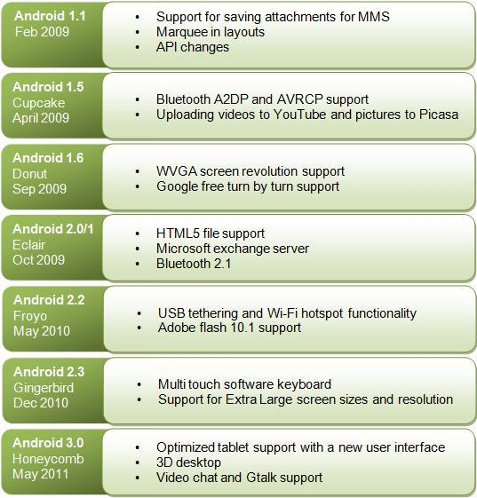

Android applications are written in java programming language. Android is available as open source for developers to develop applications which can be further used for selling in android market. There are around 200000 applications developed for android with over 3 billion+ downloads. Android relies on Linux version 2.6 for core system services such as security, memory management, process management, network stack, and driver model. For software development, Android provides **Android SDK** (Software development kit). Read more about [open source software](http://www.engineersgarage.com/articles/open-source-software-history-advantages).

**Applications**

These are the basics of Android applications:

•      Android applications are composed of one or more application components (activities, services, content providers, and broadcast receivers)

•      Each component performs a different role in the overall application behavior, and each one can be activated individually (even by other applications)

•      The manifest file must declare all components in the application and should also declare all application requirements, such as the minimum version of Android required and any hardware configurations required

•      Non-code application resources (images, strings, layout files, etc.) should include alternatives for different device configurations (such as different strings for different languages)

Google, for software development and application development, had launched two competitions ADC1 and ADC2 for the most innovative applications for Android. It offered prizes of USD 10 million combined in ADC1 and 2. ADC1 was launched in January 2008 and ADC 2 was launched in May 2009. These competitions helped Google a lot in making Android better, more user friendly, advanced and interactive.

**Fetching Code**

StringRequest stringRequest = **new** StringRequest(Request.Method.***POST***,***SHOW_URL***,  
 **new** Response.Listener<String>() {  
 @Override  
 **public void** onResponse(String response) {  
  
 **try** {  
  
 JSONArray jArray = **new** JSONArray(response);  
 **for** (**int** i = 0; i<jArray.length(); i++) {  
 JSONObject info = jArray.getJSONObject(i);  
  
 String acctype = info.getString(**"acctype"**);  
 String fid = info.getString(**"fid"**);  
 String fsub = info.getString(**"fsub"**);  
 String fattn = info.getString(**"fattn"**);  
 String fsal = info.getString(**"fsal"**);  
  
 **tvtype**.setText(acctype);  
 **tvid**.setText(fid);  
 **tvsub**.setText(fsub);  
 **tvattn**.setText(fattn);  
 **tvsal**.setText(fsal);  
 }  
 } **catch** (JSONException e) {  
 e.printStackTrace();  
 }  
  
  
 }  
 },  
  
 **new** Response.ErrorListener() {  
 @Override  
 **public void** onErrorResponse(VolleyError error) {  
 Toast.*makeText*(getContext(), error.getMessage(),Toast.***LENGTH_LONG***).show();  
 }  
 });  
  
Volley.*newRequestQueue*(getContext()).add(stringRequest);

**Working Project Images:**

