**DETAIL STATEMENT OF PROBLEM FOR RTO REGISTRATION APPLICATION**

RTO registration means registration for the learning license, permanent license, license renewal etc. So this system helps to keep track of license holder details, vehicle owner details and habitual offenders.

In license registration procedure it contains two modules. First module is for the learning or temperory license. It contains the form that contains Name, Password, the documents that you have to submit, Permanent address, Photo, Digital signature. After submitting the form that person will get the registration no for the period of one month.

The second module is for the permanent license registration. That contains the Registration no, Type of license, Name, Password, Permanent address, the documents that you have to submit, Photo, Digital signature.

The license renewal method with attribute license no will renew the license for the period of one year.

If any offender is suspected by the traffic police then the traffic police will check all the details of offender by login with user name and password and then checks license holder details.

In license registration procedure, the registrar will login to the application by providing user name and password and then check all the original documents submitted by the applicant. App details check method will take the attribute UID/PAN card number/ Passport number/Election card number and digital finger print from the registrar. And this method will check all the details with existing centralized database server which is at remote location. If some of the above field including digital finger print are not match with the existing database then app details check method will continue the registration procedure. The driving license registration method will store all details viz. personal details, registration no, photo, digital finger print and scanned documents to the database. If it is matched then app details check will cancel the registration procedure by displaying message.

The vehicle registration process with vehicle registration no, engine no, chesis no, model description, no objection certificate (N.O.C.), vehicle type, owner details will register the vehicle and the details are stored to the database. The change details will change the vehicle registration details like owner details, insurance, PUC after producing required documents by the owner.

Software Requirements Specification

For

RTO Registration Application

Version 1.0

**Prepared by Prasad Chaugule**

**Reg No. 1450014**

VJTI, Mumbai.

17 November, 2014

Table of Content

1. Introduction 1

1.1 Purpose 1

1.2 Document Conventions 1

1.3 Intended Audience and Reading Suggestions 1

1.4 Product Scope 2

1.5 References 2

2. Overall Description 3

2.1 Product Perspective 3

2.2 Product Features 3

2.3 User Classes and Characteristics 3

2.4 Operating Environment 4

2.5 Design and Implementation Constraints 5

2.6 User Documentation 5

2.7 Assumptions and Dependencies 5

3. System Features and Functional Specifications 6

4. External Interface Requirements 8

4.1 User Interfaces 8

4.2 Hardware Interfaces 11

4.3 Software Interfaces 11

4.4 Communications Interfaces 11

5. Other Nonfunctional Requirements 11

5.1 Performance Requirements 11

5.2 Safety Requirements 11

5.3 Security Requirements 12

5.4 Software Quality Attributes 12

**1. Introduction**

**1.1 Purpose**

The system aims at creating and displaying information database of driving license registration and holder’s details, vehicle registration and their own details and details offence done by the driver.

The main objectives of this system are as follows

1. Registration of learning license

2. Registration of permanent license

3. Renew the driving license

4. Registration of new vehicle

5. Register the offender

**1.2 Document Conventions**

To develop the document the font type is Times New Roman and the fonts are sized such that the hierarchy of the topics is easily understood and followed as in the case any conventional documentation practice as follows:

IEEE Standard Software Requirement Specification Format used.

* Heading:

Font Style: Times New Roman

Size: 16

* Subheading:

Font Style: Times New Roman

Size: 14

* Content:

Font Style: Times New Roman

Size: 12

**1.3 Intended Audience and Reading Suggestions**

This document is intended for readers that include

* Developers
* Project managers
* Users Documentation writers

This RTO Registration tool which would enable the participating actor says a Registrar if it is new then register learning license otherwise permanent license and vehicle registration and also update both. It will ease to maintain the records of all License holder information, maintaining records of vehicle registration and its owner information and maintaining records of offence done by driver. We describe what features are in the scope of the software and what are not in the scope of the software to be developed.

**1.4 Project Scope**

**In Scope:**

* Learning license registration.
* Renew the driving license.
* Vehicle registration.
* Keep track of offence.

**Benefits Objectives & Goals:**

1. Easy insertion, updating and retrieval of data using GUI are achieved through this system.

2. Input validation can be performed.

3. Access to system is provided with password & registration no.

The system is also minimizes the work load by allowing traffic inspector or concerned authority to send a request to the main server and receiving information within a span of minutes.

**1.5 References**

* Standard IEEE 830 Recommended practice for Software Requirement Specification is referred.

**2. Overall Description**

**2.1 Product Perspective**

The RTO registration is developed to replace the existing manual process of registration. This system will help in reducing the load on RTO department and it made easy to check drivers all details to traffic police. It also keep track of habitual offender.

Existing system Limitations:

* All the data is maintained on paper.
* There is chance that paper may loss, stole or misuse.
* There is no track of offence done by the drives.
* There is workload on traffic police to check all details other than license.
* One is also able to apply for the new license from license from different RTO in the case, when the existing license get cancels due to offense if any.

**2.2 Product Features**

Main features available in this project

* Registration of learning license.
* Registration of permanent license
* Registration of Vehicle.
* Maintaining records of License holder information.
* Maintaining records of vehicle registration and its owner information.
* Maintaining records of offence done by driver.

**2.3 User Classes and Characteristics**

As this is system developed as RTO registration application the users are broadly classified as following:

**Administrator:**

The administrator manage authorized user accounts (create users, modify users information and delete users), manage authentication (user login and log out).

**Registrar:**

Registrar will register the learning license, permanent license, vehicle registration, renew the license and updating the vehicle registration as per applicants application.

**Traffic Police:**

Check the details of suspected/ offender driver and the vehicle, by using license no, registration no. Enter the offence details if he/she break the rules.

**Applicant:**

An applicant can be a agent or common people. They can apply for new driving license or renew existing license or vehicle registration applicants can apply online also.

**2.4 Operating Environment**

The software is design to run at least in the most widely used operating system like,

**Software Requirements:-**

1] Technology used:

* Java
* Oracle. For data storage and maintainance.

2] Operating system:-

* Windows-XP / Macintoosh / Linux etc.

3] Server:-

* Oracle.

**Hardware Requirements:-**

* Processor with 2.66GHz or above frequency.
* 1 GB RAM or Higher.
* 160 of HDD or Higher.
* Standard Monitor, Keyboard, Mouse and Scanner

**2.5 Design and Implementation Constraints**

* User must keep their password & registration no confidential.
* User must keep their own individual login-id.
* Only Administrator could undergo addition and deletion of User Account.
* Only Administrator can performs reports on the user login sessions.

**2.6 User Documentation**

The propped system is in development stage and requires a complete model for necessary documentation. However once the prototype is ready any user can access the modules for the client as well as general users, user modules would be provided in hand for Client Users. The software is to be well equipped with user manuals to be read before and after installation of the software. To efficiently use the software, or user can find help online in the form of tutorials in the home page.

**2.7 Assumptions and Dependencies**

Assumption is the requirements which we assume before development product. We develop the product for that we must prepare the requirements of project. First step in development is to assume the project need for e.g.

Each user must have login A/C and Password.

* Two entities are connected every communication one is user side and then the system side.
* There is only one administrator.
* Internet Connection is must.
* Test Reader should be present to view the HELP files.
* The system could be affected if these assumptions are incorrect, are not shared, or change.

Dependencies means the product development is depend on our assumption which is important to project. So assumption and dependencies are important for development of that project.

**3. System Features**

Applicant can apply for driving license via Agent or personally. He/ she will fill the form and submit require documents like Id proof example PAN card, Voter ID card and address proof light bill etc.

Registrar will check all required document before register the license. Some of the applicants are trying to issue new license after suspending previous license from another station. In order to avoid this registrar will enter all details and verified with existing database. If it is not match with any document then the registrar will first learning license which is valid for six months. After the one month applicant is eligible to give the test drive. One senior inspector will take this test. The applicant has to pass this test then the registrar will issue the proper license in the name of applicant.

In similar way registrar will register the vehicle also. If there some changes like change in the name, address, change vehicle owner, no objection certificate (N.O.C.) registrar will update that information in the database as per the applicants request. License has its expiry date. After the expiry date license has to renew the license. Registrar will renew the license after receiving the application from license holder.

The functional requirements specification of system are described as follows:

|  |  |  |
| --- | --- | --- |
| User Class | Use Case | Description |
| System  Authentication | |  | | --- | | Login | | Modify Profile | | Logout | | |  | | --- | | Login into system | | Change details of profile | | Logout from system | |
| Administrator | |  | | --- | | Create Authorized  Profile | | Modify Authorized  Profile | | Delete Authorized  Profile | | |  | | --- | | Create new profile, assign default privileges | | Change details of authorized profile | | Remove the authorized profile | |
| Registrar | |  | | --- | | Register the learning  license | | Register the permanent license | | Renew the Driving license | | Register the Vehicle | | |  | | --- | | Get the data required document check,scan and store registration details to database server | | Get to he data required document,verify registration no and store to server | | Renew the license of applicants after checking all required documents | | Get the data required documents check, scan and register the applicants and store the registration details to the database server | |
| Traffic Police | |  | | --- | | Check the details of License holder | | Enter offence details | | |  | | --- | | Check the details of suspected/offender driver, by using license no | | Enter the offence details | |
| Applicant | Apply for the various registration | The agent/normal people can apply for various registration to RTO office |
|  |  |  |

**4. External interface requirement**

**4.1 User Interfaces**

These interfaces to be implemented are designed to be user friendly and up to the standard so that it allows the actors to achieve their goals. These includes self explanatory tools/icons.

This specification describes the user interface look operation and feel of RTO registration system.

**Login GUI**

Login for user includes submit and cancel button the user need to type valid user name and password.

In case user sets invalid as User name and Password then the communication is incomplete by sending error message as invalid under or password.

**Learning License Registration Form**

The details of the applicant is entered such as name, DOB, gender , address, phone number, password, duration of stay at the present address in month, city, pin code, state, nationality, e-mail etc.

**Permanent License Registration Form**

The details of the applicant is entered such that name, gender, address, type of license, PAN card number, Passport number etc.

**License Renew Form**

This form will have all the details of applicant. Register will extend the validity.

**Vehicle Registration Form**

On this form registrar have to enter all the details of vehicle as well as owner details.

1

**4.2 Hardware interfaces**

The server has direct access the authorized user on complimentary can access the database on his login credentials and thus access the available data as RDBMS. Traffic police access to the server database and filling of information about the offence.

**4.3 Software interfaces**

Proposed system is user friendly as well as powerful because of its use of RDBMS which is powerful database management tool to work upon The system proposed ,Company Management system uses c#.net as the front end and MS-SQL server as the back end. The proposed system does the same work as the current system but in a more efficient way.

**4.4 Communication interfaces**

The system will be required to communicate the database using standard protocol. For internet communication protocols the traffic police and other users can easily download forms and apply online.

**5. Nonfunctional Requirements**

**5.1 Performance Requirements:**

It is designed not to delay the system from other key processes. The response time of the program is direct and the application is considered real-time. Furthermore, the system can check for updates whenever is requested by the user. The load time for user interface screens shall take no longer than two seconds. The log in information shall be verified within five seconds. Response to queries shall return within five seconds

**5.2 Safety Requirements:**

All system data must be backed up every 24 hours and the backup copies stored in another server at different building or location for disaster recovery. Password need to be changed regularly after some interval to avoid phishing attacks

**5.3 Security Requirements:**

As every authorized user is given a unique user id with the undisclosed password and registration number he can easily access the database and can provide vital login status to the server which report session

**5.4 Software Quality Attributes:**

The source code would be not an open source it would be stringent and left over to system administrator and programmers to make it effective. However as per need future modifications are always expected.

The quality of the software is maintained in such a way that , the system is so user friendly and efficient. Other qualities that includes:

* Availability: The system is available for use 24 by 7, thus having no timing restriction for accessing the application. Thus providing flexibility for using the system.
* Robustness: If the connection between the user and the system is broken during the updating to the database i.e. either confirmed or canceled, the e-billing system shall enable the user to recover from an incomplete transaction.
* Consistency: The "RTO Registration Application" system automatically updates all the transactions data performed by user in database, so the most recent data is responded to query.

**Use Case Diagram**

Use Case Diagram for RTO Registration Application

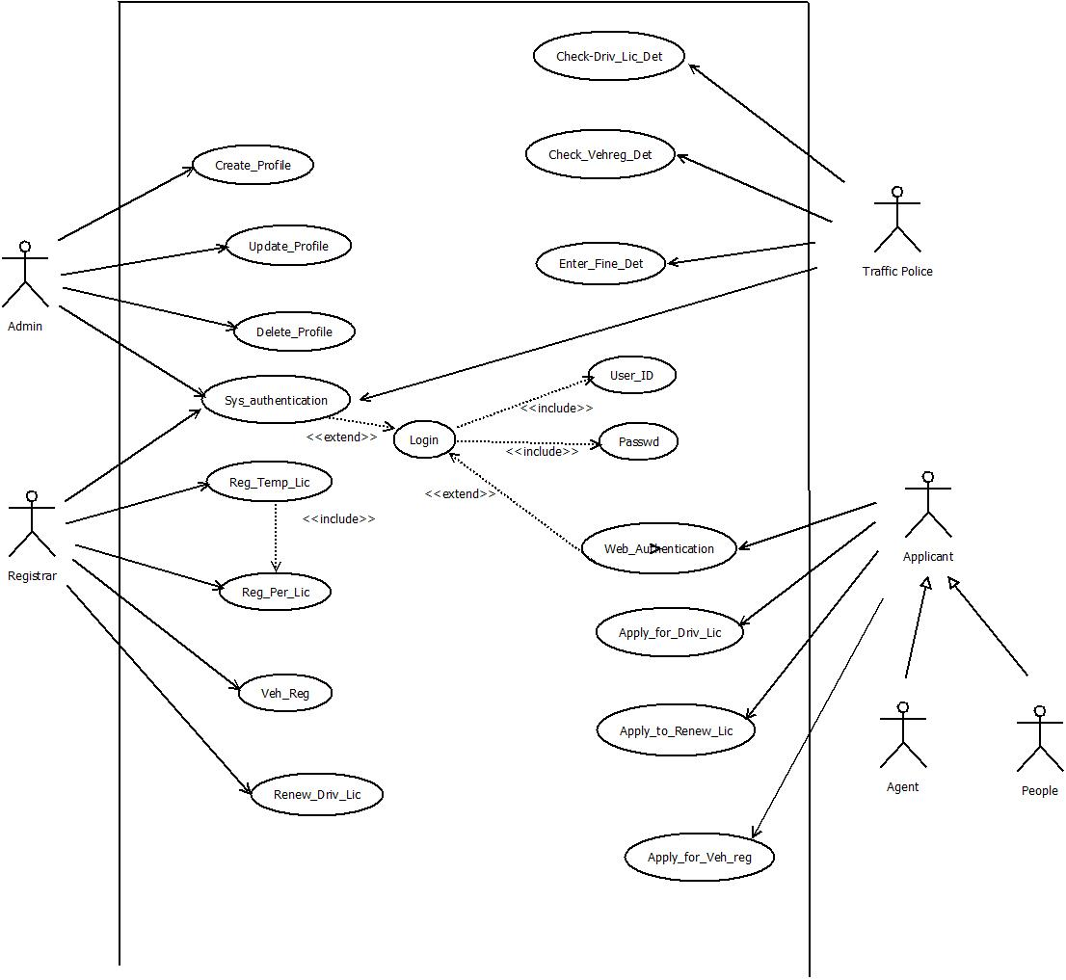

**USE CASE DIAGRAM FOR RTO REGISTRATION**

**Actors:-**

1. Administrator
2. Registrar
3. Traffic Police
4. Applicant
5. Agent
6. People

Use cases:-

1. Use case :- Create_Profile

Actor:- Administrator

Purpose:- It is used for creation of Authorised Profile

Overview:- It allows the Administrator to create the new authorized profile of authorised people like Registrar, Traffic police etc.

1. Use case:- Update_Profile

Actor:- Administrator

Purpose:- It is used for updation of Authorized profile

Overview:- It allows the Administrator to modify the details of authorized profiles.

1. Use case:- Delete_Profile

Actor:- Administrtor

Purpose:- It is used to deletion of Authorized profile

Overview:- It allows administrator to delete the authorized profiles.

1. Use case:- Check_App_Det

Actor:- Registrator

Purpose;- It is used to check the details of the applicant with the existing database.

Overview:- It allows the Registrar to check the details like required document of applicant.

1. Use case:- Reg_Temp_Lic

Actor:- Registrar

Purpose:- It is used to Temperory License Registration

Overview:- It allows the Registrar to temporary license in the applicant if the name of the applicant d oes not exists in the database.

1. Use case:- Reg_Per_Lic

Actor:- Registrar

Purpose:- It is used to Permanent License Registration

Overview:- It allows the Registrar to permanant license in the applicant if the name of the applicant does not exists in the database.

1. Use case:- Renew_Driv_Lic

Actor:- Registrar

Purpose:- It is used to Renew driving license

Overview:- It allows the Registrar to renew the driving license.

1. Use case:- Veh_Reg

Actor:- Registrar

Purpose:- It is used to Vehicle registration

Overview:- It allows the Registrar to registration of vehicle in the name of applicant if the applicant is not exist in the database.

1. Use case:- Check_Driv_Lic

Actor:- Traffic police

Purpose:- It is used to check the details of driving license

Overview:- It allows the Registrar to check the details of driving license like validity, type etc.

Precondition

Basic flow of interaction

Alternate flows of interaction

Post condition

Special condition

**Non-Functional requirements**