

Adedoyin Odugbesan & Stephon Barrett

12/11/2019 | Needs Assessment

Needs Assessment

Alfred State Training Flash Cards

Table of Contents

Introduction 2

Mission Statement 2

Pest Analyst 2

Swot Analyst 2

General Requirements 3

Technical requirements 3

Challenges 3

Maintenance 3

Planned Features 3

Design Process 4

User Stories 4

Prototype 6

Precedence’s 6

AnkiApp 7

Brain Scape 8

Study Shack 10

Prototypes Drafts 10

Draft 1 10

Draft 2 11

Draft 3 11

Final Prototype 12

Technical Process 12

Database design 12

Database Iteration 1 12

Database Iteration 2 13

Database Iteration 3 13

Database Iteration 4 14

Software Organization 14

# Introduction

The teacher/student environment is a highly complex and difficult scenario for a multitude of reasons. Students now more than ever come to college not because they want to or feel like they should. Rather it’s an expectation, an extension of high school which has resulted in dramatic difference in cognitive ability and motivation. These differences have made it difficult to address what is and is not the best way to address problems that arise from the students delivery of the content and over all environmental issues. Our software addresses a clear need for quantifiable information over classes, cognitive ability, and motivation. This data will allow for a more informed view of the trends of the development of students and in time will be able to tell if changes are effective or are needed.

# Mission Statement

Our mission is to facilitate curriculum understanding though the progression data, study environments, and topic analyst.

# Pest Analyst

|  |  |
| --- | --- |
| **Political** | **Economical** |
| Suny regulations  Federal funding  Student activities fee | Financial knowledge  Wage gap  Time  Lack of funding |
| **Social** | **Technological** |
| Student/college environment  Student/Professor dynamic  Introversion  Skills gaps  Degree demographics  Campus demographics  Town demographics  Language barriers | Firewall limitations  Multiple devices  Mobile expectations  Existing solutions  Software maintenance  Ease of use |

* Highlighted in blue are the major factor in selecting the problem addressing with the application.

# Swot Analyst

|  |  |
| --- | --- |
| **Strengths** | **Weaknesses** |
| Have a prototype  Accessibility/front end  Php backend  Security  Simple logic | Team cohesiveness  Communication  Multiple priorities |
| **Opportunities** | **Threats** |
| Broad range of use  Grading  Progression  Learning theory | New Team  New Ideas    Sneaky fox |

# General Requirements

For this project to be considered successful it should increase student’s overall GPA by an estimated 20% and in turn lower dropout rate. Additional measurement of success would be if population usage of 20% after 4 years for representative data collection.

# Technical requirements

* Students must be able to access the app on and off campus
  + Site must be able to go through the firewall
* Application must be hosted on campus to avoid data collection and SUNY regulation complications
* Application must be reasonably transportable in the need that server resources are needed
* Application must support a minimum of 500 concurrent clients
* Documentation of features and intent must be clear for future interns to understand
* Application must be maintainable with high employee turn over
* Card display algorithm that optimizes time spent learning material
* Tracking script for student progression
* Tracking script for class progression
* Ability to admins/teachers to create mini test
* Ability for class to answer questions in real time
* Ability to see class results in real time
* Ability to view student trends over time
* Ability to change status of decks from private to public
* Ability to alter created content

# Challenges

Most of the challenges are derived from the fact that for this project to be successful it will have to live on past the founders.

* Vision and intent must be communicated clearly to future interns
* Maintenance needs to be approachable so interns can fix problems
* The purpose of the future features must be clear so that they can be implemented effectively after the founders have left

# Maintenance

Due to relative size of the project bugs can be delivered to the primary owner of the site by email or by verbally informing them. The primary owner of the site can be Russell Rittenhouse but I would recommend that this title go to the most talented web developer intern.

## Planned Features

|  |  |  |
| --- | --- | --- |
| **Feature** | **Purpose** | **Estimated Time of Development** |
| Flash Card Grading | For the user to track the understanding of the material | 2 Weeks |
| Flash Card Grade Tracking | For admins and professors to see the progression of students understanding of self-created material | 6 Weeks |
| Flash Card Display Algorithm | To minimize wasted time reviewing material that has been already learned. Basic concept is to display learned cards only when it’s about to be forgotten. | 2 weeks to implement, 6+ months to tune |
| Trend analysis | Used to detect student and class trends to observe effects of changes | 12 weeks to implement, 6+ months to tune |
| IR Remote Support | This will allow for students to take mini test in class and see the results in real time | 4-12 weeks to implement |
| Multiple Choice Support | To create mini test for professors to see the progression of the class. | 6 weeks to implement |
| Real time class results for MC | To see class understanding in real time | 10 weeks to implement |
| User Deck Review | Public validation of the quality of the information provided in the deck | 2 weeks |

# Design Process

## User Stories

**Maranda**

*Started in a different major and realized that nursing was not going to work out for me. Now I feel behind compared to my peers and need something to supplement my learning.*

The application must be able to guide users to proper content to facilitate learning

**Casen**

*Looking to get the most out of my time here at Alfred State. If there was a collection of verified content that would be great. I would like to avoid the online non-sense.*

Quality content and real time feedback will be cornerstones for the project’s success

**Airlia**

*I’m taking intro classes and I’m lost. If it wasn’t for Google I wouldn’t be able to complete anything. Why are there so many loops?*

Validated concepts for students to understand should be the foundation on which people learn from. Not hoping stack overflow has the “answer”.

**Kevin**

*Students seems to be not understanding the material that I’m trying to teach. I have made a few changes, but I don’t know if it’s working or not.*

Professors need feedback on if there teaching style or changes are working. We can help with mini test and real time class feedback to highlight what people don’t understand.



**Leo**

*I feel like I’m wasting time reading this book. There has to be a better way.*

We need to be able to minimize the time spent learning material that is already understood.

## Prototype

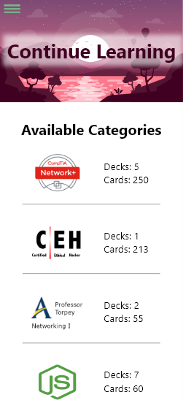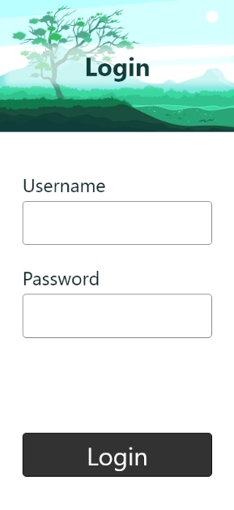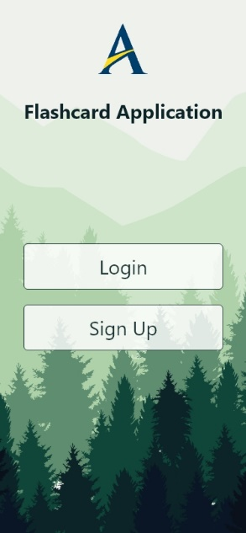

## Precedence’s

Precedence’s are used to understand what others have done before you. This allows for you to avoid some of the mistakes others have made, uses good ideas, and alter concepts to fit your requirements.

### AnkiApp

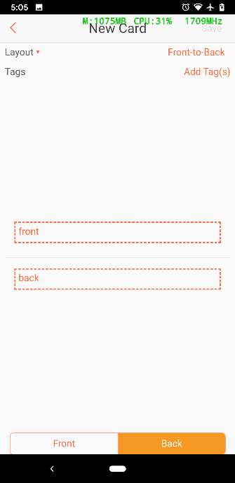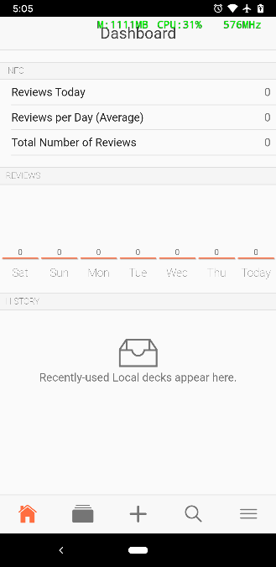

Notice that eye tracking is difficult and it’s challenging for the user to find the element they are looking for. There is no schema to work from and elements on the page are not pronounced enough to make the learning process simple. We need to avoid this at all cost for our software to be successful.

### Brain Scape

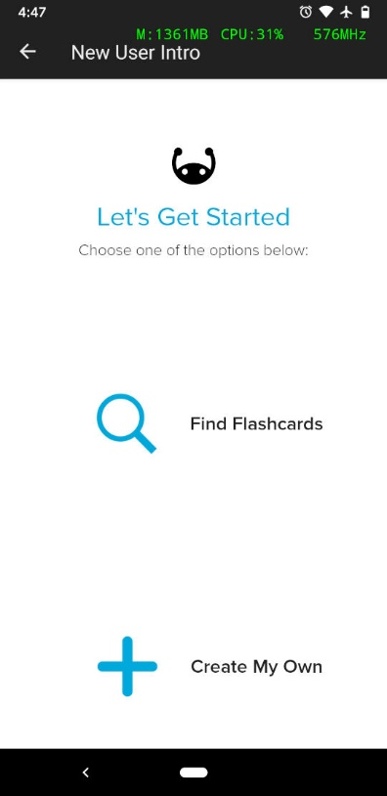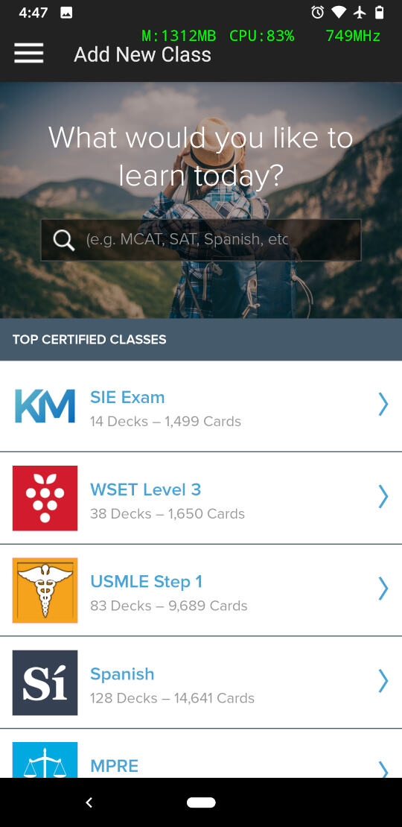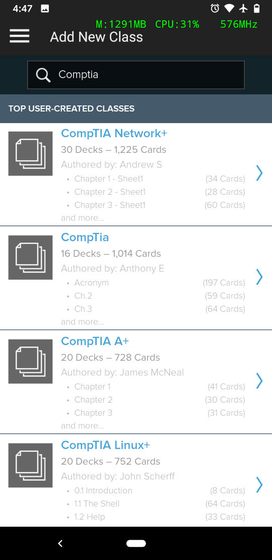

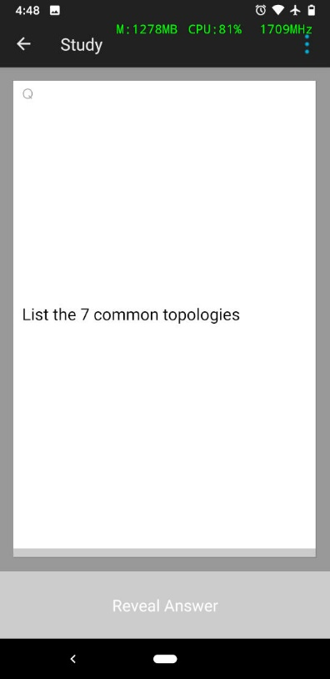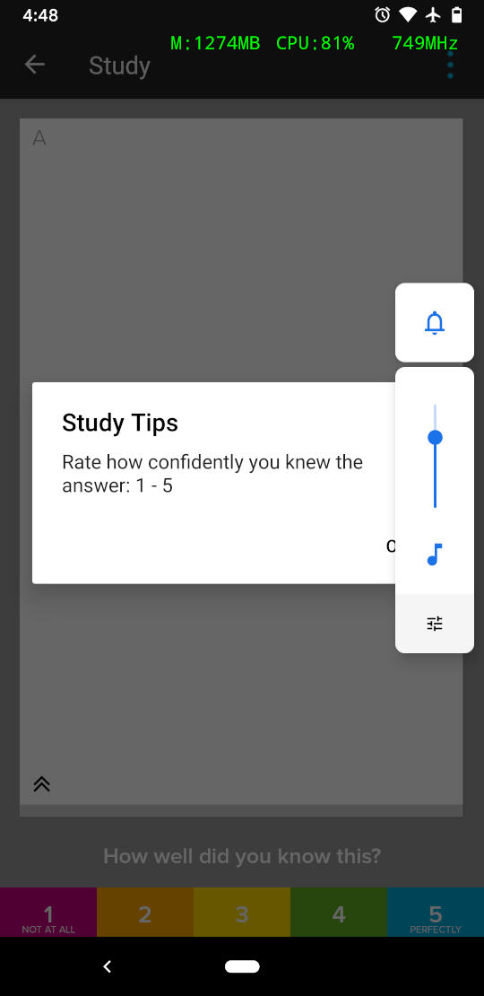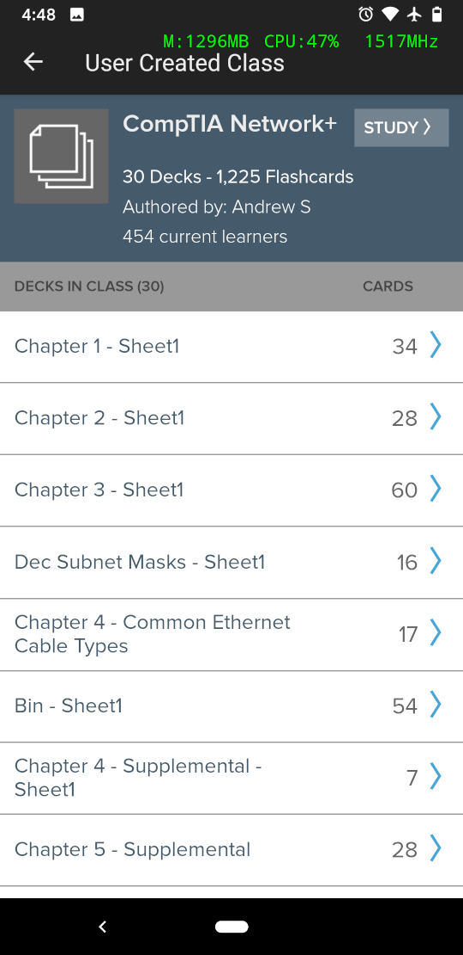

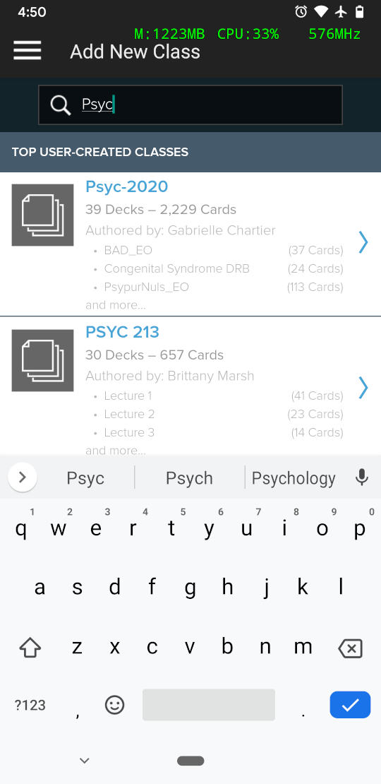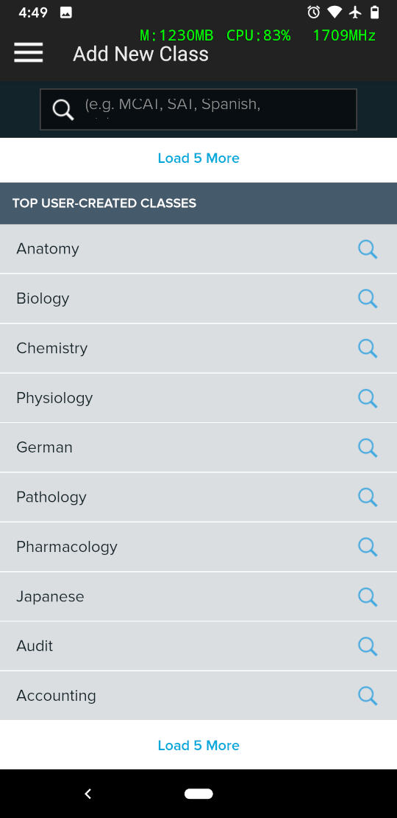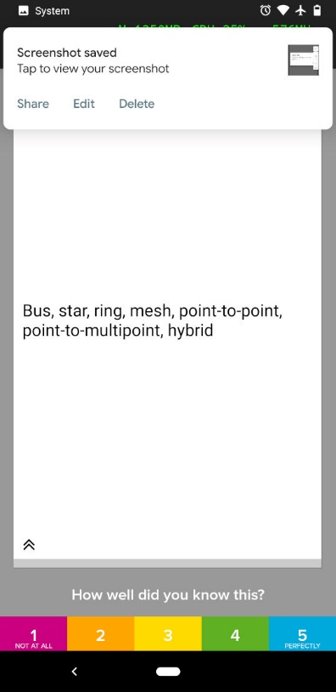

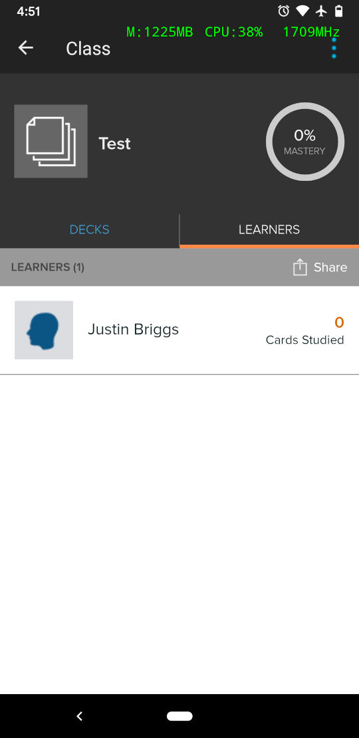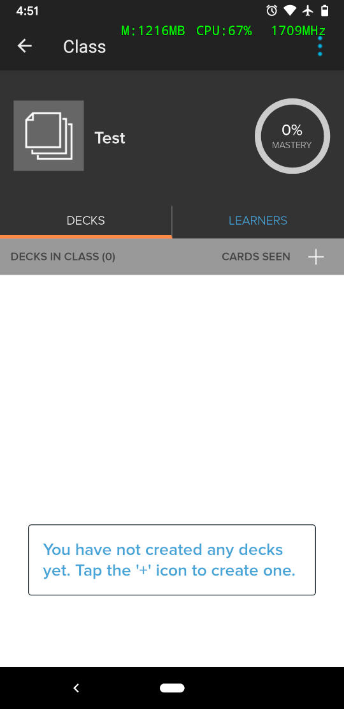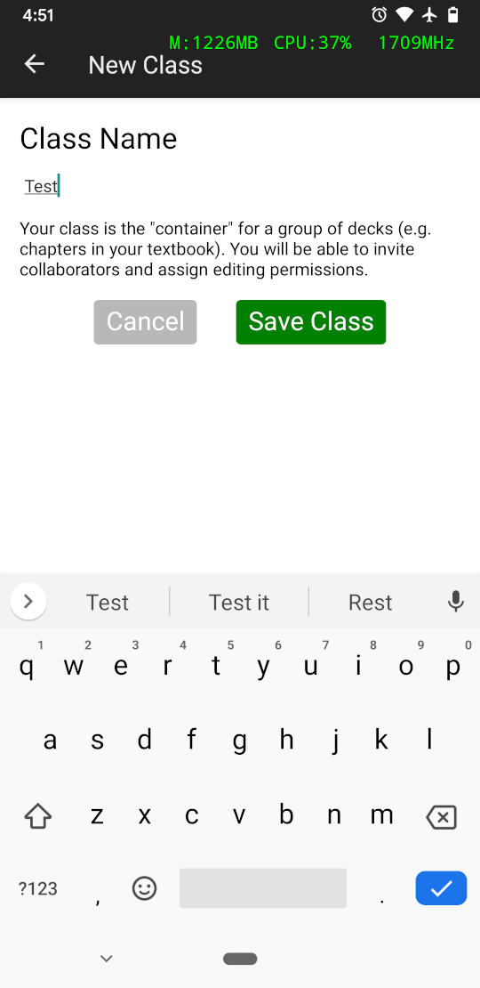

Notice that everything is easy to find, that features are tailored to helping the user complete their goal. Understand why the company did this and how they implemented it will be fundamental to making sure our software will be successful.

### Study Shack

Notice that study shack has similar issues to AnkiApp and should be avoid.

## Prototypes Drafts

Each draft was a conceptual model of what each designer thought the project should look like

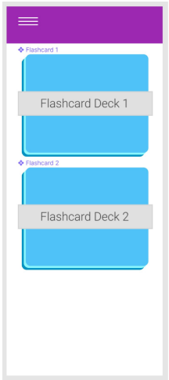Draft 1

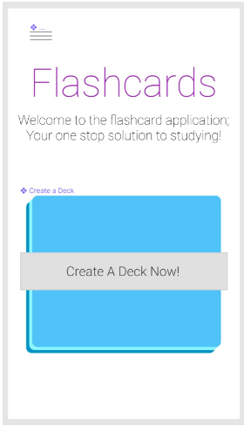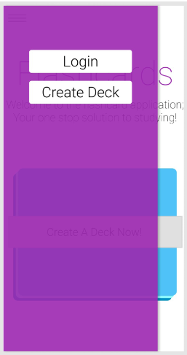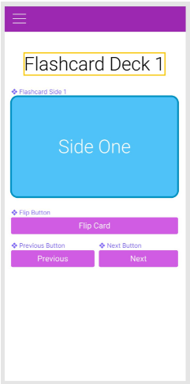

Out of this conceptional model we took the format of the flash card page, and the menu location

### Draft 2

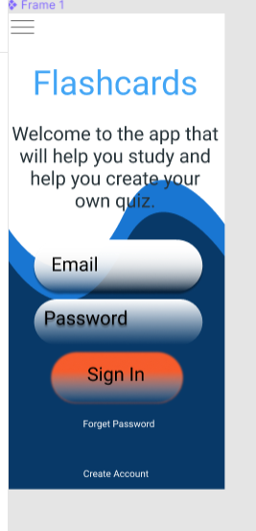

We took the prominent element idea from this draft

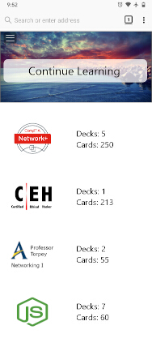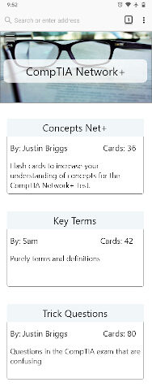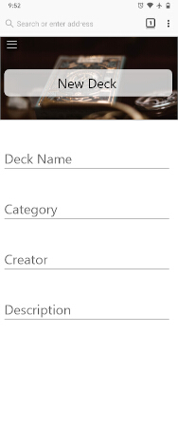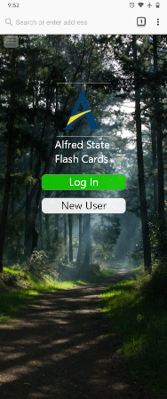Draft 3

Most of the look and feel comes from this draft.

### Final Prototype

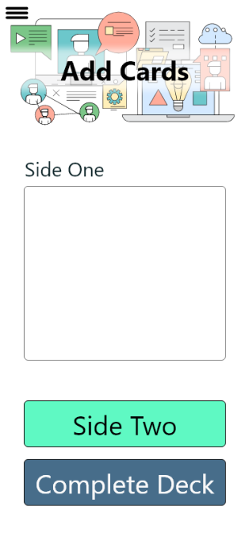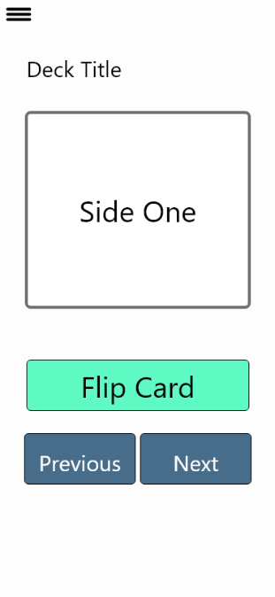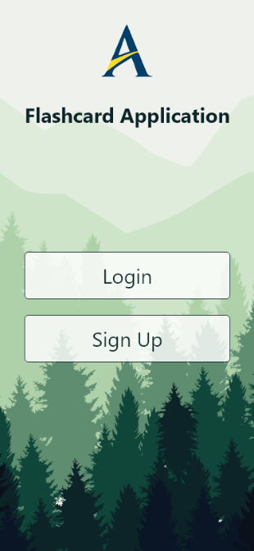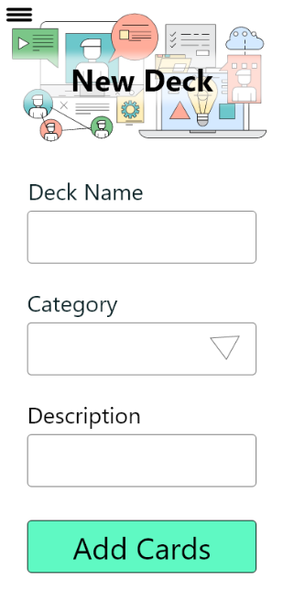

Due to the primary change in graphics. The look of the project overall had to change to match the graphics. This was done to reduce graphic size and control the color scheme.

# Technical Process

## Database design

The database when though several iterations and what is presented currently should scale well with the features that will be added.

### Database Iteration 1

Database Iteration 2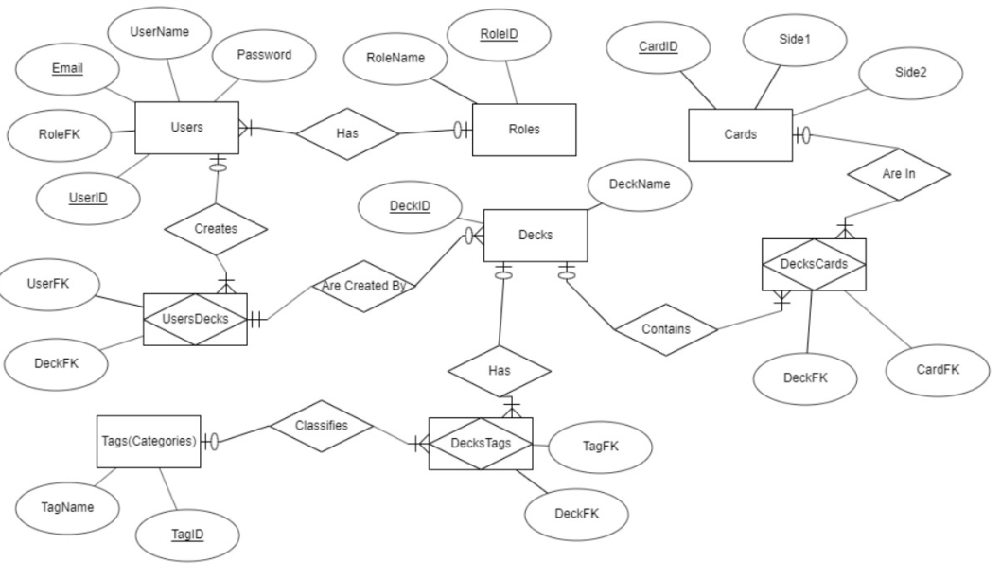

### Database Iteration 3

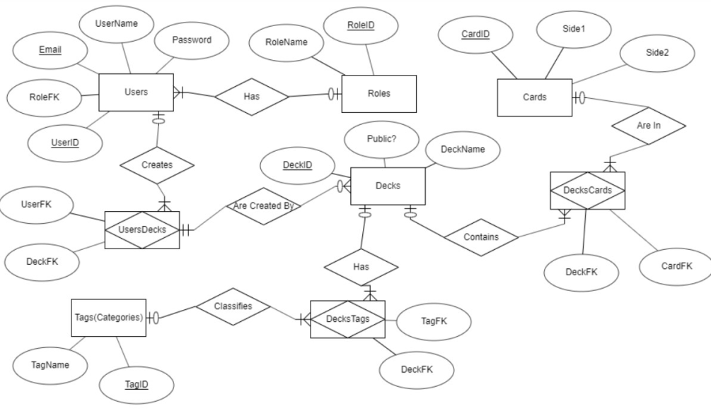

### Database Iteration 4

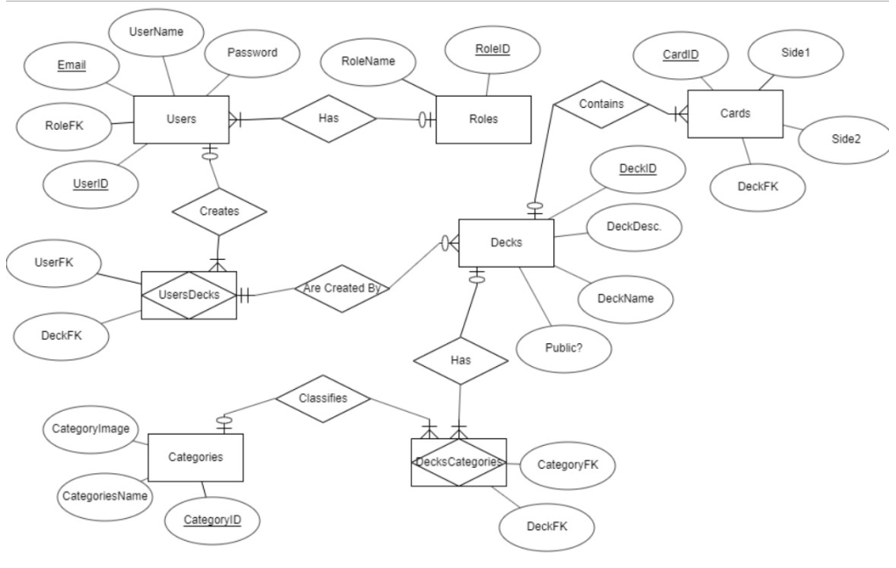

## Software Organization

The following are the primary concepts of the organization of the software

* MVC to separate operational concerns
* Models for DB connections
* Models for logical blocks of code
* Use of controllers for a feature set