Name: 徐靖甯
Date: 10/23
Topic: Understanding Program Efficiency, Part 1
Core concept from today’s OCW lecture:
Linear search, nested loops, membership testing, and duplicate removal.
AI-generated coding challenge title:
Common Course Participants
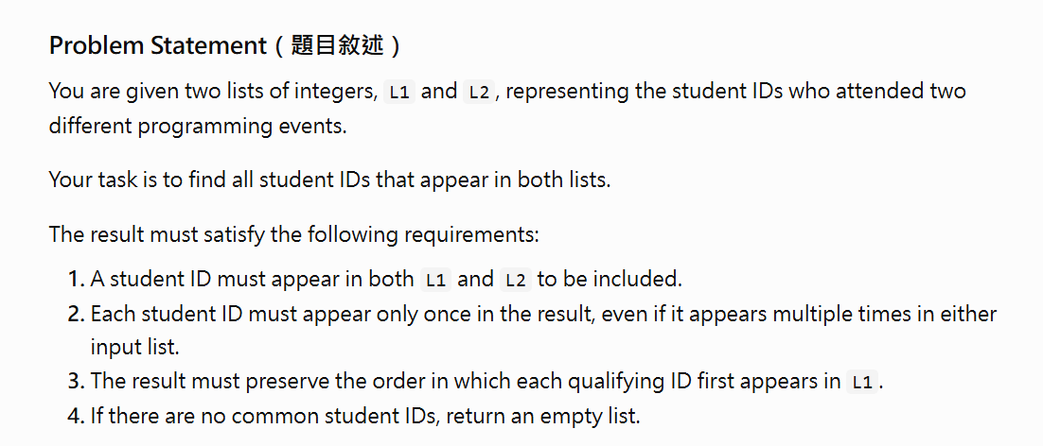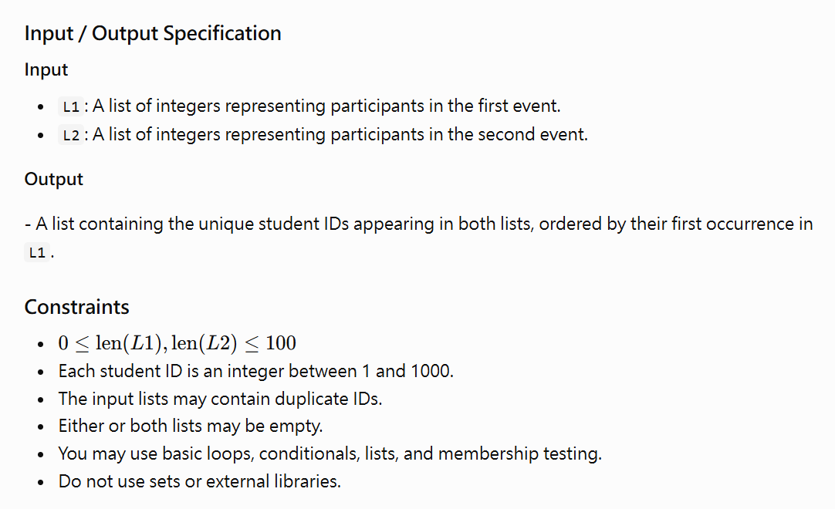

My approach:
I planned to examine each element in L1 and check whether it also exists in L2. If the element appears in both lists, I would check whether it is already in the result list. If it is not present, I would append it to the result list. This approach preserves the order of L1 and prevents duplicate IDs in the output.
Did you ask the AI Tutor for help?
☐ No — I solved it independently
☑ Yes — I received one or more hints
The most useful hint/question from AI was:
How can I check whether an ID exists in both lists while ensuring that it is added to the result list only once?
It helped me realize that:
Finding common elements and removing duplicates are two separate tasks. I need to check whether an element exists in the second list and whether it already exists in the result list before adding it.
Did you change your approach or code after interacting with AI?
☐ No
☑ Yes
What did you change, and why?
I refined my algorithm by adding a membership check before appending an element to the result list. This prevents duplicate IDs from appearing in the output. I also made sure to examine L1 from beginning to end so that the original order is preserved.
My final program:
☑ Passed the provided examples
☑ Passed additional edge cases
☐ Still has unresolved problems
One edge case I tested:
Input:
L1 = [4, 4, 2, 4, 6]
L2 = [4, 2, 2]
Expected output: [4, 2]
Actual output: [4, 2]
What idea from the OCW lecture did you transfer to this new problem?
I transferred the ideas of linear search, nested loops, membership testing, and duplicate removal from the lecture. I used membership testing to find common elements and checked the result list to prevent duplicates.
One thing I understand better now:
I understand how to find common elements in two lists while preserving their original order and removing duplicates.
One thing I am still unsure about:
I am still unsure how nested loops and membership testing affect the time complexity of a program.

