Topic: Searching and Sorting
Date: 11/7
Name:徐靖甯 114511068

1. Today’s Challenge
Core concept from today’s OCW lecture:
Sorting Algorithms: Selection Sort, Bubble Sort, and Merge Sort.
AI-generated coding challenge title:
Sort Student Scores by Rank
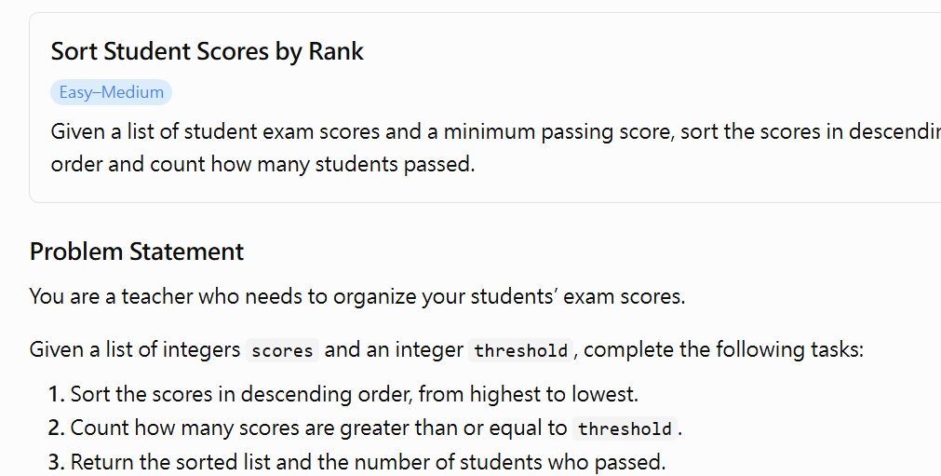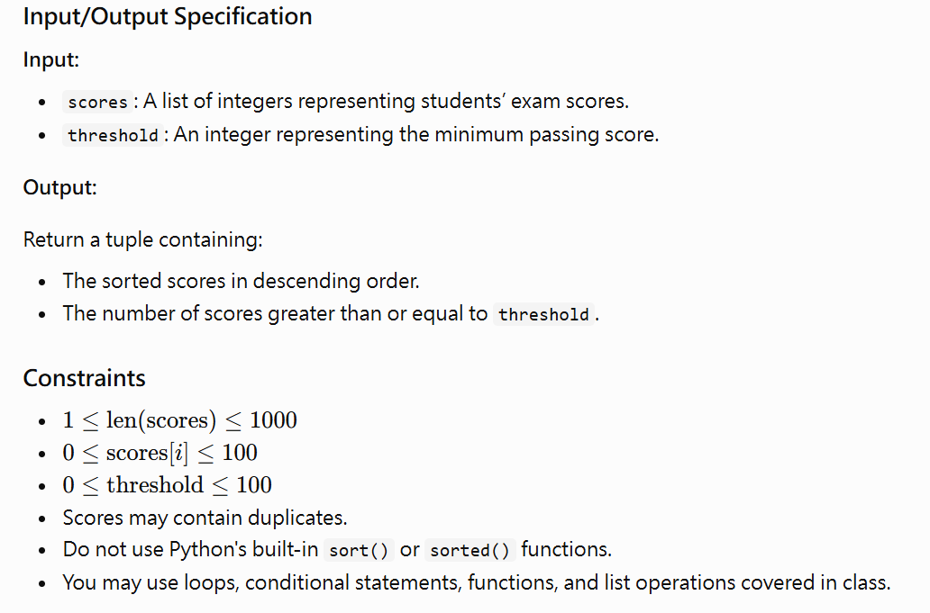
2. My Initial Approach — Before AI Help
My approach:
I planned to use Selection Sort to arrange the scores in descending order. In each iteration, I would find the maximum score in the unsorted portion of the list and move it to the correct position.
After sorting the list, I would use a loop to examine each score. If a score is greater than or equal to the passing threshold, I would increase a counter by one. Finally, I would return the sorted list and the counter as a tuple.
3. AI Tutor Help
Did you ask the AI Tutor for help?
☐ No — I solved it independently
☑ Yes — I received one or more hints
The most useful hint/question from AI was:
How can I modify Selection Sort to arrange scores from highest to lowest instead of lowest to highest? Can I separate the sorting process from counting the students who passed?
It helped me realize that:
Selection Sort can be adapted by changing its comparison condition. Instead of finding the smallest element in each iteration, I can find the largest element. I also realized that sorting and counting are separate operations that can be implemented and tested independently.
4. My Revision
Did you change your approach or code after interacting with AI?
☐ No
☑ Yes
What did you change, and why?
I clarified my approach by separating the program into two main tasks: sorting the scores in descending order and counting the scores that meet the passing threshold. This makes the program easier to understand, debug, and test.
I also considered edge cases, such as when every student passes, when no student passes, and when the list contains duplicate scores.
5. Verification
My final program:
☑ Passed the provided examples conceptually; actual execution is still required.
☐ Passed additional edge cases through execution.
☐ Still has unresolved problems.
One edge case I tested:
scores = [100]
threshold = 100
Expected output:
([100], 1)
Actual output:
([100], 1)

6. One-Minute Reflection
What idea from the OCW lecture did you transfer to this new problem?
I transferred the Selection Sort algorithm from the lecture. Instead of finding the smallest element in each iteration, I find the largest element and place it at the beginning of the unsorted portion. This allows me to sort the scores in descending order.
One thing I understand better now:
I understand that sorting algorithms can be adapted to solve different problems by changing their comparison conditions. I also understand how to combine sorting with another task, such as counting the number of scores that meet a specific condition.
One thing I am still unsure about:
I am still unsure about the differences in time complexity between Selection Sort, Bubble Sort, and Merge Sort, and why Merge Sort is generally more efficient for large datasets.

