Name: 徐靖甯
Date: 10/17
Topic: Python Classes and Inheritance
1. Today’s Challenge
Core concept from today’s OCW lecture:
Object-Oriented Programming (OOP) in Python — covering class inheritance, method overriding, class-level state variables tracking object generation/IDs, and custom operator overloading (__add__ and __eq__).
AI-generated coding challenge title:
Design a Digital Pet Breeding Registry
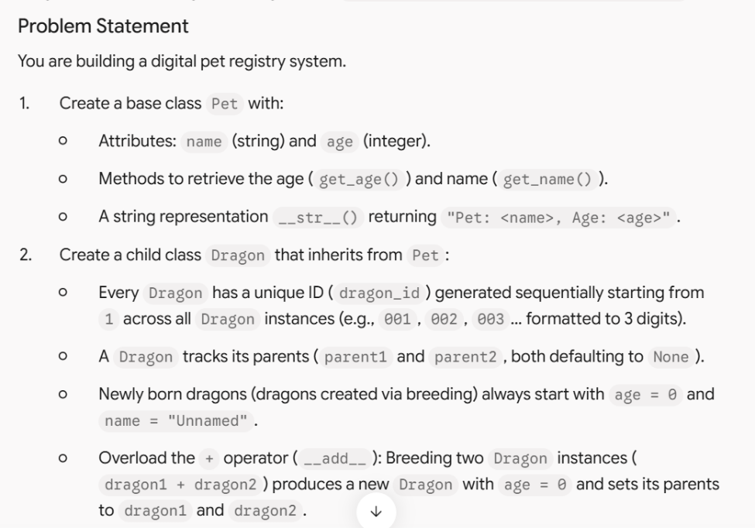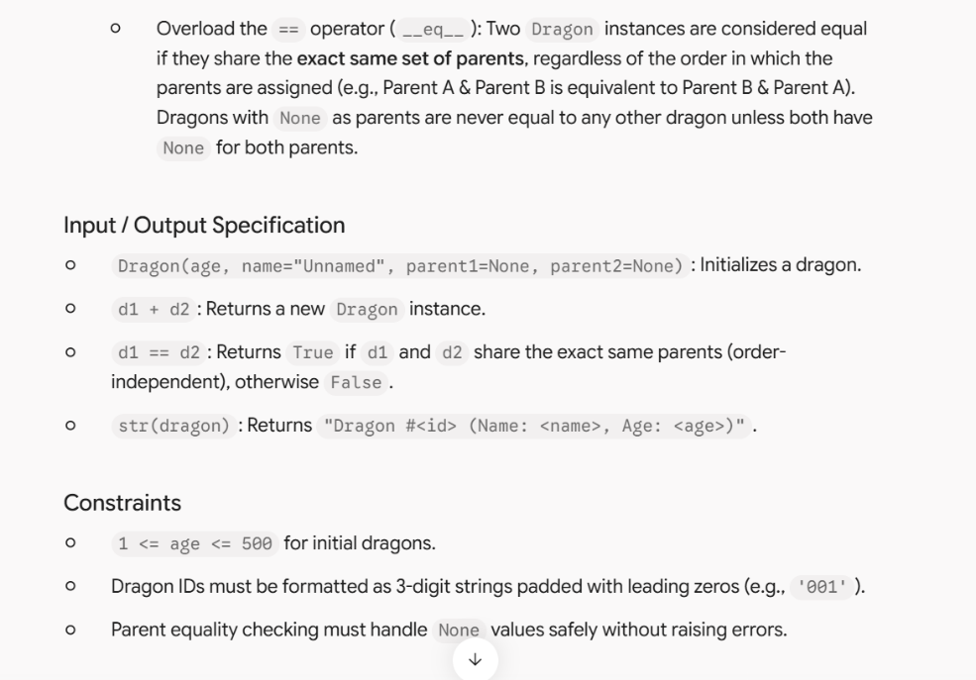

2. My Initial Approach — Before AI Help
My approach:
I planned to define a base class Pet with name and age instance variables. For Dragon, I inherited from Pet using Pet.__init__(self, age, name) and added a class variable tag initialized to 1 to assign IDs. In __init__, I used str(Dragon.tag).zfill(3) to format the ID, then incremented Dragon.tag.
For breeding (__add__), I returned a new instance Dragon(0, "Unnamed", self, other). For equality (__eq__), I extracted the parent IDs (checking for None to prevent AttributeError) and compared whether (p1_self == p1_other and p2_self == p2_other) or (p1_self == p2_other and p2_self == p1_other).

3. AI Tutor Help
Did you ask the AI Tutor for help?
☐ No — I solved it independently
☑ Yes — I received one or more hints
The most useful hint/question from AI was:
How will your __eq__ method handle comparisons when one or both dragons have none for parents without throwing an AttributeError?"
It helped me realize that:
I needed to check if self.parent1 and self.parent2 are None before trying to access .dragon_id on them, or compare parent instances directly rather than accessing their IDs directly.
4. My Revision
Did you change your approach or code after interacting with AI?
☐ No
☑ Yes
What did you change, and why?
What did you change, and why?
I updated the parent ID extraction logic in __eq__ to use safely evaluated parent IDs: p1_self_id = self.parent1.dragon_id if self.parent1 else None This prevents AttributeError: 'NoneType' object has no attribute 'dragon_id' when checking first-generation dragons that do not have parents.
5. Verification
My final program:
☑ Passed the provided examples
☑ Passed additional edge cases
☐ Still has unresolved problems
One edge case I tested:
Input:
d1 = Dragon(100, "Ignis")
d2 = Dragon(80, "Astra")
d1 == d2
Expected output:
True (both dragons have parent1 = None and parent2 = None, so their parents match)
Actual output:
True
6. One-Minute Reflection
What idea from the OCW lecture did you transfer to this new problem?
I transferred the concept of using a class variable (Rabbit.tag -> Dragon.tag) as a global counter to auto-assign unique formatted IDs, along with using magic methods (__add__ and __eq__) to define domain-specific behavior for object
operations.
One thing I understand better now:
How inheritance chain initializations(SuperClass.__init__(self, ...)) pass core state upward while child classes maintain their own specialized logic and class-level state.
One thing I am still unsure about:
How Python resolves method calls when multiple inheritance (inheriting from multiple parent classes) is used, and when to use super().__init__() instead of directly referencing the parent class name.

