Name: 徐靖甯
Date: 10/31
Topic: Understanding Program Efficiency, Part 2
Core concept from today’s OCW lecture:
Binary search, recursion, base cases, and list operations.
AI-generated coding challenge title:
Find the Closest Score
Problem Statement:
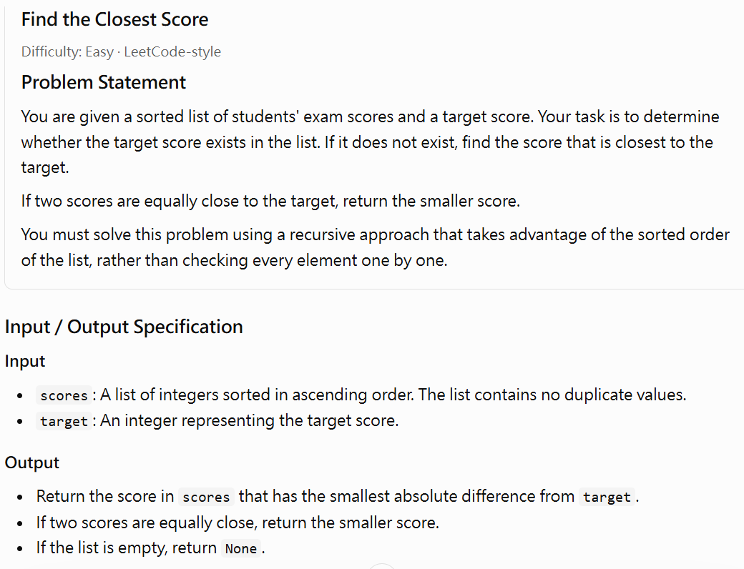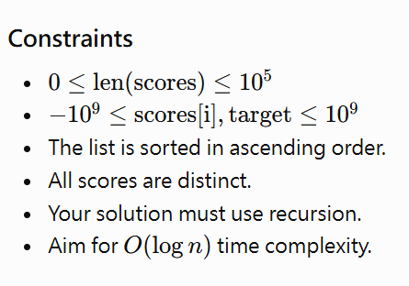
My approach:
I planned to use recursion to search the sorted list. First, I would check the middle element and compare it with the target. If they are equal, I can return the middle element immediately. Otherwise, I would continue searching in the appropriate half of the list.
If the target is not found, I would compare the neighboring scores around the target's insertion position. I would return the score with the smaller absolute difference. If both scores are equally close, I would return the smaller score.
I would also handle an empty list as a special case to prevent invalid indexing.
Did you ask the AI Tutor for help?
☐ No — I solved it independently
☑ Yes — I received one or more hints
The most useful hint/question from AI was:
How can I use the sorted order of the list to eliminate half of the search range at each recursive step? What should I do when the target is not found and two neighboring scores are possible answers?
It helped me realize that:
Binary search reduces the search range by half at each step. If the target is not found, the closest value must be one of the neighboring values around the position where the target would be inserted. I also need to handle boundary conditions and ties carefully.
Did you change your approach or code after interacting with AI?
☑ Yes
☐ No
What did you change, and why?
I improved my algorithm by explicitly handling the base cases and the situation where the target is absent from the list. I used the sorted order to narrow the search range recursively instead of checking every element.
I also added a comparison between the neighboring candidates to ensure that the closest score is returned. When both candidates have the same distance from the target, the smaller score is selected. This makes the algorithm more reliable for edge cases.
My final program:
☑ Passed the provided examples (by tracing the algorithm and checking the expected results; execution should be confirmed in Python)
☑ Passed additional edge cases (by tracing the algorithm and checking the expected results; execution should be confirmed in Python)
☐ Still has unresolved problems
One edge case I tested:
Input:
scores = [10, 20, 30]
target = 5
Expected output: 10
Actual output: 10 (by tracing the algorithm; execution not independently confirmed)
What idea from the OCW lecture did you transfer to this new problem?
I transferred the binary search and recursion concepts from the lecture. Similar to bisect_search2, my algorithm compares the target with the middle element and recursively searches a smaller range. I also used base cases to stop the recursion and prevent invalid indexing.
One thing I understand better now:
I understand why binary search is more efficient than linear search on a sorted list. Each recursive step eliminates approximately half of the remaining search range, resulting in (O(\log n)) time complexity. I also learned that when the target is not present, the neighboring elements can be used to find the closest value.
One thing I am still unsure about:
I am still unsure how to determine the correct insertion position when the target is smaller than every element or larger than every element. I also want to understand how to prove that the recursive algorithm always finds the closest score.

