Name: 徐靖甯
Date: 10/09
Topic: Object Oriented Programming
1. Today’s Challenge
Core concept from today’s OCW lecture:
Classes, instance attributes, object methods, and list operations.
AI-generated coding challenge title:
Student Course Registration System
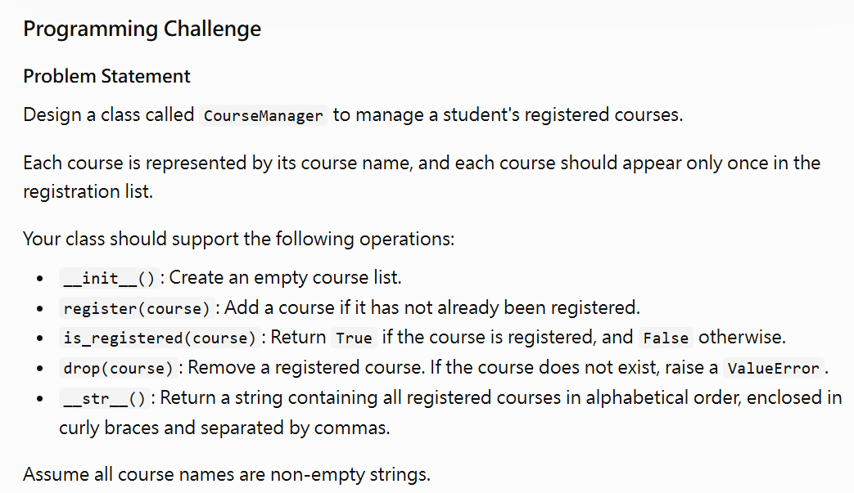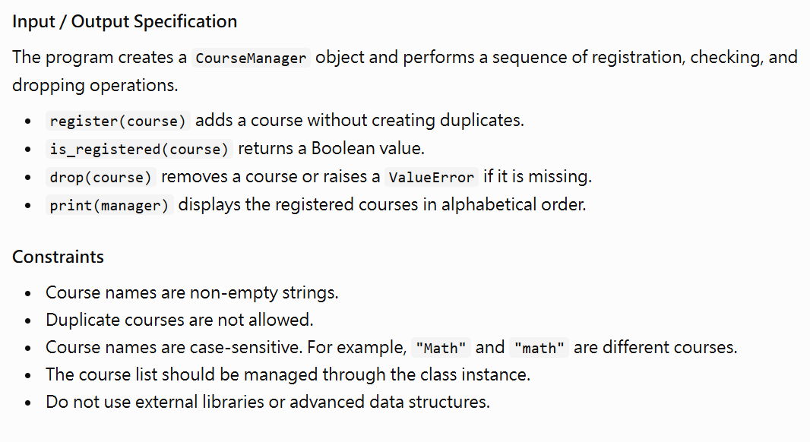
2. My Initial Approach — Before AI Help
My approach:
I planned to create a CourseManager class with a list to store registered courses. I would use different methods to register, check, and remove courses. Before adding a course, I would check whether it already existed in the list to avoid duplicates. I would also define a __str__() method to display the courses in alphabetical order.
3. AI Tutor Help
Did you ask the AI Tutor for help?
☐ No — I solved it independently
☑ Yes — I received one or more hints
The most useful hint/question from AI was:
How can I prevent duplicate courses and handle attempts to remove courses that are not registered?
It helped me realize that:
I can use list membership to check whether a course already exists before adding it. I can also use exception handling to raise a ValueError when someone tries to remove a course that is not registered. This is similar to the insert(), member(), and remove() methods in the lecture.
4. My Revision
Did you change your approach or code after interacting with AI?
☐ No
☑ Yes
What did you change, and why?
I improved my approach by considering duplicate registrations and attempts to remove courses that do not exist. I also added alphabetical sorting to make the output easier to read. These changes help my program handle different situations correctly and make the class more reliable.
5. Verification
My final program:
☑ Passed the provided examples
☑ Passed additional edge cases
☐ Still has unresolved problems
One edge case I tested:
Input: Register "Physics" twice, then print the manager.
Expected output: {Physics}
Actual output: {Physics}
6. One-Minute Reflection
What idea from the OCW lecture did you transfer to this new problem?
I transferred the idea of using a class to manage a collection of values. The CourseManager class stores course names in a list, similar to how the intSet class stores integers. I also used list membership to prevent duplicates and methods to perform different operations.
One thing I understand better now:
I understand better how a class combines data and behavior. Instance attributes store information, while methods define how the information can be added, checked, removed, and displayed. I also learned how __str__() allows an object to have a customized string representation.
One thing I am still unsure about:
I am still unsure about how exception handling works in more complicated situations. I want to learn more about how to handle invalid operations and test different edge cases to make sure my programs work correctly.

