Table of Contents

[1] Colocation Argo-2-Satellite 1

[1.1] Compute Argo at 10 m and the Argo average surface-2-10m 1

[2] PLOTS: Argo Vs Satellite 1

[2.1] Plot: Argo geolocation 1

[2.2] PLOT Argo profiles 3

[2.2.1] plot raw Vs interp T and S of a given Profile (nprof) 3

[2.2.2] COLORPLOT all-Profiles by the same Argo platform 3

[2.2.3] More than one profile-platform, make mean and compare all profiles 4

[2.4] BOXPLOTS 5

[2.4.1] boxplots: Argo data versus Satellite data (at float location) 5

[2.4.2] boxplots: ALL Argo data versus ALL Satellite data 6

[2.5] TIMESERIES 7

[2.5.1] TIMESERIES: SSS at float location 7

[2.5.2] TIMESERIES: ALL-SSS at ALL-float location 8

[2.5.3] TIMESERIES: dSSS at each float location 9

[2.5.4] TIMESERIES: ALL-dSSS at ALL-float location 10

[2.6] TAYLOR DIAGRAMS 11

# [1] Colocation Argo-2-Satellite

# [1.1] Compute Argo at 10 m and the Argo average surface-2-10m

# [2] PLOTS: Argo Vs Satellite

# [2.1] Plot: Argo geolocation

Plots in one map locations of same platform

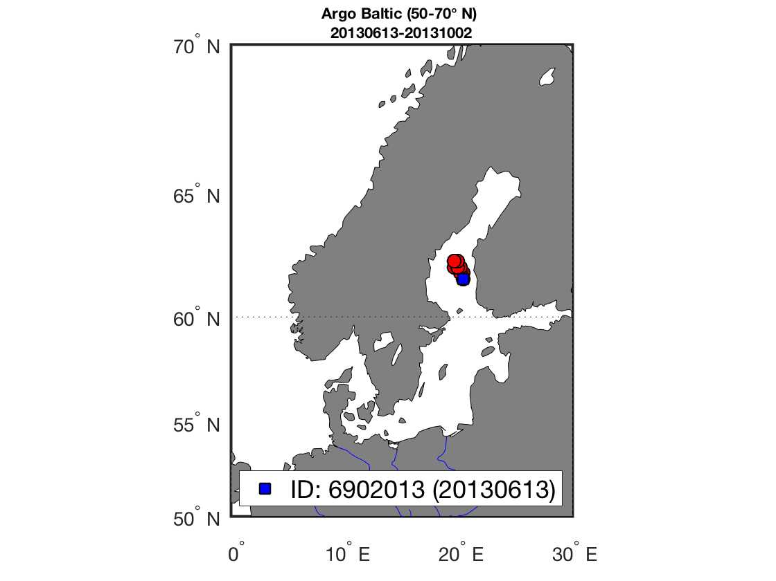

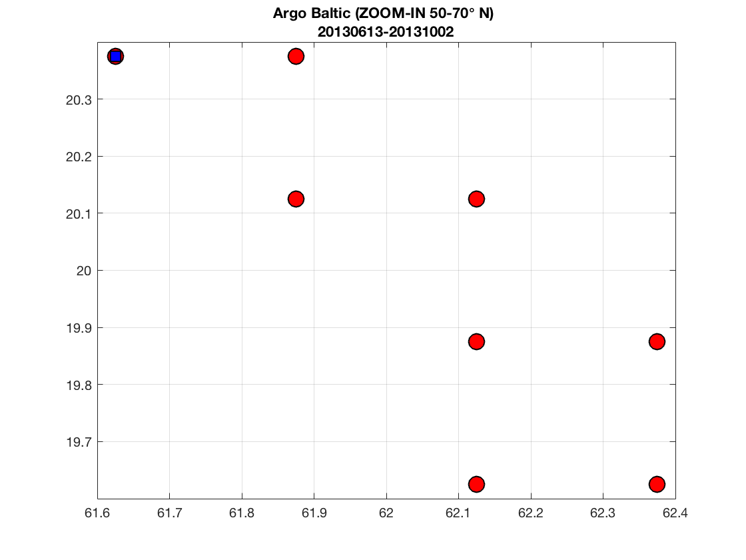

# [2.2] PLOT Argo profiles

# [2.2.1] plot raw Vs interp T and S of a given Profile (nprof)

# [2.2.2] COLORPLOT all-Profiles by the same Argo platform

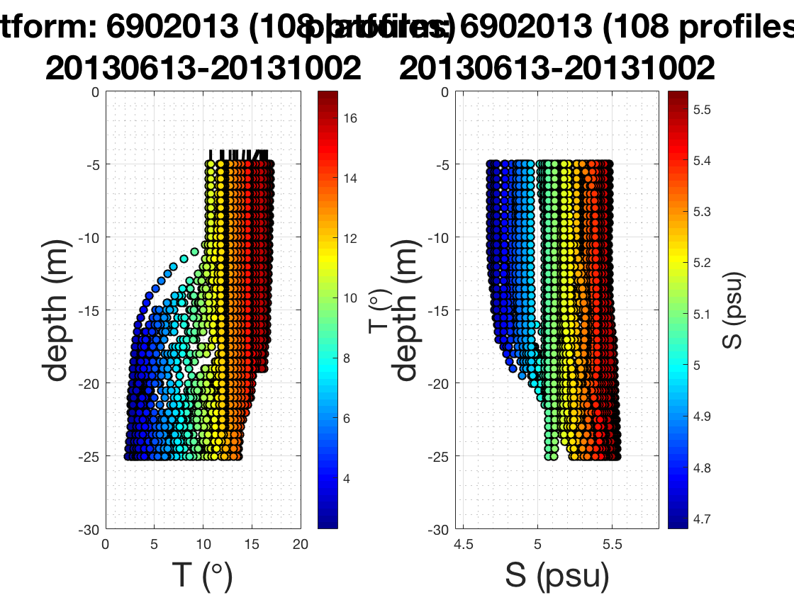

# [2.2.3] More than one profile-platform, make mean and compare all profiles

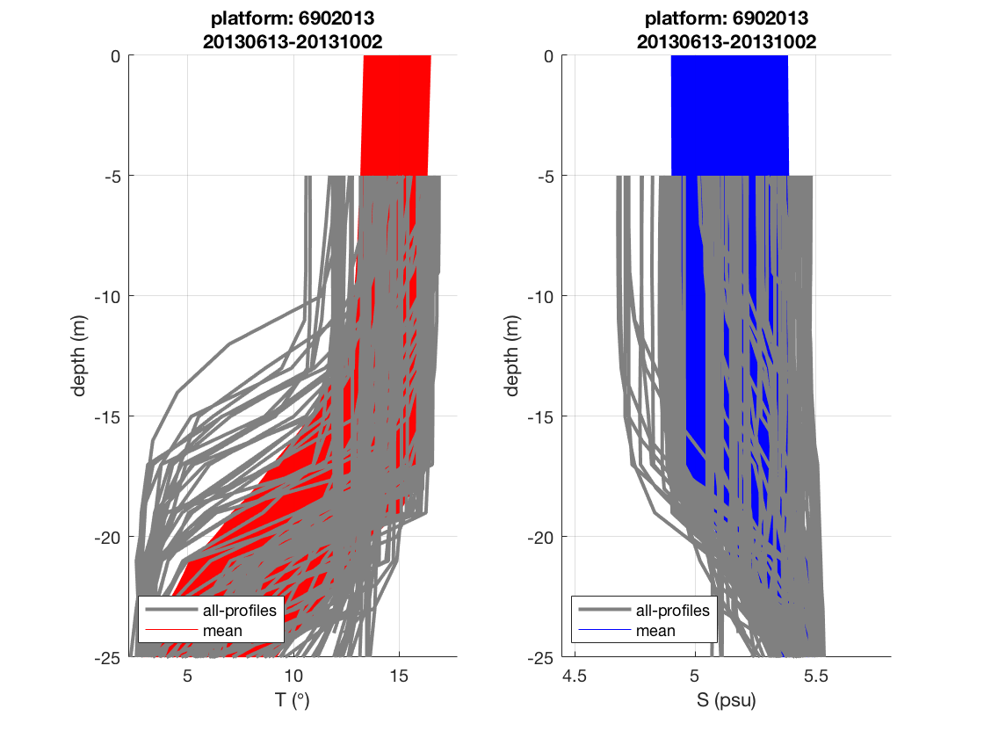

# [2.4] BOXPLOTS

# [2.4.1] boxplots: Argo data versus Satellite data (at float location)

shall we use the median of SSS to be compared againts

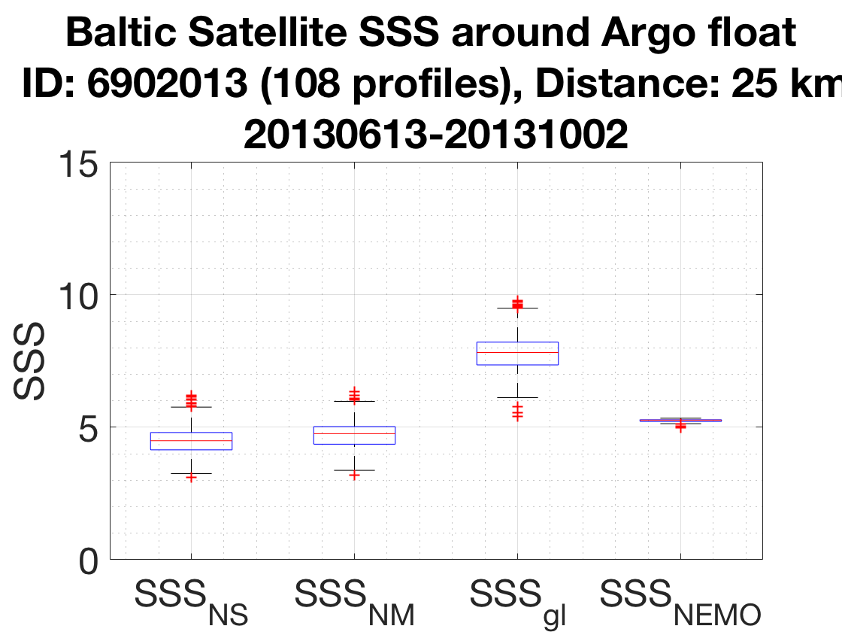

# [2.4.2] boxplots: ALL Argo data versus ALL Satellite data

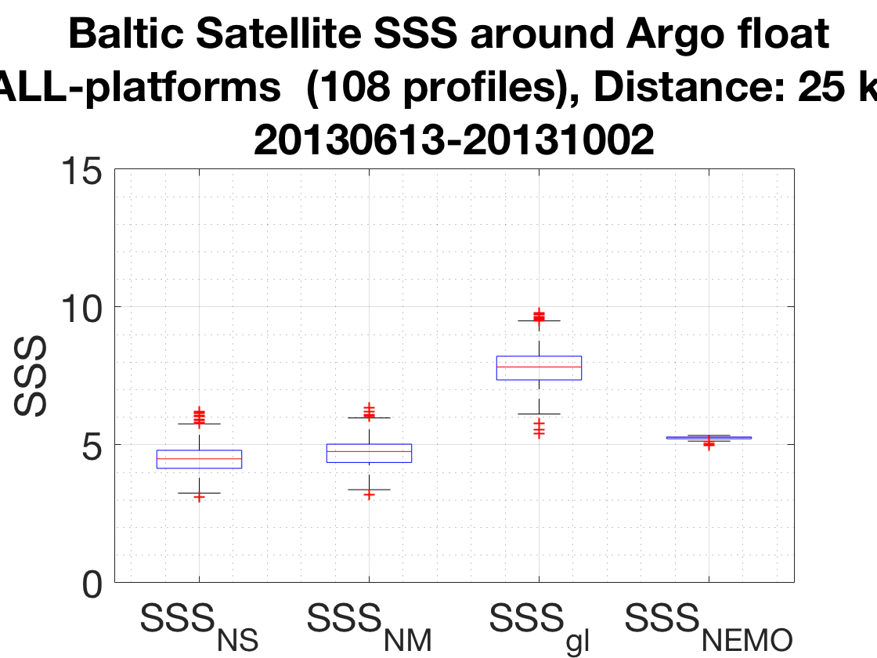

# [2.5] TIMESERIES

# [2.5.1] TIMESERIES: SSS at float location

Compare each product to Salinity Argo 10-m and to Argo [0-10m] average

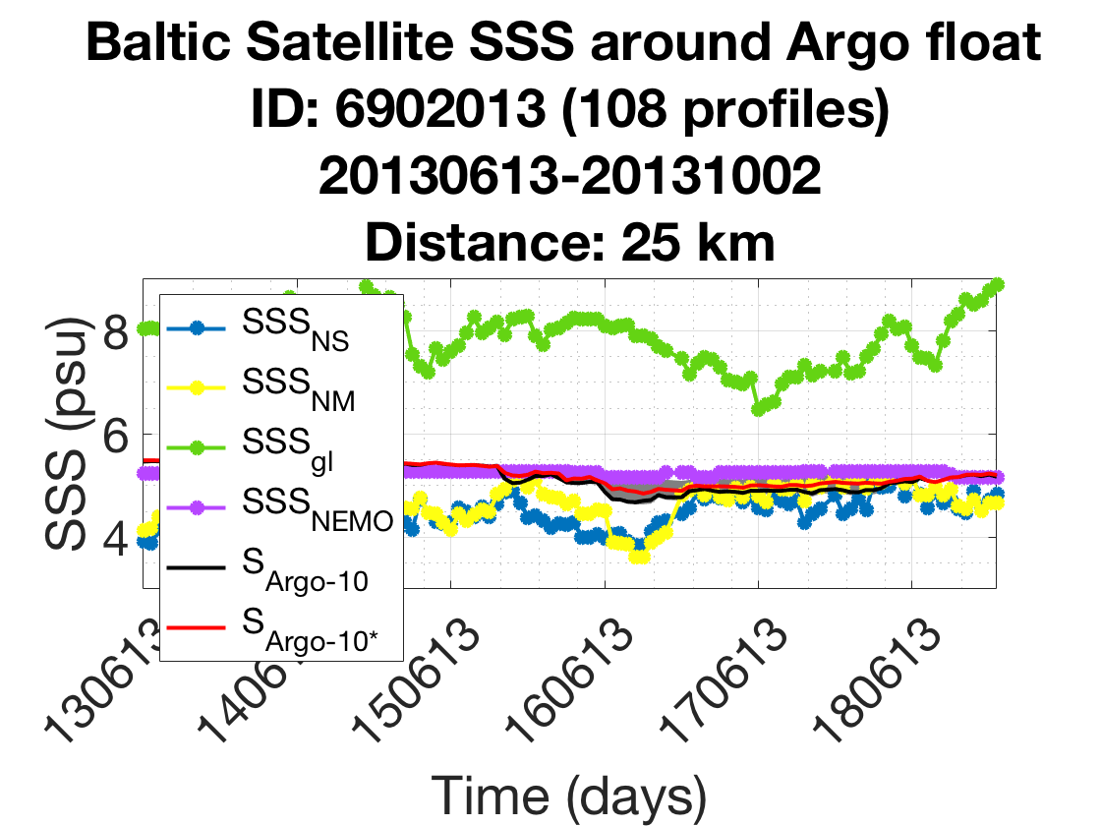

# [2.5.2] TIMESERIES: ALL-SSS at ALL-float location

Compare each product to Salinity Argo 10-m and to Argo [0-10m] average

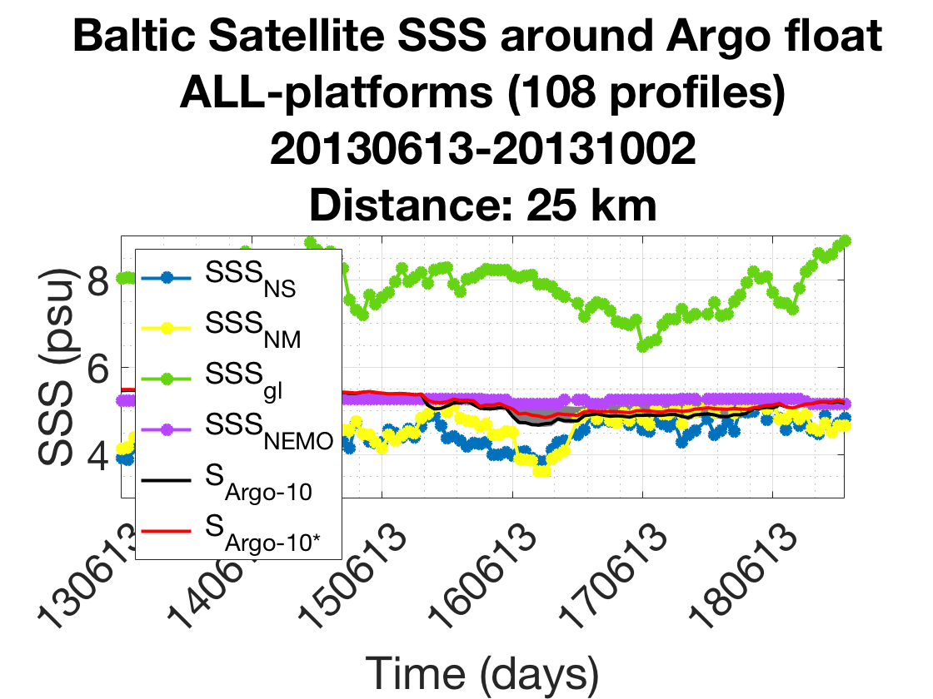

# [2.5.3] TIMESERIES: dSSS at each float location

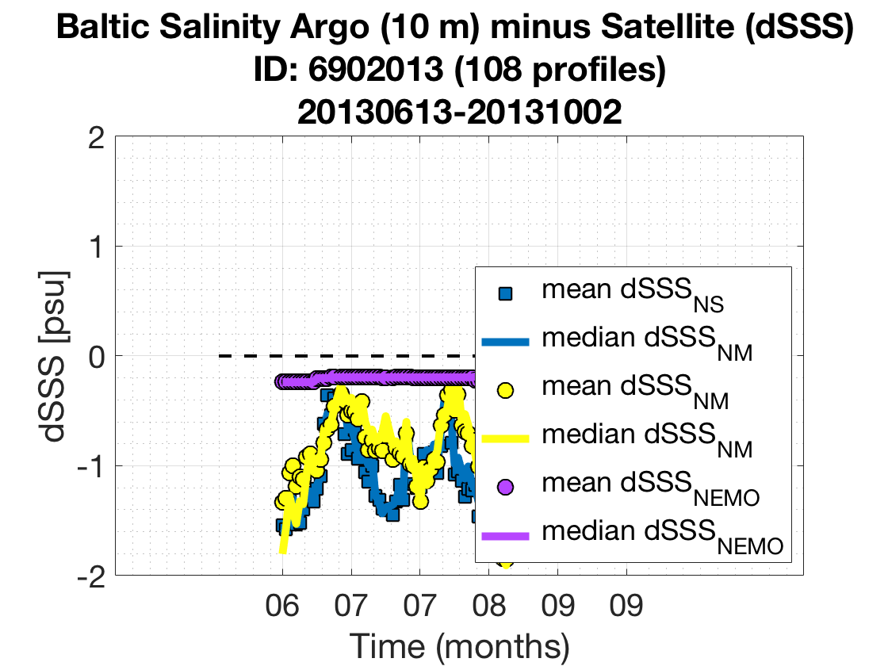

# [2.5.4] TIMESERIES: ALL-dSSS at ALL-float location

[dSSS = Argo - Satellite (NS and NM)]

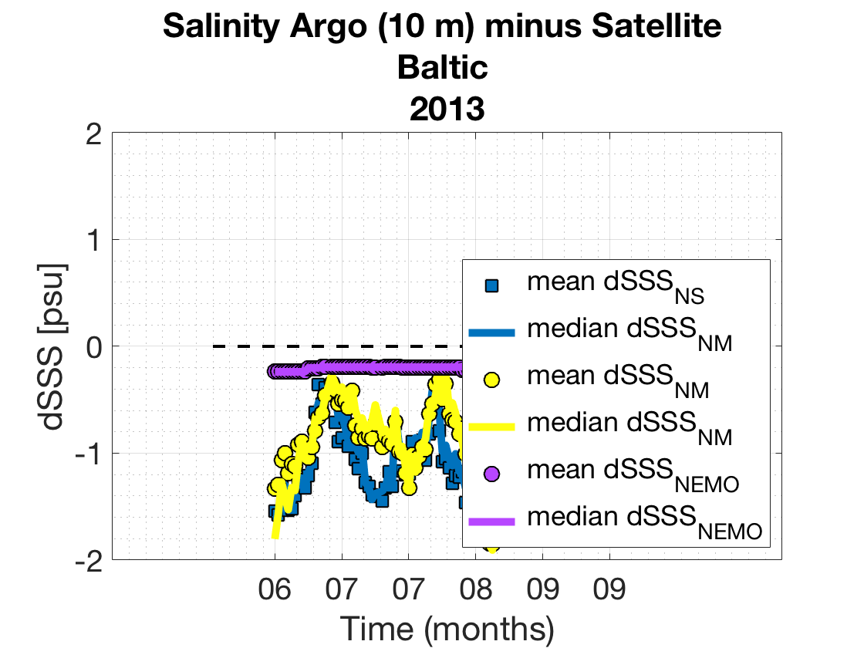

# [2.6] TAYLOR DIAGRAMS

