Table of Contents

Plot monthly MAPS   
Model Regional study (variability within each study region)   
Plot with all the study regions in the Baltic as seen in DUM (p.28)   
Time series at each location   
2 > Plot stats   
2.1 >> Time Series Mean   
2.1 >> Time Series Median [box plot at each study region]   
[3] SSS-NEMO Vs SSS-SMOS (Baltic+ data)   
[3.1] Get SSS-SMOS data (Baltic+ data)

# Plot monthly MAPS

# See in Projects > Baltic> Validation > NEMO > MAPS

# Or Download [here](https://www.dropbox.com/transfer/AAAAAMvSsibXZzNw6jbNz16f1MeZTPqBwj3sK85jAw45RUP_jamjnWk)

# Model Regional study (variability within each study region)

There are four Baltic+ study regions (see Baltic+ DUM, p. 28): [1] Arkona Basin [ArB] (55°31'30.22"N, 16°16'15.06"E) [2] Bothian Sea [BOS] (61°55'50.19"N, 19°14'46.24"E) [3] Gulf of Finland [GOF] (59°35'55.07"N, 23°07'27.96"E) [4] Northern Baltic Proper [NBP] (57°36'10.05"N, 19°48'25.78"E)

# Plot with all the study regions in the Baltic as seen in DUM (p.28)

ans =

Figure (1) with properties:

Number: 1

Name: ''

Color: [0.9400 0.9400 0.9400]

Position: [440 378 560 420]

Units: 'pixels'

Show all properties

Current plot released

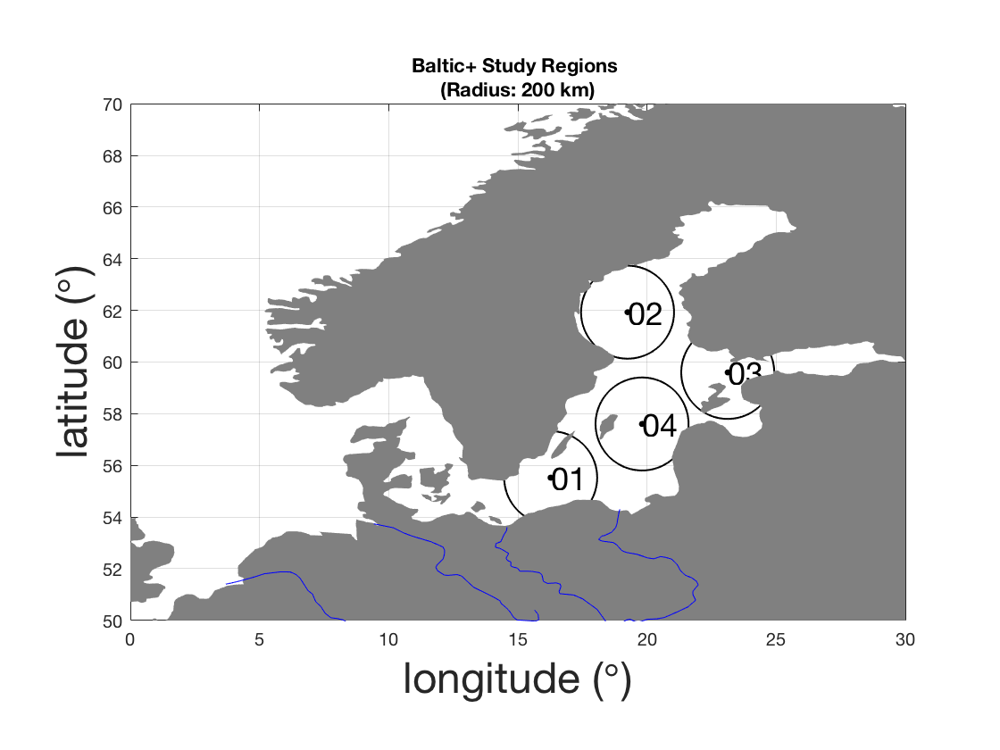

# Time series at each location

# 2 > Plot stats

# 2.1 >> Time Series Mean

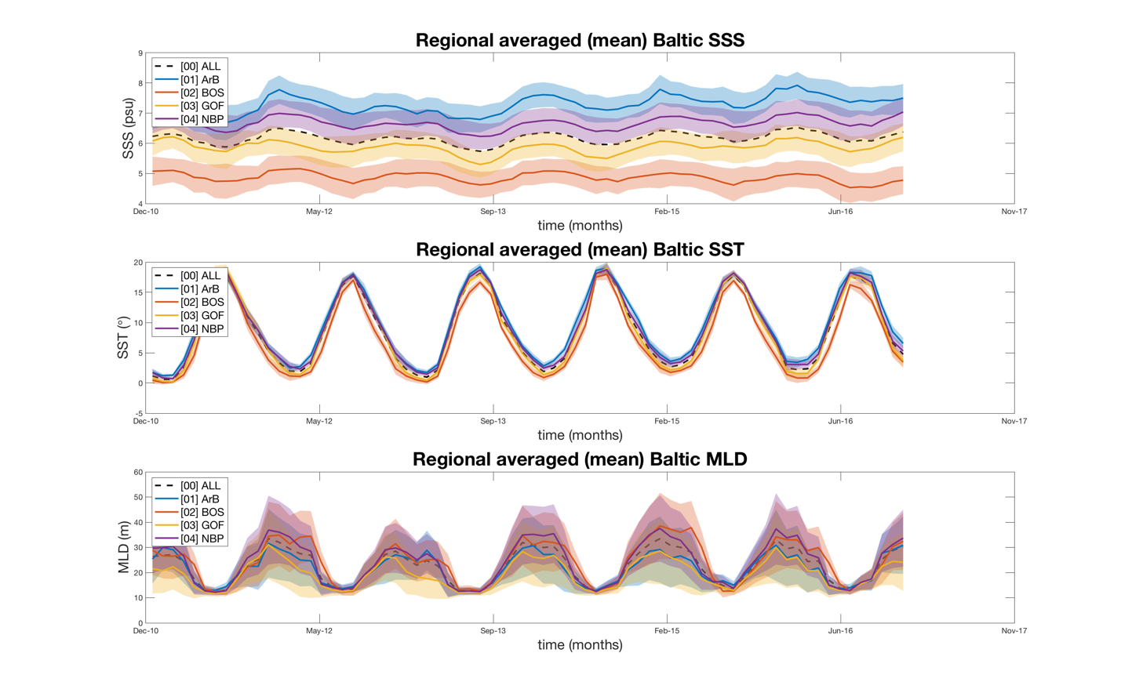

# 2.1 >> Time Series Median [box plot at each study region

# 

# 

# 