Question number 1:

#include<iostream>

#include<fstream>

using namespace std;

struct baseball

{

string name;

int no_of_runs;

int no_of_homeruns;

}s1;

void input1(baseball p[3])

{

cout << "-------------------------------------------INPUT DATA------------------------------------------------------" << endl;

for (int i = 0;i < 3;i++)

{

cout << "enter name of player at index "<<i<<" = " << endl;

cin >> p[i].name;

cout << "enter name of runs of player " << i << " = " << endl;

cin >> p[i].no_of_runs;

cout << "enter number of home runs of player " << i << " = " << endl;

cin >> p[i].no_of_homeruns;

}

cout << "-----------------------------------------------------------------------------------------------------------" << endl;

}

void output(baseball p[3])

{

cout << "-----------------------------------------OUTPUT-----------------------------------------------------------" << endl;

for (int i = 0;i < 3;i++)

{

cout << "player name = " << endl;

cout << p[i].name << endl;

cout << "no of home runs = " << endl;

cout << p[i].no_of_homeruns << endl;

cout << "total number of runs = " << endl;

cout << p[i].no_of_runs << endl;

}

cout << "-----------------------------------------------------------------------------------------------------------" << endl;

}

void updatedata(baseball p[3])

{

cout << "---------------------------------------UPDATE DATA--------------------------------------------------" << endl;

/*baseball* p;

p = new baseball[3];*/

ofstream write;

write.open("updated record.txt");

if (write.fail())

{

cout << "the file was unable to open = " << endl;

exit;

}

else

cout << "file opened succesfully ! " << endl;

cout << "enter index of array for which you have to update the data out of 3 = " << endl;

int choice;

cin >> choice;

if (choice < 0 && choice>2)

{

cout << "not an valid option program is going to terminate ! " << endl;

exit;

}

else {

for (int i = choice;i <= choice;i++)

{

cout << "enter name of the player which you chose to edit and is at index " << i << " = " << endl;

cin >> p[i].name;

cout << "enter number of home runs of the player which you chose to edit and is at index " << i << " = " << endl;

cin >> p[i].no_of_homeruns;

cout << "enter number of total runs of the player which you chose to edit and is at index " << i << " = " << endl;

cin >> p[i].no_of_runs;

}

for (int i = 0;i < 3;i++)

{

write << p[i].name << endl;

write << p[i].no_of_homeruns << endl;

write << p[i].no_of_runs << endl;

}

write.close();

}

cout << "-----------------------------------------------------------------------------------------------------------" << endl;

}

int main() {

baseball p[3];

int x;

cout << "enter 1 for inputing data = " << endl;

cout << "enter 2 for outputing data = " << endl;

cout << "enter 3 for updating the data = " << endl;

cin >> x;

switch (x)

{

case 1:

{

input1(p);

cout << "do you want to contiune to output ? " << endl;

string t;

cin >> t;

if (t != "yes")

{

break;

}

}

case 2:

{

output(p);

cout << "do you want to contiune to update ? " << endl;

string t;

cin >> t;

if (t != "yes")

{

break;

}

}

case 3:

{

updatedata(p);

break;

}

default:

{

cout << " invlaid option terminating the program = " << endl;

break;

}

}

system("pause");

return 0;

}

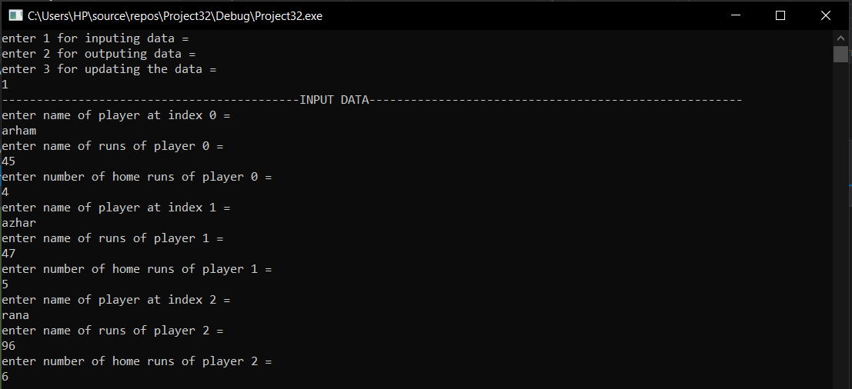

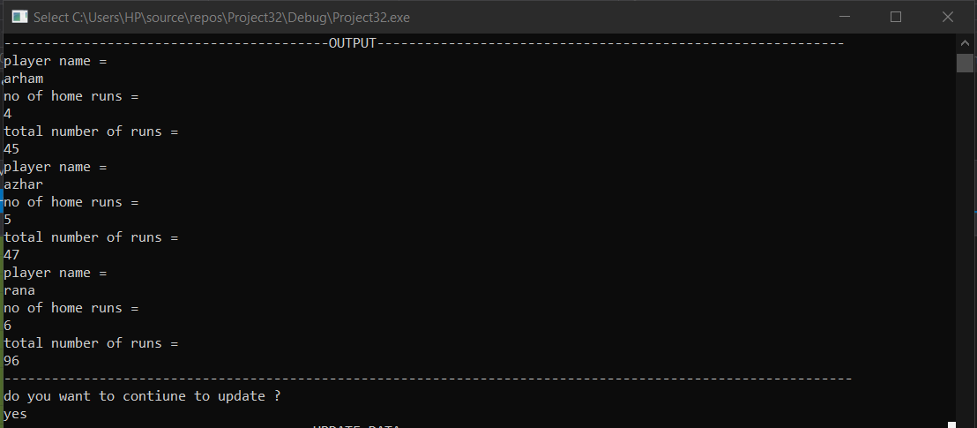

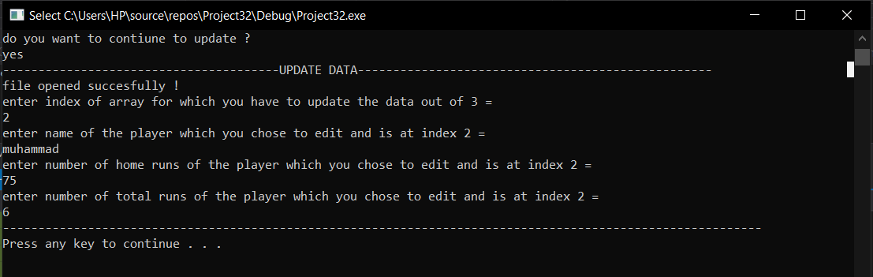

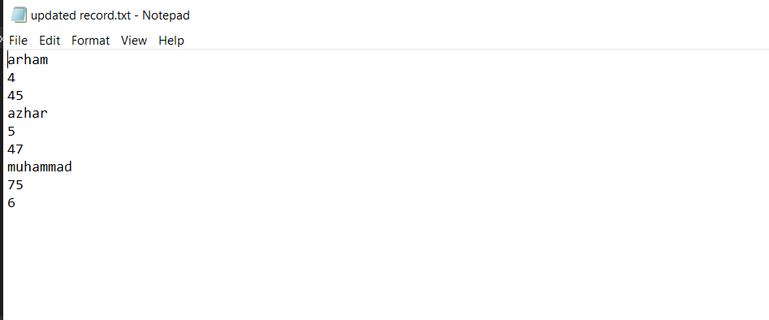

QUESTION 2:

#include<iostream>

#include<string>

using namespace std;

struct database

{

string name;

float age;

float gpa;

struct address

{

string house;

string city;

string street;

string province;

}address;

}arham1;

int main()

{

int x;

cout << "how many data of students you want to enter ? " << endl;

cin >> x;

database *p;

p = new database[x];

for (int i = 0;i < x;i++)

{

cout << "enter data for student at index = " << i << " = " << endl;

cout << "name = " << endl;

cin >> p[i].name;

cout << "age= " << endl;

cin >> p[i].age;

cout << "gpa = " << endl;

cin >> p[i].gpa;

cout << "city name = " << endl;

cin >> p[i].address.city;

cout << "street number = "<<endl;

cin >> p[i].address.street;

cout << "house number = "<<endl;

cin >> p[i].address.house;

cout << " province name = " << endl;

cin >> p[i].address.province;

}

cout << "----------------------------------Output---------------------------------------" << endl;

for (int i = 0;i < x;i++)

{

cout << endl;

cout << "enter data for student at index = " << i << " = " << endl;

cout << "name = " << endl;

cout<< p[i].name<<endl;

cout << "age" << endl;

cout << p[i].age << endl;

cout << " gpa " << endl;

cout << p[i].gpa<<endl;

cout << "THE ADDRESS IS = " << endl;

cout <<"house no "<<p[i].address.house << ", street " << p[i].address.street <<","<< p[i].address.city <<","<< p[i].address.province << endl;

cout << "-------------------------------------------------------------------------------" << endl;

}

system("pause");

return 0;

}

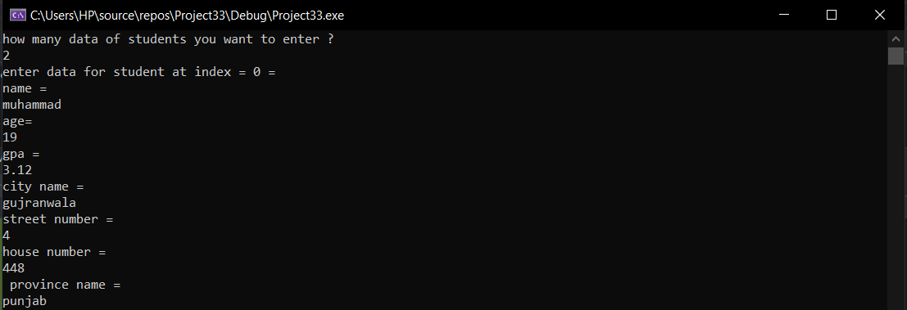

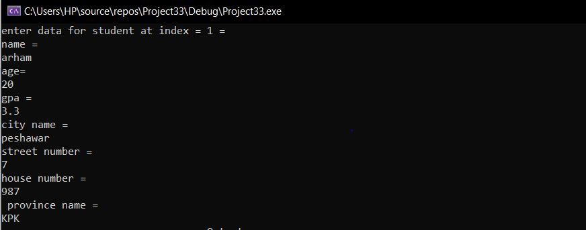

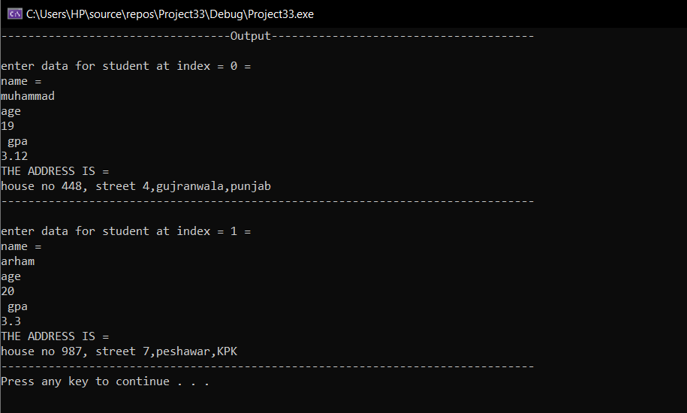

QUESTION 5:

#include<iostream>

using namespace std;

class Date

{

private:

int day;

int year;

int month;

public:

int d1()

{

cout << "enter day = ";

cin >> day;

return day;

}

int y1()

{

cout << "enter year = ";

cin>>year;

return year;

}

int y2()

{

cout << "enter month = ";

cin>>month;

return month;

}

void format1()

{

cout << y2() << "/" << d1() << "/" << y1() << endl;

}

void format2()

{

string x;

if (month == 1 )

{

x = "january";

}

else if (month == 2)

{

x = "february";

}

else if (month == 3)

{

x = "march";

}

else if (month == 4)

{

x = "april";

}

else if (month == 5)

{

x = "may";

}

else if (month == 6)

{

x = "june";

}

else if (month == 7)

{

x = "july";

}

else if (month== 8)

{

x = "august";

}

else if (month == 9)

{

x = "september";

}

else if (month == 10)

{

x = "october";

}

else if (month == 11)

{

x = "november";

}

else if (month== 12)

{

x = "december";

}

cout << x << " " << day << "," << year;

}

void format3()

{

string x;

if (month == 1)

{

x = "january";

}

else if (month == 2)

{

x = "february";

}

else if (month == 3)

{

x = "march";

}

else if (month == 4)

{

x = "april";

}

else if (month == 5)

{

x = "may";

}

else if (month == 6)

{

x = "june";

}

else if (month == 7)

{

x = "july";

}

else if (month == 8)

{

x = "august";

}

else if (month == 9)

{

x = "september";

}

else if (month == 10)

{

x = "october";

}

else if (month == 11)

{

x = "november";

}

else if (month == 12)

{

x = "december";

}

cout << day << " " << x << "," << year;

}

}date;

int main()

{

date.format1();

cout << endl;

date.format2();

cout << endl;

date.format3();

cout << endl;

system("pause");

return 0;

}

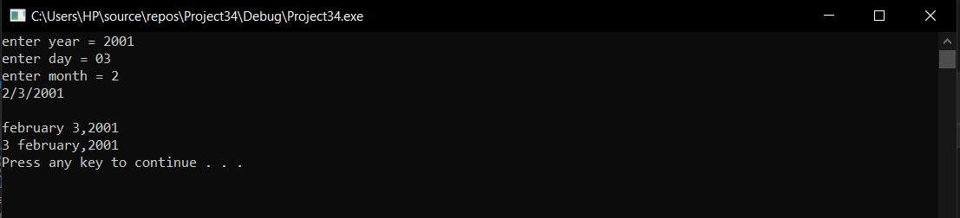

Question 3:

#include<iostream>

#include<fstream>

using namespace std;

struct matrix {

int row, col;

}arham;

int main()

{

int i = 0;

matrix p[100][100];

int counter = 0;

string rows, cols;

ifstream read;

read.open("myfile.txt");

if (read.fail())

{

cout << " the file was unable to open = " << endl;

exit;

}

else

{

while(!read.eof())

{

read >> arham.row;

cout << arham.row << endl;

}

}

read.close();

int** q;

q = new int* [arham.row];

for (int i = 0;i < arham.row;i++)

{

q[i] = new int[arham.col];

}

/*for (int i = 0;i < arham.row;i++)

{

for (int j = 0;j < arham.col;j++)

{

cout << q[i][j];

}

cout << endl;

}*/

system("pause");

return 0;

}

Question 4:

#include<iostream>

#include<string>

using namespace std;

union ok {

char name[100];

char address[100];

char phone[100];

}arham;

void name()

{

{

cout << "enter name = " << endl;

cin.getline(arham.name, 100);

cout << "-----------------------------------------------output------------------------------------------" << endl;

cout << "the name is = " << endl;

cout << arham.name << endl;

}

}

void address() {

{

cout << "enter address = " << endl;

cin.getline(arham.address, 100);

cout << "--------------------------------------------------output----------------------------------------------" << endl;

cout << "the address is = " << endl;

cout << arham.address << endl;

}

}

void phone() {

{

cout << "enter phone number = " << endl;

cin.getline(arham.phone, 100);

cout << "-----------------------------------------------------------output-----------------------------------------------" << endl;

cout << "the phone number is = " << endl;

cout << arham.phone << endl;

}

}

int main()

{

string x;

cout << "enter 1 for entering name and outputting name = " << endl;

cout << "enter 2 for entering address and outputting address = " << endl;

cout << "enter 3 for entering phone number and outputting phone number = " << endl;

cin >> x;

if (x=="1")

{

cin.ignore();

name();

exit;

}

else if (x == "2")

{

cin.ignore();

address();

exit;

}

else if (x=="3")

{

cin.ignore();

phone();

exit;

}

}

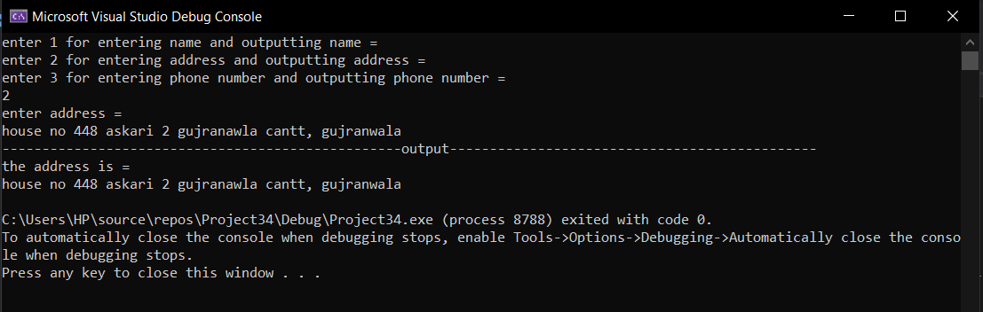

Question 6:

#include<iostream>

#include<string>

using namespace std;

class {

private :

string name;

int age;

bool male;

string occupation;

bool cook;

public:

void enter_name()

{

cout << "enter name = " << endl;

cin >> name;

}

void getname()

{

cout << "the name is = " << endl;

cout << name << endl;

}

void enter_age()

{

cout << "enter age = " << endl;

cin >> age;

}

void getage()

{

cout << "the age is = " << endl;

cout << age << endl;

}

void enter_male()

{

int x;

cout << "if male enter 1 else enter any integer " << endl;

cin >> x;

if (x == 1)

{

male = true;

cout << "the person is male " << endl;

}

else

{

cout << "the person is female " << endl;

male = false;

}

}

void enter_occupation()

{

cout << "enter occupation = " << endl;

cin >> occupation;

}

void get_occupation() {

cout << " occupation = " << endl;

cout << occupation << endl;

}

void enter_cook() {

int y;

cout << "can cook ? if yes enter 1 else any integer " << endl;

cin >> y;

if (y == 1)

{

cout << "can cook ! " << endl;

cook = true;

}

else

{

cout << "can t cook ! " << endl;

cook = false;

}

}

}p1,p2;

int main() {

p1.enter_name();

p1.getname();

p1.enter_occupation();

p1.get_occupation();

p1.enter_age();

p1.getage();

p1.enter_cook();

p1.enter_male();

cout << "using p2 ! " << endl;

p2.enter_name();

p2.getname();

p2.enter_occupation();

p2.get_occupation();

p2.enter_age();

p2.getage();

p2.enter_cook();

p2.enter_male();

}