**Question 1:**

#include<iostream>

#include<string>

using namespace std;

class person

{

string name, address, lastname;

public:

void setname(string name)

{

this->name = name;

}

string getname()

{

return name;

}

void setlastname(string lastname)

{

this->lastname = lastname;

}

string getlastname()

{

return lastname;

}

void setaddress(string address)

{

this->address = address;

}

string getaddress()

{

return address;

}

void input()

{

cout << "enter name = " << endl;

getline(cin, name);

cout << "enter last name = " << endl;

getline(cin, lastname);

cout << "enter address = " << endl;

getline(cin, address);

}

void output()

{

cout << "-------------------------------OUTPUT--------------------------------" << endl;

cout << "name is = " <<name << endl;

cout << "lastname is = " << lastname << endl;

cout << "adress is = " << address << endl;

}

};

class coustomer :public person

{

double coustomer_number;

bool mailing_list = false;

public:

void getcoustomer_number(double coustomer_number)

{

this->coustomer_number = coustomer_number;

}

int setcoustomer_name()

{

return coustomer_number;

}

void getmailing_list(bool mailing_list)

{

this->mailing_list = mailing_list;

}

bool setmailinglist()

{

return mailing_list;

}

void input()

{

person::input();

cout << "enter coustomer id number = " << endl;

cin >> coustomer_number;

cout << "enter status of mailing list = " << endl;

cin >> mailing_list;

}

void output() {

cout << "-------------------------------OUTPUT--------------------------------" << endl;

person::output();

cout << "coustomer id is = " << coustomer_number<<endl;

cout << "status mailing list = " << mailing_list;

}

};

int main() {

person okay;

okay.setname("arham");

okay.setlastname("azhar");

okay.setaddress("house no 448");

okay.output();

coustomer ojb = coustomer();

ojb.input();

ojb.output();

system("pause");

return 0;

}

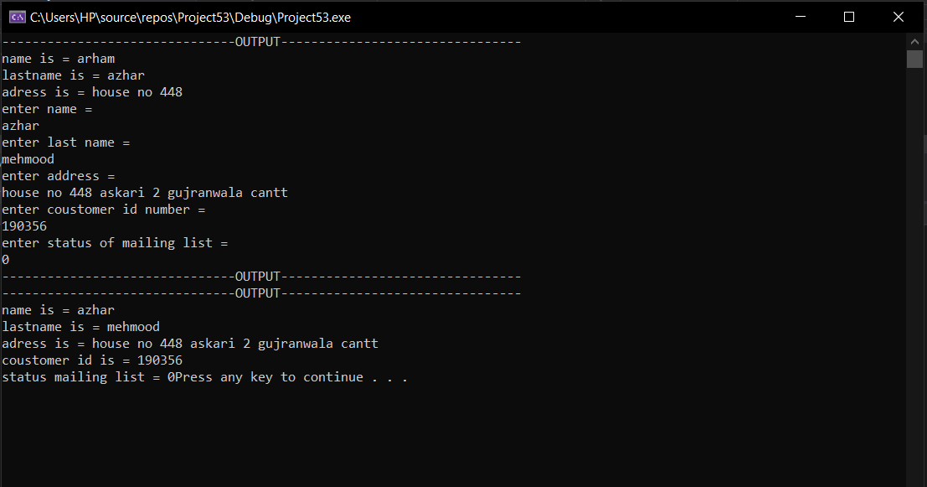

**Question 2:**

#include<iostream>

#include<string>

using namespace std;

class person

{

string name, address, lastname;

public:

void setname(string name)

{

this->name = name;

}

string getname()

{

return name;

}

void setlastname(string lastname)

{

this->lastname = lastname;

}

string getlastname()

{

return lastname;

}

void setaddress(string address)

{

this->address = address;

}

string getaddress()

{

return address;

}

void input()

{

cout << "enter name = " << endl;

getline(cin, name);

cout << "enter last name = " << endl;

getline(cin, lastname);

cout << "enter address = " << endl;

getline(cin, address);

}

void output()

{

cout << "-------------------------------OUTPUT--------------------------------" << endl;

cout << "name is = " <<name << endl;

cout << "lastname is = " << lastname << endl;

cout << "adress is = " << address << endl;

}

};

class coustomer :public person

{

double coustomer_number;

bool mailing_list = 0;

public:

void getcoustomer_number(double coustomer_number)

{

this->coustomer_number = coustomer_number;

}

int setcoustomer_name()

{

return coustomer_number;

}

void getmailing_list(bool mailing_list)

{

this->mailing_list = mailing_list;

}

bool setmailinglist()

{

return mailing_list;

}

void input()

{

person::input();

cout << "enter coustomer id number = " << endl;

cin >> coustomer_number;

cout << "enter status of mailing list = " << endl;

cin >> mailing_list;

}

void output() {

cout << "-------------------------------OUTPUT--------------------------------" << endl;

person::output();

cout << "coustomer id is = " << coustomer_number<<endl;

cout << "status mailing list = " << mailing_list;

}

};

class preffered_coustomer :public coustomer

{

double purchaseAmount, discountLEVEL;

public :

void purchaseamount_()

{

coustomer:input();

cout << "enter the number of purchases made = " << endl;

cin >> purchaseAmount;

}

void discount()

{

if (purchaseAmount >= 2000)

{

this->discountLEVEL = 10;

}

else if (purchaseAmount >= 1500)

{

this->discountLEVEL = 7;

}

else if (purchaseAmount >= 1000)

{

this->discountLEVEL = 6;

}

else if (purchaseAmount >= 500)

{

this->discountLEVEL = 5;

}

}

int getdiscountlevel() {

return discountLEVEL;

}

void output()

{

coustomer::output();

discount();

cout << endl;

cout << "the discount level is equal to = "<<discountLEVEL << endl;

}

};

int main() {

person okay;

okay.setname("arham");

okay.setlastname("azhar");

okay.setaddress("house no 448");

okay.output();

preffered_coustomer ojb = preffered_coustomer();

ojb.purchaseamount_();

ojb.output();

system("pause");

return 0;

}

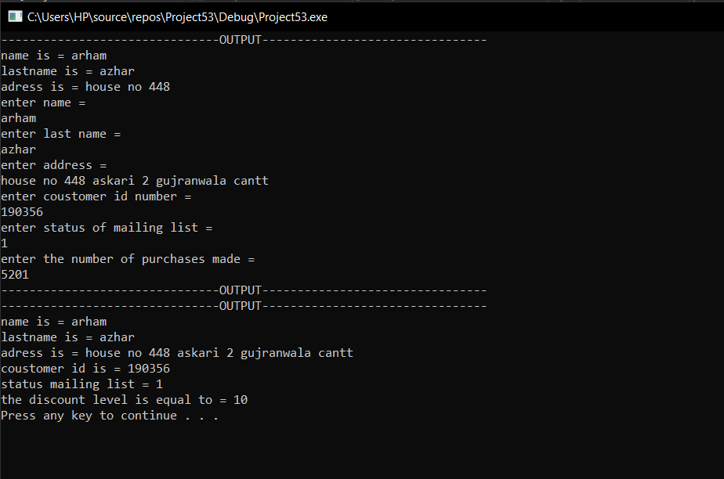

**Question 3:**

#include<iostream>

#include<string>

using namespace std;

class person

{

private :

string age, gender;

public :

string name;

person()

{

name = "arham azhar";

}

};

class employee :public person {

public:

string cnic;

employee()

{

cnic = "35202-0725554-0";

}

void employ()

{

cout << " Hi, I am Employ from Employed Class " << endl;

}

};

class umemployee :public person {

public :

umemployee() {

cout << "Hi, I am UnEmploy from UnEmployed Class ." << endl;

}

};

class bussinessman: private employee

{

public:

bussinessman() {

}

void display() {

cout << "name= " << person::name << endl;

cout << "cnic = " << cnic << endl;

employ();

}

};

int main() {

bussinessman arham=bussinessman();

arham.display();

cout << endl;

system("pause");

return 0;

}

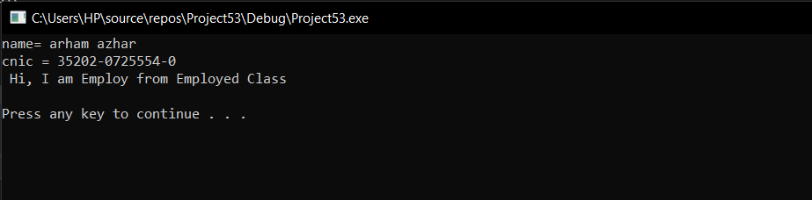

**QUESTION 4:**

#include<iostream>

using namespace std;

class vehicle {

private :

double speed, distance;

public:

void setspeed(double speed)

{

this->speed = speed;

}

double getspeed()

{

return speed;

}

void setdistance(double distance)

{

this->distance = distance;

}

double getdistance()

{

return distance;

}

double computeduration() {

double x;

x = speed / distance;

return x;

}

};

class wheelvehicle :public vehicle

{

double wheels;

public:

void setwheels(double wheels)

{

this->wheels = wheels;

}

double getwheels() {

return wheels;

}

};

class wingvehicle:public vehicle

{

double wings;

public:

void setwings(double wings)

{

this->wings = wings;

}

double getwings() {

return wings;

}

};

class truck :public wheelvehicle

{

double carryingload;

public:

void setload(double carryingload) {

this->carryingload = carryingload;

}

double getload() {

return carryingload;

}

};

int main() {

cout << "----------------------------OUTPUT FROM TRUCK OBJECT--------------------------" << endl;

truck arham;

arham.setspeed(22.4);

cout << "THE SPEED IS = " << arham.getspeed() << endl;

arham.setdistance(10);

cout << "THE DISTANCE IS = " << arham.getdistance() << endl;

cout << "THE TIME DURATION IS EQUAL TO = " << arham.computeduration() << endl;

arham.setwheels(4);

cout << "THE NUMBER OF WHEELS ARE = " << arham.getwheels() << endl;

arham.setload(210);

cout << "THE LOAD IS EQUAL TO = " << arham.getload() << endl;

cout << endl;

cout << "----------------------------OUTPUT FROM WINGVEHICLE OBJECT--------------------------" << endl;

wingvehicle arham2;

arham2.setspeed(120);

cout << "THE SPEED IS = " << arham2.getspeed() << endl;

arham2.setdistance(40);

cout << "THE DISTANCE IS = " << arham2.getdistance() << endl;

cout << "THE TIME DURATION IS EQUAL TO = " << arham2.computeduration() << endl;

arham2.setwings(2);

cout << "THE NUMBER OF WINGS ARE = " << arham2.getwings() << endl;

}

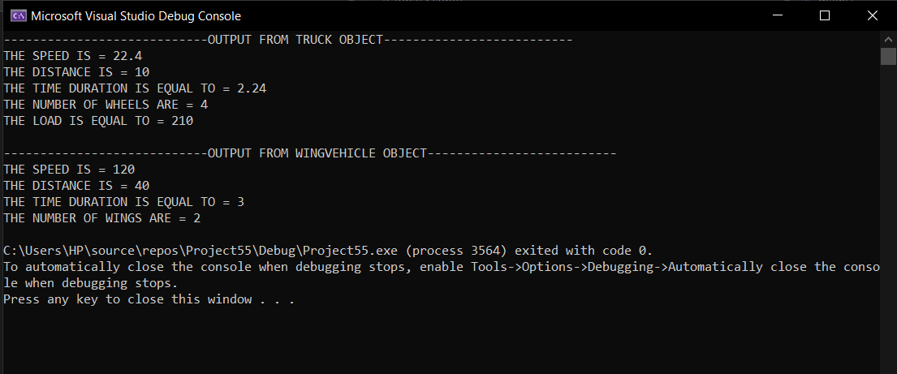

**Question 5:**

#include<iostream>

using namespace std;

class A {

public:

A() {

cout << "CLASS A's CONSTRUCTOR IS CALLED " << endl;

}

};

class B {

public:

B() {

cout << "CLASS B's CONSTRUCTOR IS CALLED " << endl;

}

};

class C:public B,public A {

public:

C()

{

cout << "CLASS C's CONSTRUCTOR IS CALLED " << endl;

}

};

int main() {

C arham;

system("pause");

return 0;

}

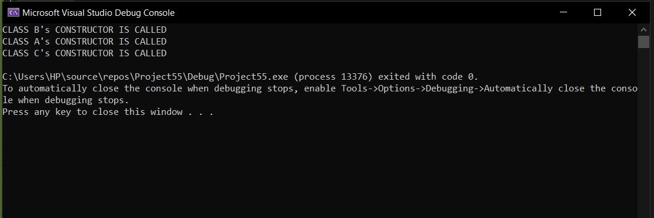

**Question 6:**

**Header file :**

#pragma once

#include<iostream>

using namespace std;

class Person

{

//Data members of person

public:

Person(int x);

};

class Faculty :public Person

{

//data members of faculty

public:

Faculty(int x);

};

class Student :public Person

{

//data members of student

public:

Student(int x);

};

class TA :public Faculty, public Student

{

public:

TA(int x);

};

**Implementation file :**

Person::Person(int x)

{

cout <<"Person::Person(int) is called "<< endl;

}

Faculty::Faculty(int x) :Person(x)

{

cout<<"Faculty::Faculty(int) is called"<< endl;

}

Student::Student(int x) : Person(x)

{

cout<<"Student::Student(int) is called"<< endl;

}

TA::TA(int x) : Student(x), Faculty(x)

{

cout<<"TA::TA(int) is called"<<endl;

}

**Source file :**

int main() {

{

TA ta1(30);

system("pause");

return 0;

}

}

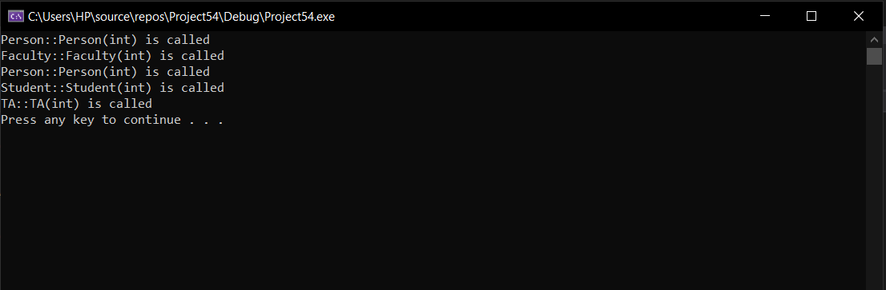

**Question 7:**

“Header”

#pragma once

#include<iostream>

#include <string>

using namespace std;

class animal

{

public:

string name;

void setname(string n);

string getname();

void sound();

};

class deer : public animal

{

public:

string name;

void sound();

};

class cat : public animal {

public:

void sound();

};

class dog : public animal {

public:

void sound();

};

class TigerFamily : public animal {

private:

void sound();

public:

TigerFamily()

{

sound();

}

};

class tiger : public TigerFamily {

public:

void sound();

};

class lion : public TigerFamily {

public:

void sound();

};

“Implementation file”

#include "AnimalSounds.h"

void animal::setname(string n)

{

name = n;

}

string animal::getname() {

return name;

}

void deer::sound()

{

cout << "Deer:\nBuck" << endl;

}

void cat::sound()

{

cout << "Cat:\nMeow" << endl;

}

void dog::sound()

{

cout << "Dog:\nBark" << endl;

}

void TigerFamily::sound()

{

cout << "_________________WELCOM TO TIGER FAMILY_________________" << endl << endl;

}

void tiger::sound()

{

cout << "Tiger:\nGrowl" << endl;

}

void lion::sound()

{

cout << "Lion:\nRoar" << endl;

}

“Source file”

#include "AnimalSounds.h"

int main()

{

cout << "_________________WELCOM TO ANIMAL FAMILY_________________" << endl << endl;

deer dr;

dog dg;

cat c;

string n;

cout << "Enter the name of deer: ";

getline(cin, n);

dr.setname(n);

cout << endl;

cout << "Enter the name of dog: ";

getline(cin, n);

dg.setname(n);

cout << endl;

lion l;

cout << endl;

cout << "Enter the name of lion: ";

getline(cin, n);

l.setname(n);

cout << endl;

tiger t;

cout << endl;

cout << "Enter the name of tiger: ";

getline(cin, n);

t.setname(n);

cout << endl;

cout << "Enter the name of cat: ";

getline(cin, n);

c.setname(n);

cout << endl;

cout << "_______________________SOUNDS_______________________" << endl << endl;

cout << dr.getname() << " ";

dr.sound();

cout << endl;

cout << dg.getname() << " ";

dg.sound();

cout << endl;

cout << l.getname() << " ";

l.sound();

cout << endl;

cout << c.getname() << " ";

c.sound();

cout << endl;

cout << t.getname() << " ";

t.sound();

cout << endl;

system("pause");

return 0;

}

