ARIA Radar Development Kit
User Manual

Document Version
Version | Date | Description
1.0 | 2024/09/04 | Issued

1.Introduction
ARIA RDK (Radar Development Kit) is a complete suite to evaluate ARIA Radar Devices and/or to develop custom application algorithms to radar data. ARIA RDK allows for the simultaneous data acquisition from one or more ARIA radar devices. Consequently, users may exploit ARIA RDK to develop different applications, ranging from single-device evaluation, to customer’s application development, and to advanced applications such as radar tomography.

2.Software Architecture
The system architecture is shown in Fig.1.
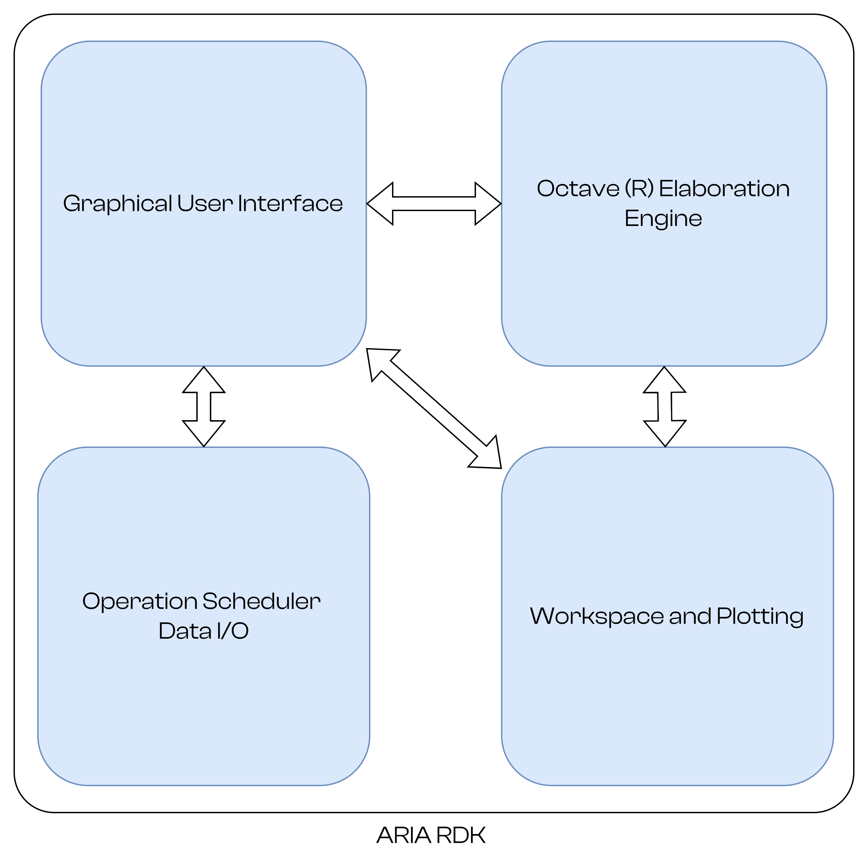Fig. 1: ARIA RDK Main Architecture
ARIA RDK includes four main components:
1. A Graphical User Interface (Windows and Linux) to create custom projects
2. An interface component to the Scientific Programming Language Octave to run custom algorithms on radar data
3. A Scheduler & Data I/O component to coordinate radar acquisitions and execute user scripts
4. A data workspace management and plotting component

3. Prerequisites
ARIA RDK requires the following components to be compiled and installed in your system:
- Qt6 (>= 6.7.2)
- VTK: The Visualization Toolkit (https://vtk.org/)
- JKQTPlotter: an extensive Qt5 & Qt6 Plotter Framework
(https://jkriege2.github.io/JKQtPlotter/index.html)
- Eigen: C++ template library for linear algebra (>= 3.4.0) (https://eigen.tuxfamily.org/)
- Octave (>=9.2.0): a scientific programming language environment
Please refer to respective build/install instruction.
ARIA-RDK is designed to be compiled with CMake®. Currently it has been compiled and tested under Clear Linux SO.

3.1 Workspace
ARIA RDK introduces the concept of workspace, i.e. a folder structure where all the building blocks of a customer application project are defined.
A workspace contains the following elements:
- A set of radar modules definitions: a radar module is a description of one specific UWB module, with the firmware it runs, and its interface with the PC (Fig. 2);
- A set of elaboration scripts: a script is a set of instructions to run customer applications and algorithms. Currently ARIA-RDK support the Octave scientific-programming language;

- A set of radar devices: a device is a physical board attached to the PC. Each device must have its corresponding module definition properly loaded.
- One or more schedulers (handlers): one scheduler is responsible to synchronize more devices to run at the same time, to enable multi-radar acquisition.
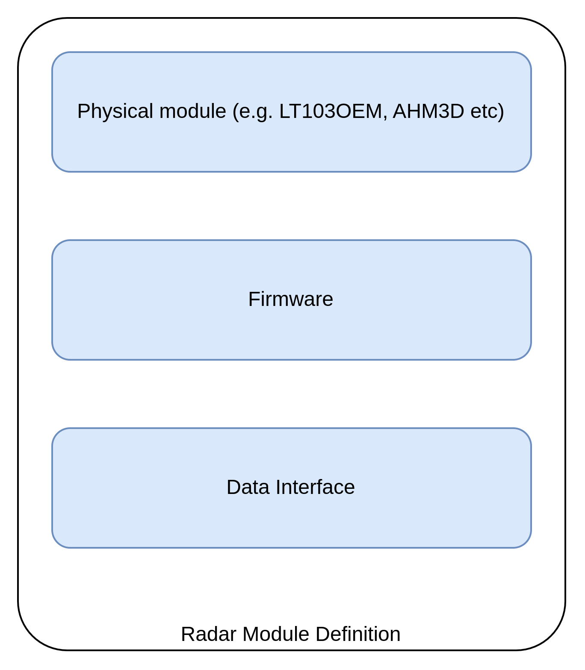Fig. 2: Radar Module Definition
These components are described in the following sections.

3.2 Radar Module
One “radar module” is the definition of a peculiar family of radar devices. Each module is uniquely identified by the following data:
- Its name;
- A set of parameters which are the radar variables exposed to the PC. They vary according to the radar module and the installed FW. For instance, a module with “basic” FW would provide only the radar’s raw-data while the same module with a more advanced FW (e.g. to detect and locate people) would provide the results of the elaboration (e.g. the presence detection outcome and the position of the detected person);
- Optional: the definition of the antenna array, with the antennas models and their position to evaluate the beamforming capability;
- The scripts that are to be executed at start-up, before and after each data acquisition;
- The configuration of the serial port

Radar Definitions
The ARIA RDK allows users to operate with different radar devices and different ARIA radar models.
Each

Radar Cycle
A radar cycle is made of 3 steps:
1. init phase: all initialization scripts and variables are set
2.pre-acquisition: all parameters that affect next acquisition are set
3. post-acquisition: this is where customer post-acquisition algorithms are expected
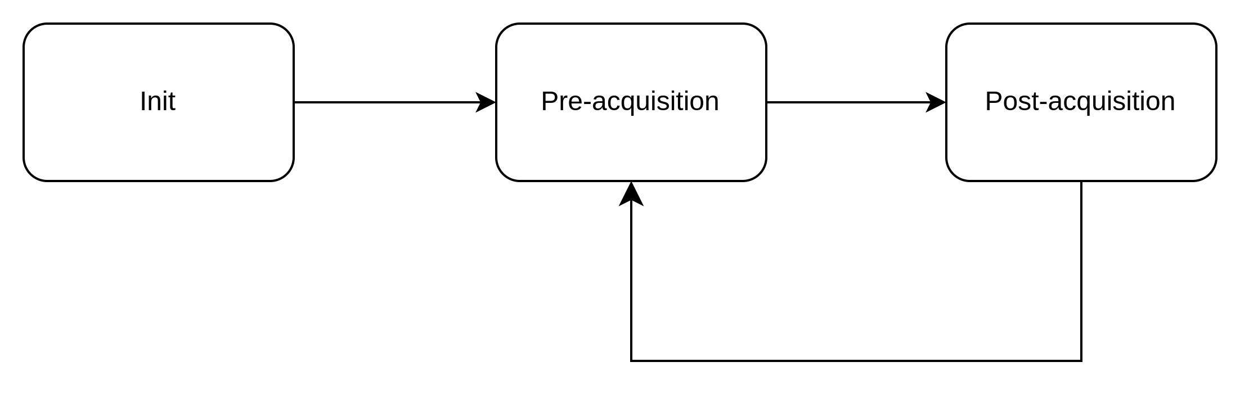

Policy during init, pre_acquisition and post_acquisition
All phases are further split in 3 different steps:
1. Inquiry of output params and
2. Execution of the scripts related to
3. Update of the params that are Input, I/O and that are modified by Octave

Radar Flow of Operations

Parameter Update
1. When a parameter is updated, the sw object send the data and it updates the value according to the corresponding return value. This is done in the radarInstance::set_value method.
When transmit_param is set, the transmission process is started too.

Tests
Test | Pass Criteria
Modify a param in the GUI | Param must be passed to device  Param must be updated according to device return  Octave and GUI views must be updated
Modify a param in Octave | Param must be passed to the device  Param value must be read and radar object must update accordingly  Octave and GUI views must be updated with the new value

1. Update param from GUI: check that update bidir is effective (e.g. range_max)
2. Run a script from octave in halted conditions: check

License
ARIA-RDK is distributed with a LGPL-3.0 License.
ARIA-RDK can be is distributed for the evaluation of algorithms based on ARIA UWB Radars SoCs and Modules. It can be used freely, but WITHOUT ANY WARRANTY; without even the implied warranty of FITNESS FOR A PARTICULAR PURPOSE.

