Hydrogen v1.1
Datasheet

Document Version
Version | Date | Description
1.0 | 2024/09/04 | Issued

1.Introduction
Hydrogen SoC is a complete low-power, high-precision, Ultra-WideBand (UWB)-Radar System on Chip (SoC) enabling 1D, 2D or 3D detection. The Hydrogen SoC is a highly configurable system deploying a wide set of advanced features:
- Up to 4 Tx channels and up to 4 Rx channels to enable different antenna-arrays configurations;
- Programmable center frequency from 6.2GHz to 9GHz;
- Programmable bandwidth from 600MHz to 1.3GHz (BW @ -10dB);
- Advanced pulse coding with single-pulse and coded-pulse modes available;
- Physical-layer pre-processing unit;
- Internal 2X 32bit RISC-V core to run user-application code;
- 256kB SRAM;
- UART/SPI/QSPI interfaces.

3.System Architecture
The system architecture is shown in the Fig.1.
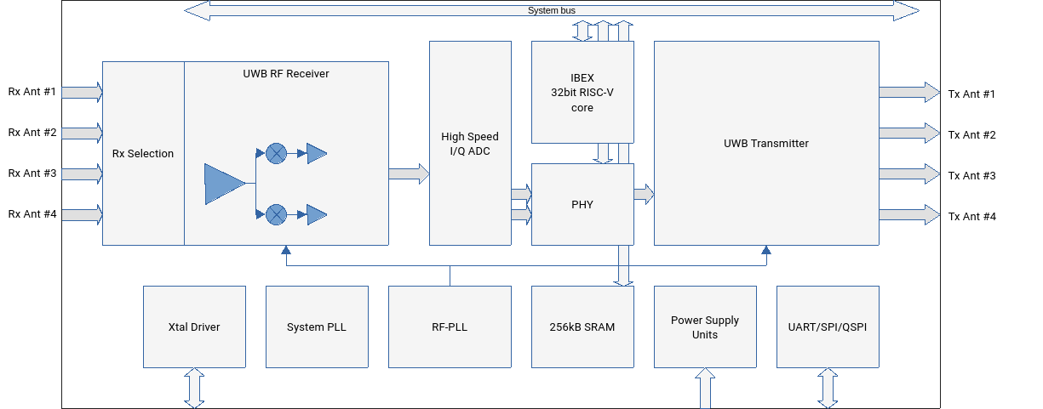Fig. 1: Hydrogen SoC System Architecture
The Hydrogen SoC includes a highly configurable UWB transmitter which generates the RF pulses sent to the (external) transmitting antennas. A variable number of antennas (from 1 to 4 can be connected to the Hydrogen SoC UWB Transmitter and, correspondingly, a variable number of transmitter channels can be activated, according to the transmitter array configuration.
The UWB transmitter can produce UWB pulses at different center frequencies and with different time length, corresponding to different bandwidth usage (leading to configurable down-range resolution).
The receiver, similarly, can be attached to a variable number of receiving antennas (from 1 to 4). Consequently different antenna arrays can be designed, according to the application requirements in terms of cross-range resolution vs. system form-factor. Up to 16 antennas combination (called TxR channels) can be implemented, leading to great flexibility in the design of custom radar arrays.
The receiver operates in I/Q down-conversion mode, and it is provided with 2x high-speed low-power ADCs capable to operate up to 1.8GSPS.
One specialized programmable digital unit is dedicated to the radar pre-processing (i.e. the processing of “physical” data) and to optimize the performance of the entire transceiver chain. A RISC-V processor is already embedded to run user-application code.
Different interfaces are available:
- General Purpose IOs (GPIOs)
- UART
- SPI/QSPI

4.Operating Principle

4.1 Simple 1D case

4.1.1 Single-pulse mode
In its simplest operating mode, Hydrogen operates by enabling one Receiver channel and one Transmitter channel and single-pulse mode.
The detection process is as follows: one pulse is generated by the UWB Transmitter and sent to the transmitter antenna which, in turn, radiates the pulse into the environment.
When a radiated pulse “hit” an object into the environment, a part of the transmitted energy bounces back and a reflected (echo) pulse is “radiated” from the illuminated object. This secondary wave travels back to the receiver where it is picked by the receiving antenna.
The electrical signal is the fed to the receiver chain of the Hydrogen pulse where it is downconverted (ZIF- Zero IF downconversion) and converted to an I/Q high-speed ADC.
At this stage, two different vectors of value are provided to the data pre-processor. These vectors are the I/Q signals sampled by the high-speed ADC. The time-values of these vectors correspond to the time-of-flight needed by a transmitted pulse to reach a certain distance and for the corresponding echo to travel back to the receiver. The pulses fly at the speed of light in air (ca. 3E8 m/s).
The process is then repeated at a given time period, which is called Pulse Repetition Time (its inverse is called Pulse Repetition Frequency, PRF).
To increase the overall Signal-to-Noise Ratio (SNR) at the input of the digital elaboration unit, a set of consecutive pulses is added coherently. This way the input noise, assumed being uncorrelated, additive and with null mean value, is relatively averaged out, with respect of the coherent integration of consecutive pulses. The SNR gain is therefore:

Where N is the number of consecutive pulses integrated.
Therefore, to build a single reading to be sent to the “user”,
Anyway, in presence of a moving target, the readings are affected by a relative delay (the position and, consequently, the time-of-flight of the echoes changes from one reading to the next one); consequently, when adding consecutive readings, the process allows to gain SNR as long as the phase coherence is reasonably maintained over the entire frame.

4.1.2 Multi-pulse mode
A more advance operating mode can be exploited by enabling the multi-pulse mode. In this operating mode, a sequence of coded pulse can be transmitted each

5. Electrical

6. Pin list

7. Package

8. Firmware

