Project Management
1. Radar Modules
Antenna models and scripts are ALWAYS referred to the proper folder in the project. The possibility of using “random” path files is removed.
→ Saving antennas and scripts with filename only
→ When loading radar Module file, antennas and scripts file must be loaded according to the full fil
→ Antennas and scripts are radarProject’s projectItem so when loading a radarModule, they should be redirected to radarProject’s projectItem
→ Name should be fileName, not baseName
→ RadarModule GUI needs to refer to the available project scripts / antennas only
→ _available_antenna now corresponds always to the project DB antennas

radarProject.
Check creating: ok
Check loading (empty). ok
Check loading after copy (empty).

Check creating new radarModule.

Projects
A project is a tree whose structure is the one below.

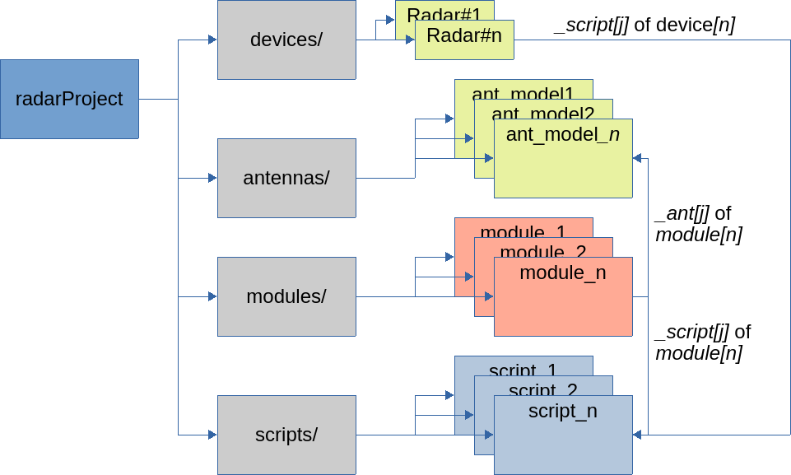Fig. 1: Project Structure

Radar Modules
When an antenna model is loaded, let’s check if it is available.
If not, add a new antenna

Radar Modules Save/Save as policies
_source contain the initial *radarModule

Cases
New Module | Found | Save
true | null | Saving a new module data into a new module  (actually it is a save as since we have to ask the new module)  → save _radar_module to file  → need to add _radar_module to the database  → _source ← _radar_module (pointers)  → create new module (_radar_module = new)  → set new module to false  emit “new item”
true | !null | Saving a new module data into an old module  → copy data from _radar_module to “found” previous one  → set new module to false  → emit radar_saved(found)  → set _source to “found”
false | !null  (_source = _found) | Saving an existing module  → save _radar_module to file  → copy data from _radar_module to _source  → emit update(source)
false | !null  (_source != _found) | Saving an existing module into an old module  → save _radar_module  → copy data from _radar_module to _found  → emit radar_saved(_found)  → set _source to _found
false | null | Saving an existing module as a new one  → save _radar_module  → add _radar_module to the database  → set _source = _radar_module (ptrs)  → emit new item (_source)  → create new _radar_module

Initial | Saved as | _source | _found
blank | new | null | null
blank | existing | null | 0xAB
existing | same | 0xAB | 0xAB
existing | new | 0xAB | null
existing | overwrite | 0xAB | 0xCD

Radar Device
A “logical” radar device represents a single ARIA module connected to the PC and it is defined as an instance of a project’s radar Module.
A single physical radar device can be identified by a Unique Identifier (UID) and/or the serial/USB port to which it is attached.

Parameter
Input parameter: a parameter that can be varied by the controller only
Output Parameter: a parameter that can be varied by the physical device only
I/O: both the device and the controller can change the value

Radar Instance
→ Open with an existing instance
→

Scheduler
Do we need a thread per each radar?

To Do List |  | Done
When loading a module file, check that filename is not the one of a previous module. | If it is a prev module,  newModule = false  _source = found item | Yes
 | If it is not a previous module,  newModule = true  _source = nullptr | Yes

Scripts / Parameter order
Output parameter are fed into octave before any scripts
I/O parameter are fed into octave before any script
Scripts are executed
I/O parameter are fed into radar after scripts
Input parameter are fed into radar after scripts

