ARIA Radar Development Kit
User Manual

Document Version
Version | Date | Description
1.0 | 2024/09/04 | Issued

Introduction
ARIA RDK (Radar Development Kit) is a complete suite to evaluate ARIA Radar Devices and/or to develop custom application algorithms to radar data. ARIA RDK allows for the simultaneous data acquisition from one or more ARIA radar devices. Consequently, users may exploit ARIA RDK to develop different applications, ranging from single-device evaluation, to customer’s application development, and to advanced applications such as radar tomography.

Software Architecture
The system architecture is shown in Fig.1.
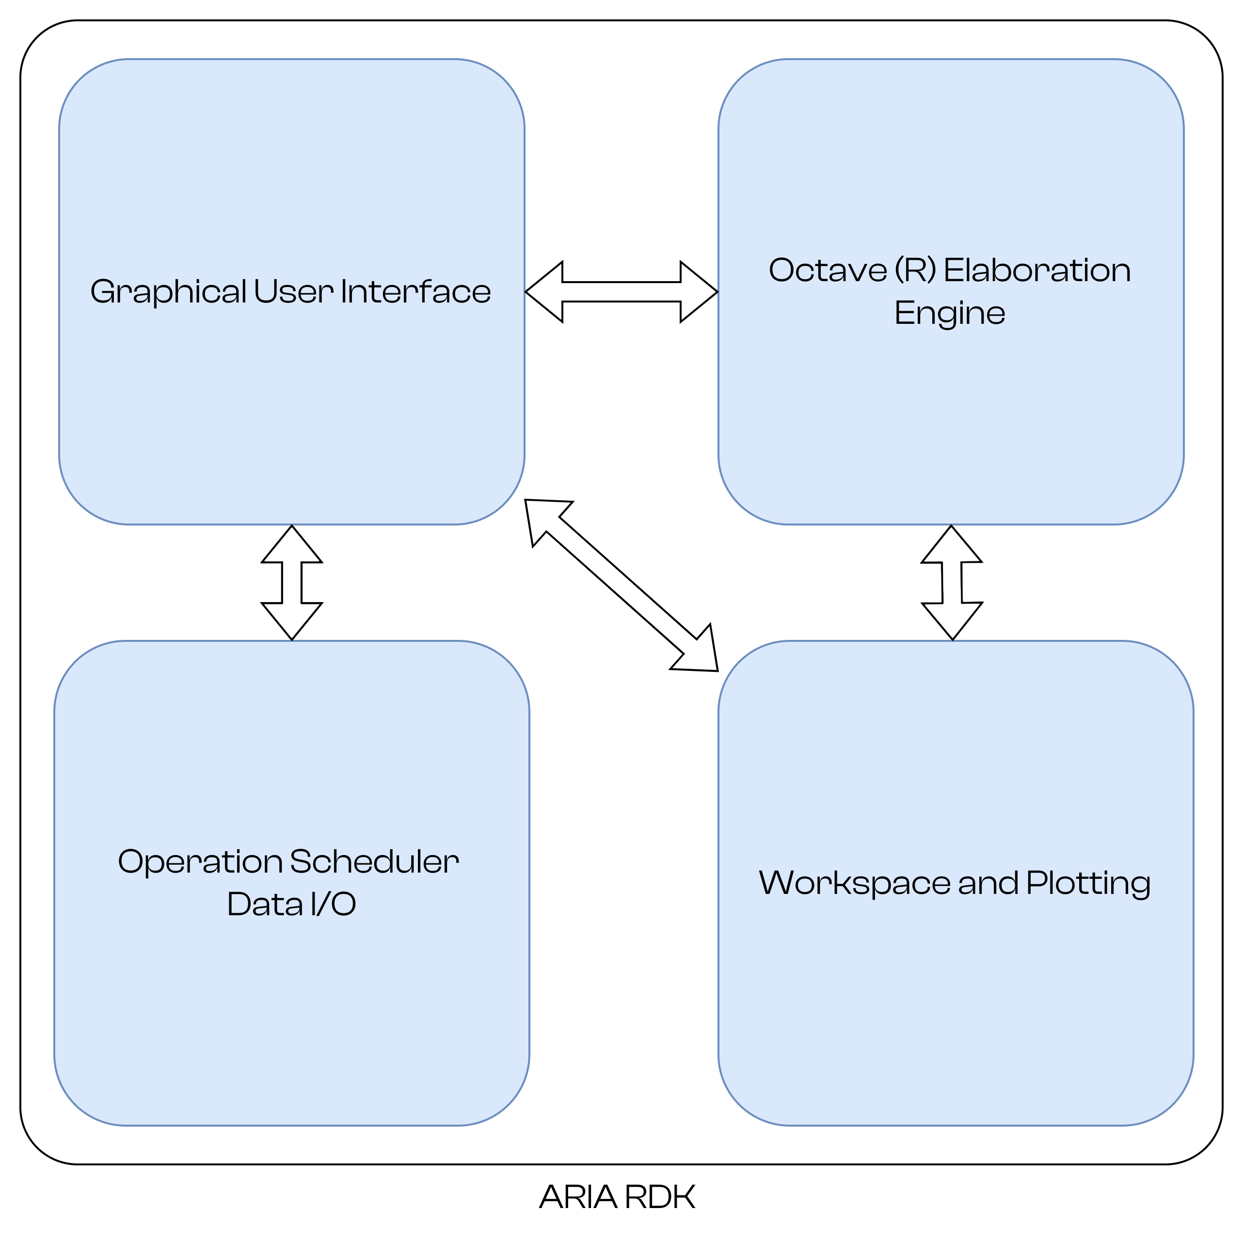Fig. 1: ARIA RDK Main Architecture
ARIA RDK includes four main components:
1. A Graphical User Interface (Windows and Linux) to create custom projects
2. An interface component to the Scientific Programming Language Octave to run custom algorithms on radar data
3. A Scheduler & Data I/O component to coordinate radar acquisitions and execute user scripts
4. A data workspace management and plotting component

Prerequisites
ARIA RDK requires the following components to be compiled and installed in your system:
- Qt6 (>= 6.7.2)
- VTK: The Visualization Toolkit (https://vtk.org/)
- JKQTPlotter: an extensive Qt5 & Qt6 Plotter Framework
(https://jkriege2.github.io/JKQtPlotter/index.html)
- Eigen: C++ template library for linear algebra (>= 3.4.0) (https://eigen.tuxfamily.org/)
- Octave (>=9.2.0): a scientific programming language environment
Please refer to respective build/install instruction.
ARIA-RDK is designed to be compiled with CMake®. Currently it has been compiled and tested under Clear Linux SO.

Building Instructions
The following instructions have been tested in Clear Linux SO, but it is expected full compatibility with other operating systems.

Qt
Install Qt through Qt-Creator self-installer program.

JKQTPlotter
- Download source code:
> git clone https://github.com/jkriege2/JKQtPlotter.git
> cd [folder where JKQTPlotter is downloaded]
> mkdir build
> cd build

- Start cmake-gui :
>cmake-gui ..

- Select the target compiler.
Start Configure and check that Qt6 is found:
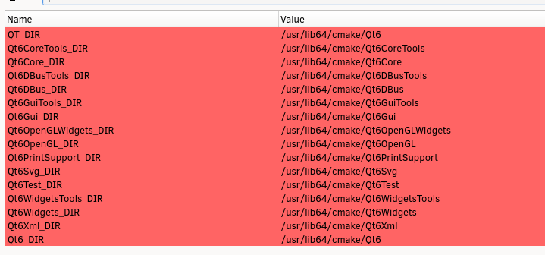
- Verify that “CMAKE_BUILD_TYPE” is set to “Release”
- Set a proper installation folder, the installation folder has to be part of, or included into, OS search path.
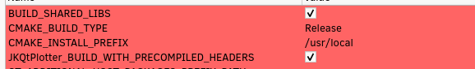

- Run Configure and Generate and build & install:
> cmake - - build .
> sudo cmake - - install .

NOTE: during compilation of ARIA-SDK, PrintSupport may not be found. In this case, the compilation is not successful.
To overcome this, check the following “JKQtPlotter_BUILD_FORCE_NO_PRINTER_SUPPORT”

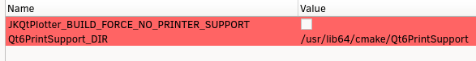

VTK
- Download source archive from https://vtk.org/download/.
- (Linux) Install the following packages
build-essential \
cmake-curses-gui \
mesa-common-dev \
mesa-utils \
freeglut3-dev \
- Create a folder (e.g. ~/VTK) and unarchive the source code.
- Enter the new folder and mdkir build folder. Enter build folder
> cd [folder where VTK source code folder is extracted]
> mkdir build
> cd build

- Run the configuration ccmake
> ccmake -S path_to_vtk_source -B path_to_vtk_source/VTK-build

- Verify / set the following parameters
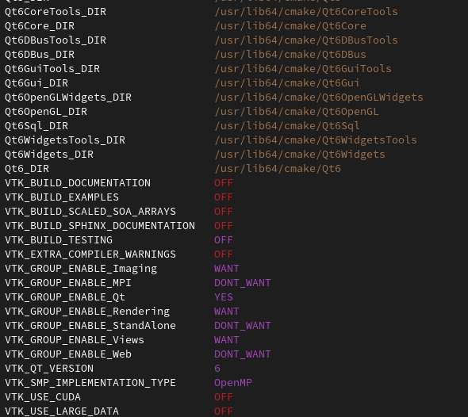
(NB Actual Qt paths may be different)
- Verify that the installation prefix is set to a folder included in the search path, e.g.
- Press c to configure and g to generate
- Go into VTK source folder
> cmake --build path_to_vtk_source/VTK-build
> sudo cmake - - install . path_to_vtk_source/VTK-build

Additional Notes
ARIA RDK require the Octave library and headers to be known and linked during build process.
The actual position of the Octave library and header files may change, depending on the installation path of Octave.
Before compiling, in the CmakeLists.txt the following lines must be updated with actual position of the library files (.dll in windows environment).
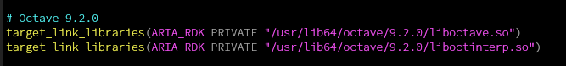While the header files folder must be update as well.
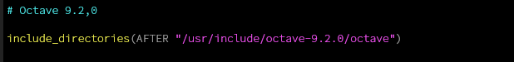

ARIA-RDK Main Concepts

Workspace
ARIA RDK introduces the concept of workspace, i.e. a folder structure where all the building blocks of a customer application project are defined.
A workspace contains the following elements:
- A set of radar modules definitions: a radar module is a description of one specific UWB module, with the firmware it runs, and its interface with the PC (Fig. 2);
- A set of elaboration scripts: a script is a set of instructions to run customer applications and algorithms. Currently ARIA-RDK support the Octave scientific-programming language;
- A set of radar devices: a device is a physical board attached to the PC. Each device must have its corresponding module definition properly loaded.
- One or more schedulers (handlers): one scheduler is responsible to synchronize more devices to run at the same time, to enable multi-radar acquisition.
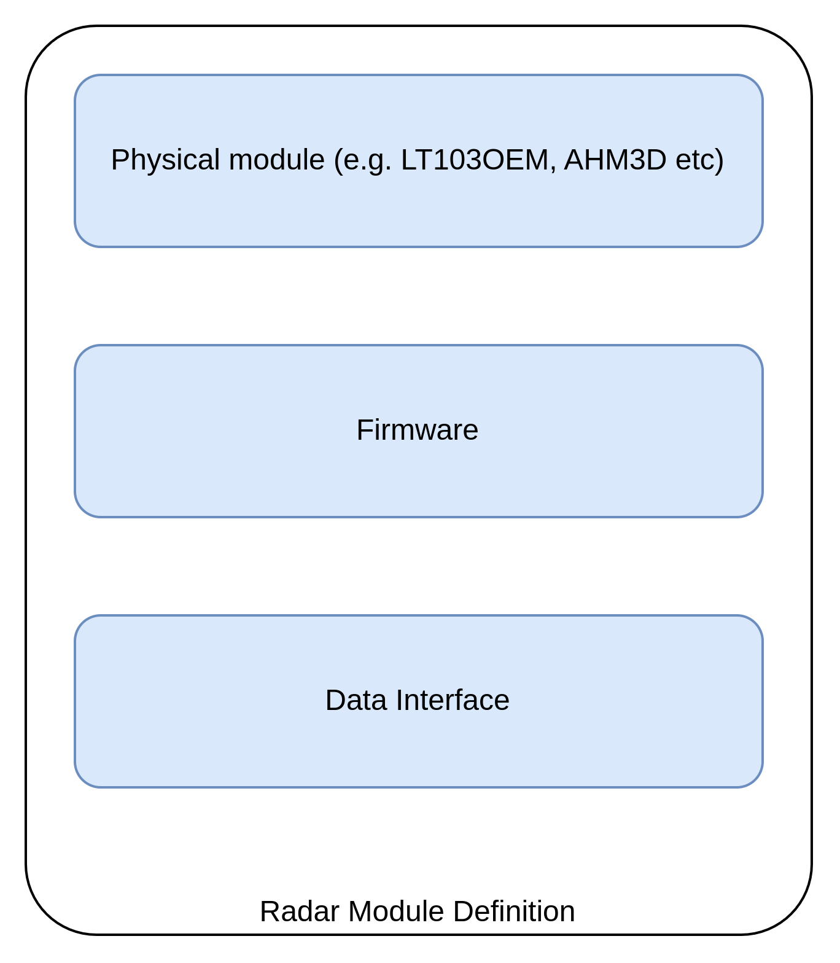Fig. 2: Radar Module Definition
These components are described in the following sections.

Radar Modules
One “radar module” is the definition of a peculiar family of radar devices. Each module is uniquely identified by the following data:
- Its name;
- A set of parameters which are the radar variables exposed to the PC. They vary according to the radar module and the installed FW. For instance, a module with “basic” FW would provide only the radar’s raw-data while the same module with a more advanced FW (e.g. to detect and locate people) would provide the results of the elaboration (e.g. the presence detection outcome and the position of the detected person); see chapter 5.4 for further details.
- Optional: the definition of the antenna array, with the antennas models and their position to evaluate the beamforming capability;
- The scripts that are to be executed at start-up, before and after each data acquisition;
- The configuration of the serial port.

Radar Devices
A radar device is the physical device connected to the PC. It is the logic representation of a physical device (Fig. 3).
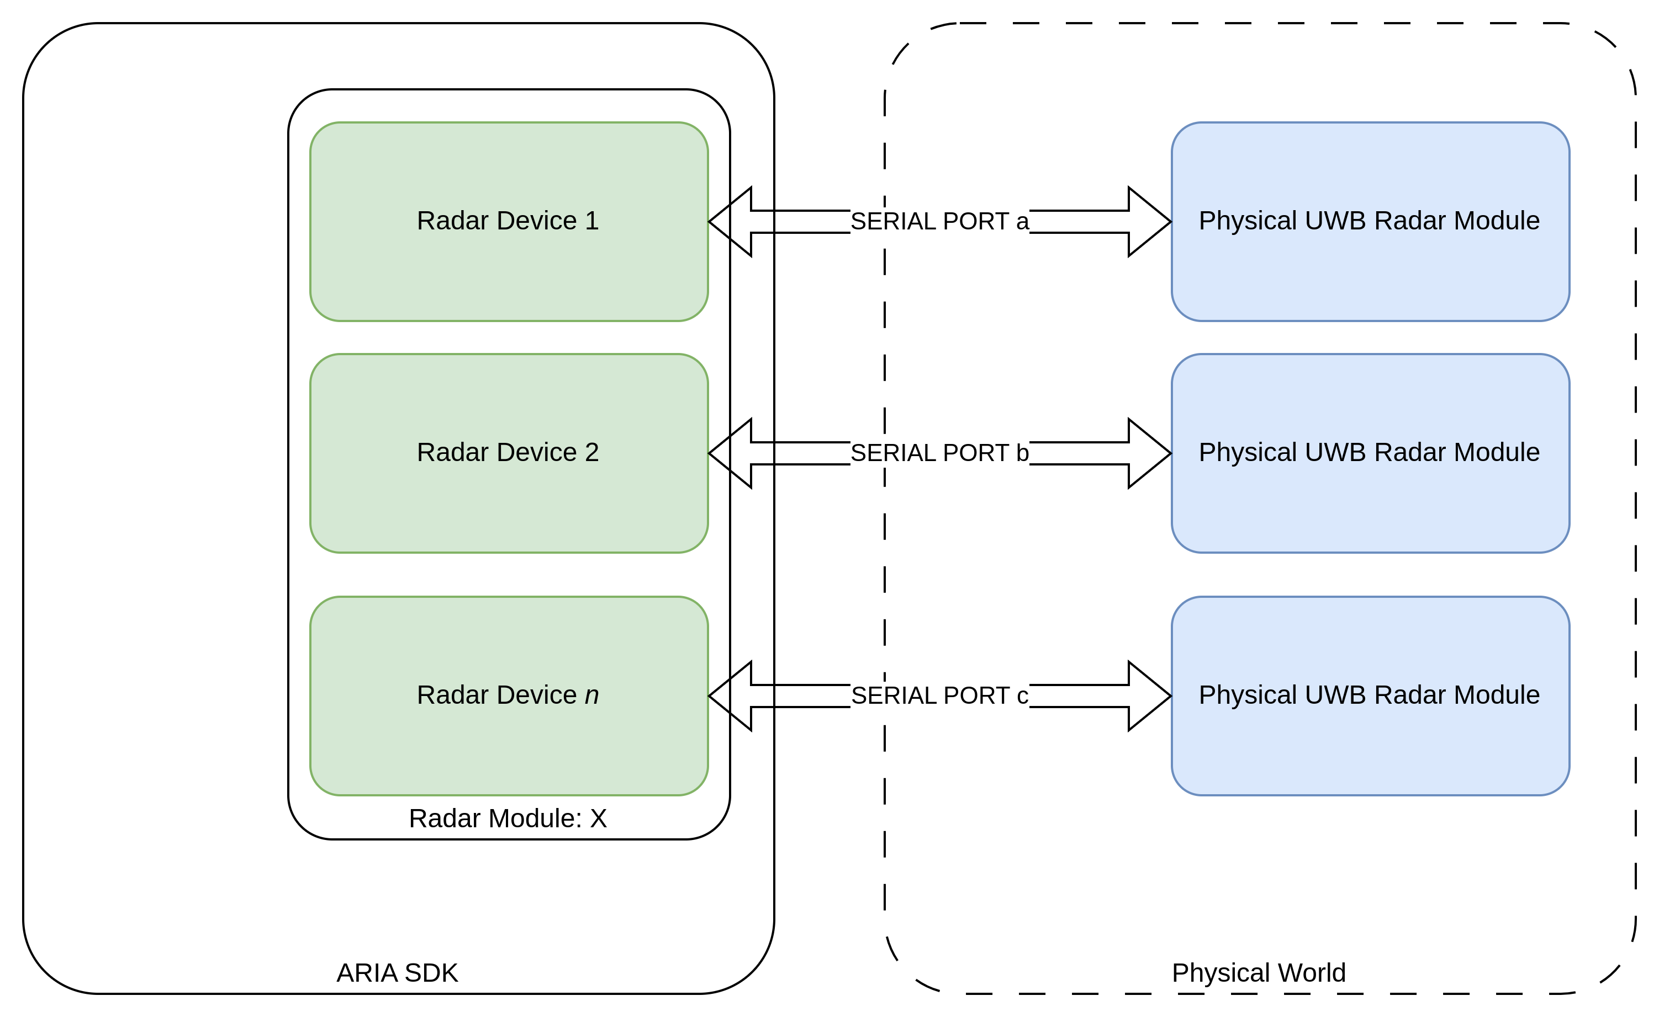Fig. 3: Logical and Physical Representation of Radar Devices
A radar device is defined by its radar module definition (from which the parameters are inherited) and a set of scripts that are executed
- at start-up (i.e. before the 1st acquisition cycle)
- before any acquisition cycle
- after any acquisition cycle
See below for details on radar acquisition cycles.

Radar Cycle
A radar cycle is made of 4 steps:
1. init phase: all initialization scripts and variables are set
2.pre-acquisition: all parameters that affect next acquisition are set
3. post-acquisition: this is where customer post-acquisition algorithms are expected
4. frame-rate synchronization
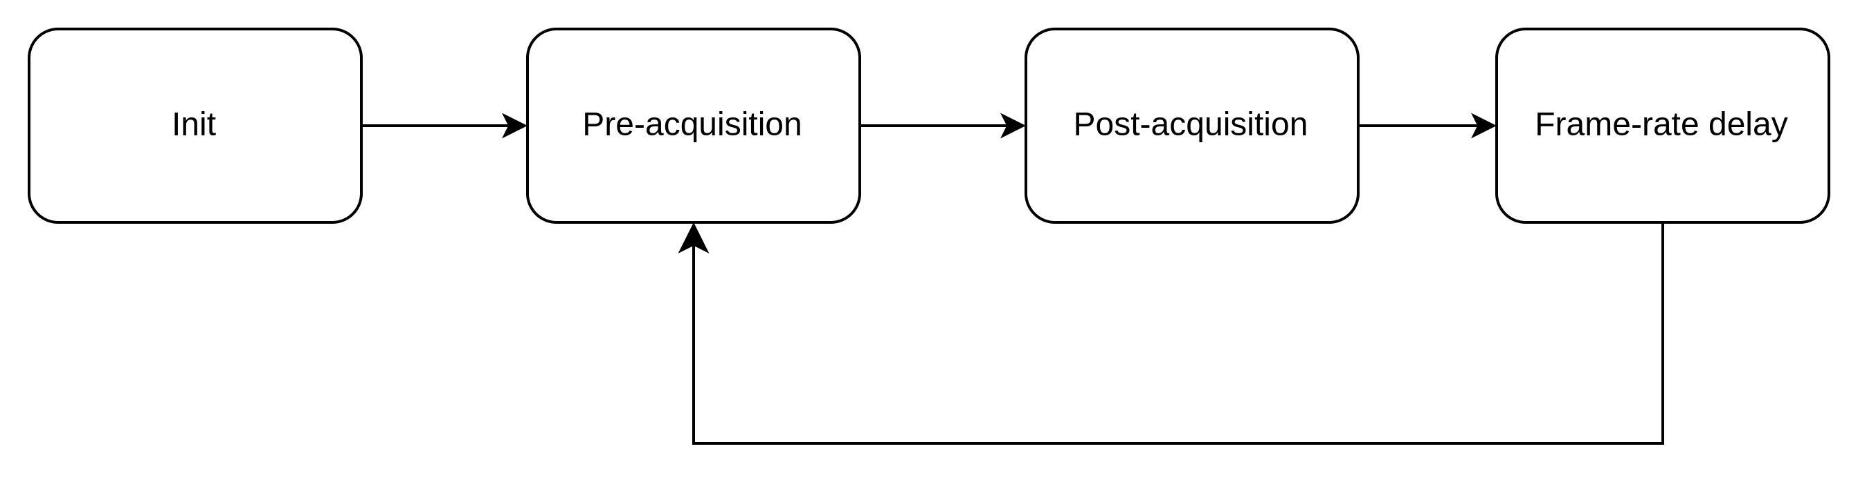Fig. 4: Basic Radar Cycle
In Fig. 4, the basic radar cycle is shown: after a setup phase (“init”), each acquisition cycle is made of a pre-acquisition phase where the selected scripts are executed and, then, the corresponding parameters are fed into the physical device. When the radar device is able to provide data to the PC and the transfer of the selected parameters is complete, another optional set of scripts is executed (post-acquisition). Please note that the proper acquisition is made by the firmware running into the physical device, so from the RDK perspective we have just two different “moments”: before starting an acquisition and after the acquisition has been completed.
If this process (pre-acquisition, acquisition, post-acquisition) is faster than the required refresh rate, a delay is added to maintain the required refresh-rate.
If, instead, the process is longer than the refresh-rate, the behavior of the system is defined into the scheduler options. See Schedulers for further details.

Policy during init, pre_acquisition and post_acquisition
All phases are further split in 3 different steps:
1. Inquiry of output params and
2. Execution of the scripts related to
3. Update of the params that are Input, I/O and that are modified by Octave

Radar Flow of Operations

Parameter Update
When a parameter is updated, the new value is sent through the serial port to the physical device. It may happen that the actual value stored inside the physical radar differs slightly from

Parameters
A parameter is a variable that is exposed from the physical device / firmware. ARIA RDK can therefore inquiry for actual value(s) of a parameter, or set its desired value(s).
Basically, each device parameter in ARIA-RDK corresponds to an internal variable in the corresponding radar boards.
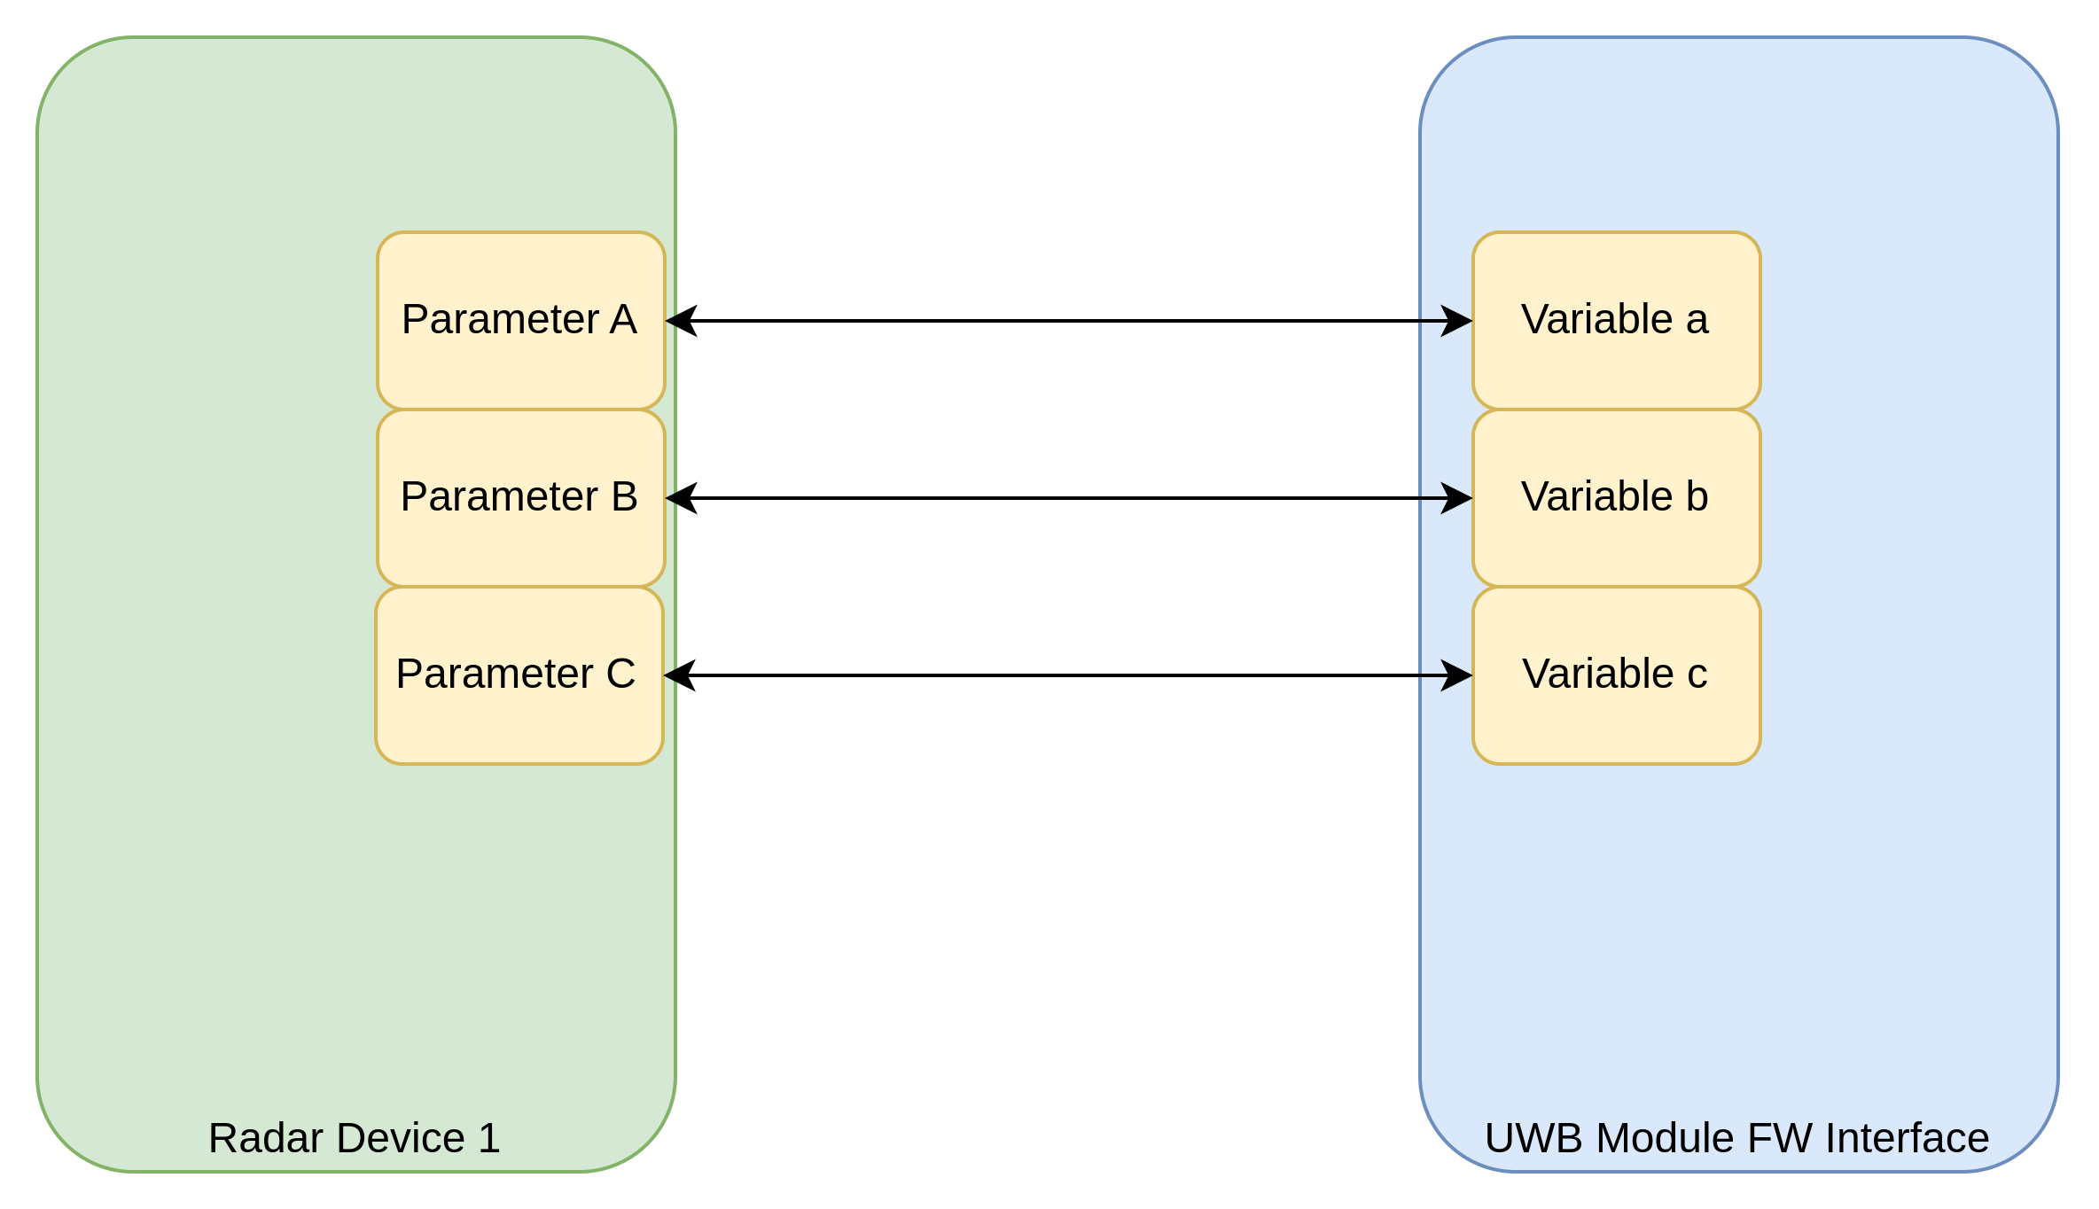Fig. 5: Parameters and link to physical module's FW variables

Name
Each parameter is defined by a unique, non empty name.

Value
The value of the parameter is the copy of the value of the corresponding variable in the FW of a radar device; clearly, a parameter (and its value) is meaningful only if it is exposed from the radar firmware. Different variables may have different value types. Consequently, the associated parameter defined in ARIA-SDK must contain this information to guarantee proper data transfer/interpretation.
Parameters’ values may be of different types, these types are enlisted as follows:
 | Description | Data size (bytes)
void | Parameter without data.  This kind of parameters are, in fact, pure commands | 0
int8,uint8 | 8-bit integer (unsigned) value or vector | 1 * number of elements
int16,uint16 | 16-bit integer (unsigned) value or vector | 2 * number of elements
int32,uint32 | 32-bit integer (unsigned) value or vector | 4 * number of elements
float | 32-bit float value or vector | 4 * number of elements
char | String or single char | 1 * number of elements
enum | Set of available uint8 values with a string descriptor | 1 * number of elements

Any parameter (except the “void” case) can be a single value or an array. In case of an enum parameter, a parameter value belongs to a set of valid values. Each valid value is described by a unique string. Each element of the valid set is a pair <int8_t, string> where the first part (int8_t field) is the data effectively passed to/from the physical device. The second part (string field) is just a descriptor of the corresponding value.
As an example, the TX POWER of the LT102V2 can have one of the following values:
Value | Descriptor
0x00 | TX POWER OFF
0x01 | TX LOW POWER
0x02 | TX MID POWER
0x03 | TX HIGH POWER

ARIA UWB Radar Devices share a common protocol where the radar physical device returns the actual value of a parameter as part of the “command acknowledge” return packet. Basically, when setting the value of a parameter, the radar physical device returns the same command with the value of the corresponding variable after the modification has taken place.
This has a dual objective:
1. It may be used as a confirmation message that the transfer has been successfully interpreted by the radar device
2. Some variables are modified in the radar device according to the desired value but the final value may be different from the desired one for different reasons: for instance, when setting the desired maximum range the LT102V2 rounds the actual value to the closest round-trip distance, sampled according to the sampling speed. With this return value one can check how a device responds to a variable modification request.

Transfer Direction
A parameter may be defined as:
- Input parameter: the value is set only by the ARIA-SDK.
- Input/Output parameters: values can be defined either by the SDK or by the radar device
- Output parameter: values can be defined only by the physical device. The straightforward example is the current radar raw-data. These parameters do not have a value to be attached to the command sent from the ARIA-RDK to the device. Moreover, they don’t have an inquiry value.

Valid values
Each parameter (aside from VOID, which has no value associated, and from enum type) value can optionally be limited by:
1. a valid min-max interval (a value is valid if and only if it is greater than or equal to the min value and lower than or equal to the max value)
2. a set of valid values (actual value is valid if and only if it belong to said set)

Command String
This is the string that is sent to the physical device through the serial port for parameters inquiry / update.

Inquiry Value
Ideally, when a variable’s value is modified by the FW running in a physical module, the corresponding parameter in ARIA-SDK should reflect the actual value.
To reduce the number of transfers over the serial port, ARIA-SDK is responsible for asking the actual value of a parameter, when needed.
To interrogate the actual value of a variable, the corresponding parameter is provided with a “special value”. This peculiar value is called the “Inquiry Value”. When sending the “inquiry-value” to the radar physical device, the latter does not change the variable corresponding to the parameter. Instead, it returns the actual value of the internal variable.

Command String
This is the string sent along with the payload (either the set-value or the inquiry-value) to allow the radar physical device to identify which parameter/variable is involved in the transfer.

Grouped Values
Some parameters are grouped in several sub-parameters and transferred at once at every single command.
For instance the radar version for LT102V2 is defined by 3 fields which are handled as 3 different parameters
- Version (reserved) [uint16]
- Version_hw_id [uint16] which is a word describing the HW board
- Version_fw_id [uint32] which is a word describing the FW identifier

Data Workspace
The data workspace is a set of variables that can be read from the radar devices, or modified / create during scripts execution.
It also provides a seamless link between a radar device, and its parameters and the scripts that are executed by the RDK itself.

Scripts
A script is a set of instructions to be performed on radar or application data. The underlying elaboration tool and interface is Octave (https://octave.org/)
ARIA-RDK provide an active link to/from the Octave interpreter; this allows for great flexibility in algorithms description / prototyping.

Antennas
The ARIA-RDK allows to handle antenna radiations properties. In UWB systems, antennas may be as important as the front-end: differences in group delay over azimuth and elevation should be taken into account when evaluating complete UWB systems. For this reason, ARIA-RDK is able to read FFIO files exported from EM-simulation tools.
FFIO files contains information about electric field, in the Theta, Phi polar representation, radiated from an antenna, at a reference distance of 1m to the antenna.

Getting Started
Once ARIA-RDK is properly installed, it starts with an empty environment (Fig. 6). The on the right part of the main windows, the Octave Interface window is shown.
Fig. 6: RDK Appearance at Start-up

Octave Interface
The “octave interface” window is the window to write/load/save and execute scripts, plot variables, execute prompt-commands.
NOTE: as of release 0.1. no “debug” function is available during scripts execution.
With a link to the versatile Octave engine, a user can exploit also different packages/toolboxes to perform different tasks, from data processing to advanced applications.
On the right side of the “octave interface”, a table (Workspace in Fig. 6) containing all variables is shown.

Workspace
The workspace section contains all the variables that are part of the current project. These variables may be created / updated by an Octave script or can be the

Scripts
Scripts are “m” files that can be interpreted / executed by the linked Octave library.

Create/open a new script
From the Octave interface window, click respectively New Script or Open Script on the top-left corner of the Octave Window (Fig. 7).
Fig. 7: Create or Open a script

Run a script
Once a script is available, it can be run simply by pressing the “Run” Button (Fig. 8). The workspace is updated immediately after the script execution.
Fig. 8: Script execution

Prompt commands
In the bottom line of the Octave Interface Window, users can type any octave command to be executed immediately. Once the command is done, the workspace is updated immediately.
NOTE: contrary to normal Octave interface, “executing” a variable name do not display its value in the output window. To print out the content of variable, type
var_name = var_name [ENTER]
In the example below: ts is a single double value (ts = 5e-12), to print it out, in the command prompt ts = ts command is issued.
Fig. 9: Command to print-out the variable ts

Plots
The ARIA-RDK provides a set of plots:
- Line Plot
- Scatter Plot
- Box Plot
- Area Plot
- Bar Plot
- Density Plot
- Arrow Plot
- 2D Vector field (e.g. quiver).

Line Plot
Line plot is a plot where a set of (X,Y) data is represented. A segment is added between each consecutive (X,Y) pairs. If no X data is given, X is assumed being an integer from 0 to N-1 where N is the number of samples of Y vector.

Create a Line Plot
To create a Line Plot, select one or more variables in the workspace table.
Right-click and a pop-up menù will appear. Select plot and one of the following voices:
- new plot (each curve into own plot)
- new plot (all data into the same plot)
- new plot (x,y1,.. . . , yn)
When “new plot (each curve into own plot)” is clicked upon, each variable is associated with Y values of the plot, and X data is created as vector of values in the [0..N-1] range, where N is the number of samples of the corresponding Y vector. Each set of data is plotted into a single dedicated plot.
For example, if the following script is executed:
% Create a simple sin signal in time domain

ts = 5e-12;
tmax = 1e-9;
t = 0:ts:tmax-ts;
fc = 7e9;

out = sin(2*pi*fc*t);
o2 = 5*cos(3*pi*fc*t);

When selecting “o2” and “out” from the workspace table, the following plot is produced (Fig. 10).
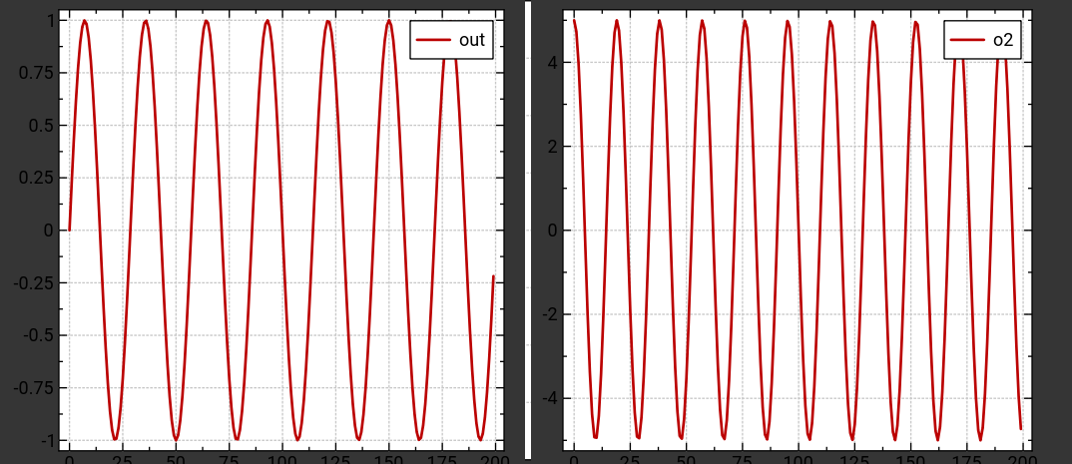Fig. 10: new plot (each curve into own plot)
When “new plot (all data into the same plot)” is clicked upon, each variable is associated with Y values of the plot, and X data is created as vector of values in the [0..N-1] range, where N is the number of samples of the corresponding Y vector. Plotting the example above:
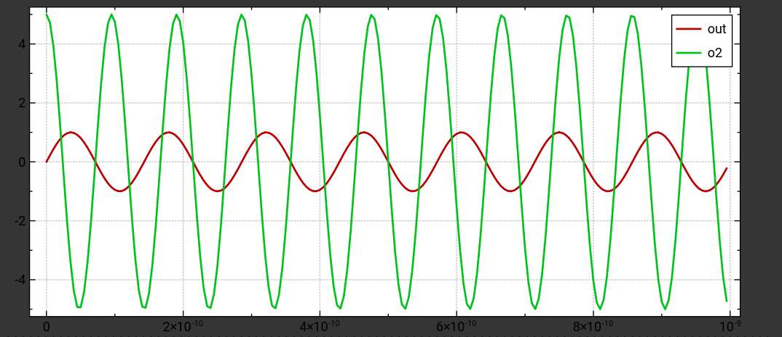Fig. 11: new plot (all data into the same plot)
When selecting new plot (x,y1,.. . . , yn) the first variable selected is associated with X-values, each other vector is associated with Y values. In this case all vector must have the same number of values.
Note: X data does not to be monotonic.
(e.g. when selecting o2 and then out , the following plot is created - Fig. 12).
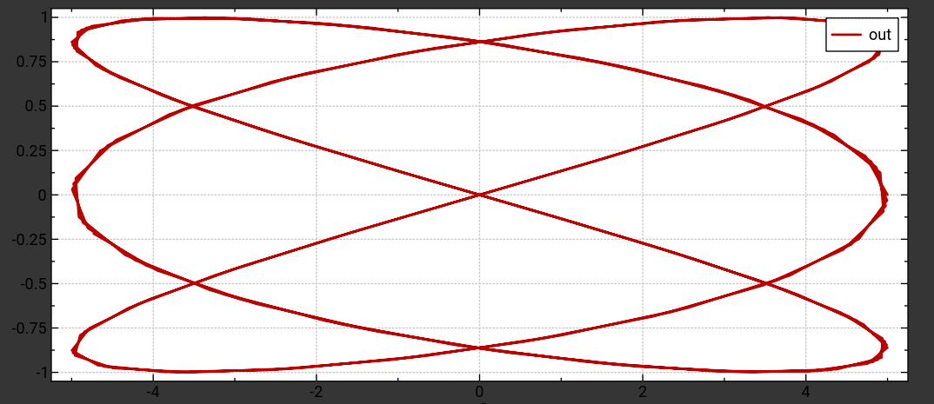Fig. 12: new plot (x,y1,.. . . , yn)
If one of the selected variables is a matrix, then a curve is created per each column or row of the matrix. The current selection (rows / columns major) is done according to the following policies:
1. if no X data is given, the selection is done in order to minimize the number of curves: e.g. if a matrix is sized 200 rows, 2 columns, one plot is created per each column. If a matrix is sized 2 rows, 200 columns, one plot is created per each row.
If, instead, X data is given, one of the two dimensions of the matrix must coincide with the length of X data.

Scatter plot
Scatter plot is identical to the Line Plot (see 9.5.1) except for the fact that points are not connected by a line segment but a symbol is drawn over each (X,Y) pair.
The above example is re-plotted in the next pictures
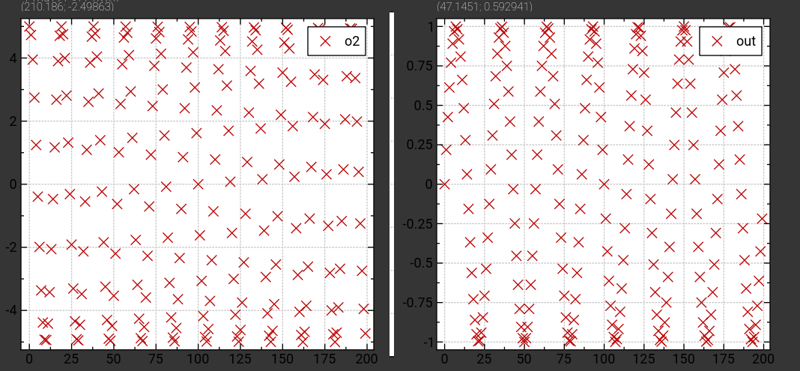Fig. 13: new scatter plot (each curve into own plot)
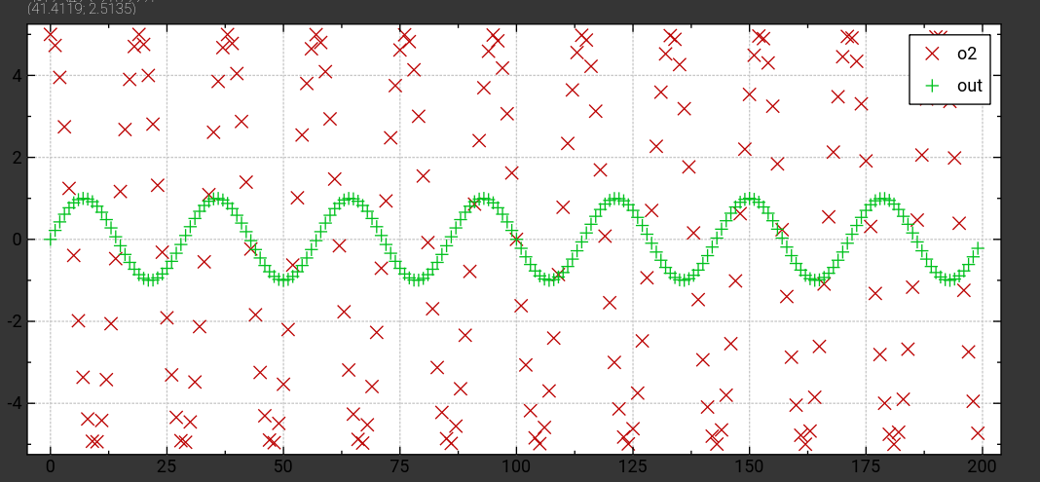Fig. 14: new scatter plot (all data into the same plot)
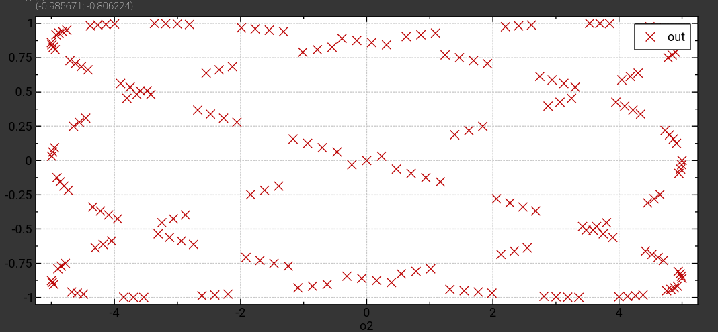Fig. 15: new scatter plot (x,y1,.. . . , yn)

Box-plot
Given a vector, the box-plot shows the statistical summary of the data contained (Fig. 16):
- Mean value: it is represented by a small cross
- Median: it is represented by the continuous line in between the main box
- First Quartile (Q25): it is the lowest boundary of the main box
- Third Quartile (Q75): it is the uppest boundary of the main box
- Max Value: it is the highest value in the input data lower than Q75+1.5 * IQR
- Min Value: it is the lowest value in the input data higher than Q25-1.5 * IQR
(IQR is the Inter-Quartile Range: Q75-Q25)
- Outliers: all values greater than Q75+1.5 * IQR or lower than Q25 – 1.5 * IQR
Fig. 16: Box-plot description

Area Plot
Area plot is similar to Scatter and Line Plots. A filled area is drawn from line Y=0 to each Y value.
The previous example is plot as follows
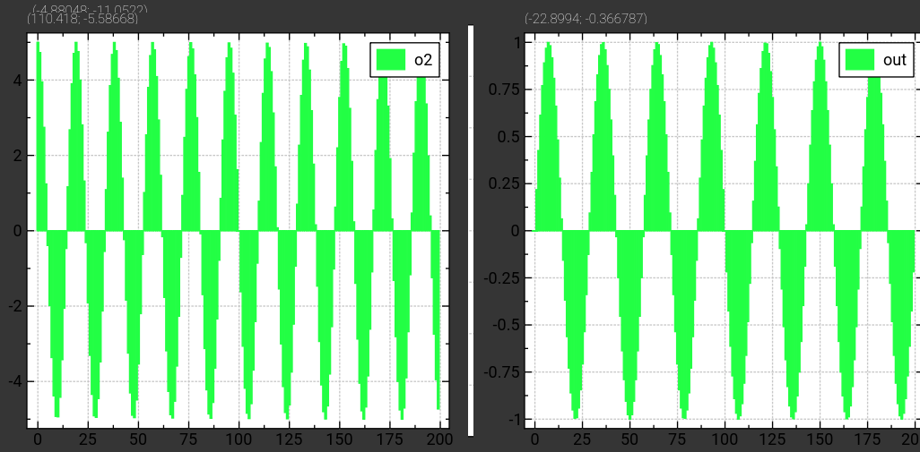Fig. 17: Area Plot

Arrow plot
Similar to the above plots, an arrow is drawn from the (X,Y=0) reference axis to the (X,Y) point. The above example is shown in Fig. 18.
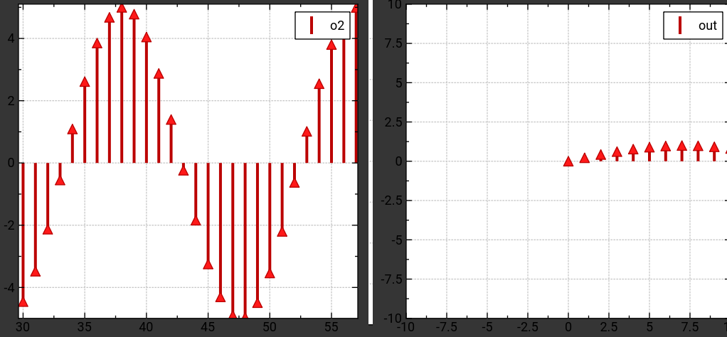Fig. 18: new arrow plot (each curve into own plot)

Density Plot
This is a 2D plot where a matrix is represented with a 2D density plot, adjusted to the data range.
In the example below the output Density plot is shown,
x = 0:1e-2:1;
y = 0:1e-2:1;
[xx,yy] = meshgrid(x,y);
z = cos(xx * 2* pi) + sin(yy*6*pi);

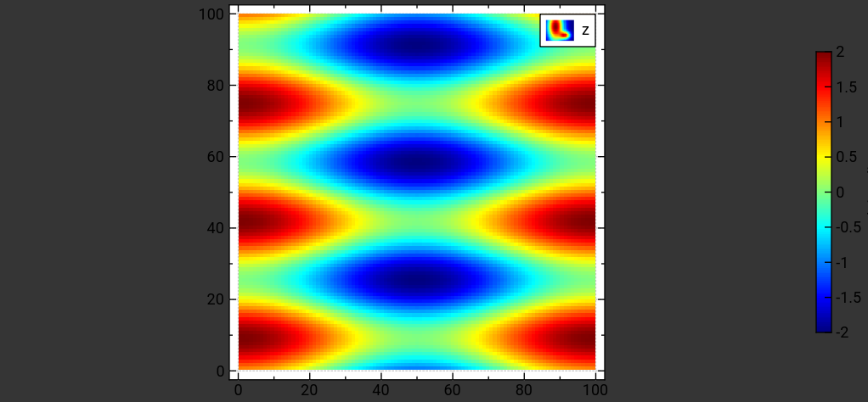Fig. 19: Density plot example

2D Vector Field
The vector field (also known as quiver) is the representation of a 2D vector field. Input data is made of two matrices (they must obviously be the same size). The first one is the x- component of the field, the second one is the y- component of the field.
As an example, the following code
x = 0:3e-2:1;
y = 0:3e-2:1;
[xx,yy] = meshgrid(x,y);
e_x = cos(xx * 2* pi);
e_y = sin(yy*6*pi);
produces the following plot (e_x, e_y)

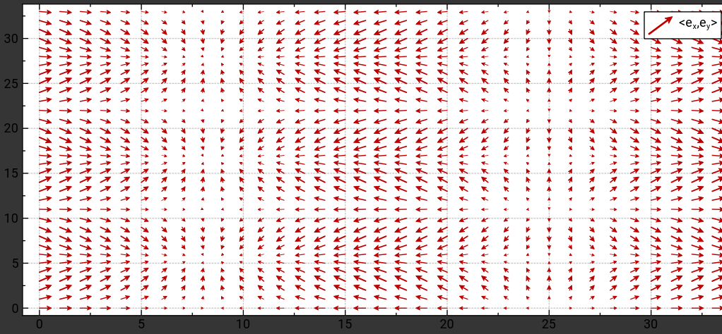Fig. 20: 2D Vector Field

Data Update
Every time a variable is updated, any plot referring to the variable is updated in real-time.

Projects

Project structure
A project is contained in a folder and it’s based on a defined folder tree (Fig. 21)
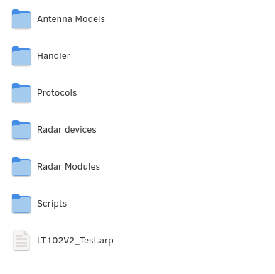Fig. 21: Project Structure
The project folder needs one file arp (ARIA Radar Project) which is an XML file containing all the information of the different elements belonging to the project. This is the project main file.
The project’s folders are:
- Antenna Models: in this folder there are all antenna model files owned by project’s radar modules
- Handler: in this folder there are all device scheduler files
- Protocols: for future releases
- Radar Devices: contains all the device definitions. These are the devices connected to the RDK and used by the projects
- Radar Modules: contains all the radar modules description files.
- Scripts: contains all the scripts used by the projects

Create a new project
Click on Main window’s menù “Project”, “New”.
A file dialog appears, asking for the project main-file name.
The extension “arp” is added to the file, if not given or a different extension is provided.
NOTE: a folder with the main-file name (without any extension) is created and the main file is created in said folder.
In the same folder, the sub-folder structure is initialized.

Open an existing project
Click on Main window’s menu “Project”, “Open” and select a valid project main file.

Save a project
Click on Main window’s menu “Project”, “Save”.

Close a project
Click on Main window’s menu “Project”, “Close”.

Copying / Importing a new project
A project can be easily exported simply by copying the main files and all the project folders (along with their content) into the desired destination.

Radar Modules
Radar Modules definitions are stored in the “Radar Modules” folder of the project. Each module definition is stored in a file with extension “arm” (ARIA Radar Module) which is an XML description of the module properties.

Create a new radar module
Once a project is open, it is possible to create radar modules definitions from scratch.
Click on main window menu “Radar Devices and Modules”, “Radar Modules”, “New Radar Module”.
The radar module editing window will appear (see paragraph 9.7.4).

Import an existing radar module
Once a project is open, it is possible to import radar modules definitions.
Click on main window menu “Radar Devices and Modules”, “Radar Modules”, “Import Radar Module”.
An open-file-dialog will pop-up; select a valid radar module file.
NOTE: when importing an existing radar module, if its scrips or its antennas are not present into the project, they will be reset.

Edit a radar module
To edit a radar module from the project tree, double click on its name. The radar module editing window will appear (see paragraph 9.7.4).

Radar Modules Editing Window
The radar modules editing window is shown in Fig. 22.
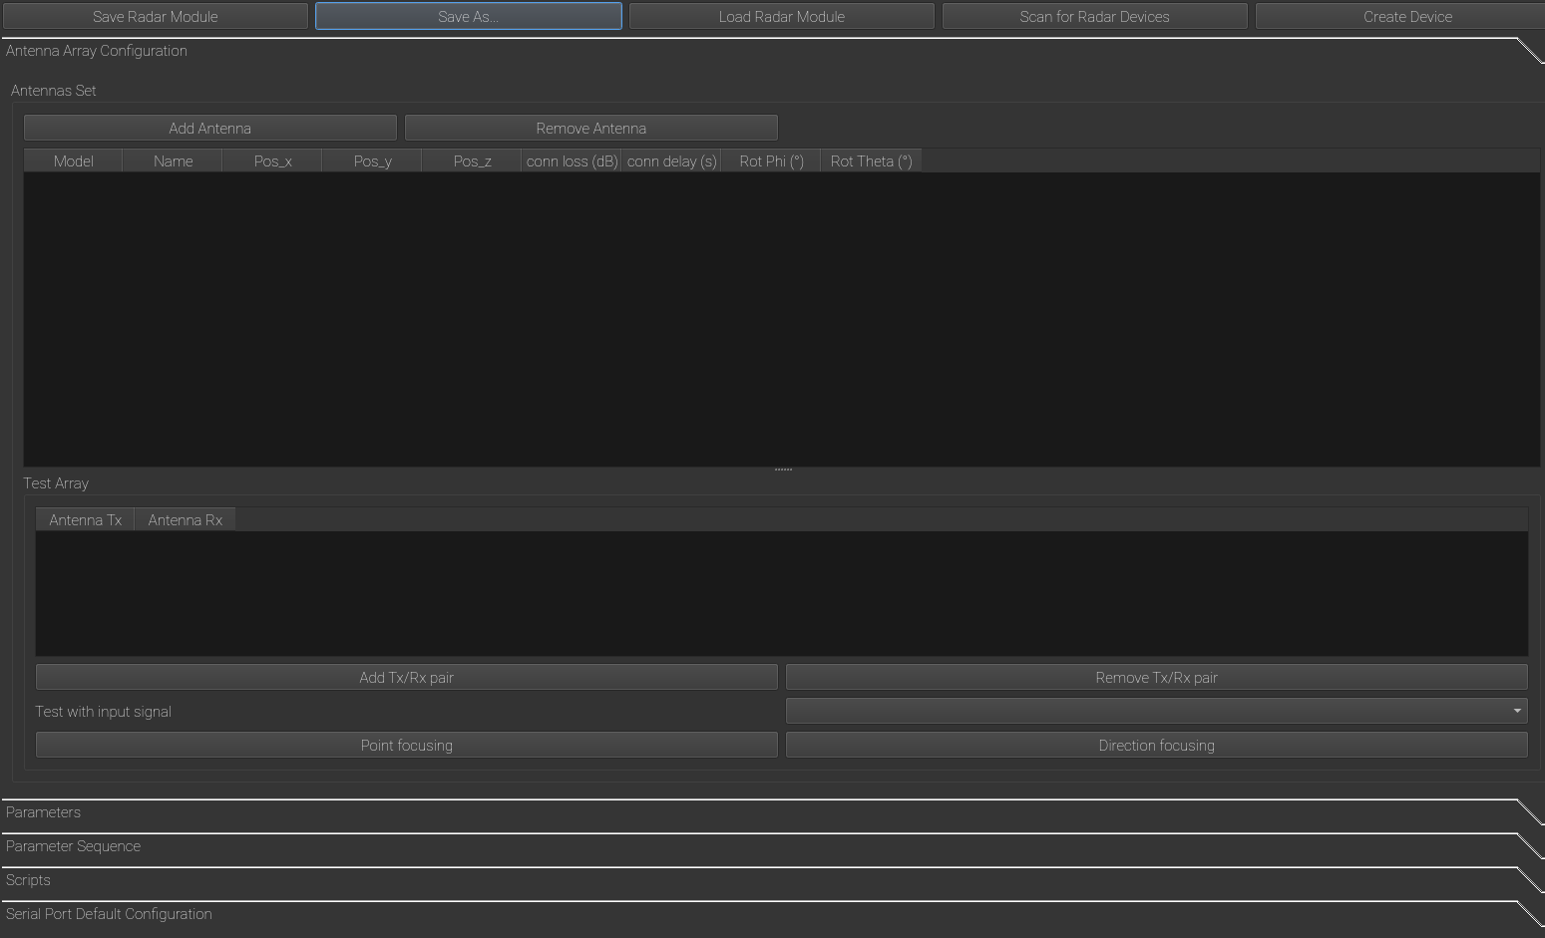Fig. 22: Radar Modules editing window
This window is made of 5 different tabs, to edit the different properties of a radar module:
- antennas set
- parameters
- parameter sequence
- scripts
- serial port default configuration

Defining antennas
In the “Antennas Set” tab it is possible to define the array of actual antennas, with their position on the board module. This allows for further evaluation of radar properties and for preliminary evaluation of the performance of a radar module, in terms of focusing capabilities.
To define an array add as many antennas as needed.
Each antenna of the array may be associated to an antenna dataset (Paragraph 8); in case the antenna model is not given, no further assumption is made and the antenna is internally marked as “no data”.
Each antenna must be given a unique name and its position. This is needed to calculate “direction focusing” properties,: i.e. the radar beam obtained combining all the antennas with relative phase-shift calculated to focus the beam over a desired azimuth / elevation angle.
It is not mandatory to define antennas but this function may be useful for prior evaluation of custom arrays.
When a new antenna is added, it is possible to declare its reference radiation dataset, by clicking on the first field of the newly created row (Fig. 23).
Fig. 23: Antenna model selection
When clicked, the list of available antennas is shown. It is possible to load a new one, or leave “no module”. When “no module” (default option) no information is available for the current antenna.
If a set of antennas is defined, it is possible to declare the combinations that are excited during beam-forming: these are expressed as a set of Tx, Rx antennas pairs.
In each pair, Tx and Rx antennas may also be the same antenna (monostatic) or different (bistatic).
NOTE: before editing the array of Tx/Rx antennas combinations, the antenna arrays must be defined entirely; save the radar module before editing the array.
When a set of Tx/Rx pairs is defined, it is possible to evaluate it’s array properties, by clicking on “Direction Focusing”. The underlying model is the Phased-Array: different antennas are fed with properly phase-shifted tones, so that the beam is focused onto a desired azimuth, elevation angle.
For UWB-Time Domain calculations, refer to the uwb-toolbox documentation (Paragraph 12.2).

Definining parameters
To define the different parameters of a radar module, open the “Parameters” tag.

Defining parameters sequence

Defining scripts

Defining serial port

Radar Devices

Create a new radar device object

Scan for devices

Delete a radar device

Scheduler

Antennas

Advanced Capabilities

C/C++ scripts

UWB-Toolbox

Octave / Hydrogen Compilation

License
ARIA-RDK is distributed with a LGPL-3.0 License.
ARIA-RDK can be is distributed for the evaluation of algorithms based on ARIA UWB Radars SoCs and Modules. It can be used freely, but WITHOUT ANY WARRANTY; without even the implied warranty of FITNESS FOR A PARTICULAR PURPOSE.

