SmartCare v0.3 - Domain Model Workbook
Week 6 student resource

Requirement-to-Concept Trace
Requirement | Concept | State/behavior | Decision
FR-01 Register Patient | Patient | Patient id, name, validity | Patient class
FR-02 Find Patient | Patient | identity used for lookup | Lookup later, coordinated outside entity
FR-03 Register Practitioner | Practitioner | Practitioner id, name, specialty | Practitioner class
FR-04 Create Appointment | Appointment, Patient, Practitioner | Appointment id, date, time, initial status | Appointment class, associates Patient + Practitioner
FR-05 Prevent conflict | Practitioner | Compare active practitioner/time bookings | Workflow/service responsibility later
FR-06 Cancel Appointment | Appointment | cancel / state transition | Appointment owns its legal state change
FR-07 Retain history | Appointment | Cancelled status retained | Do not model cancellation as deletion
FR-08 Find Appointment | Appointment | Appointment id lookup | Repository/service later
FR-09 List practitioner appointments | Appointment, Practitioner | association supports query | Zero to many * relationship
FR-10 Persist records | Patient, Practitioner, Appointment | durability | Infrastructure concern, not a domain class

CRC Cards

Patient
Responsibilities | Collaborators
Know patient id and name, protect basic patient-specific validity. | Appointment
Provide patient identity to appointment workflows. | Appointment

Practitioner
Responsibilities | Collaborators
Know practitioner id, name and specialty. | Appointment
Represent the practitioner involved in scheduling. | Appointment

Appointment
Responsibilities | Collaborators
Know appointment id, patient, practitioner, date, time and status. | Patient, Practitioner
Protect appointment state, aid with cancellation. | Patient, Practitioner

Optional class
Responsibilities | Collaborators
AppointmentService considered for conflict-checking, deferred as a later workflow/service responsibility, not a domain class

UML Class Diagram

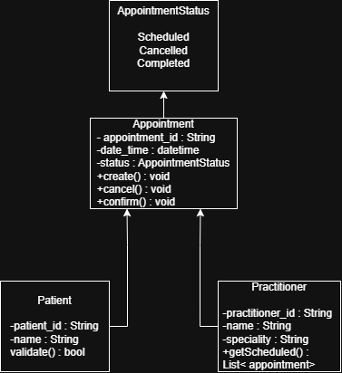
AppointmentStatus = (SCHEDULED, CANCELLED, COMPLETED)
Multiplicity:
- Patient 1 <-> 0..* Appointment
- Practitioner 1 <-> 0..* Appointment
- Each Appointment references exactly one Patient and one Practitioner

Design Rationale
The classes Patient, Practitioner and Appointment are selected due to the fact that each of them has its own Identity, State and requirement-traceable behavior. The classes Name, Status and Cancellation are not selected as classes because these are just single values without any independent identity, therefore these become attributes or operations on the class which owns them. The Clinic remains optional and Database class is rejected because this is infrastructure class rather than domain class.

The class Appointment has the 1-0..* association (and not composition) with both Patient and Practitioner as these have their existence even outside of a particular appointment and cancellation of an appointment should not lead to destruction of either of these two. There has been no inheritance introduced here; as the shared feature in Patient and Practitioner class is just the name field and canceling an appointment does not represent a new kind of appointment, just a change of its state.

AI Design Review Record
AI suggestion | Evidence | Decision | Reason | Model change
Add an AppointmentManager class to handle all appointment logic | Partial, FR-01/  FR-03 describes the behavior, but nothing requires a separate manager | Rejected | Behavior can live on Appointment itself; a manager adds indirection with no requirement calling for it | None
Give Practitioner a checkConflict(time) method | Partial, FR-04 requires conflict prevention, but conflict-checking spans multiple appointments | Modified | Conflict logic can't live on a single Practitioner object; deferred to a future AppointmentService | None added to Practitioner; noted as future service
Add a NotificationManager for email/SMS confirmations | None, not mentioned anywhere in the brief or v0.2 | Rejected | FR-11 only requires an on-screen confirmation; this is scope creep | None
Model Cancellation as its own class | Partial, brief mentions inconsistent status, but no cancellation-reason requirement | Modified | A status attribute on Appointment is enough; no need to invent fields the client never asked for | Added status: AppointmentStatus + cancel() to Appointment
Add a Clinic class owning all Practitioners/Appointments | None, single-clinic system implied throughout v0.2 | Rejected | No requirement distinguishes between clinics | None

