Solar System UI Reference Document

Written on 8/17/2023 by Shane Bennett ([srb@vt.edu](mailto:srb@vt.edu))

# UI Basics

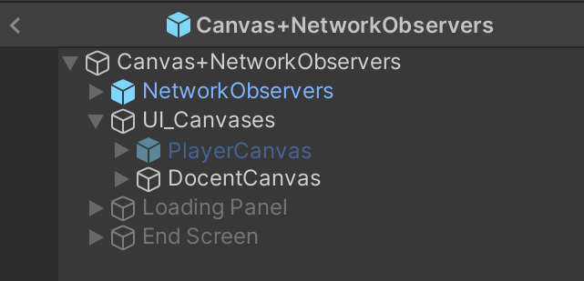All of the UI for the tablets are in a master Prefab, currently titled ***Canvas+NetworkObservers***. This prefab handles a lot of the consistency between the various scenes, and is present in all of them. Network Observers is a prefab within that contains the bulk of the Network Setup, and is present in the same prefab in order to have the Docent Canvas more development to be more consistent and trivial to reference the various network setups.

Within this Prefab, there is an empty game object titled ***UI_Canvases***. This object is pivotal in the assignment of the network assigning the canvases to the players, so don’t change the name without considering that! Other than UI_Canvases, there are the assets for the Loading Screen and End Screens. The Loading screen is enabled in ***ViewTypeObserver***, and is called every time the system attempts to change the scenes. The End Screen is enabled by the Docent when they press the “End Simulation” button.

# Docent Canvas

Within the DocentCanvas object, there are 3 primary functions, ***Settings, SceneChangers,*** and the ***Script****.* ***Height/Speed*** were intended features for changing the height of the room, and the speed of motion, but were never implemented.

Within the ***UI_Assets folder,***there are a couple of things to note. There are two Fonts, ***ButtonFont and TextFont*** are for the buttons and the Script, respectively. Additionally, many of the assets are .SVGs, but this is incompatible for anything that uses the Unity.UI Toggle feature, so I had to rasterize each of those (which is why there are several duplicates.)

# Settings

The first feature I’ll talk about is Settings, which are all of the buttons on the lefthand side of the Docent Screen. ***Setting Toggle*** is a button that toggles whether or not to display ***Specific Settings.***

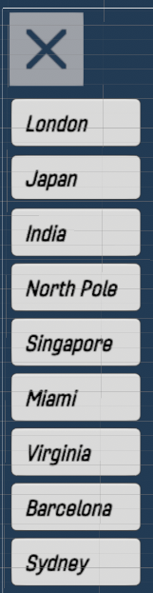***SpecificSettings*** contains the various buttons for the various functions that are Scene Specific. Each of the various rooms are toggled to their specific rooms by using Prefab Overrides for their corresponding selections.

***System, Moon,*** and ***Trivia*** each contain limited functionality, each of which assigned to the buttons within their scenes, using Prefab Overrides in the editor.

***Tide****, p*ictured on the of this page, it contains each of the locations for selecting for viewing the state of the Tide, in Scene 3. Each of them is a call using Photon to change the state for each of the players. This is how Tide is controlled for all of the users.

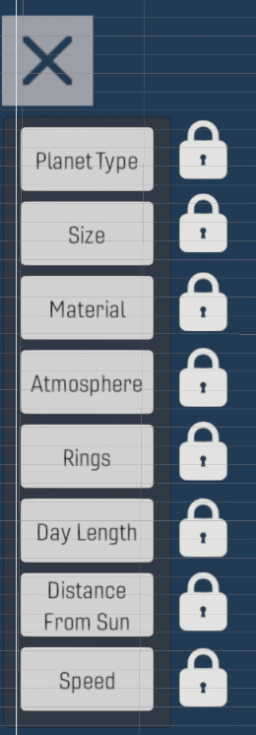***PlanetBuilder*** contains the functionality for controlling the state of the what the players can, and cannot do during the planet builder simulation. Clicking each of the buttons will either lock, or unlock the ability for the end users to select the various features of the planet builder. They are selected in an order that we deemed logical, but are not required to go in that order, nor are any of truly required to be selected. It functions using a Photon call sending the index of the selected button, where it will either enable, or disable, depending on it’s state. Due to how Unity inheritance works, both the Lock button, and the various label buttons should each be clickable.

# Scene Changers

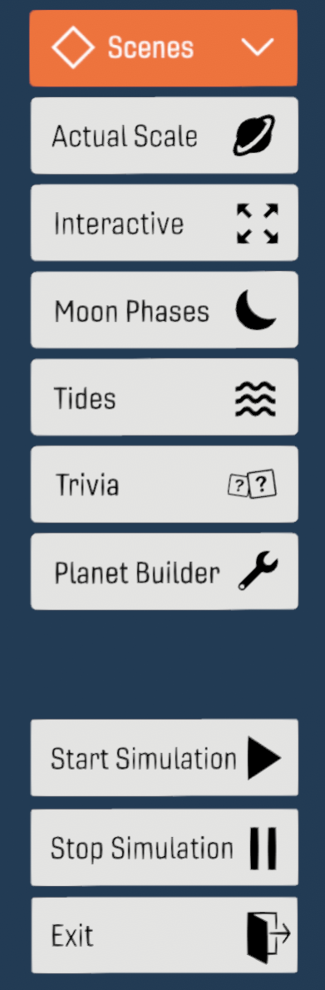Scene Changing! Functionally, these are pretty simple. They have a toggle, indicated on the right, that changes when enabled and disabled. When the scene changer buttons, located in ***Changers*** are clicked, they call ***ViewTypeObserver,*** which is located in ***NetworkObservers.*** They send a simple index for the scene, and that network observer handles the rest. When they are clicked, they enable ***Check***, which is a simple textbox asking the user to confirm their action.

***End*** calls ViewTypeObserver.End which ends the simulation.

***StartSim and StopSim*** are each scene dependent, but pause or restart the various simulations. This is especially useful in PlanetBuilder, where it launches the simulation.

# Script

In the inspector, the script is pretty simple. Once again, there is a toggle, which enables various buttons. Each of them are calling to a main script, which is a custom component on ***Script***. Titled ***ScriptManager***. This Script manager accepts CSV Files, which are the are changed using the ***Age*** button. This allows for the information narrated to change depending on the age category of the children.

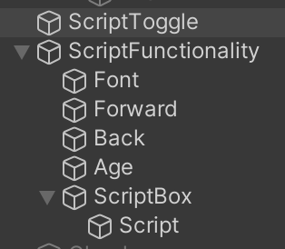***Forward and Back*** iterate through the script. ***ScriptToggle*** is the book, in the center of the page. ***Font*** changes the size of the font to various custom presets, editable in ***ScriptManager.SizePresets located in Script.*** Lastly, ***ScriptBox*** is a button you can press, which changes whether or not to expand the text.

The CSV files must be organized in a specific way:   
First off, it must be delimited with Line Breaks and ; characters. Every line of the script must be accompanied with a corresponding “expanded” line. This is so that it has something to display when it’s expanded. This is done by every Even being and expanded line, and every Odd being a basic one. If there is nothing to elaborate on, simply add a delimiter to add an empty object.

Notably, each room must receive its own CSVs, for a total of 5x the number of desired age ranges.

# PlayerCanvas

This prefab handles the children’s view during PlanetBuilder. There are two main selections here. ***Options and Choices***. Options handles the left side of the screen. This selects each of the various choices for the end user, which effects which property of the planet they are changing at a given time. This are located in Choices. Options simply enables the correct one, and disables the one that was already active. (This is what generates the Placeholder, which handles an error with this script.)

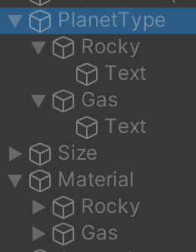Within ***Choices, e***ach choice contains some amount of buttons, each of which sending a singular, two-digit number to the desired script in PlanetBuilder. The First digit, starting with 01 with the first choice in ***PlanetType***, moving on to 02 for the second choice in ***PlanetType.*** Material, for example, selects 21-26, all of which is effecting a 2 Dimensional array of choices within PlanetBuilder. This is how all of them function, with some exceptions. ***Size, and Atmosphere*** both have a slider, which effects the size of the planet, and the alpha value of the atmosphere, respectively. Lastly, ***Rocky and Gas, within PlanetType*** enable or disable ***Rocky and Gas in Material.***