Student ID : 3003263
ITNPBD7 Assignment 2024
Best movie(s) by year

- Overview:
  - The major task of this assignment was to find the best movies based on the average ratings of the user for every unique year in the data provided
  - We also had to filter the data based on the years provided in the years.txt file such that if even one or more entry was present in this file we would only consider movies from those years in our movies data and ignore the rest of the movies belonging to other years in our result.
  - But if this file was empty we had to consider every movie in our data
  - The movie data was in the following format:
    - 387 The Green Field Action 1989 2.5
    - 387 New Beginnings Action 1996 2.3
    - 599 Tornado! Action 1996 2.1
    - ……………………………………………………….
  - Where each line consisted of Reviewer ID, Movie Title, Genres, Year, Rating
  - Our final output would be a TSV which contains the highest rated movie for each unique year in our dataset and its average rating:
    - 1990 Goodfellas 4.2
    - 1991 Silence of the Lambs, The 4.2
    - 1992 Man Bites Dog (C'est arrivé près de chez vous) 4.5
    - ………………………………………………………………………..
  - If there was a tie in any year, we have to display all the tied titles as well.
  - There is also a minimum vote condition
  - So if a movie had total number of reviewer less than this number, then that movie should not be considered in our results
  - For our final submission that value is 10 minimum voters for a particular movie to be considered in the results
- Part 1 - Use of HDFS:
  - In order to execute a Hadoop MapReduce job, involving the processing of movie ratings data using mappers and reducers, several HDFS commands were required to prepare the environment, manage data, execute the job, and clean up afterward. Below is a breakdown of these commands along with explanations of their usage:
    - Prepare HDFS Space:
      - Command: hadoop fs -mkdir /input
      - Explanation: This command creates a directory named /input in HDFS where the input data (ratings.txt) was stored. Having a designated directory for input data helps in organizing and managing data files efficiently and according to the requirements.
    - Move Data to HDFS:
      - Command: hadoop fs -put ratings.txt /input
      - Explanation: This command was used to copy the ratings.txt file from the local file system to the HDFS directory /input, making it available for processing by Hadoop jobs. Data needs to be stored in HDFS for Hadoop to access and process it
    - Run MapReduce Job:
      - Command: hadoop jar $HADOOP_HOME/share/hadoop/tools/lib/hadoop-streaming.jar -D mapred.reduce.tasks=5 -files mapper.py, combiner.py, reducer.py, years.txt -mapper mapper.py -combiner combiner.py -reducer reducer.py -input /input/ratings.txt -output /output/results
      - Explanation: This command executes the Hadoop streaming job, specifying the mapper, combiner, and reducer scripts, along with the input and output directories. It instructs Hadoop to process the input data using the provided scripts and write the output to the specified output directory.
    - Retrieve Results from HDFS:
      - Command: hadoop fs -get /output/ results.txt
      - Explanation: This command retrieves the output file from the Hadoop output directory /output and saves it as results.txt in the local file system. Retrieving results from HDFS allows for further analysis or presentation.
    - Clean-Up Temporary Files:
      - Command: hadoop fs -rm -r /input /output
      - Explanation: This command removes the input and output directories from HDFS to clean up temporary files generated during the MapReduce job execution. It helps in managing HDFS space and avoiding clutter from unnecessary files.
- Part 2 - Design:
  - Mapper:
    - Input: The mapper will receive the dataset line by line where each line consists of Reviewer ID, Movie Title, Genres, Year and Rating separated by tab, and will also be provided the years to consider for movie to be considered in results
    - Algorithm: Our Mapper will first get the years for consideration. It will process the movies line by line so for every line it has Reviewer ID, Movie Title, Genres, Year and Rating and we first need to check if we have years to consider or not if there are years to consider and movie year is not in these years then we will skip this inp[ut and move to next input. If there are no years to be considered then all the movies will be considered. Now since many movies will have multiple genres we will have to output a single movie with all its genres. The key provided to the combiner will be in the following form:
      - print("%s\t%s\t%s" % (year, title, rating)) where the year will be the primary key and data will be pushed to combiner sorted on years.
    - Output: year, title and rating for every movie in the dataset which needs to be included in the results
  - Combiner:
    - Input: the data sent by the mapper sorted in years
    - Algorithm: The combiner will be responsible for finding a single movie’s total user votes casted and aggregating the rating of all the users so that the reducer will receive the total number of votes per movie and the total collective rating of the movie along with the year and title of the movie.This way the combiner will help in reducing the network congestion and further improving the key values for the reducer
    - Output: year, title, sum of user ratings and total number of votes for every movie it receives from the mapper.
  - Reducer:
    - Input: the data sent by the combiner sorted in years
    - Algorithm: the reducer will be responsible for filtering the movies based on the minimum votes required per movie to be considered in results, finding the average rating for every movie and finding the highest average rated movie per year. The results produced the the producer will be our final output
    - Output: The TSV consisting of the Year, Title and the average rating of the movie for every unique year which was to be considered.
- Part 3- Implementation:
  - Output: Final output is in the following form where the minimum votes value was set to 10 and the file used was ratings.txt:
    - 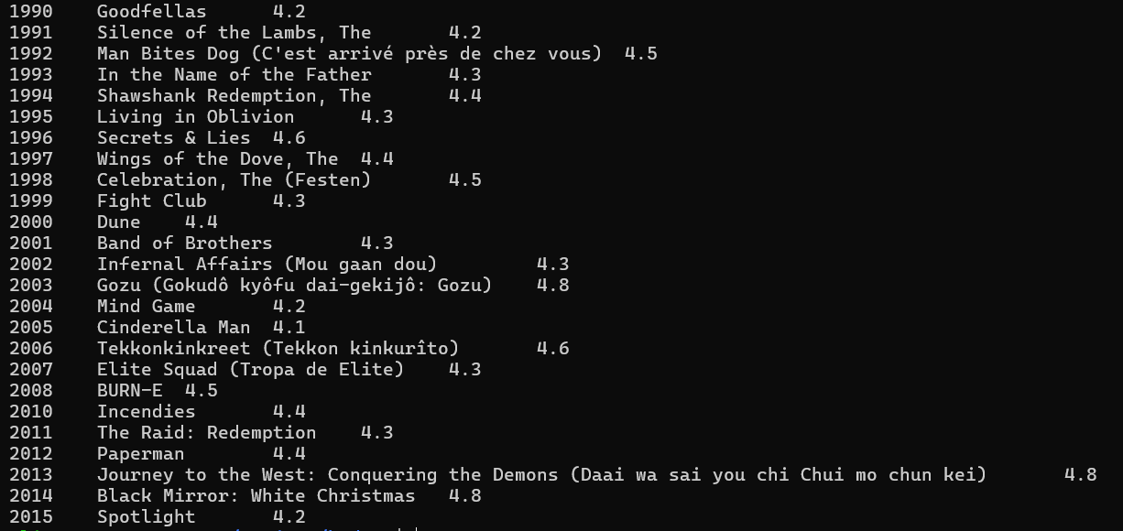
- Part 4 - Pros and Cons of Utilizing a Computational Cluster like Condor:
  - Flexibility in Environment:
    - Condor offers a versatile computing environment, allowing users to harness resources across a cluster of machines. This adaptability is advantageous for accommodating diverse computing needs and workflows.
  - Tailored Job Scheduling:
    - Condor provides customizable job scheduling policies, enabling users to prioritize, schedule, and manage jobs according to specific requirements and constraints. This customization can optimize resource utilization and job throughput.
  - Versatility in Workload Support:
    - Condor caters to a wide array of workloads, including batch processing, parallel computing, and high-throughput computing. Its capability to handle varied computational tasks efficiently makes it suitable for analyzing large datasets such as a petabyte-sized dataset.
  - Scalability:
    - Designed for scalability, Condor seamlessly scales to meet expanding computational demands. It efficiently distributes and manages jobs across numerous machines in a cluster, facilitating scalable data processing capabilities.
- Part 4 - Challenges of Utilizing a Computational Cluster like Condor:
  - Complex Setup and Management:
    - The configuration and administration of a Condor cluster demand expertise in system administration and cluster management. Configuring Condor policies, managing job queues, and resolving issues can pose complexities and require significant time investment.
  - Limited Fault Tolerance:
    - Unlike distributed frameworks like Hadoop, Condor lacks built-in fault tolerance mechanisms. Failures in individual nodes or jobs may necessitate manual intervention or job resubmission, potentially affecting job completion times and system reliability.
  - Data Movement Overhead:
    - Analyzing petabyte-sized datasets on a computational cluster like Condor may entail considerable data movement overhead. The transfer of large data volumes between storage systems and compute nodes can introduce latency and impact job performance.
  - Resource Fragmentation:
    - In a shared computational cluster environment, resource fragmentation may occur when resources are underutilized or jobs queue up for extended periods. This fragmentation can lead to inefficient resource allocation and prolonged job wait times.
- Part 4 - Comparison with Hadoop:
  - Batch Processing Suitability:
    - While both Condor and Hadoop are well-suited for batch processing tasks, Hadoop's distributed file system (HDFS) and MapReduce framework offer inherent fault tolerance and data locality optimizations, making them advantageous for processing massive datasets with minimal data movement overhead.
  - Ease of Use vs. Customization:
    - Hadoop's ecosystem provides user-friendly tools and higher-level abstractions for data processing and analysis, offering accessibility to users with varying levels of expertise. In contrast, Condor allows for greater customization and control over job scheduling and resource management, albeit requiring specialized knowledge for setup and configuration.
  - Fault Tolerance and Scalability:
    - Hadoop's distributed architecture inherently offers fault tolerance and scalability features, critical for efficiently processing petabyte-sized datasets. While Condor can scale to handle large workloads, ensuring fault tolerance and reliability at scale may require additional effort.
- Part 4 - Conclusion:
  - For analyzing a petabyte-sized dataset, Hadoop's distributed framework is better suited due to its built-in fault tolerance, data locality optimizations, and seamless scalability. However, Condor can be a viable option for specialized use cases requiring fine-grained control over job scheduling and resource management, provided that the complexity of setup and management is adequately addressed. The selection between Hadoop and Condor hinges on specific requirements, constraints, and the expertise of users and administrators involved.

