TOOLS AND TECHNIQUES FOR DATA SCIENCE
( ASSIGNMENT 01 )

SUBMITTED BY:
- L1F22BSDS0010 M ARIF RUBBANI
- L1F22BSDS0001 HARIS MASOOD

SUBMITTED TO: MUHAMMAD RIZWAN

1. Introduction:
The goal of this project is to collect detailed information about faculty members from the University of Central Punjab's Faculty of Information Technology and Computer Science. This data includes names, designations, email addresses, and research interests. The purpose is to support research efforts by providing structured and accessible data.

2. Methodology:
- Web Scraping Process:
  - The scraping task was performed by sending HTTP requests to the university's faculty webpage using the requests library.
  - The response data was parsed using BeautifulSoup to navigate and extract specific HTML elements containing relevant information.
- Tools Used:
  - requests for fetching the webpage.
  - BeautifulSoup from the bs4 library for parsing and navigating HTML.
  - pandas for organizing the extracted data and saving it to a CSV file.
- Data Points Collected:
  - Name
  - Designation
  - Email
  - Research Interest
- Code Structure and Key Functions:
  - fetch_page_content: Fetches and parses webpage content.
  - extract_faculty_positions: Extracts HTML elements containing faculty designations.
  - is_relevant_position: Filters positions based on relevant keywords.
  - extract_faculty_info: Extracts detailed faculty information (name, profile link, email, research interest).
  - extract_email: Extracts email from the profile page.
  - extract_research_interest: Extracts research interest from the profile page.
  - collect_faculty_data: Orchestrates the data collection by calling other functions.
  - save_to_csv: Saves the collected data into a CSV file.

3. Results:
- Summary: The collected data includes information on faculty members such as their names, designations, email addresses, and research interests. This data was structured and saved in a CSV format for easy analysis and access.
- Sample Output:
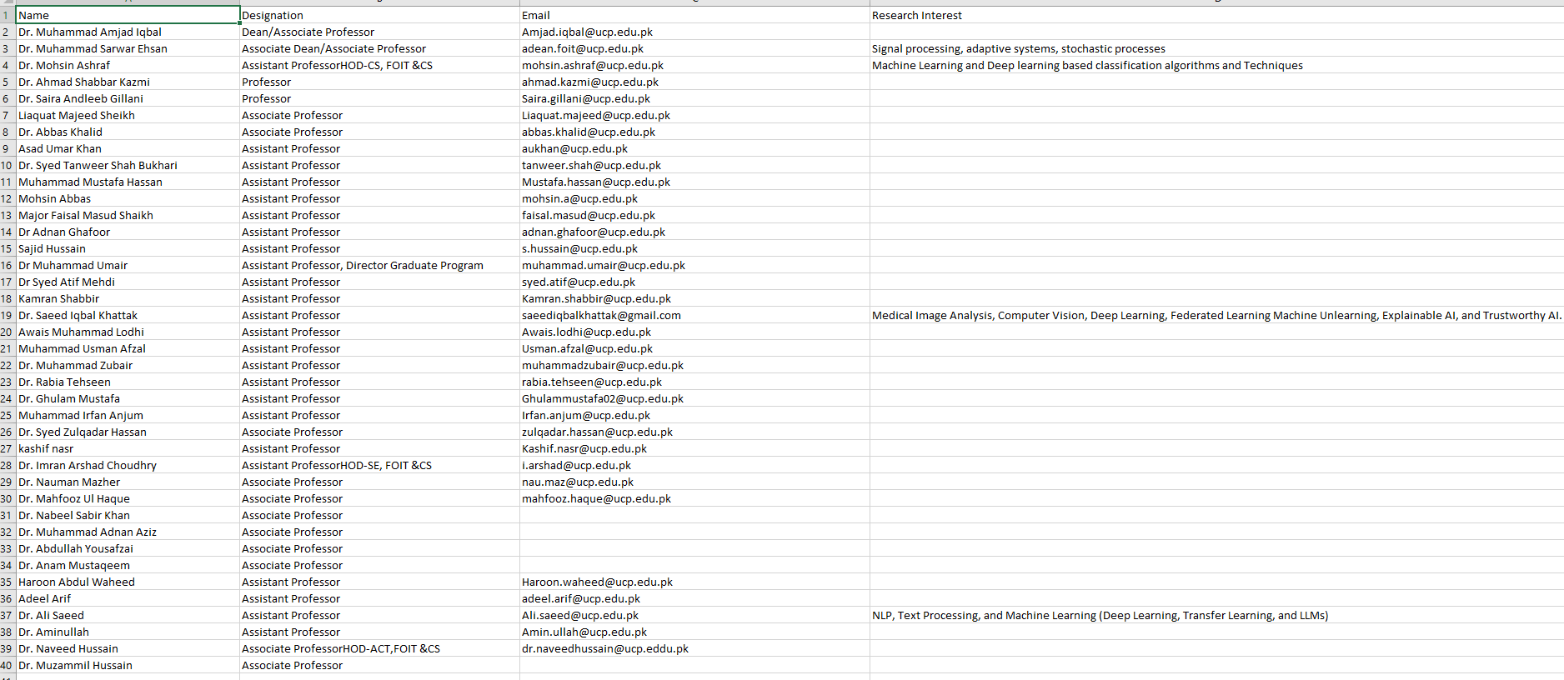

4. Challenges Faced:
- Website Structure: Changes in website structure can affect the scraping process. HTML tags or class names may change, requiring updates to the scraping logic.
- Incomplete Data: Some profiles may not contain all the desired information, such as missing research interests or email addresses.

5. Future Recommendations:
- Dataset Maintenance:
  - Implement automated scripts to periodically update the dataset.
  - Monitor the website for structural changes to ensure the scraping script remains functional.
- Ethical Considerations:
  - Ensure data is used responsibly, respecting privacy and consent.
  - Inform the relevant stakeholders or obtain permissions if required when collecting and using personal data.

6. Conclusion:
This project successfully collected and structured valuable faculty information for the University of Central Punjab. The dataset supports ongoing research by providing a comprehensive view of faculty profiles, enhancing the analysis of academic trends and expertise within the institution.

