Portfolio link : arif
Github link : link

Portfolio Report

Introduction
This portfolio showcases my key projects, skills, and professional achievements. It highlights my expertise in Python programming, data analysis, machine learning, and software development. The projects demonstrate real-world problem-solving capabilities and practical implementations of data science and machine learning techniques.

Code Description
The projects are developed using modular code structures for readability and scalability. Each project consists of multiple components, such as data preprocessing, model training, and visualization. Advanced libraries like TensorFlow, Scikit-learn, and Pandas were used to streamline workflows and enhance efficiency.

UI Overview
The user interface (UI) is designed to provide a seamless and user-friendly experience. Below are screenshots showcasing the UI of different sections of my portfolio:

About Section
Highlights my education and experience.
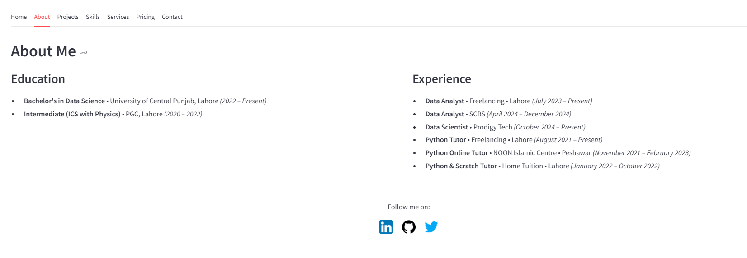

Home Page
Presents an overview of my portfolio, including a welcome message and key highlights.
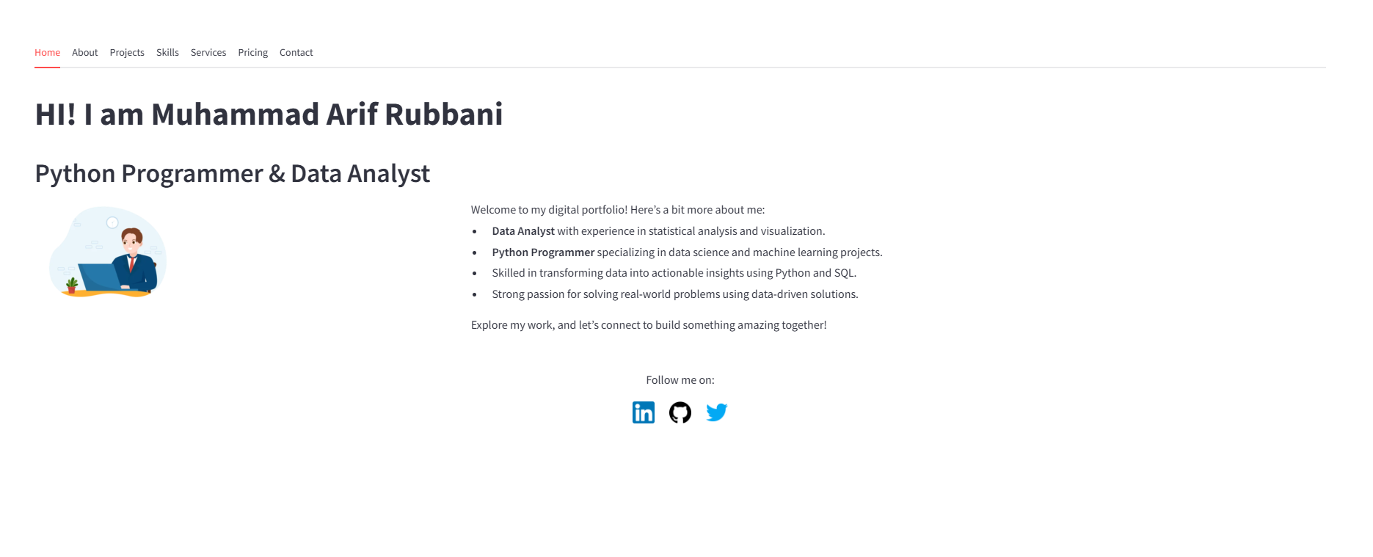

Contact Page
Allows visitors to reach out through a simple form.
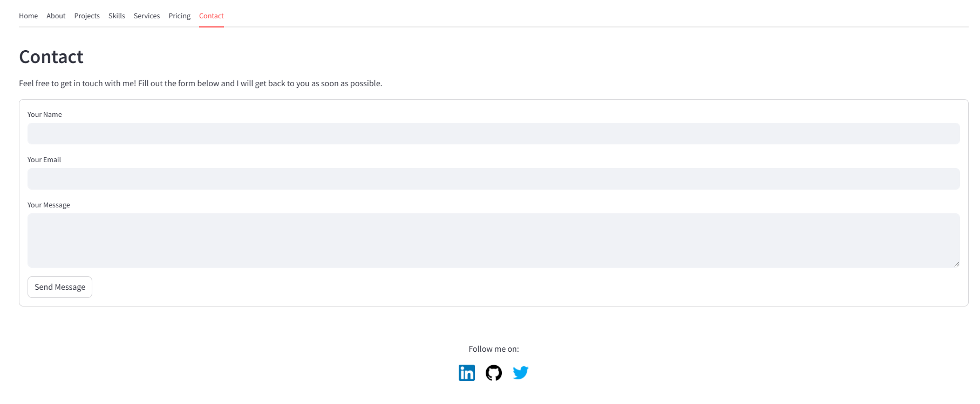

Pricing Plans
Lists available service plans with their respective features and costs.
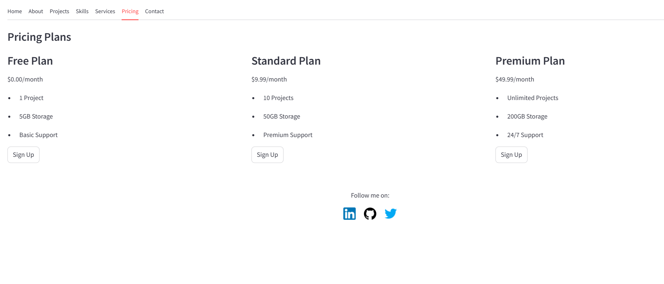

Projects Overview
Displays the key projects undertaken, along with detailed descriptions.
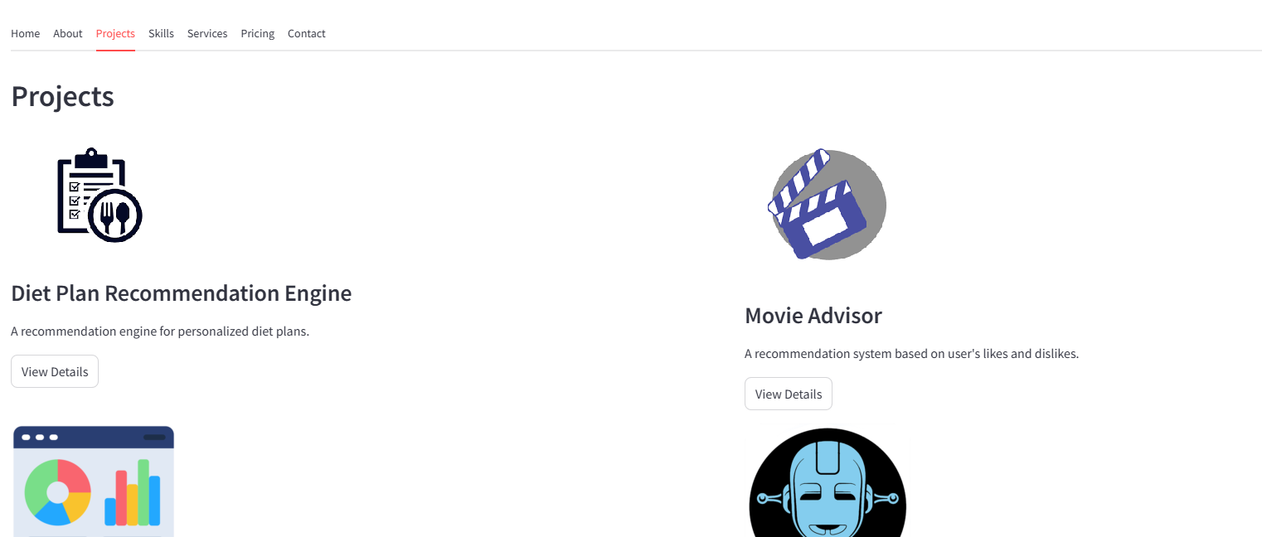

Skills Section
Showcases my technical and soft skills in an organized layout.
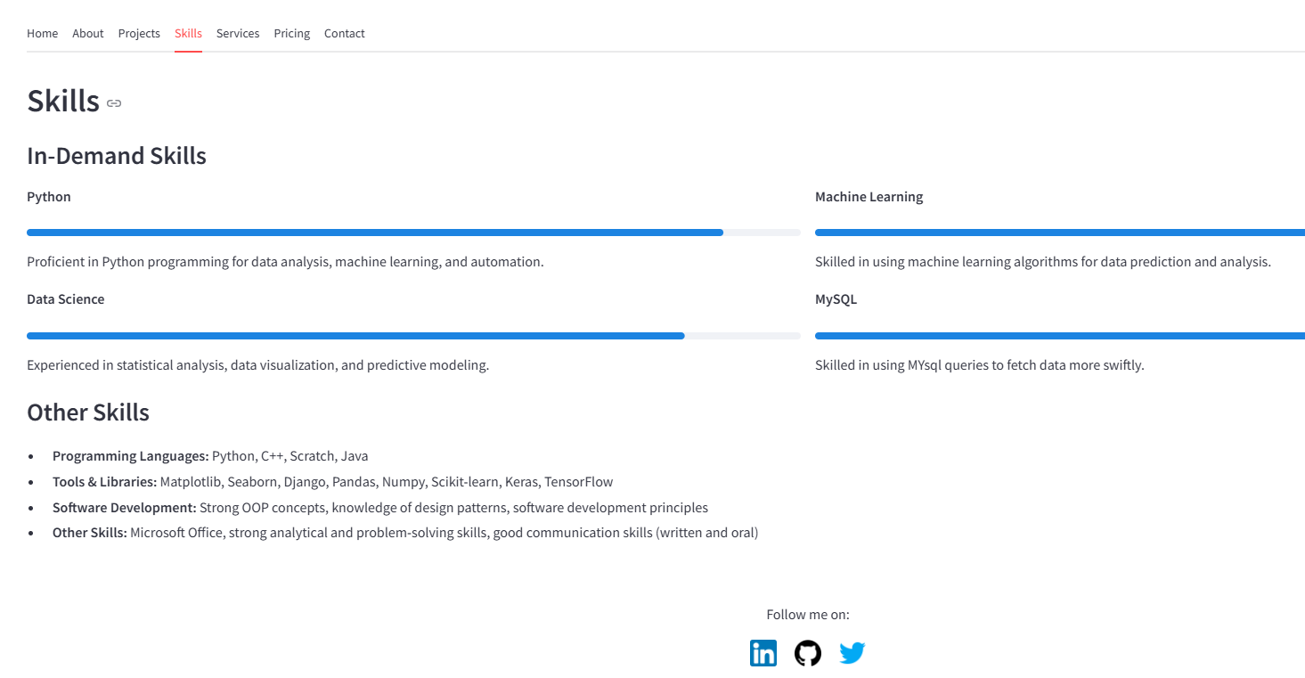

Services Overview
Details the services offered, including data analysis and machine learning.
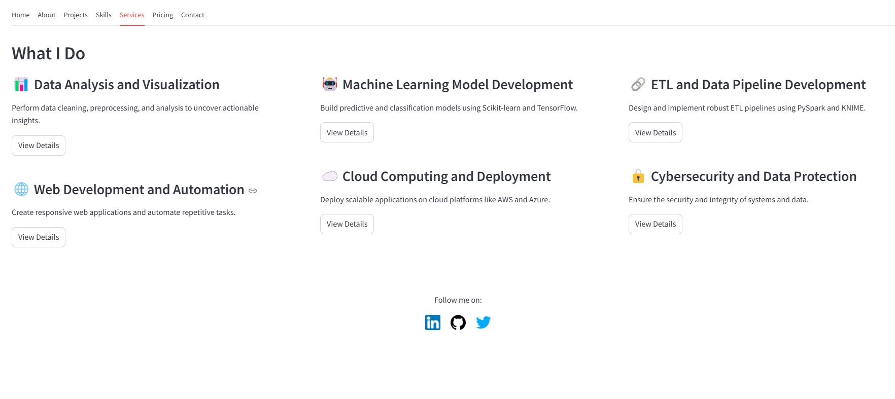

Services Detail Page
Explains the specifics of each service, such as data cleaning and preprocessing.
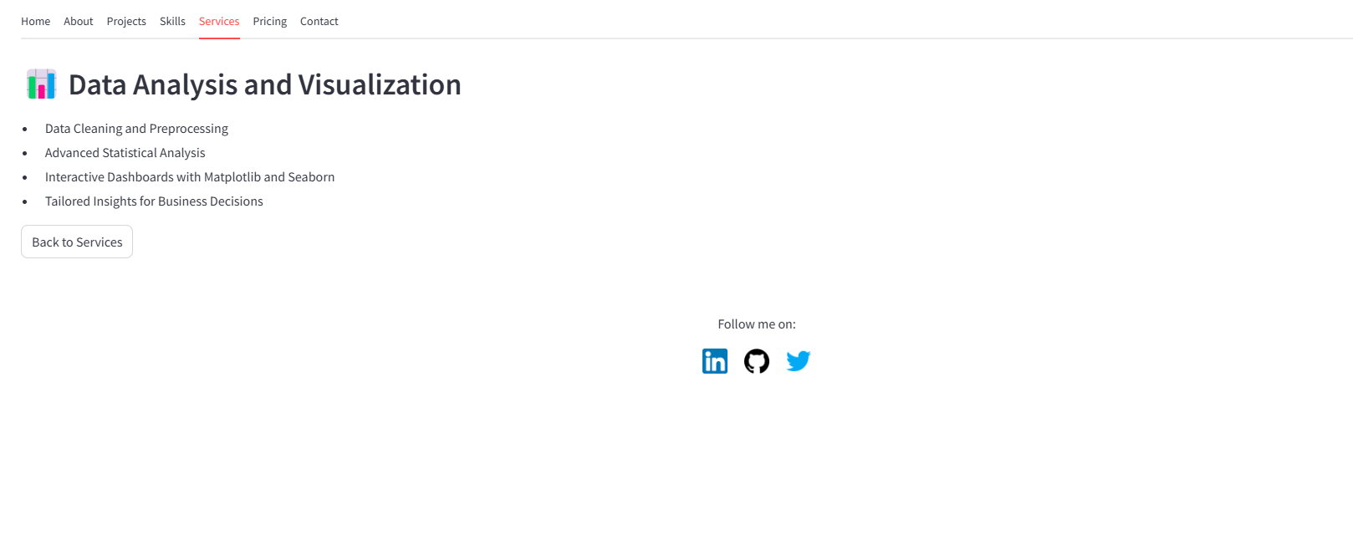

Conclusion
This portfolio demonstrates my ability to deliver impactful solutions through data-driven approaches. The projects highlight my expertise in leveraging technology to solve complex problems. This portfolio serves as a testament to my technical capabilities and dedication to continuous learning.

