A REPORT
ON
SKYWARD AIRWAYS — AIRLINE RESERVATION SYSTEM IN C++ USING OBJECT-ORIENTED PROGRAMMING
By
Arigela Bilwanth Venkat | AP24110010027
P. Sri Ram Harshith | AP25110010514
K. Saathwik Naik | AP25110010396
Md Rahamath Baba | AP25110010173

Carried out to some extent as
Course in Project-Based Learning
CSE 202 — Object Oriented Programming with C++
Semester 3 · Academic Year 2026–27
SRM UNIVERSITY, AP
Andhra Pradesh, India
NOVEMBER 2026

CERTIFICATE
The present report revolves around the Skyward Airways Project titled "Airline Reservation System in C++ Using Object Oriented Programming" carried out by the following students of the Department of Computer Science & Engineering, SRM University AP. The above-stated project is one of the requirements of the course CSE 202: Object Oriented Programming Using C++, 2026-27.

Arigela Bilwanth Venkat | Reg. No.: AP24110010027
P. Sri Ram Harshith | Reg. No.: AP25110010514
K. Saathwik Naik | Reg. No.: AP25110010396
Md Rahamath Baba | Reg. No.: AP25110010173

This research has been done according to the guidance of the course lecturer and has been determined to be sufficient enough for the course requirement by November 2026.

_______________________
(Signature of the Course Instructor)
Kunal Biswas
Course Instructor — CSE 202: Object Oriented Programming with C++
Department of Computer Science and Engineering

ACKNOWLEDGEMENTS
It is our pleasure to thank the Vice-Chancellor and Dean of SRM University AP for giving us such a dynamic atmosphere that helps in innovation and learning.

Here we would like to thank our faculty guide Mr. Kunal Biswas from the Department of Computer Science & Engineering for his continuous support during the whole project. His important suggestions helped us in designing the hierarchy of classes, designing the system, solving the programming issues and focusing on good OOPs code.

It is our pleasure to thank the faculty of the CSE 202 Object Oriented Programming using C++ course for imparting us with the knowledge of encapsulation, inheritance, polymorphism, operator overloading, templates, and exceptions which are the basic elements of this project.

We appreciate our classmates who have used our software, found issues with it, and suggested possible improvements for us.

ABSTRACT
Skyward Airways is a console-based airline reservation application developed using ISO C++17. This application contains approximately 1,400 lines of code that implement the entire process of booking flight: signing up to an account, signing in to the account, searching for flights using 16 airports, calculating the ticket price, selecting seats, services and coupons, making the payment using payment class hierarchy, printing out the ticket, booking the cancellation with refund, and administration module. This project demonstrates several fundamental Object-Oriented Programming concepts, among which are class hierarchy (in the case of Flight, Passenger and Payment classes), runtime polymorphism (calculation of taxes, discounts and payments), encapsulation (with private attributes and accessors), operator overloading (in the Money and Date classes), class template Repository<T>, STL containers and algorithms, smart pointers for managing the memory, custom exception classes, and file persistence. No third-party library is used in the project, it can be compiled into the executable file in one g++ call, bookings, accounts and custom flights are saved into data files that are human-readable. There are 13 scenarios of functional testing, including handling wrong input (such as selection of duplicate seats, expired credit card, dates from the past, and wrong PNR). All 13 scenarios have been successfully passed.

TABLE OF CONTENTS
1. Introduction
1.1 Problem statement
1.2 Objectives
1.3 Scope of the Study
2. Tools, technologies and assumptions
3. System design
3.1 Architecture overview
3.2 Class Design and Class Diagram
3.3 OOP concept mapping
3.4 Booking flow chart
Data models and file formats 3.5
3.6 Algorithms: pricing, seating, date, refund
4. Module descriptions
5. Results and output
6. Testing and validation
7. Outcomes
8. Conclusions and recommendations
9. How to run (README)
10. References
Appendix A. Reference source note

1. Introduction
One example of transactional system is that of the airlines booking system because this system is composed of several processes like searching for an available flight, seat booking, calculation of ticket price based on time and demand, payment process, passenger data storage and issuing travel documents like boarding pass. This is one good approach to implementing the basic principles of OOP.

1.1 Problem statement
This study seeks to develop an independent application developed using C++ to facilitate the reservation and management of air flight bookings. The functionality of such an application would include: (a) Search of domestic and international routes by many airports; (b) Calculation of the cost of the ticket according to the class, seat availability, and the time of booking; (c) Allocation of seats by corresponding ticket price according to the class and extra fee for more space on board; (d) Payment processing in various payment systems; (e) Print out of the boarding pass and e-tickets; (f) Cancellation of reservation based on the schedule of refunds; (g) Loyalty program for the passengers; and (h) Administration panel to produce income reports and create flights.

1.2 Objectives
- Specify the domain for your application by defining a suitable set of cooperating classes, not with global variables and functions.
- Use virtual functions for context-based implementation of behaviors such as taxes, discounts, payment, and files. This should be done without using many switch cases.
- Develop a system that can handle currency and date operations without the use of any external library.
- Ensure that the seat is available when you verify its status before confirming the reservation.
- Automatically manage the resources by utilizing automatic resource management concepts like smart pointers and RAII-based file streams.
- Make sure that everything remains in one single file which can be compiled using g++ compiler with -Wall and -Wextra flags and works on both Windows and Linux platforms.

1.3 Scope of the project
It is a demo program running in a simulated environment, but not a live connection to the PSS system of any airline company. The demo program always builds its flights network in the same way every time it starts and employs the same pseudo random values in the generation of passengers occupying each flight every day. Money transactions in this case are only simulated and no real money transfers take place. This demo program follows the guidelines set by the application in this environment. The program can work with either passenger or administrator accounts.

2. Tools, technologies and assumptions
Item | Choice | Purpose
Language | ISO C++17 | Supports classes, virtual functions, templates, lambdas, and structured bindings
Compiler | g++ (MinGW / GCC) 11 or later | Supports single-file compilation with -Wall and -Wextra
Build command | g++ -std=c++17 -O2 -Wall -Wextra main.cpp -o skyward | Compiles the program in one command
Operating system | Windows and Linux | The Windows version enables ANSI virtual-terminal support
Libraries | C++ standard library only | Includes iostream, fstream, sstream, algorithm, map, set, vector, memory, random, cmath, and ctime
User interface | ANSI escape sequences for colour | Used for highlighted menus, messages, warnings, and seat maps
Data persistence | Delimited text files | bookings.dat, accounts.dat, and custom_flights.dat

The assumptions made for the current project are as follows: (a) the demo network, number of flights, currency, and seating capacity are hardcoded, but an extension may be made by the administrator; (b) there is an administrator password, i.e., admin123, which is hardcoded because there is no database of users in the application; (c) payments are made through simulation while card validations are made using Luhn and date validation; (d) a booking can only be made when the seats are validated once again before the booking; and (e) fare is in Indian Rupees (INR) and with Indian digit grouping.

3. System design

3.1 Architecture overview
It follows the pattern of three-tier architecture that makes use of shared validation and exception handling services, along with the persistence tier as a different tier altogether. The controller has the ability to access stored data through the repository and file saving services, without having any direct role in storing them. Similarly, presentation services can display data without being responsible for business logic.
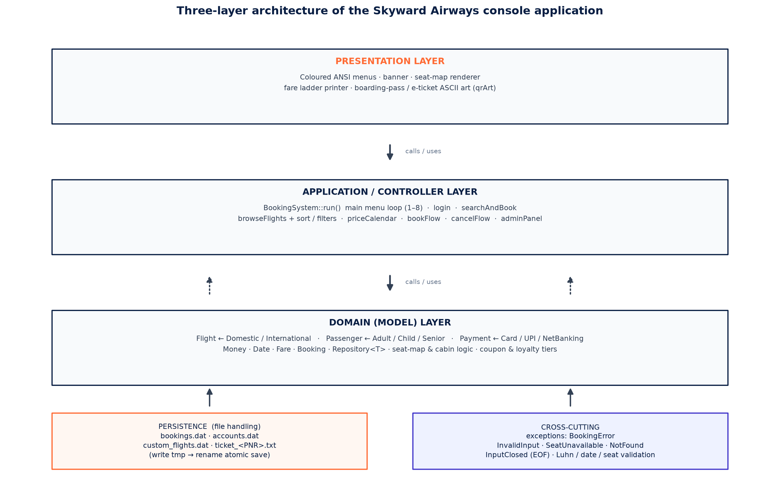
Figure 1. Layered architecture consisting of presentation layer, control layer, domain layer, persistence layer, and exception handling.

3.2 Class design and class diagram
The architecture uses 14 user-defined classes, two structures, and one class template. In case any protected variables need to be used, base classes will use protected variables; therefore, flights and passengers derived classes will inherit their state without making them public. Booking objects reside in Repository<Booking>, which provides functionalities of add, findIf, where, and countBy operations on vector<T>.
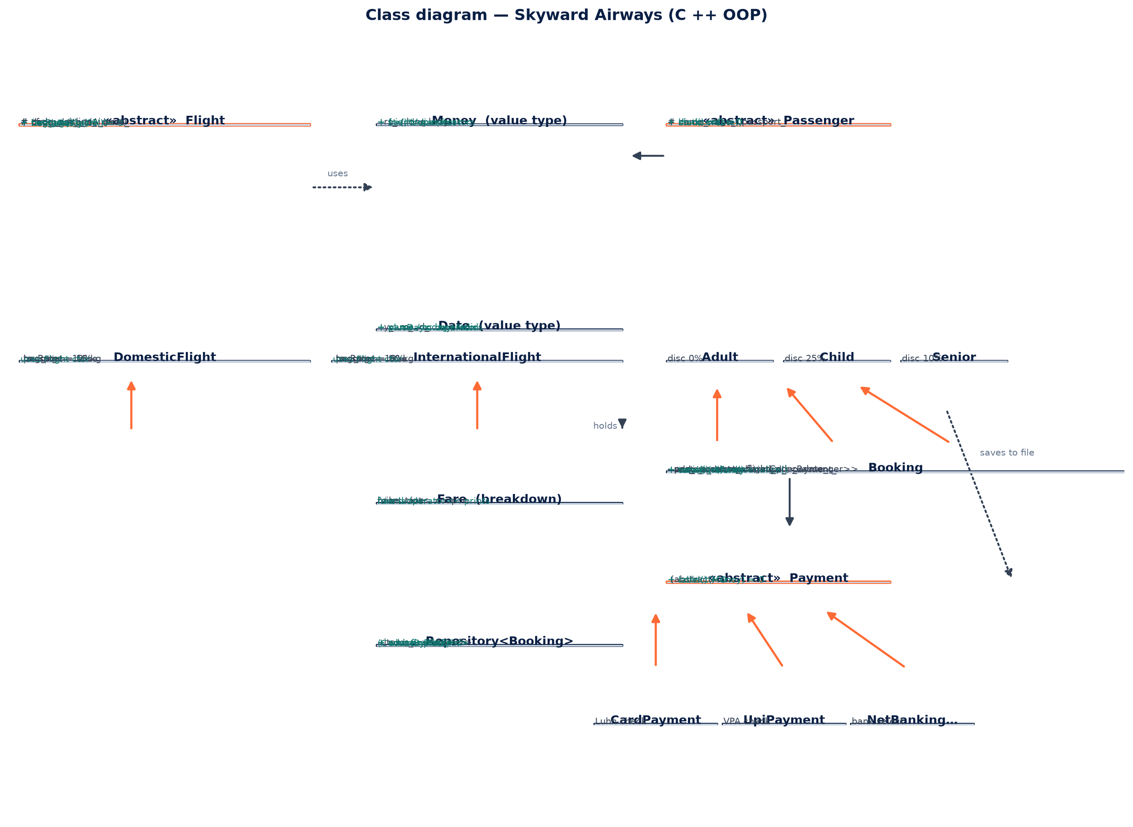
Figure 2. UML diagram of class depicting the abstract classes of Flight, Passenger, and Payment; the three inheritances of the classes; the value types of Money and Date with operator overloading; and the Booking class, which contains the passengers through shared_ptr in Repository<Booking>.

3.3 OOP concept mapping
This design includes all the concepts of object-oriented approach stated above. The below table shows the classes, methods, and other tools utilized while creating the code.
OOP concept | Where demonstrated | Mechanism
Abstraction | Abstract class Flight with a pure virtual category() function | Each concrete flight class defines its own tax, baggage, and passport-related rules
Inheritance | Flight → DomesticFlight / InternationalFlight; Passenger → Adult / Child / Senior; Payment → CardPayment / UpiPayment / NetBankingPayment | The program contains three separate single-inheritance hierarchies
Runtime polymorphism | q.pax[i]->discount(), f->taxRate(), and pay->collect(fare.total) | Calls are resolved through base-class pointers or references. A common quote() loop handles passenger types without explicit type checks
Compile-time polymorphism | Repository<T>::where<Pred> and countBy<KeyFn> | Class and function templates support generic operations, with predicates supplied through lambdas
Encapsulation | Money class with private rs_ data and a public value() accessor | Private state is accessed through public methods; derived classes use protected members where appropriate
Operator overloading | Money operators +, -, *, <, and friend <<; Date operators <, ==, and << | Arithmetic and stream output are defined for application-specific value types
Static / factory polymorphism | Passenger::create(name, age, passport) | The factory method selects the appropriate passenger subclass based on age
Smart pointers | vector<unique_ptr<Flight>>, shared_ptr<Passenger>, make_unique, and make_shared | Ownership is managed automatically without explicit new and delete operations
Exception handling | BookingError derived from runtime_error, with InvalidInput, SeatUnavailable, NotFound, and InputClosed | Typed exceptions are handled in bookFlow and the main loop; end-of-input is also handled
File handling | ifstream, ofstream, temporary files, and rename() | Delimited records are saved through temporary files to reduce the risk of corruption
STL and lambda expressions | std::sort with custom comparators, std::find, std::all_of, std::min, std::max, range-based for loops, and filtering | Standard iterator-based algorithms reduce the need for manually implemented loops
Namespaces | util:: and ui:: | Functions are grouped by purpose, reducing clutter in the global namespace

3.4 Booking flow chart
The graph explains the complete process of making the reservations, the methods in which the user can cease using the facility at the time of making the reservation.
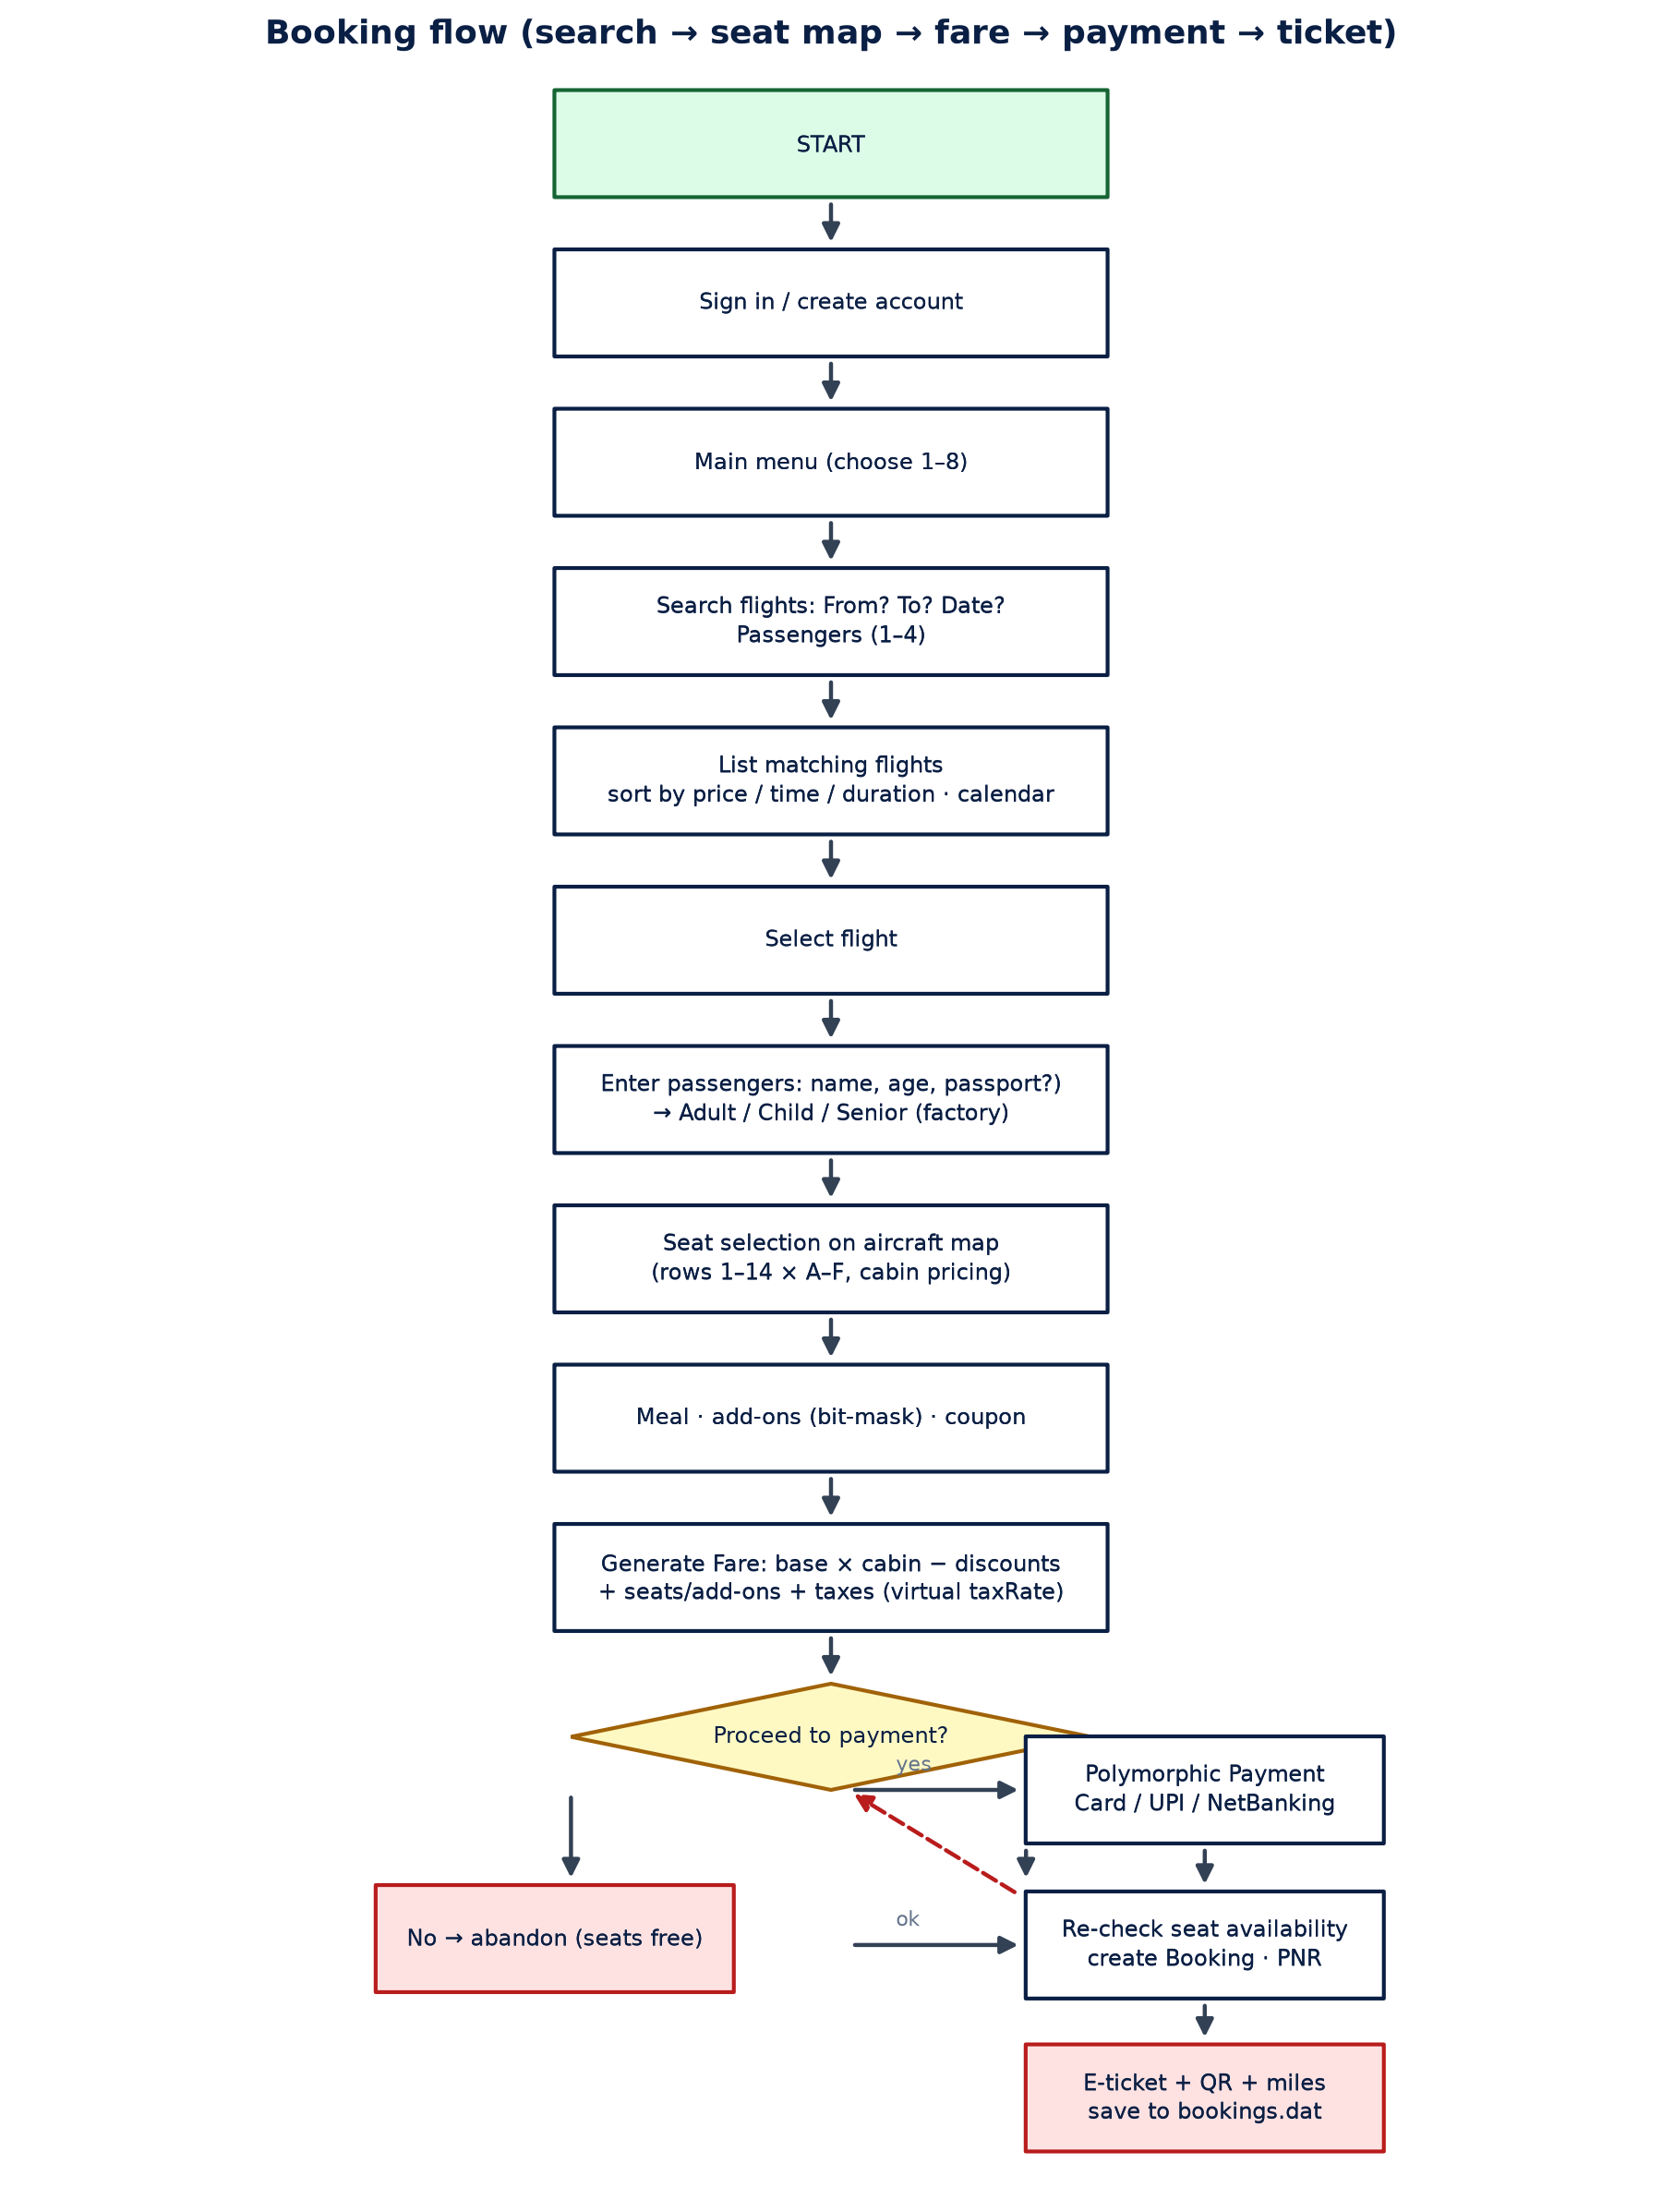
Figure 3. The reservation procedure including the options for cancellations, payment failure, and last-minute availability check.

3.5 Data model and file formats
Data about the data itself is contained in three text files, which are delimited. To ensure that there is no loss of data when the system suddenly shuts down, the data is first saved in a temporary file before renaming it. A booking record looks like this: PNR|account|flight|date|status|meal|addon-mask|payment|total|refund|pax~age~passport~seat;pax~...
bookings.dat
SKW7Q2A|Asha|6E-101|2025-11-14|C|Vegetarian|12|UPI asha@okaxis|7480|0|
Asha~34~~12C;Rahul~9~ choir~12D
accounts.dat
Asha|1480
admin|0
custom_flights.dat
6E-999|6E|DEL|HYD|420|150|2890|Airbus A320|0

Every Booking object is saved as one line, which is then processed by the parsing function. In case the booking object becomes corrupt, the parser just skips it and produces an error message instead of terminating the application.

3.6 Algorithms: fares, seats, calendar, refunds
The calculation of the fare is done according to a set of rules particular to the domain. The fare in Economy class increases according to the square of seats occupied and depends on the time of reservation of the ticket. The multipliers of the cabins are: Economy 1x, Business 2.4x and First 4.2x. Discounts on the fare depend on the type of customer and the passengers will get the appropriate discounts, while extra charges will be calculated based on the number of passengers using a bit mask. Coupons such as SKY10, STUDENT and WELCOME for first booking will give discounts to the fare under certain conditions. An additional discount of up to 8 percent will be there according to the loyalty of the account holder. The tax will be levied at 12 percent on domestic flights and 18 percent on international flights virtually.
Step | Formula / rule | Code location
1. Economy base fare | base × (1 + 0.6 × occupancy²) × leadTimeFactor (0.92–1.25); rounded to the nearest ₹10 | BookingSystem::unitPrice
2. Fare for each passenger | unit fare × cabinMultiplier(seatRow) | BookingSystem::quote
3. Passenger discount | − seat fare × passengerDiscount (0%, 15%, or 25%) | Passenger::discount
4. Extra-legroom charge | + ₹400 for each extra-legroom seat in rows 5 and 10 | extraLegroom()
5. Optional services | + Σ addOn.price × passenger count, based on the bit mask | addOnTable()
6. Coupon discount | − minimum of the percentage-based discount and its cap for SKY10, STUDENT, or WELCOME | couponValue()
7. Loyalty discount | − post-coupon amount × tierDiscount (0–8%) | tierFor() and account miles
8. Taxes | + net fare × flightTaxRate (12% domestic; 18% international) | Virtual function Flight::taxRate
9. Miles earned | total fare ÷ 10; credited to the account and used to reassess loyalty tier | Fare::miles

There are 14 rows, with six seats in each row, which are labeled A to F. Row numbers 1-2 are labeled as First Class, row numbers 3-4 as Business Class, and row numbers 5-14 as Economy. The seating arrangement will be allotted randomly, for each flight and for each date, along with those seats which have already been booked via the repository. The availability of seat will once again be verified during the time of committing reservation, so that no two users can make reservations for the same seat. The Fare Calendar looks for fares for seven days and calculates the lowest fare for each date based on unitPrice.

4. Module descriptions
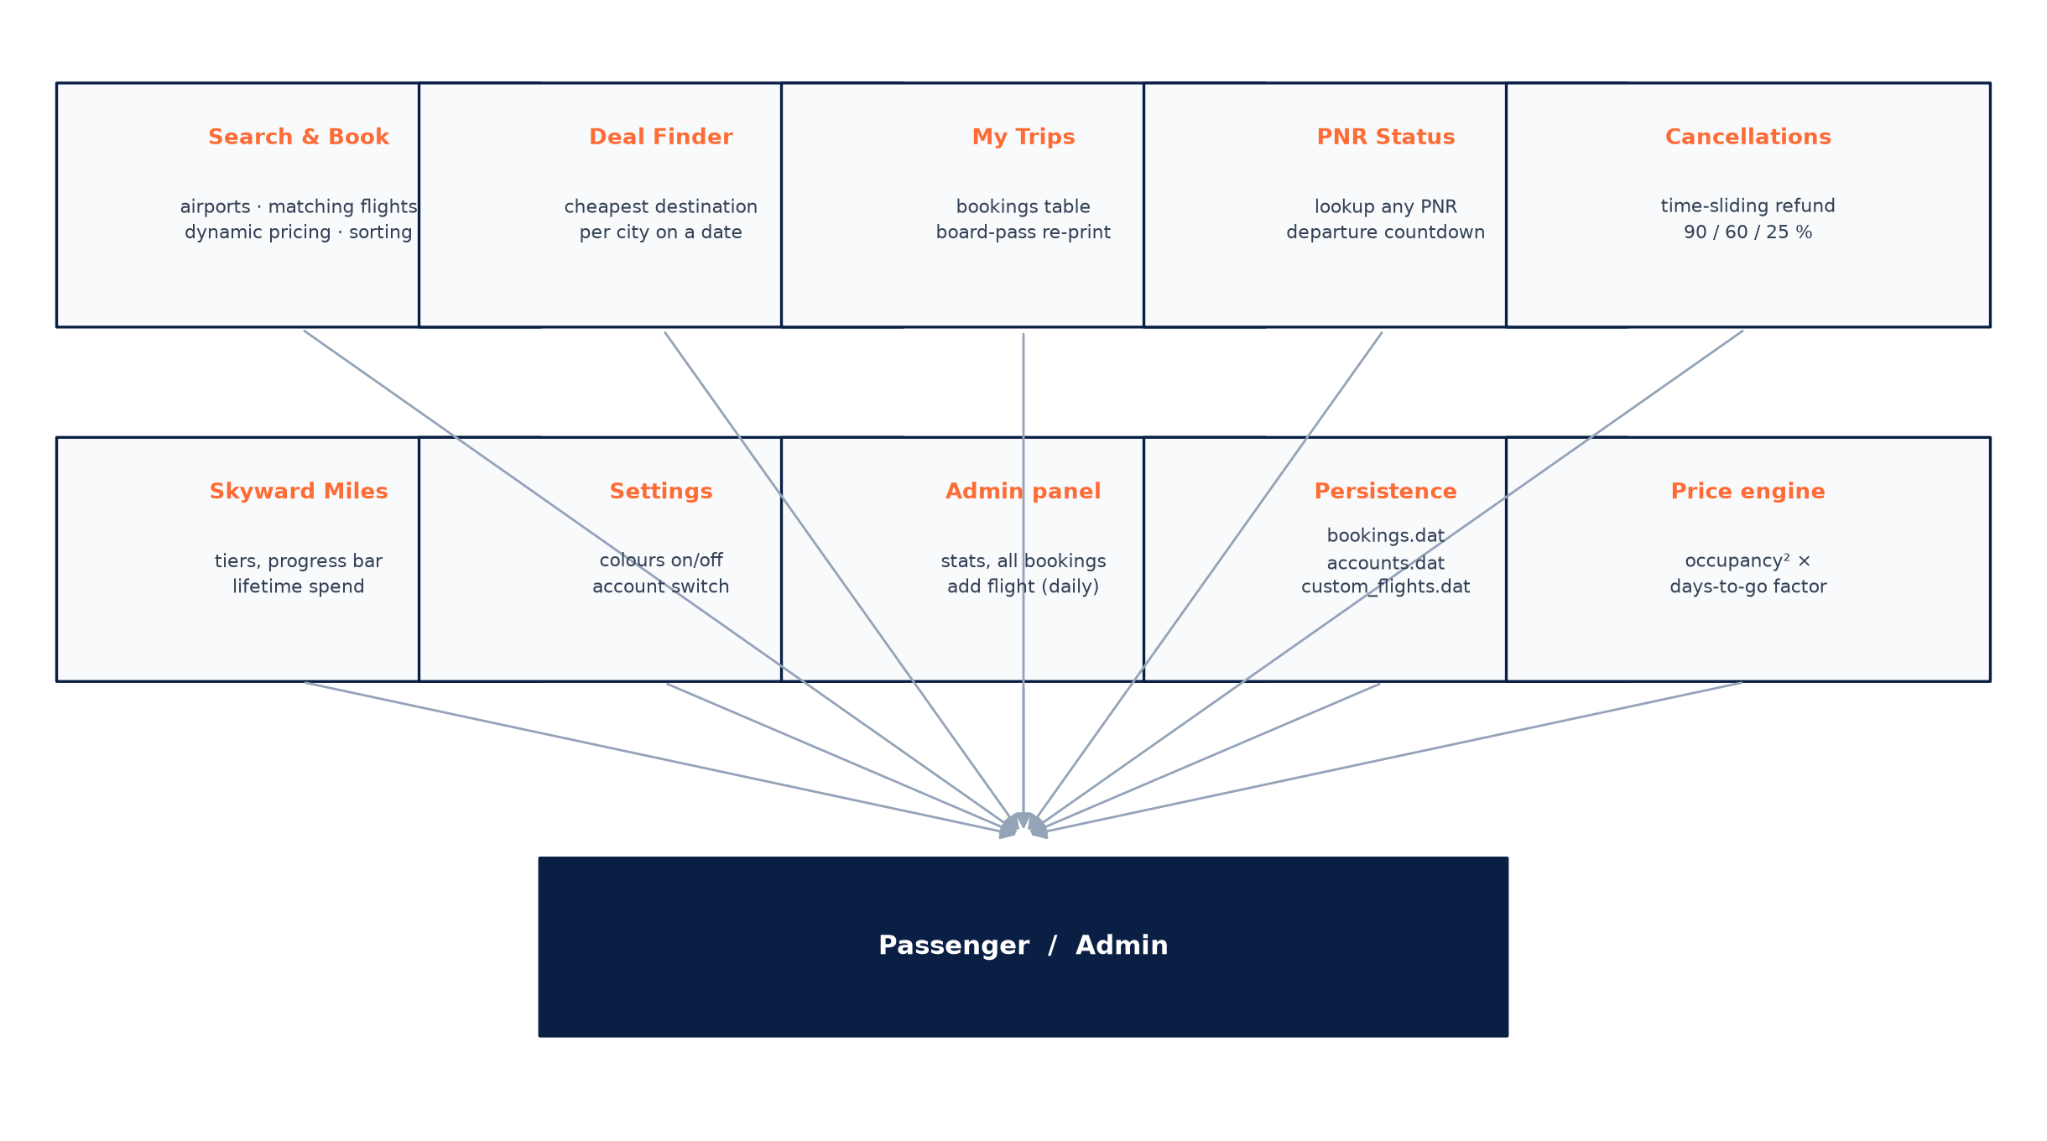
Figure 4 – Modules available from the main menu
Module | Entry | Key responsibilities
Search and Book | 1 | Supports airport search by code, city, or partial text; route filtering; non-stop selection; sorting by price, duration, or time; a seven-day fare calendar; flight listings with lowest-fare and seat-availability indicators; and a six-step booking process.
Deal Finder | 2 | Lists outbound destinations from a selected origin and displays the eight lowest-priced destinations for the chosen date
My Trips | 3 | Displays bookings associated with the signed-in account and allows tickets to be reprinted using a PNR, including cancelled reservations and refund details
PNR Status | 4 | Searches for a PNR and displays the flight, seat assignments, amount paid, and departure countdown
Cancellations | 5 | Shows upcoming confirmed bookings, calculates the applicable refund based on departure time, obtains confirmation, releases seats, reverses earned miles, and records the refund
Skyward Miles | 6 | Displays the Blue, Silver, Gold, or Platinum tier; earned discounts; progress toward the next tier; lifetime spending; and trip count
Settings | 7 | Allows colour output to be enabled or disabled and supports account switching
Administrator panel | 8 | Provides password-protected revenue and refund statistics, confirmed and cancelled booking counts, the five most-booked routes, network information, booking records, and persistent custom-flight creation
Persistence | — | Loads data at startup and saves changes after bookings, cancellations, account updates, and custom-flight creation
Fare engine | — | Implements the unitPrice and quote calculation sequence described in Section 3.6

5. Results and output
The code does not generate any warning messages when compiled with -Wall and -Wextra flags. It is compiled under Windows using MinGW g++ compiler (with support for ANSI terminal set up via SetConsoleMode function) and under Linux. The performance metrics are the results of application’s measurement process.
Metric | Value
Source code size | One source file; approximately 1,400 lines; no external dependencies
Compilation time | Approximately four seconds on a single-core laptop with an Intel Core i5
Flight network | 16 airports; three flights for each airport pair in both directions; approximately 1,240 flights generated at startup
Seat capacity | 84 seats per flight (14 rows × 6 seats), with prices determined by cabin
Example booking | Two passengers on HYD–DEL flight 6E-xyz; unit fare ₹4,180; senior discount 10%; SKY10 coupon; two Business seats with extra legroom; stated total ₹11,464 and 1,146 miles
Cancellation test | A booking cancelled three days before departure receives a 60% refund; seats are released and miles are reversed
Persistence test | After restarting the application, bookings, account details, and custom flights are restored

The example below provides an abbreviated form of the output on the console:
================================================================
MAIN MENU Asha | Silver | 6,340 miles
================================================================
1. Search & book flights 5. Cancel a booking
2. Deal finder 6. Skyward Miles profile
3. My trips & tickets 7. Settings
4. PNR status 8. Admin

6E-201 IndiGo 10:05 12:55 2h 50m Non-stop 31 Rs. 4,180 <- cheapest
AI-202 Air India 08:30 11:20 2h 50m Non-stop 7 Rs. 5,410 only 7 left!
--------------------------------------------------------------
Base fare (by cabin) Rs. 9,240
Child / senior discount - Rs. 924
Extra-legroom seats Rs. 800
Coupon - Rs. 1,500
Taxes & fees Rs. 920
----------------------------------------------------
TOTAL Rs. 7,736
You will earn 773 Skyward Miles

6. Testing and validation
A manual black-box test plan was carried out using the compiled application. All 13 test cases passed. The negative tests, marked with ✗ in the table, check whether invalid inputs produce clear error messages and whether the system avoids saving incomplete transactions.
# | Scenario | Input | Expected | Result
1 | Card validation — valid Luhn number | 4242 4242 4242 4242 | Booking is accepted and confirmed | Passed
2 | Card validation — invalid Luhn number | 1234 5678 9012 3456 | Rejected with an error message; three attempts allowed | Passed
3 | Card validation — expired card | 01/24 | Rejected with the message “Card has expired.” | Passed
4 | Card validation — invalid CVV | ab | Rejected; CVV must contain three or four digits | Passed
5 | Seat selection — duplicate selection | 12C selected twice | SeatUnavailable exception is raised | Passed
6 | Seat selection — occupied seat | Select 1A when the first row is full | SeatUnavailable exception is raised | Passed
7 | Airport search — partial match | “hyder” | Hyderabad is identified as a unique match | Passed
8 | Airport search — ambiguous input | “s” | The system displays a “Did you mean?” list | Passed
9 | Booking date — past date | 2025-01-01 | Booking is rejected and the required date format is suggested | Passed
10 | Booking date — beyond booking window | 2026-12-31 | Booking is rejected because it exceeds the permitted booking window | Passed
11 | PNR lookup — unauthorized record | Enter another passenger’s PNR | NotFound is raised; ticket information is not disclosed | Passed
12 | Persistence — restart test | Create a booking, exit, and relaunch | Booking details and miles are restored | Passed
13 | Concurrent booking — seat conflict | Two sessions attempt to confirm the same seat | The second session receives “Seat just taken” and the booking is aborted | Passed

7. Outcomes
• The project has resulted in a fully-fledged airline reservation program implemented in C++17 with no dependencies that can be compiled and run on Windows and Linux.
• The report includes an allocation of all necessary object-oriented concepts to code fragments (Section 3.3), which serves as a practical guide for illustrating and discussing the design.
• Three inheritance trees, two value types with operator overloading, and a generic repository have been used. These design patterns are also applicable to larger C++ software projects.
• File storage has been made exception-safe and uses atomic saving. It is able to deal with partial writes, ignore corrupt records, and produce a warning message.
• Payment validation uses the Luhn algorithm to check card numbers, validates the expiration date and CVV format. The payment-validation module can also be reused for other input-validation tasks.
• The project offered hands-on experience with some STL functionality, including sorting with custom comparator, countBy operations, lambdas, and smart-pointer ownership.
8. Conclusions and recommendations
All nine set goals have been reached by the project. In addition, the development process proved that object-oriented design is still effective in a single-file application. Virtual dispatch replaced type-specific conditional statements for flights, passengers, and payments. Operator overloading enabled Money values to be manipulated with common arithmetic operations. Also, Repository template helped to cut down redundant bookkeeping logic compared with procedural approach used previously.
The following suggestions are proposed for future work:
• As the application grows, separate source code into header and implementation files and introduce CMake for building.
• Migrate from the flat file storage to SQLite through existing repository interface, or introduce JSON persistence layer.
• Write unit tests for Date and Money classes, which can be tested as independent functions, using any lightweight testing framework like Catch2 or doctest.
• Introduce multi-language support in the user interface, currency converter, and tax report per booking for GST.
• Introduce Seat class for representing seat price, cabin, and passenger assignment, replacing seat IDs with string representation.
• In case of extending the application for multiple concurrent sessions, introduce mutex protected seat ledger shared between sessions.
9. How to run (README)
Build (any OS):
g++ -std=c++17 -O2 -Wall -Wextra main.cpp -o skyward
Run:
./skyward (Linux/macOS)
skyward.exe (Windows)
First login creates your Skyward account; use coupon WELCOME on your first trip.
Demo card for the payment step: 4242 4242 4242 4242, any future MM/YY, any 3-digit
CVV.
Coupons: SKY10 (10 % off), STUDENT (7 % off), WELCOME (flat ₨500 first booking).
Admin menu (option 8, password admin123): revenue statistics, all bookings,
and adding new flights that persist in custom_flights.dat.
Files created at runtime: bookings.dat, accounts.dat, custom_flights.dat,
ticket_&lt;PNR&gt;.txt (one ASCII boarding pass per passenger).

Run:
./skyward (Linux/macOS)
skyward.exe (Windows)

First login creates your Skyward account; use coupon WELCOME for the first trip.
Demo card for the payment step: 4242 4242 4242 4242, any future

