MyLiveDealz Creator Platform Review

LIVE SESSIONZ
LIVE DASHBOARD: Live Dashboard page spacing + responsiveness
Surface: Live Dashboard

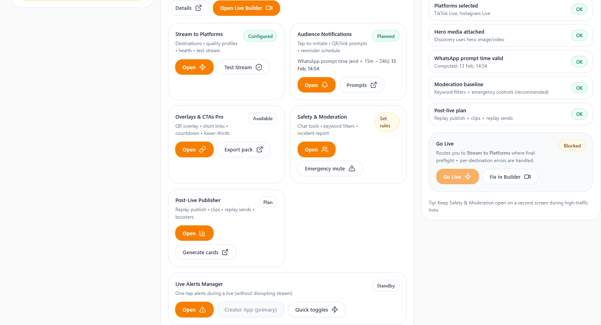
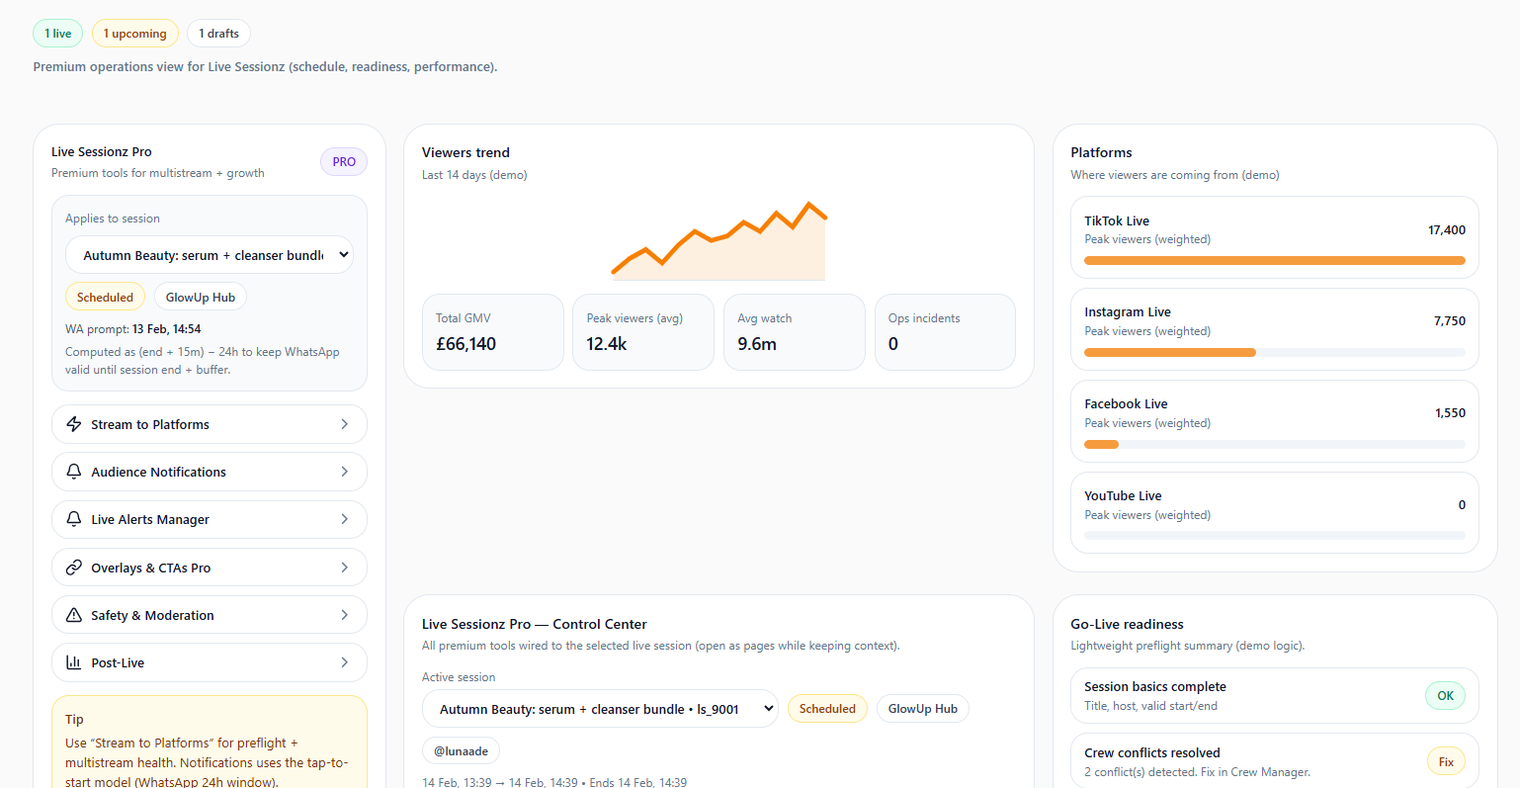
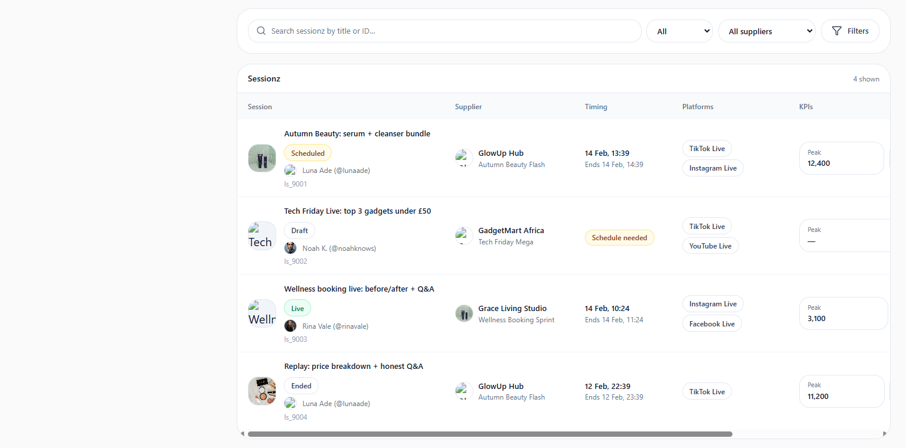

Requirements:
- Remove unnecessary vertical and horizontal spacing (marked areas) to make the dashboard feel compact and premium.
- Ensure responsive scaling across all breakpoints (mobile, tablet, desktop, wide desktop).
- Preserve Pro sub-links mini-sidebar behavior (do not alter navigation logic or interactions).
- Vertical spacing not removed.
- Responsiveness not achieved

OPPORTUNITIES
Suppliers Directory Page: restrict opportunity visibility
Surface: Suppliers Directory
Requirements:
- Creators should only see opportunities from suppliers they are actively collaborating with.
- Hide opportunities from suppliers that are not open for collaboration or not linked to the creator.
- Invite-only suppliers should no appear and request invite does no also apply here.

PROPOSAL INBOX: My pitch
Surface: Proposal inbox-proposals
Requirements
- Remove the proposal journey flow UI.
- Remove “Accept Proposal” and “Reject Proposal” buttons (no creator-side acceptance workflow required here).
- This applies only to “My Pitch”. Retain the proposal journey flow UI and the “Accept Proposal”, “Reject proposal” buttons for all proposals from the supplier.

IPHONE 13 OBSERVATIONS

Issue: Responsiveness
- General responsiveness is lacking on iPhone 13.
- UI elements do not adapt properly to screen size and device constraints.
ONBOARDING -Payout Details
Issue: Payout Policy & Settlement Rules Gate
Surface: Payout Policy & Settlement Rules Section
Observed Problems
- No enforcement gate before proceeding.
- User can bypass the policy by simply ticking the checkbox without reading or scrolling through the content.

REVIEW AND SUBMIT
Issue 1: Full Policy Document Gate
Surface: Full Policy Document Section
Observed Problems
- No scroll enforcement gate.
- User was able to submit for approval without scrolling through the policy document.
Issue 2: Post-Submission Navigation Flow
Observed Problems
- After tapping Submit for Approval, the app redirects back to Onboarding Page 1 (Profile Basics).
- This creates confusion and suggests submission failed or onboarding restarted.

