**A novel one-class convolutional** **autoencoder combined with excitation-emission matrix fluorescence spectroscopy for authenticity identification of food**

Xiaoqin Yan1, Baoshuo Jia1, Wanjun Long2, Kun Huang1, Tong Wang*,1, Hailong Wu*,1, Ruqin Yu1

1. State Key Laboratory of Chemo/Biosensing and Chemometrics, College of Chemistry and Chemical Engineering, Hunan University, Changsha, 410082, PR China
2. The Modernization Engineering Technology Research Center of Ethnic Minority Medicine of Hubei Province, School of Pharmaceutical Sciences, South-Central Minzu University, Wuhan 430074, PR China

*Corresponding author 1: Tong Wang

*State Key Laboratory of Chemo/Biosensing and Chemometrics, College of Chemistry and Chemical Engineering, Hunan University, Changsha 410082, People's Republic of China*

E-mail: [wangtong@hnu.edu.cn](mailto:wangtong@hnu.edu.cn)

* Corresponding author 2: Hailong Wu

*State Key Laboratory of Chemo/Biosensing and Chemometrics, College of Chemistry and Chemical Engineering, Hunan University, Changsha 410082, People's Republic of China*

E-mail: [hlwu@hnu.edu.cn](mailto:hlwu@hnu.edu.cn)

**Table of Contents**

Table S1 The overview of each part of the optimized convolutional autoencoder 1

Figure S1 The loss curve 1

Figure S2 The ablation experimental results 2

Figure S3 The authenticity identification results from the CAO case 2

Figure S4 The raw and reconstructed spectra from the CAO case 3

Figure S5 The visualization results from the CAO case 3

Figure S6 The classification results of four anomaly detection methods in the CAO case. 4

Figure S7 The classification results of OC-CAE and PLS-DA methods in the two cases. 5

# Table S1 The overview of each part of the optimized convolutional autoencoder

**Table S1** The overview of each part of the optimized convolutional autoencoder.

|  |  |  |  |  |  |  |
| --- | --- | --- | --- | --- | --- | --- |
| Name | Input | Kernel size | Stride | Padding | Activation Function | Output |
| Conv1 | [1,1,80,120] | 3×3 | 1 | 1 | ReLU | [1,16,80,120] |
| Maxpool1 | [1,16,80,120] | 2×2 | 2 | 0 |  | [1,16,40,60] |
| Conv2 | [1,16,40,60] | 3×3 | 1 | 0 | ReLU | [1,32,38,58] |
| Maxpool2 | [1,32,38,58] | 2×2 | 2 | 0 |  | [1,32,19,39] |
| FC1 | 23712 |  |  |  |  | 120 |
| FC2 | 120 |  |  |  |  | 32 |
| FC3 | 32 |  |  |  |  | 120 |
| FC4 | 120 |  |  |  |  | 23712 |
| Maxunpool1 | [1,32,19,39] | 2×2 | 2 | 0 |  | [1,32,38,58] |
| Deconv1 | [1,32,38,58] | 3×3 | 1 | 0 | ReLU | [1,16,40,60] |
| Maxunpool2 | [1,16,40,60] | 2×2 | 2 | 0 |  | [1,16,80,120] |
| Deconv2 | [1,16,80,120] | 3×3 | 1 | 1 | Tanh | [1,1,80,120] |

# Figure S1 The loss curve

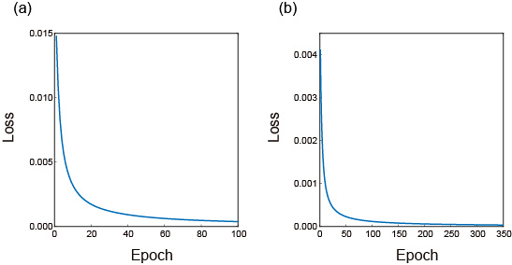

**Figure S1** The loss curves obtained by convolutional autoencoder through the data-augmented training set;

(a) ZAV case (b) CAO case.

# Figure S2 The ablation experimental results

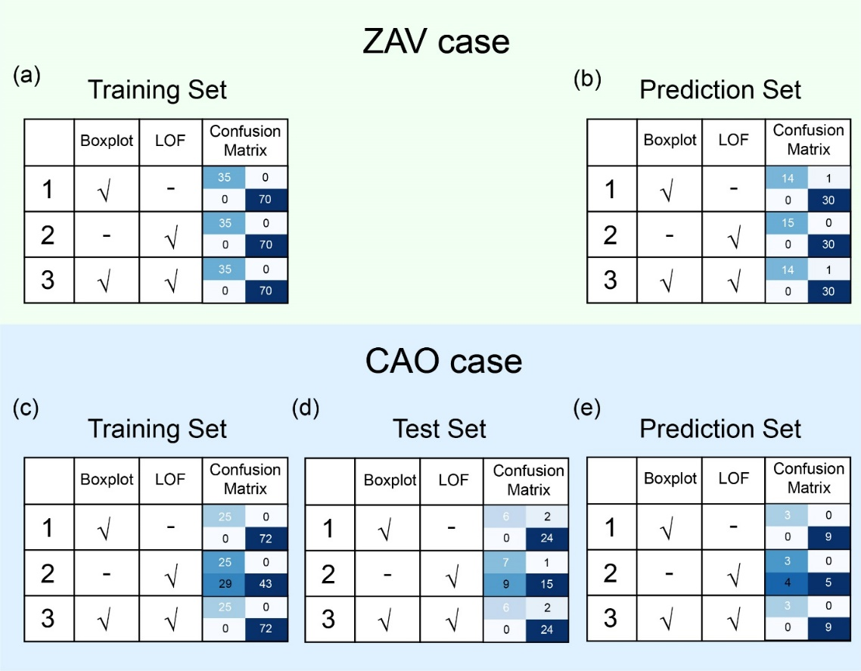

**Figure S2** The ablation experimental results of ZAV case (a-b) and CAO case (c-e).

# Figure S3 The authenticity identification results from the CAO case

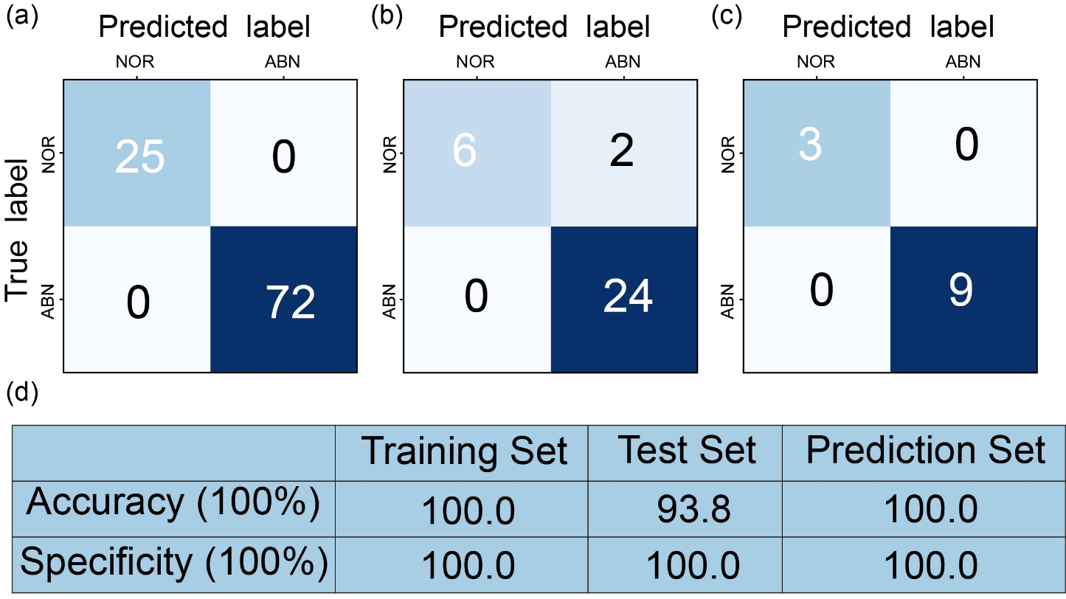

**Figure S3** The authenticity identification results obtained by the CAO case based on the OC-CAE model, where (a), (b) and (c) were the confusion matrices of the training set, test set and prediction set in the CAO case respectively, NOR represented the normal samples and ABN represented abnormal samples. (d) the accuracies and specificities obtained by the OC-CAE model.

# Figure S4 The raw and reconstructed spectra from the CAO case

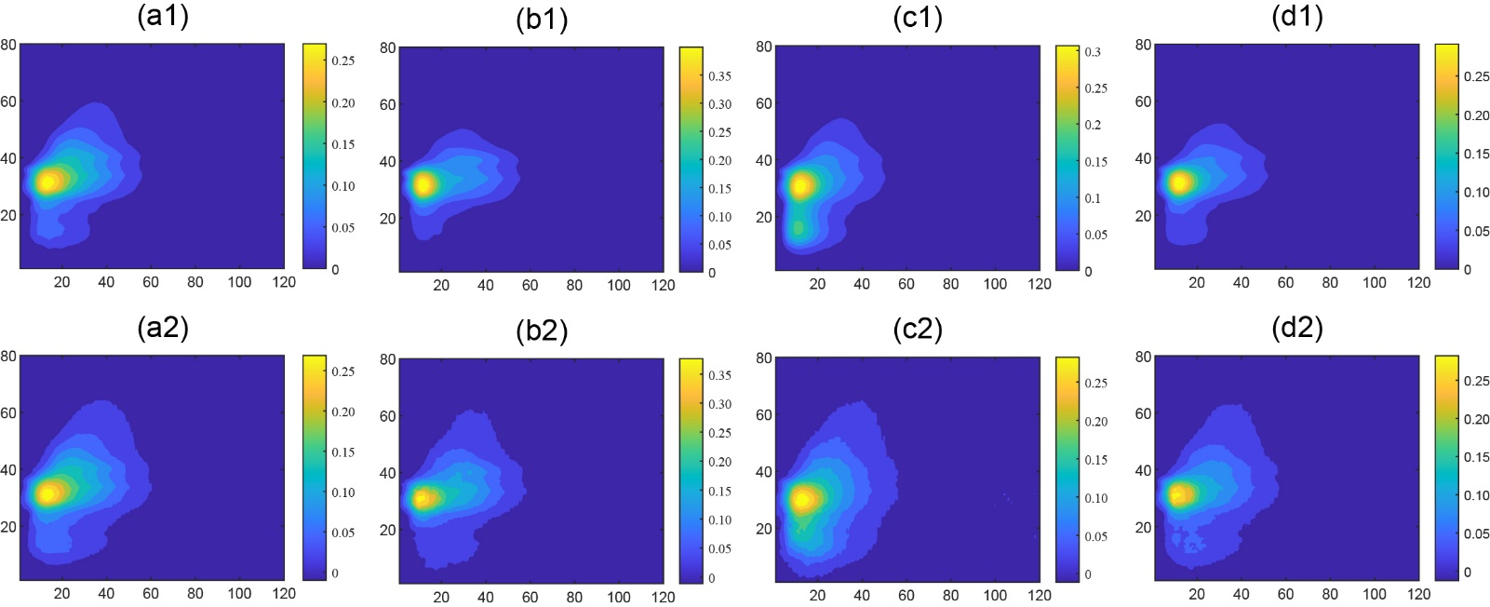

**Figure S4** The raw spectra and reconstructed spectra from CAO case; The raw spectra of pure CAO (a1), adulterated CAO with SBO (b1), adulterated CAO with PO (c1) and adulterated CAO with SO (d1); The reconstructed spectra of pure CAO (a2), adulterated CAO with SBO (b2), adulterated CAO with PO (c2) and adulterated CAO with SO (d2).

# Figure S5 The visualization results from the CAO case

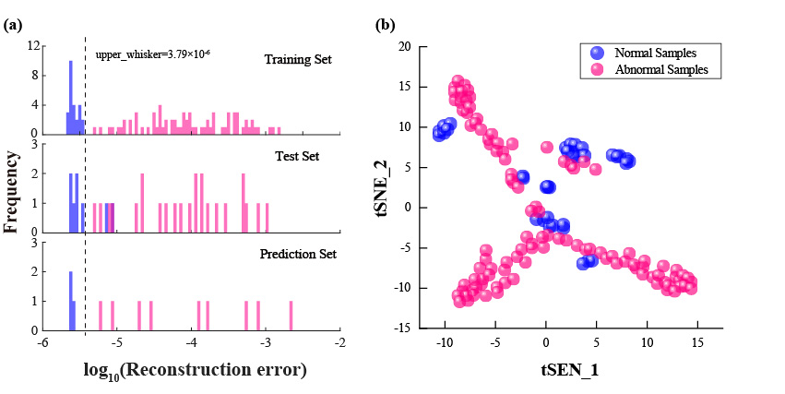

**Figure S5** The visualization results obtained by CAE on the CAO case; (a) the histogram of the reconstruction errors; (b) the t-SNE result of the features extracted by the hidden layer in the convolutional autoencoder.

# Figure S6 The classification results of four anomaly detection methods in the CAO case.

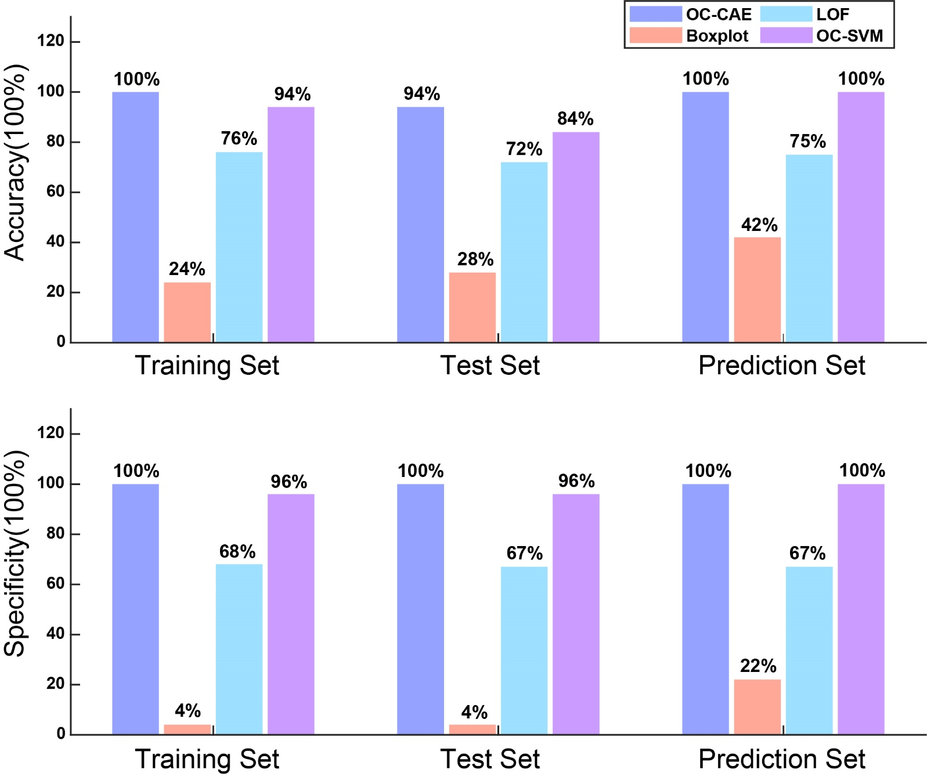

**Figure S6** The classification results obtained by four anomaly detection methods in the CAO case.

# Figure S7 The classification results of OC-CAE and PLS-DA methods in the two cases.

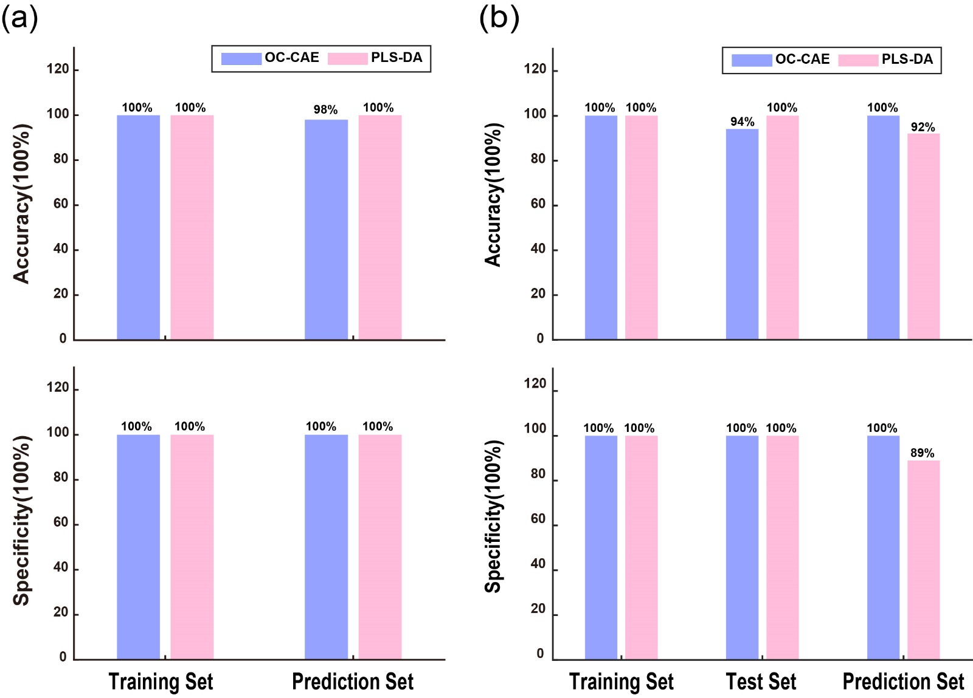

**Figure S7** The classification results of OC-CAE and PLS-DA methods in the two cases. (a) ZAV case (b) CAO case.