Anna University Regional Campus Coimbatore

Anna University: Chennai-600 025

DEPARTMENT OF ELECTRONICS AND COMMUNICATION ENGINEERING



IBM Naan Mudhalvan Phase 4 Submission

**Development Part-II**

**Title**: **AIR QUALITY ANALYSIS AND PREDICTION IN TAMILNADU**

Name : N ARISTATILE

Register Number: 710021106002

Department :ECE

Sem/year :5,3

Air Quality Analysis and Prediction in Tamil Nadu

**Objective:**

The Objective of the project is to analyze and visualize the air quality data from the various monitoring stations in Tamil Nadu. The give dataset contains the measurements of the various gases that release into the atmosphere. Some of the gases that given in the dataset are Sulphur Dioxide(SO2), Nitrogen Dioxide(NO2) and Respirable particulate matter and these are measured in different cities, villages, towns. This Project aim is to gain the insight of air pollution trends, estimate the RSPM/PM10 levels based on SO2 and NO2 levels

**Description of dataset:**

The link for the chosen dataset is mentioned below,

[https://tn.data.gov.in/resource/location-wise-daily-ambient-air-quality-tamil-nadu-year-2014](https://tn.data.gov.in/resource/location-wise-daily-ambient-air-quality-tamil-nadu-year-2014indias-state-wise-air-quality-data-tamil-nadu)

The above dataset contains the combined version of air quality of Tamil Nadu. This contains the district wise dataset for the prediction of air quality parameter in the state of Tamil Nadu. This data was released by the Ministry of Environment and Forests and Central Pollution Control Board of India under the National Data Sharing and Accessibility Policy

OVERVIEW OF THE PROCESS

The following steps are the overview of the process of building an air quality analysis and prediction model.

**STEP1: Choosing a dataset**

Choosing the proper dataset for implementing the project

**STEP2: Data Pre-processing**

In data pre-processing we have selected data for the analysis of air quality in the various district of Tamil Nadu. Each of the dataset was cleaned by remove null values of the chosen dataset. Microsoft Excel Software was used to remove unnecessary, irrelevant and erroneous data.

**STEP3: Splitting of the dataset**

The chosen datasets are split into training and test data. These are used to train the model and then test it against the original data. The values predicted by the machine learning algorithm and to predict accuracy of the data.

**STEP4: Training the dataset**

Empirical studies show the best results which are obtained if 80% of the data is used for training. Random sampling is used as a way to divide the data into train and test sections. It is widely accepted and is very popular.

**STEP5: Testing the dataset**

Empirical studies show the best results that are obtained if the remaining 20% of the data is used for testing. Random sampling is used as a way to divide the data into train and test sections. It is widely accepted and is very popular.

**STEP6: Feature Scaling**

The data should be normalized in order to make the dataset more flexible and more consistent. Standard Scalar from Scikit-Learn Library has been used to do so. It normalizes the features by deleting the mean and scaling the unit variance

**STEP7: Applying various Machine learning techniques**

After the normalization, we need to apply the various machine learning technique for analysing the data. Some of the machine learning technique random forest regression, support vector regression which are used to analysis the air quality index.

STEP8:**Applying ML technique-random forest regression**  
Random forest is a supervised machine learning algorithm that is used for classification and regression problems. It creates decision trees from several samples, using the majority vote for classification and the average in the case of regression. A random forest produces precise predictions that are easy to understand. Effective handling of large datasets is possible.

STEP 9:**Calculation of evaluation metric for each ML techniques**  
The metrics used for the proposed work are R-SQUARE, MSE, RMSE, MAE, and the accuracy of various algorithm.

**STEP 10: Determine the efficient Visualization techniques**

Visualizations play a crucial role in conveying insights from air quality data analysis. Here are some visualization methods and techniques that can be employed in the **“Air Quality Analysis and Prediction in Tamil Nadu”**

**CODE:**

Loading the pre-processed dataset:

import pandas as pd

df=pd.read_csv('preprocessed_airquality.csv')

**One Hot Encoding:**

For categorical variables where no such ordinal relationship exists, the integer encoding is not enough.

In fact, using the one hot encoding technique and allowing the model to assume a natural ordering between categories may result in poor performance or unexpected results. This can be applied to the integer representation.

pd.get_dummies(df,columns=['City/Town/Village/Area','Type of Location'])

dist=(df['City/Town/Village/Area'])

distset=set(dist)

dd=list(distset)

dict0fwords={dd[i]:i for i in range(0,len(dd))}

df['City/Town/Village/Area']=df['City/Town/Village/Area'].map(dict0fwords)

dist=(df['Type of Location'])

distset=set(dist)

dd=list(distset)

dict0fwords={dd[i]:i for i in range(0,len(dd))}

df['Type of Location']=df['Type of Location'].map(dict0fwords)

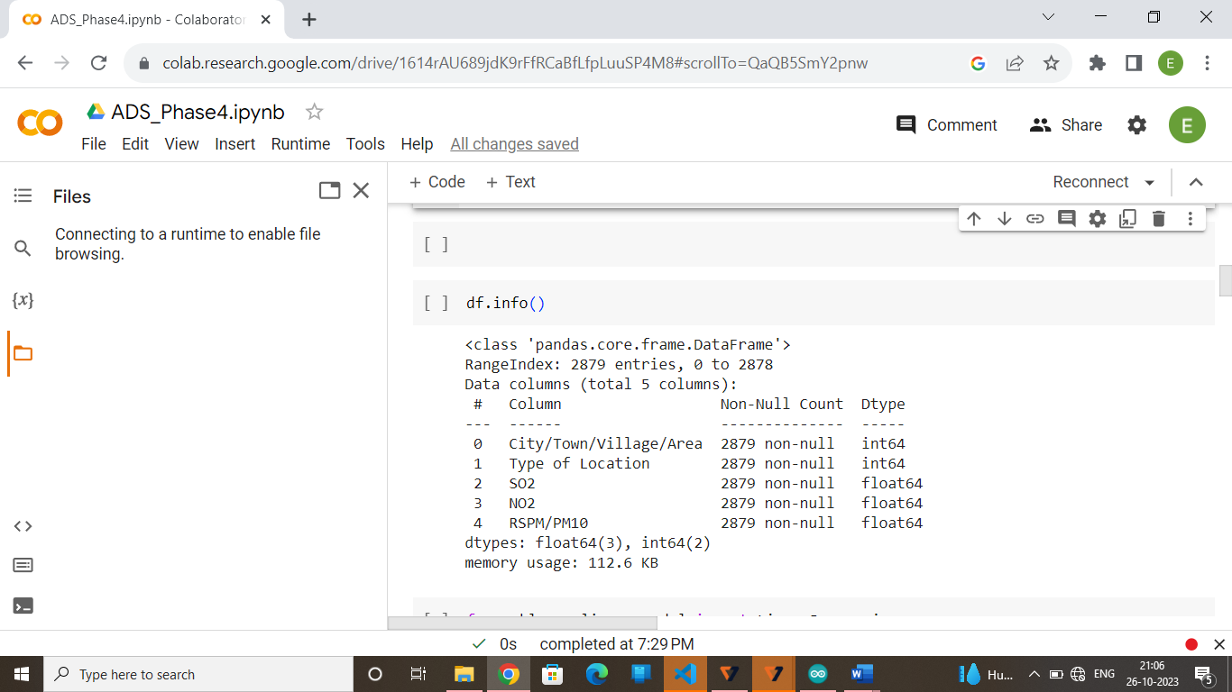

Model Training:

* Choose a machine learning algorithm
* There are number of different machine learning algorithms that can be used for air quality analysis such as linear regression, KNN, Lasso Regression and Random Forests.

Model Evaluation:

* Model Evaluation is the process of assessing the performance of a machine learning model on unseen data. This is important to ensure that the model will generalize well to the new data.
* There are number of different metrics that can be used to evaluate the performance of air quality analysis and prediction model
* Some of the most common metrics include:
* **Mean Squared Error (MSE):** This metric measures the average squared difference between the different areas/cities in Tamil Nadu and the various pollutants such as SO2, NO2 and RSPM/PM10.
* **Root Mean Squared Error (RMSE):** This metric is the square root of the MSE
* **Mean Absolute Error (MAE):** This metric measures the average absolute difference between the different areas/cities in Tamil Nadu and the various pollutants such as SO2, NO2 and RSPM/PM10.
* **R-Squared:** This metric measures how well the model explains the variation in the pollutants in the different areas.

Linear Regression:

from sklearn.linear_model import LinearRegression

from sklearn.model_selection import train_test_split

X=df[['City/Town/Village/Area']].values

y=df[['SO2','NO2','RSPM/PM10']].values

X_train,X_test,y_train,y_test=train_test_split(X,y,test_size=0.2,shuffle=False)

lr_model=LinearRegression()

lr_model.fit(X_train,y_train)

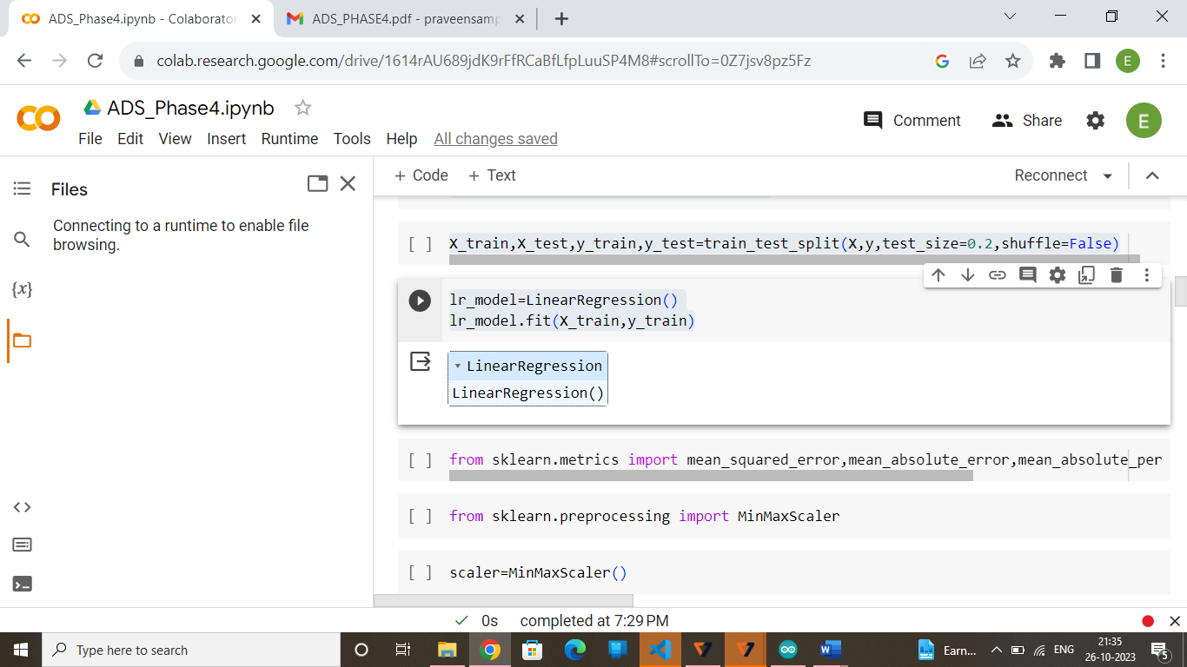

from sklearn.metrics import mean_squared_error,mean_absolute_error,mean_absolute_percentage_error,r2_score

from sklearn.preprocessing import MinMaxScaler

scaler=MinMaxScaler()

X=scaler.fit_transform(X)

y=scaler.fit_transform(y.reshape(-1,1))

y_pred=lr_model.predict(X_test)

lr_model.fit(X_train,y_train)

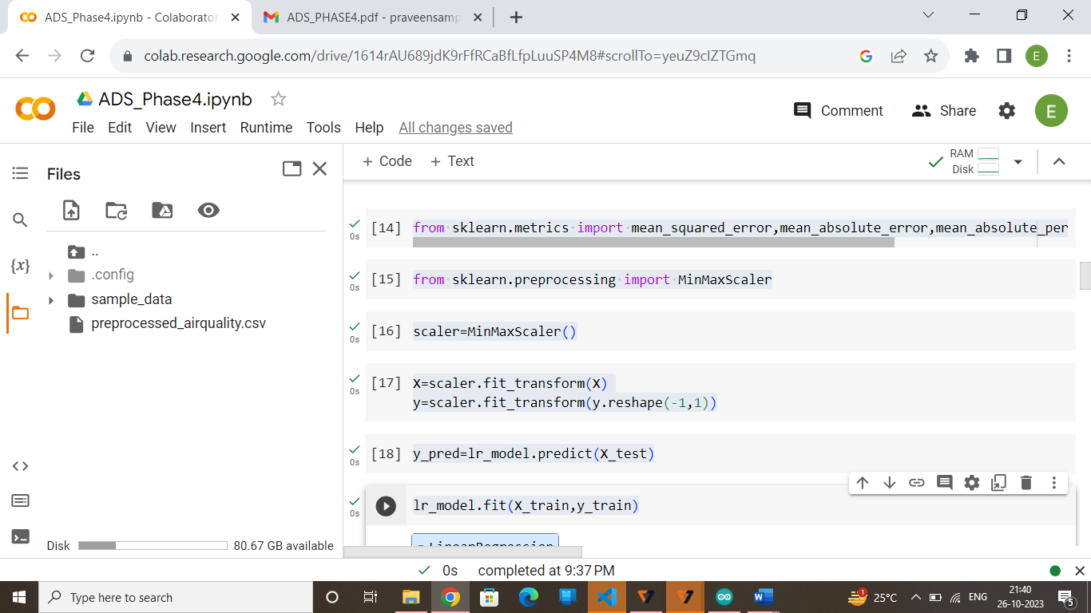

y_pred=scaler.inverse_transform(y_pred)

import numpy as np

validation=[["MSE:",mean_squared_error(y_test,y_pred)],["RMAE:",np.sqrt(mean_absolute_error(y_test,y_pred))],

 ["MAE:",mean_absolute_error(y_test,y_pred)],["r2:",r2_score(y_test,y_pred)]]

for name,val in validation:

  val=val

  print(name,round(val,3))

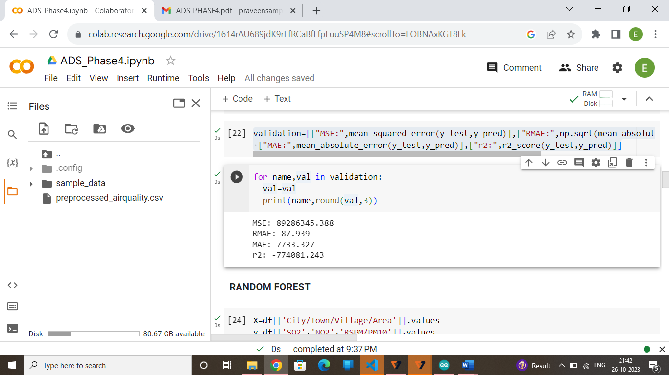

**RANDOM FORESTS:**

X=df[['City/Town/Village/Area']].values

y=df[['SO2','NO2','RSPM/PM10']].values

X_train,X_test,y_train,y_test=train_test_split(X,y,test_size=0.2,shuffle=False)

**Model Training**

from sklearn.ensemble import RandomForestRegressor

rf_model=RandomForestRegressor(n_estimators=100,random_state=0)

rf_model.fit(X_train,y_train)

**Model Evaluation**

from sklearn.metrics import mean_squared_error

import math

y_pred=rf_model.predict(X_test)

mse=mean_squared_error(y_test,y_pred)

rmse=math.sqrt(mse)

print(f"Mean squared error:{mse}")

print(f"Root Mean squared error:{rmse}")

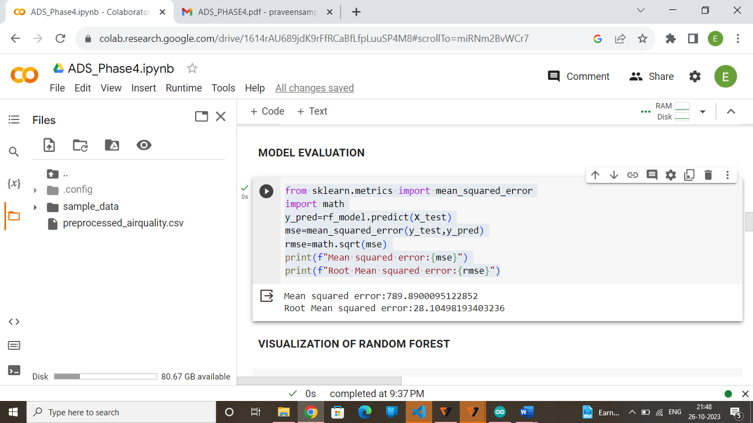

**Visualization of Random Forest**

import matplotlib.pyplot as plt

data_range=df.index[-len(y_test):]

plt.figure(figsize=(12,6))

plt.plot(df['City/Town/Village/Area'],label='Areas',linewidth=2)

plt.plot(df['NO2'],label='Pollution of NO2',linewidth=2)

plt.title("AIR QUALITY ANALYSIS")

plt.xlabel('Areas')

plt.ylabel('Pollution')

plt.legend()

plt.grid()

plt.show()

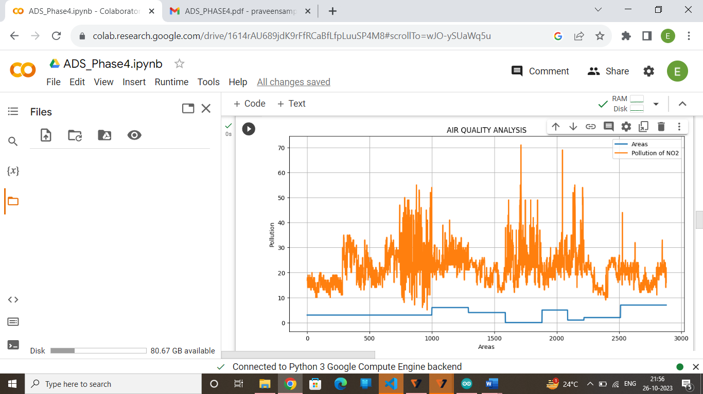

import matplotlib.pyplot as plt

data_range=df.index[-len(y_test):]

plt.figure(figsize=(12,6))

plt.plot(df['City/Town/Village/Area'],label='Areas',linewidth=2)

plt.plot(df['SO2'],label='Pollution of SO2',linewidth=2)

plt.title("AIR QUALITY ANALYSIS")

plt.xlabel('Areas')

plt.ylabel('Pollution')

plt.legend()

plt.grid()

plt.show()

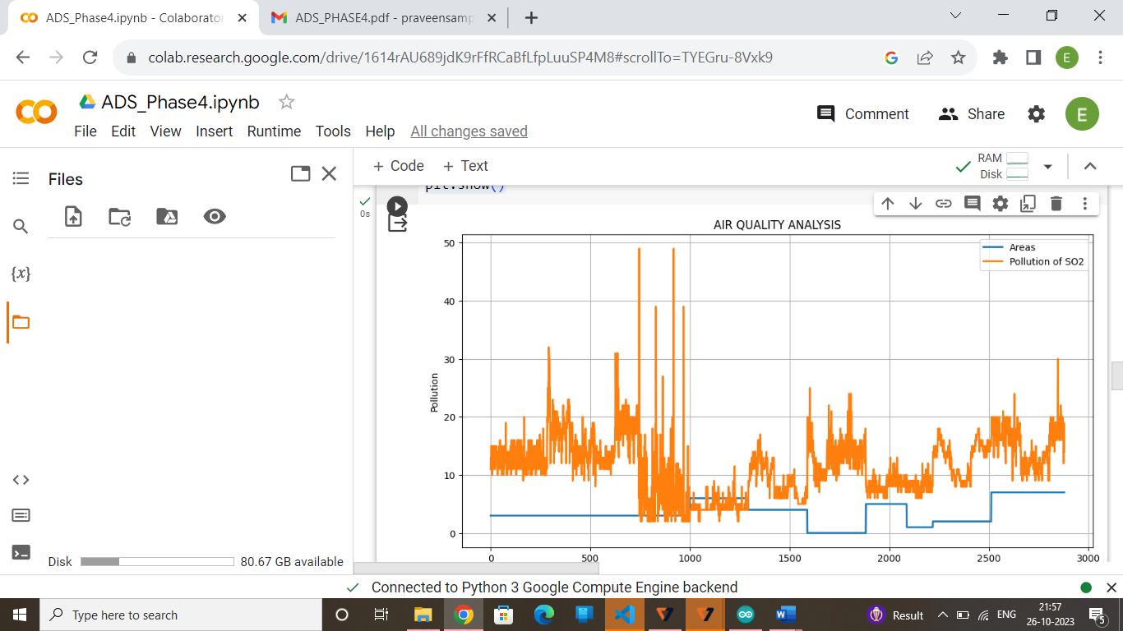

import matplotlib.pyplot as plt

data_range=df.index[-len(y_test):]

plt.figure(figsize=(12,6))

plt.plot(df['City/Town/Village/Area'],label='Areas',linewidth=2)

plt.plot(df['RSPM/PM10'],label='Pollution of RSPM/PM10',linewidth=2)

plt.title("AIR QUALITY ANALYSIS")

plt.xlabel('Areas')

plt.ylabel('Pollution')

plt.legend()

plt.grid()

plt.show()

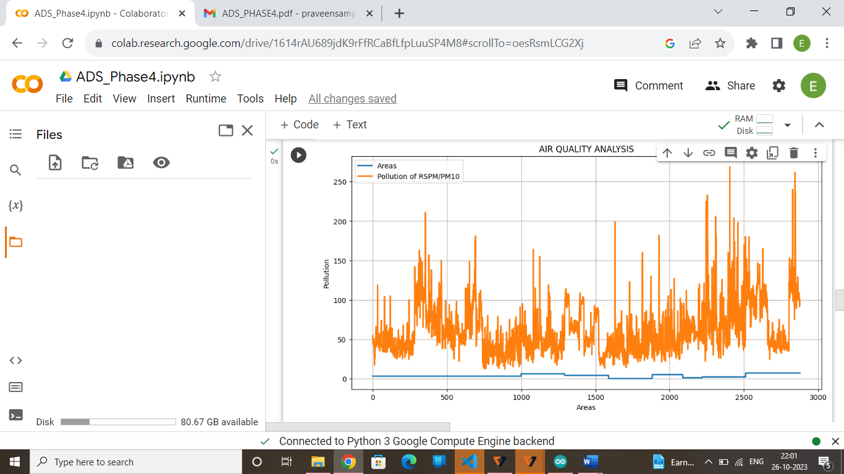

**KNN:**

X=df[['City/Town/Village/Area']].values

y=df[['SO2','NO2','RSPM/PM10']].values

X_train,X_test,y_train,y_test=train_test_split(X,y,test_size=0.2,shuffle=False)

from sklearn.neighbors import KNeighborsRegressor

knn_model=KNeighborsRegressor(n_neighbors=5)

knn_model.fit(X_train,y_train)

from sklearn.metrics import mean_squared_error

import math

y_pred=knn_model.predict(X_test)

mse=mean_squared_error(y_test,y_pred)

rmse=math.sqrt(mse)

print(f"Mean squared error:{mse}")

print(f"Root Mean squared error:{rmse}")

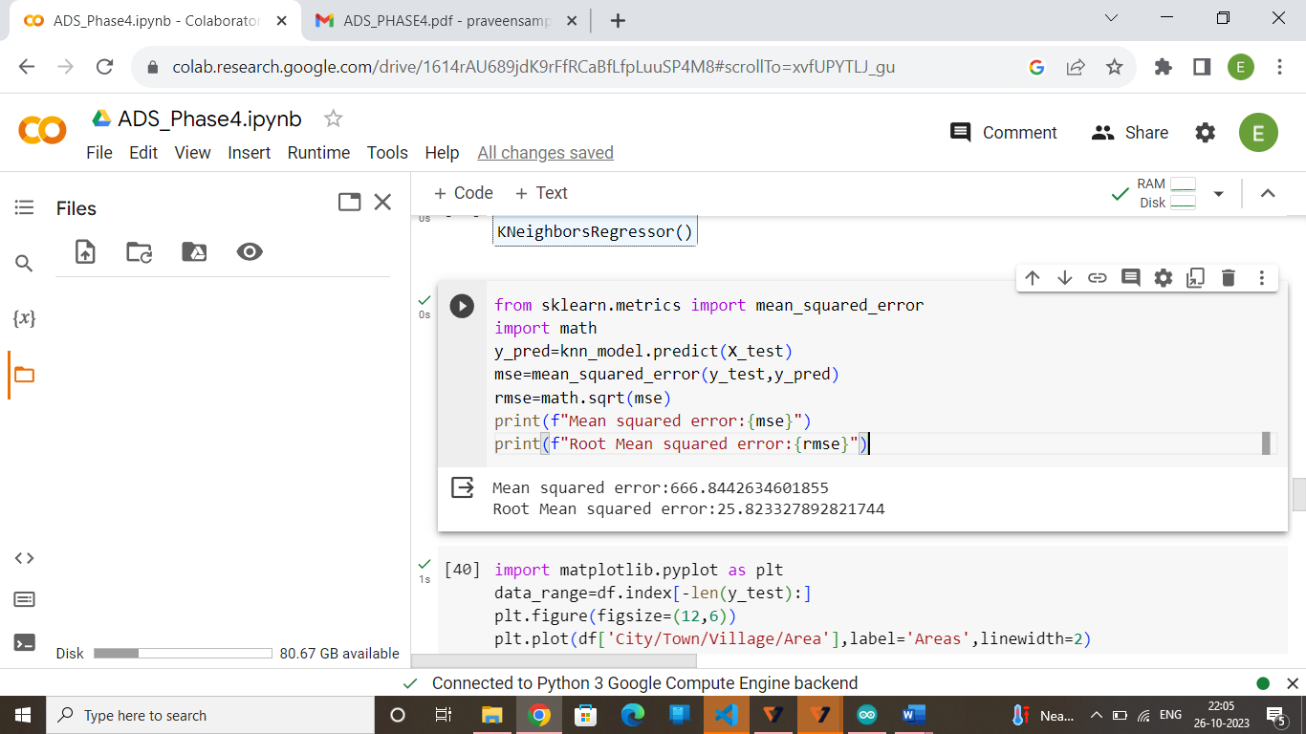

import matplotlib.pyplot as plt

data_range=df.index[-len(y_test):]

plt.figure(figsize=(12,6))

plt.plot(df['City/Town/Village/Area'],label='Areas',linewidth=2)

plt.plot(df['NO2'],label='Pollution of NO2',linewidth=2)

plt.title("AIR QUALITY ANALYSIS")

plt.xlabel('Areas')

plt.ylabel('Pollution')

plt.legend()

plt.grid()

plt.show()

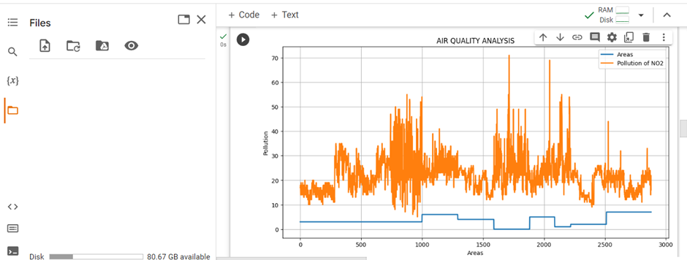

import matplotlib.pyplot as plt

data_range=df.index[-len(y_test):]

plt.figure(figsize=(12,6))

plt.plot(df['City/Town/Village/Area'],label='Areas',linewidth=2)

plt.plot(df['SO2'],label='Pollution of SO2',linewidth=2)

plt.title("AIR QUALITY ANALYSIS")

plt.xlabel('Areas')

plt.ylabel('Pollution')

plt.legend()

plt.grid()

plt.show()

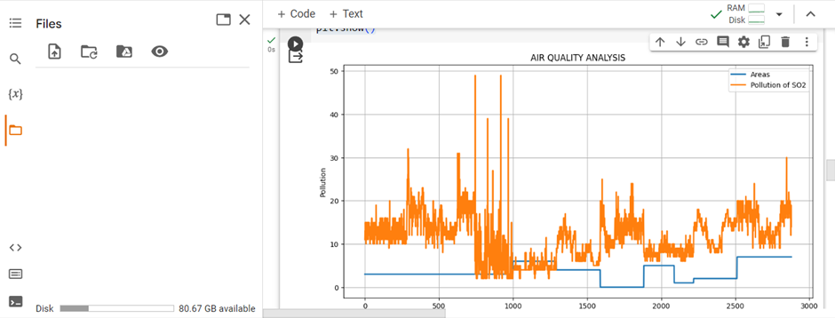

import matplotlib.pyplot as plt

data_range=df.index[-len(y_test):]

plt.figure(figsize=(12,6))

plt.plot(df['City/Town/Village/Area'],label='Areas',linewidth=2)

plt.plot(df['RSPM/PM10'],label='Pollution of RSPM/PM10',linewidth=2)

plt.title("AIR QUALITY ANALYSIS")

plt.xlabel('Areas')

plt.ylabel('Pollution')

plt.legend()

plt.grid()

plt.show()



**Import Libraries:**

from sklearn.linear_model import Lasso,SGDRegressor,Ridge

from sklearn.svm import SVR

from sklearn.gaussian_process import GaussianProcessRegressor

from sklearn.tree import DecisionTreeRegressor

from sklearn.model_selection import train_test_split

import seaborn as sns

**Model Training:**

X_train,X_test,y_train,y_test=train_test_split(X,y,test_size=0.2,shuffle=False)

ms=[]

ma=[]

mse=mean_squared_error

mae=mean_absolute_error

def model_training_and_score(model):

  model.fit(X_train,y_train)

  y_pred=np.nan_to_num(model.predict(X_test))

  print(mse(y_test,y_pred))

  print(mae(y_test,y_pred))

  ms.append(mse(y_test,y_pred))

  ma.append(mae(y_test,y_pred))

**Model Evaluation:**

1. **Random Forest**

model=RandomForestRegressor(n_estimators=5)

model_training_and_score(model)

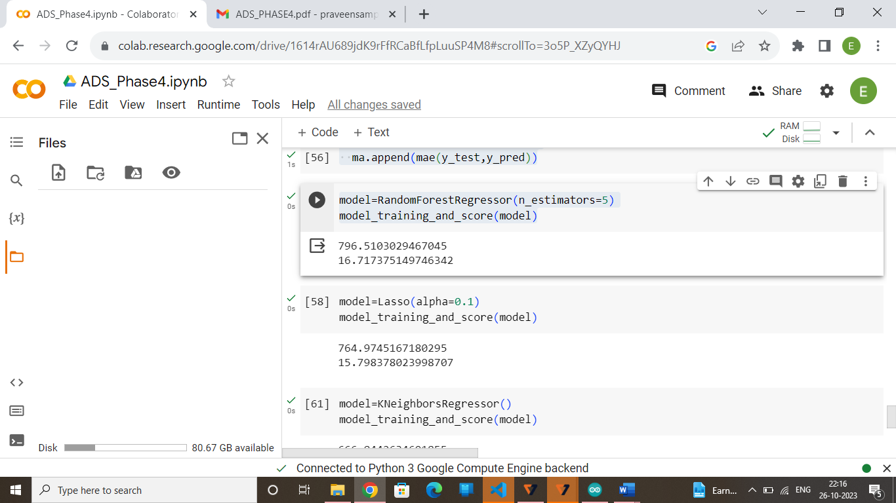

**2.Lasso Regrssion**

model=Lasso(alpha=0.1)

model_training_and_score(model)

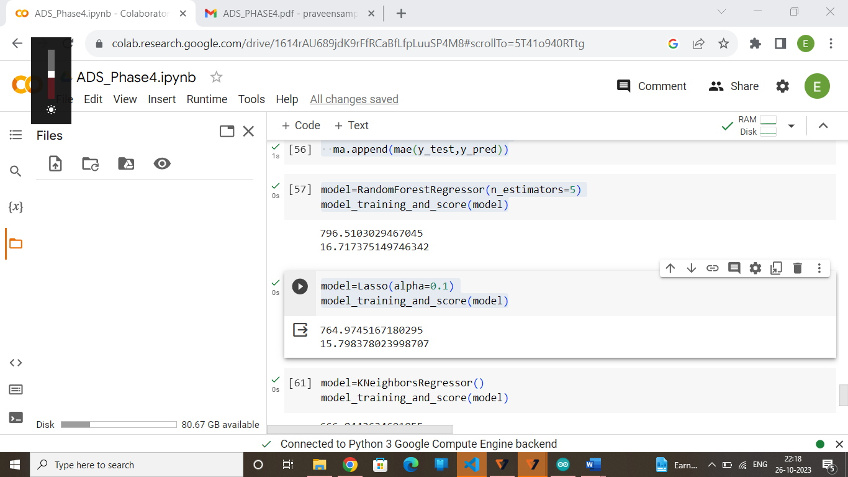

**3.K Neighbors Regression**

model=KNeighborsRegressor()

model_training_and_score(model)

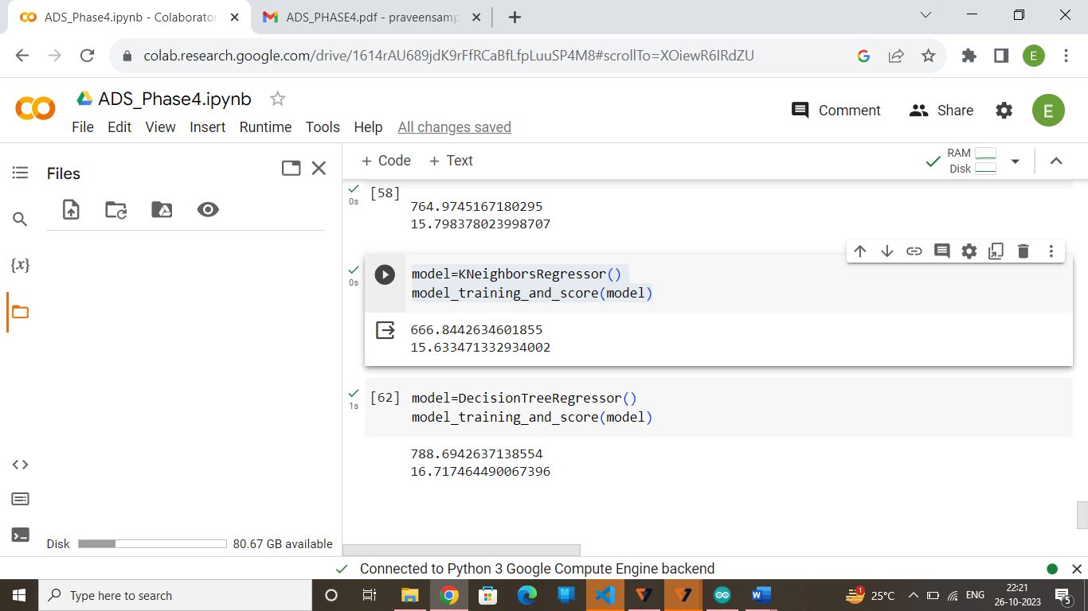

**4. Decision Tree Regression**

model=DecisionTreeRegressor()

model_training_and_score(model)

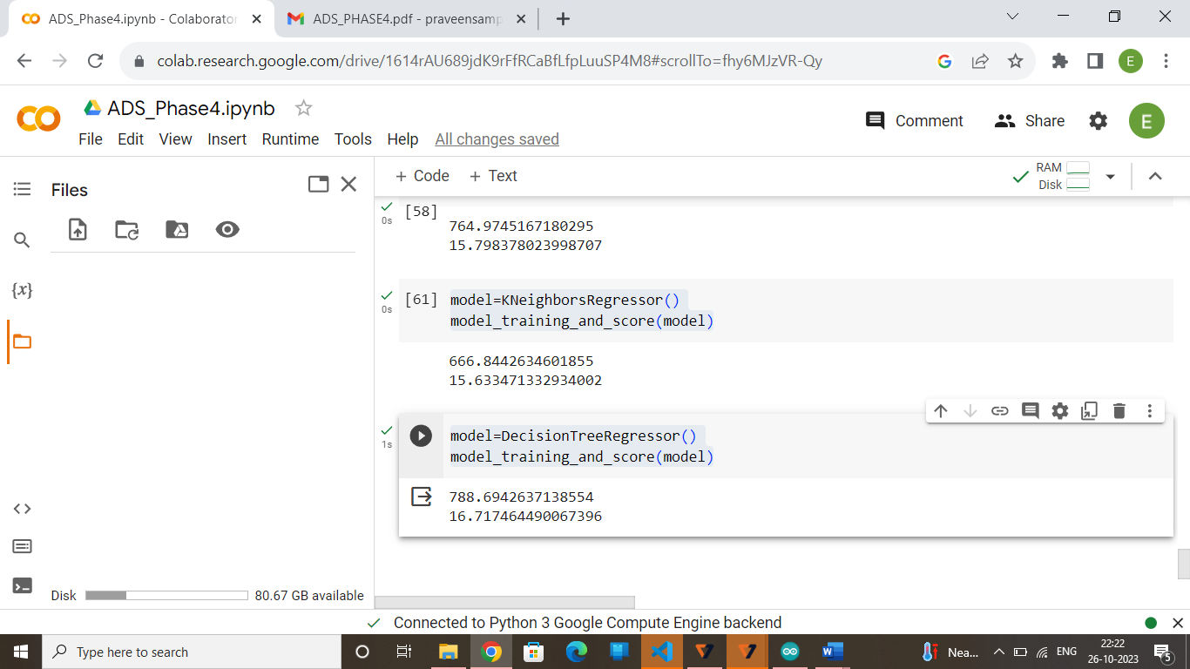

**CONCLUSION:**

In conclusion, while data science techniques can provide valuable insights into **air quality analysis and prediction in Tamil Nadu.** Moreover, it determines the various pollutants that affect the different cities in Tamil Nadu and it will be used to prediction of air quality across the various regions of Tamil Nadu to control the air pollution across the state