**ARRAYS**

#import <Foundation/Foundation.h>

int main ()

{

int n[ 10 ];

int i,j;

**for** ( i = 0; i < 10; i++ )

{

n[ i ] = i + 100; /* set element at location i to i + 100 */

}

**for** (j = 0; j < 10; j++ )

{

NSLog(@**"Element[%d] = %d\n"**, j, n[j] );

}

return 0;

}

**Creating an Array**

#import <Foundation/Foundation.h>

int main ()

{

NSString *object1 = @**"Hello"**;

NSString *object2 = @**"world!"**;

NSNumber *object3 = [NSNumber numberWithInt:45];

NSArray *myArray;

myArray= [NSArray arrayWithObjects: object1, object2, object3, nil];

NSLog(@**"Array contents = %@"**,[myArray componentsJoinedByString:@**", "**]);

return 0;

}

The code above generates the following result.

http://www.java2s.com/Tutorials/Objective_CImage/myResult/C/CREATING_AN_ARRAY__D26BE0EC10C1DD66F71B.PNG

**Accessing All Items in an Array**

#import <Foundation/Foundation.h>

int main ()

{

NSString *object1 = @**"Hello"**;

NSString *object2 = @**"world!"**;

NSString *object3 = @**"Good-bye"**;

NSArray *myArray;

myArray= [NSArray arrayWithObjects: object1, object2, object3, nil];

**for** (NSString *randomVariable in myArray)

{

NSLog (@**"Array element = %@"**, randomVariable);

}

return 0;

}

The code above generates the following result.

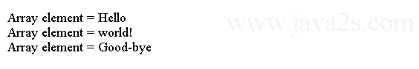

**Array for loop**

#import <Foundation/Foundation.h>

int main ()

{

NSString *object1 = @**"Hello"**;

NSString *object2 = @**"world!"**;

NSNumber *object3 = [NSNumber numberWithInt:45];

NSArray *myArray;

myArray= [NSArray arrayWithObjects: object1, object2, object3, nil];

int i;

**for** (i = 0; i < [myArray count]; i++)

{

NSLog (@**"Element %i = %@"**, i, [myArray objectAtIndex: i]);

}

return 0;

}

The code above generates the following result.

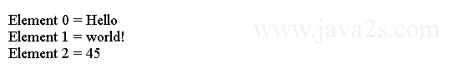

**Accessing an Item in an Array**

#import <Foundation/Foundation.h>

int main ()

{

NSString *object1 = @**"Hello"**;

NSString *object2 = @**"world!"**;

NSNumber *object3 = [NSNumber numberWithInt:45];

NSArray *myArray;

myArray= [NSArray arrayWithObjects: object1, object2, object3, nil];

NSLog(@**"Array contents = %@"**,[myArray componentsJoinedByString:@**", "**]);

NSLog (@**"Index position 1 = %@"**, [myArray objectAtIndex:1]);

return 0;

}

The code above generates the following result.

