 

Prediction of LC50 value using QSAR models







|  |  |  |  |
| --- | --- | --- | --- |
|  |  |  |  |
|  | 25/07/2023 | Arjun singh |  |
|  |  |  |  |
|  |  |  |  |
|  |  |  |  |
|  |  |  |  |
|  |  |  |  |



|  |  |  |  |
| --- | --- | --- | --- |
|  |  |  |  |
|  |  |  |  |



|  |  |  |  |  |
| --- | --- | --- | --- | --- |
|  |  |  |  |  |
|  |  |  |  |  |











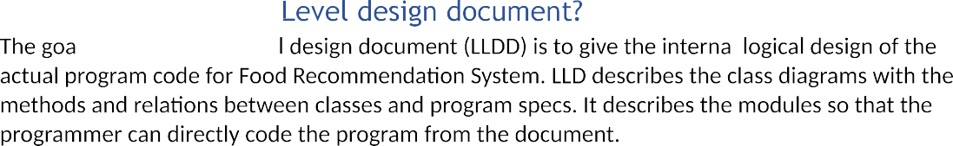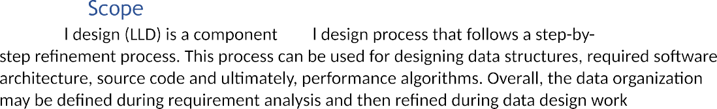





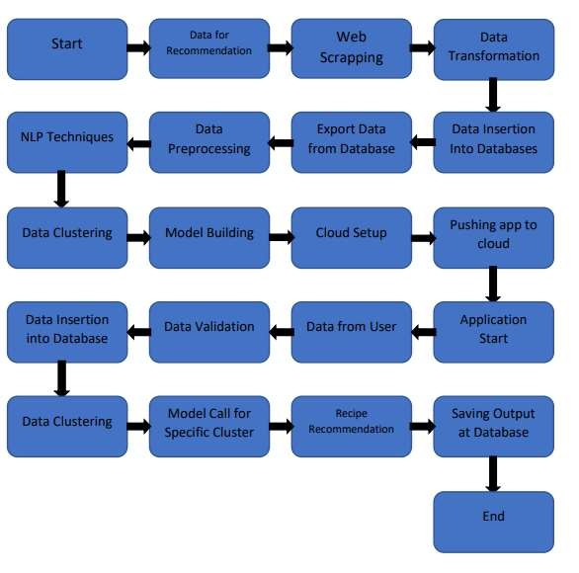









The architecture for predicting LC50 values using QSAR models involves several interconnected components, each serving a specific purpose in the model development and prediction process. The architecture design can be outlined as follows:

**1. Data Collection and Preprocessing:**

* Data Sources: Gather diverse and high-quality datasets containing chemical structures, experimental LC50 values, and relevant biological activity data from reputable sources or experimental studies.
* Data Preprocessing: Cleanse and preprocess the data to handle missing values, remove duplicates, and perform outlier detection to ensure data integrity and consistency.

**2. Molecular Representation:**

* Molecular Descriptors and Fingerprints: Extract molecular descriptors and fingerprints from the chemical structures to encode relevant physicochemical and structural features of the compounds.
* Feature Engineering: Perform feature engineering to enrich the dataset with additional descriptors or derived features that may enhance model performance.

**3. Algorithm Selection and Model Development:**

* Machine Learning Algorithms: Explore various machine learning algorithms such as support vector machines, random forests, gradient boosting, and neural networks to identify the most suitable models for LC50 prediction.
* Hyperparameter Tuning: Optimize hyperparameters for the chosen algorithms to improve model performance.

**4. Model Training and Validation:**

* Train-Test Split: Divide the preprocessed dataset into training and testing subsets to evaluate model performance effectively.
* Cross-Validation: Implement k-fold cross-validation on the training data to assess model generalization and minimize overfitting.
* External Validation: Validate the trained models on an independent test set to verify their performance in real-world scenarios.

**5. Model Interpretation:**

* Feature Importance Analysis: Conduct feature importance analysis to interpret the contribution of molecular descriptors to the prediction of LC50 values.
* Structure-Activity Relationship (SAR) Exploration: Analyze the learned relationships between chemical structures and biological activity to gain insights into the underlying toxicological mechanisms.

**6. Applicability Domain Definition:**

* Define the domain of applicability for the QSAR models based on the chemical space covered by the training data. Establish criteria for identifying compounds outside the applicability domain to provide appropriate warnings or limitations for predictions.

**7. Model Deployment and Integration:**

* Web or Desktop Application: Implement a user-friendly interface to deploy the trained QSAR models, allowing users to input chemical structures and obtain LC50 predictions.
* API Integration: Optionally, provide an Application Programming Interface (API) to enable integration of the QSAR models into other software systems or workflows.

**8. Performance Monitoring and Maintenance:**

* Performance Metrics: Continuously monitor model performance using appropriate metrics like mean squared error, correlation coefficient, and concordance index.
* Model Updates: Regularly update the models with new data to improve accuracy and adapt to changing chemical landscapes.

The architecture design ensures that the QSAR models for LC50 prediction are robust, accurate, and easily accessible to researchers and stakeholders. By following this design, the prediction of LC50 values using QSAR models becomes an efficient and valuable tool for toxicity evaluation, environmental risk assessment, and drug discovery processes.





 



we create a simple function **calculate_lc50** that takes a trained QSAR model and a molecular descriptor as inputs and returns the predicted LC50 value. The **test_calculate_lc50** function is a unit test that checks whether the **calculate_lc50** function produces the expected LC50 value for a given sample input. The **assert** statement checks if the absolute difference between the predicted LC50 and the expected LC50 is within an acceptable error range (0.01 in this example).

Unit tests like these help ensure that the individual components of the program (in this case, the **calculate_lc50** function) work correctly in isolation and can help detect any issues or bugs early in the development process.







      
      
      
      
      