

Vilnius Gediminas technical university

Faculty of fundamental sciences

Department of Information Technology

Students name and surname

Group code

**Report of Professional Internship 2**

Title of the internship/employment organization: „Company Name“

Supervisor in the organization: position Name Surname

Supervisor in the university: assoc. prof. Inga Tumasonienė

Vilnius, 202..

**Content**

1. Introduction 3

1.1. Area of the Internship 3

1.2. Aim of the Internship 3

1.3. Tasks of the Internship 3

2. Results of the Internship 5

2.1. Order Management Processes in ltd. “ABC“ 5

2.2. Overview of PrestaShop and TradeState Systems 5

2.3. Integration architecture of PrestaShop and TradeState systems 5

2.4. Implementation of PrestaShop and TradeState integration 6

2.5. Validation of the Integration Solution 6

3. Summary of Internship Plan and its Results 8

4. Conclusions 9

5. References 10

6. ANNEXES – Testimonial of Internship Supervisor in the Enterprise/Certificate on Work Experience (leave only one, appropriate for you) 11

7. Survey on Internship Search and Execution Process 12

1. Introduction

Note. Delete blue comments!!!!!!!!

Use this document as a template to produce an internship report. There will be some styles, which usage will allow to achieve consistent and suitable report formatting. All the blue italic text is as explanations, while chapter titles, examples will be presented in regular presentation, by using appropriate styles. As well you will find some recommendations, explanations on what should be presented in the report.

In the Introduction section, it is important to define the internship area, aim, and tasks. Each of them should be presented in different subsections, as presented below in the examples.

* 1. Area of the Internship

Define what the area of your internship is. It should be an explanation on what is the area, a sector where you plan to do the internship, and how it is connected to your study program and specialization. There is no need to go into details, but it is important to highlight why your internship area is suitable for the Information technology study program student. For example, the text could be similar to this:

Ltd. “ABC” is a bicycle manufacturer but actively uses digital and information technologies in their work. A department of Information technology and system center is established for information technology maintenance and information system management in the enterprise. The internship will be executed in this department and concentrated on order management processes and their automation.

Do not be afraid to mention in which department you will be working, maybe even in what position. And provide insights into why it is related to your study program. If it is obvious based on enterprise and your position in the internship, you can skip the explanation, however, it will not harm you if you will add it anyway, just to be sure you are not a delivery boy or girl in an IT company.

* 1. Aim of the Internship

You must provide what is the aim of your internship. Do not formulate the aim as your aim to learn something, to get experience, etc. You should get the aim from your supervisor in the enterprise, defining what is your aim in the organization, what you should achieve during the internship. For example:

Automate the management process of orders, obtained from the e-shop.

It is enough to provide one sentence. Do not present a list of tasks what has to be done, just what you try to achieve by doing all these tasks (tasks will be presented in the next subchapter). Make sure this sentence is discussed with your supervisor in the enterprise.

* 1. Tasks of the Internship

While the aim of the internship defines what you try to achieve in the internship, you should specify what exact tasks you have to achieve the aim. It is like steps that must be done in the internship. So those should be discussed with your supervisor in the enterprise as well.

List all tasks as a numbered list. There should be at least 3 tasks. There is a recommendation to have one of the tasks get introduced to the enterprise, its department, activity, system you will be working with, etc. For example, the list of tasks could look like this:

During the internship these tasks are planned to achieve the goal of the internship:

Understand the order management process in ltd. “ABC” organization.

Investigate the principles and architecture of e-shop and order management systems, used in the enterprise.

Prepare specification of e-shop and order management system integration possibilities.

Implement the designed e-ship and order management system integration solution.

Test the implemented solution, to validate the integration suitability and system load.

In this chapter you do not need to detail the tasks – just list them. What exactly was done in each of these tasks will be written in a further chapter.

1. Results of the Internship

In this chapter, you should summarize your results during the internship. Therefore you should provide information on what exactly you did, learned, what skills you achieved. There are no strict requirements for this chapter, but we recommend presenting the results of each task of the internship as a separate subchapter. The title of the chapter does not have to match the tasks but could be related to them. While in each of those subchapters you should present not only what you did, but present the results. For example, if you needed to analyze the structure of the organization – provide some description of the organization, maybe its structure, departments, operation areas, etc. If you had to design a system – present the specification, diagrams illustrating its architecture. If the results are very massive, takes a lot of pages – present just the main aspects, properties.

For example, based on the previously presented example tasks, the subchapter and content of each chapter could be as follows:

* 1. Order Management Processes in ltd. “ABC“

Illustrations, tables are preferred to summarize the situation, rather than just plain text. It helps the reader to understand the area better and proves you are capable to summarize data and visualize it. You can use UML, BPMN, or any other type of diagrams and pictures, which are appropriate to present the main aspects. This applies to all chapters, not thus this one.

* 1. Overview of PrestaShop and TradeState Systems

It’s a good example when you present general tasks in the introduction, while in the results you add more details, like what e-shop management system will be analyzed, etc.

All tables and figures (diagram, chart, image – all threaten as figures) must be numbered and have a title. The number and title of the table should be presented on top of the table, while the figure number and title must be below the image. There are some examples of tables and figure, just take into account all tables and figures should be mentioned in the text – it is not enough to add it, you should describe what is presented in it.

Comparison of PrestaShop and TradeState properties

|  |  |  |
| --- | --- | --- |
| **Function** | **PrestaShop** | **TradeState** |
| Item ordering form | Exists | Absent |
| ... | ... | ... |
| Order history export to *.CSV format file | Absent | Exists |

* 1. Integration architecture of PrestaShop and TradeState systems

You can use some data and images from other sources (it is an advantage you are basing your data on some references), however, do not forget to provide the reference to the source. It should be done by adding the source to the list of references at the end of the report, while in the text, where you are referencing the source, just add brackets with a number (for example [7]) of the source in the reference list. Usually, you are adding the reference at the end of the sentence, before the dot. If you are listing some elements, which are based on some reference – add the reference before the : sign, starting the listing. For example:

PrestaShop system has two main parts [1]:

1. Front office.

Back office.

These two parts are separated both in the front-end as well as back-end (see Fig. 1).

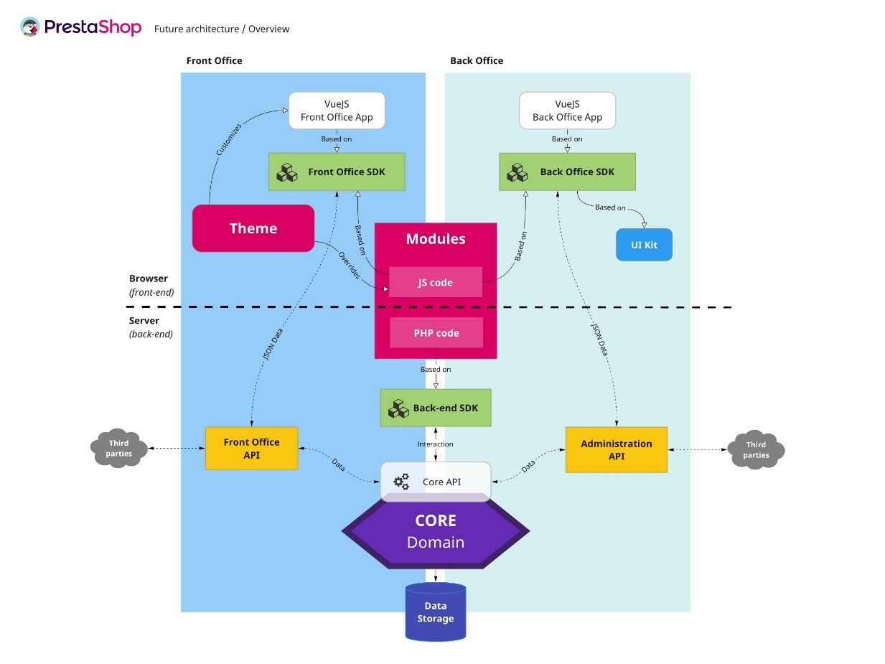

* + - * 1. Schema of PrestaShop integration points [1]
  1. Implementation of PrestaShop and TradeState integration

References should be used not just in text but for images and tables as well if it is taken from some source. Even if you took the idea and redrawn the image, you need to add the reference to the original source. This is valuable for understanding whether it is done completely by you, or somebody else. As well by adding references you will be sure there are no problems with plagiarism.

When you present the list of references, you should present the author (some person or list of persons, or organization, webpage title, if there is no specific person mentioned as author), title, and other data – publishing date, publisher, page numbers, URL, date of reading the source.

If you are placing the exact text from the source, it should be in brackets as well. Usually, you should not copy-paste the text, but read it and rewrite it by yourself. This allows gathering just the most important data. Even if you translate it or just read for some ideas – do not forget to add the reference. The reference provides evidence it is based on some external source, not just your thoughts.

* 1. Validation of the Integration Solution

There is a list of styles, which should be used for the formatting of the report. All styles, which you should use start with the letters PR. The description of those styles is presented in table 2.

Styles and their descriptions, proposed for the formatting of the report

|  |  |  |
| --- | --- | --- |
| **Style** | **Purpose** | **Parameters** |
| PR 1 level chapter | Chapter styles | 14 pt, Bold, no indent, justified alignment, 1.15 line spaces. |
| PR 1 level chapter | 12 pt, Bold, no indent, justified alignment, 1.15 line spaces. |
| PR 1 level chapter | 12 pt, Italic, no indent, justified alignment, 1.15 line spaces. |
| PR main text | Main text formatting | 12 pt, Normal, 1.27 cm first-line indent, justified alignment, 1.15 line spaces, 6 pt space between paragraphs. |
| PR numbered list | Tasks, reference list, and other numbered elements | Analog to the main text, just an additional 2 cm indent is used. |
| PR figure | Image and its title formats | Center alignment, no spaces after the image. |
| PR figure number and title | 11 pt, Italic, no indent, center alignment, 1.15 line spaces, 6 pt space after the title (used below the figure). |
| PR table text | Table and its title formats | 11 pt, Normal, no indent, justified alignment, 1.0 line spaces, no spaces between paragraphs. |
| PR table number and title | 11 pt, Italic, no indent, justified alignment, 1.15 line spaces, 6 pt space before the title (used above the table). |

All styles have the same font – Times New Roman. The page size is A4, where the margins are: left – 3 cm, right – 1 cm, top – 2 cm, bottom – 2 cm. The page numbers should be at the bottom of the page. The page number should not be shown on the title page.

Each first-level chapter should start on a new page (use page breaks, not enters).

1. Summary of Internship Plan and its Results

In this chapter, you should summarize what tasks were done, how you succeeded in it, how much time was spent on it, etc. You should fill a table, where all tasks should be mentioned, presenting how much time was spent on it and what is the accomplishment level (in percent). If you were not able to achieve 100% achievement of some tasks – provide some text to explain the reasons.

You can add some additional tasks, out of the official ones, if you were able to do it.

Additionally, one line should be dedicated to the preparation of the report.

While you will be assigning hours to each of the tasks – the total sum of hours should be 160 hours. It’s the duration of your internship, therefore the table serves as a prove you did all hours which were dedicated for the internship.

The work plan of the internship and its accomplishment level

|  |  |  |
| --- | --- | --- |
| **Tasks** | **Dedicated hours** | **Accomplishment percent (if it is not 100 %, provide the reason why)** |
| 1. Understand the order management process in ltd. “ABC” organization. | 12 | 100 % |
| 2. Investigate the principles and architecture of e-shop and order management systems, used in the enterprise. | 20 | 100 % |
| 3. Prepare specifications of e-shop and order management system integration possibilities. | 45 | 100 % |
| 4. Implement the designed e-ship and order management system integration solution. | 60 | 70 %, some integration options were eliminated because of the system load. |
| 5. Test the implemented solution, to validate the integration suitability and system load. | 10 | 100 % |
| PrestaShop theme editing based on new system design. | 10 | 100 % |
| Preparation of Internship report. | 3 | 100 % |
| Total | 160 |  |

The results of the internship are more important in comparison to the size of the report. However, the report should be at least 8 pages long and preferable not to exceed more than 20 pages (there is no need to present details of the internship, the main achieved results are more important).

To get the final mark for the internship you need to provide the report as well as testimonial of your supervisor in the enterprise. The form for the supervisor’s testimonial is presented in mano.vgtu.lt system. The supervisor should shortly describe what you did in the company and how he evaluates you – the mark for the internship has to be written (on a 10-grade scale).

The internship report should be presented in mano.vgtu.lt system (Studies 🡪 Internship).

The final mark for the internship is calculated based on the formula:

GP = 0,5 x VP + 0,5 x A

where VP – supervisors in the enterprise proposed mark, A – report mark, written by the supervisor in the university.

1. Conclusions

The report should be summarized by conclusions. You should summarize some new knowledge you gained during the internship, what insights you can provide on your work aspects (strong and week sides). You should provide at least two conclusions, orientated both on your specialty as well as personal improvement. For example, the conclusions could look similar to those:

1. The manual workload can be decreased by integrating two systems. It decreases the number of human errors as well, but at the same time requires additional system load, which has to be taken into account for suitable system operation.
2. The communication with colleagues during the internship was not complicated and it was easy to understand the principles of the enterprise. However, some personal self-confidence is still lacking as it was not easy to announce personal opinions and ideas loud among all colleagues.
3. References
4. Pablo Borowicz. PrestaShop In 2019 And Beyond, Part 3: The Future Architecture. Interactive <https://build.prestashop.com/news/prestashop-in-2019-and-beyond-part-3-the-future-architecture/>, viewed on 2021-06-22.
5. ANNEXES – Testimonial of Internship Supervisor in the Enterprise (form next page)/Certificate on Work Experience (leave only one, appropriate for you)

There you should present the testimonial of the internship supervisor in the enterprise, written on the form, available in mano.vgtu.lt system.

If you already have a job in an IT company, you can place a request to accept your working experience as an internship. This should be done in mano.vgtu.lt system. In such a case you need to get an official certificate from your employee, stating how long you are working, on what position, etc. The certificate should be presented in mano.vgtu.lt as well as there, instead of the supervisor’s testimonial.

**supervisor’s of Practical training**

**review**

**about STUDENT’s practice**

|  |  |  |  |  |  |  |  |  |
| --- | --- | --- | --- | --- | --- | --- | --- | --- |
| Vilnius Gediminas Technical University | | | |  | | | | faculty |
|  | group student |  | | | | | performed practice | | |
|  |  | (Name and surname) | | | | |  | | |
|  | | from |  | | until |  | |  |
| (Place of Practice) | |  | (Year, month, day) | |  | (Year, month, day) | |  |

|  |  |  |
| --- | --- | --- |
| Practical training supervisor‘s review about the Student (evaluation of Student‘s knowledge and skills ): | |  |
|  |
|  |
|  |
|  |
|  |
|  |

|  |  |  |
| --- | --- | --- |
| Suggestions for the improvement of the study program if the student lacked theoretical knowledge or skills: |  | |
|  | |
|  | |
|  | |

|  |  |
| --- | --- |
| Recommendations of practice supervisor in the company for improving the organization of practices: |  |
|  | |
|  | |
|  | |

**Assessment of student's practice with a grade (10-point scale) ____________________________________**

(In number and in word)

|  |  |  |  |  |  |  |
| --- | --- | --- | --- | --- | --- | --- |
| Supervisor of practice |  |  |  |  |  |  |
|  |  | (Position in the company) |  | (Signature) |  | (Name and Surname) |

_______________

1. Survey on Internship Search and Execution Process

To indicate potential problems in the internship organization and execution, this survey should be filled in. Its results will not affect the final mark of the internship and will be used to log internship results and improve the internship process in the future.

You can mark multiple possible answers in most of the questions. In some questions, you will need to provide some text.

We value your opinion and experience, so be free to provide as much feedback as possible. And be honest if you have some criticism.

Survey on internship search and execution process

|  |  |  |  |  |  |  |  |  |  |  |  |
| --- | --- | --- | --- | --- | --- | --- | --- | --- | --- | --- | --- |
| **No.** | **Question** | **Answer** | | | | | | | | | |
|  | Title of the company, where you had an internship. |  | | | | | | | | | |
|  | Period of the internship. | **Date from** | | | | | | **Date to** | | | |
|  | | | | | |  | | | |
|  | How/Where you searched for and received internship proposals? | **Way** | | **Searched for the internship** | | | **Found internship proposals** | | | | **Received internship position** |
| mano.vgtu.lt system | |  | | |  | | | |  |
| Carrier days in VilniusTech | |  | | |  | | | |  |
| Work/Internship proposal system | | (write what was it)  ... | | | (write what was it)  ... | | | | (write what was it)  ... |
| Personal recommendations | |  | | |  | | | |  |
| Other ways | | (write what was it)  ... | | | (write what was it)  ... | | | | (write what was it)  ... |
|  | How many companies you were contacting for internship places? |  | | | | | | | | | |
|  | How many companies responded to your request? |  | | | | | | | | | |
|  | How many proposals did you receive to choose from? |  | | | | | | | | | |
|  | Was there a personal talk, interview, or task for acceptance to the internship? | (if yes, provide some information about what was it, how you managed with it)  ... | | | | | | | | | |
|  | What was your position in the internship? |  | | | | | | | | | |
|  | Did you receive a salary from the internship company? | (if yes, how big was it)  ... | | | | | | | | | |
|  | Did you have some training in the internship company? | (if yes, provide was it individual, group, or another training program,)  ... | | | | | | | | | |
|  | How often you communicate with the internship supervisor in the university? | **Everyday** | **Several times a week** | | | **Once a week or even rarer** | | | | **I did not communicate with the supervisor in the university** | |
|  |  | | |  | | | |  | |
|  | On what questions you were communicating with the supervisor in the university? | **Internship agreement** | **Internship execution** | | | **IT-specific knowledge** | | | | **Internship report** | |
|  |  | | |  | | | |  | |
|  | How often you communicate with the internship supervisor in the company? | **Everyday** | **Several times a week** | | | **Once a week or even rarer** | | | | **I did not communicate with the supervisor in the company** | |
|  |  | | |  | | | |  | |
|  | On what questions you were communicating with the supervisor in the company? | **Internship agreement** | **Internship execution** | | | **IT-specific knowledge** | | | | **Internship report** | |
|  |  | | |  | | | |  | |
|  | What form of work did you apply during the internship? | **Individual work** | | | **Work in one group** | | | | **Work with multiple different groups** | | |
|  | | |  | | | |  | | |
|  | Did you receive a computerized working place in the company? | (if yes, provided did you used it, was it enough to do all tasks)  ... | | | | | | | | | |
|  | How the work was organized? | **Distance work from home, individually** | **Distance work with video conferences** | | | **Work in one company location** | | | | **Work in multiple company locations, departments** | |
|  |  | | |  | | | |  | |
|  | Did you have a chance to communicate with company clients? | **No** | | | **Participated by inspecting, but not communicating directly** | | | | **Participated in meetings and communicated with the client directly** | | |
|  | | |  | | | |  | | |
|  | What technologies did you use during the internship? |  | | | | | | | | | |
|  | What systems did you use during the internship? |  | | | | | | | | | |
|  | What hardware devices you used during the internship? |  | | | | | | | | | |
|  | What knowledge, skills you were lacking for smooth internship execution? |  | | | | | | | | | |
|  | Did you receive a proposal from the company to stay work in it? | (if yes, did you accepted it)  ... | | | | | | | | | |
|  | How you would evaluate the company’s communication atmosphere? | **Excellent, everyone was very friendly and helpful** | **Good, but the communication was in the formal are only** | | | **Average, I was working without communication with others** | | | | **Bad, I got no or negative response to my questions** | |
|  |  | | |  | | | |  | |
|  | How would you rate the company where you had an internship? | **Excellent, I would like to work for a company like this** | **Good, but I would like to work in a better company than this one** | | | **Average, the company has where to improve** | | | | **Bad, I do not want to have anything in common with this company anymore** | |
|  |  | | |  | | | |  | |
|  | How do you evaluate your internship in this company? | **Excellent, I gained a lot of knowledge and experience** | **Good, I learned a lot, but I am not sure will I apply it in future** | | | **Average, I had everything that was needed, so I do not feel like I got something new** | | | | **Bad, it was wais of my time** | |
|  |  | | |  | | | |  | |
|  | What additional notices or recommendations you have on internship organization in the university? |  | | | | | | | | | |
|  | What additional notices or recommendations you have on internship execution in the company? |  | | | | | | | | | |