**Microservices Architecture**

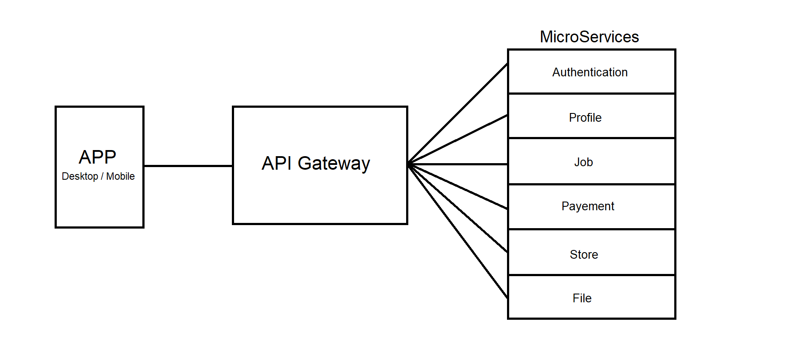

**Serveries:**

**Authentication:**

* Register User with Email
* Register User using third party like Google, Twitter, Facebook
* Login User
* Authenticate User

**Profile:**

* Update User Info
  + Name
  + Email
  + Password
  + Phone No
  + Registration No
* Delete Account

**Job:**

* Create Job
* Bid for job
* Withdraw bid
* Interview
* Start contract
* Submit Work
* End contract
* Hide Job
* Open a dispute
* View Jobs History
* Job status
* Post review

**Payment:**

* Add payment method
* Submit payment for job
* Release payment
* Withdraw payment

**Store:**

* Buy/Sell products/Fertilizers

**File:**

* Read/Write file
* Delete File
* Move File
* Copy File