Practical No. 1
Study of Networking

Aim :- To study the IP address.

Circuit Diagram :-
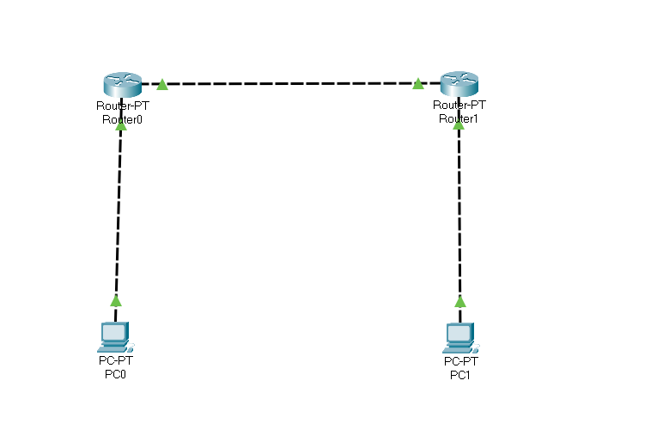
Program :-
Router 0 > cli :-
enable
configure terminal
interface fastethernet 0/0
ip address 10.0.0.1 255.0.0.0
no shutdown
exit
interface fastethernet 0/1
ip address 20.0.0.1 255.0.0.0
no shutdown
exit

Router 1 > cli :-
enable
configure terminal
interface fastethernet 0/0
ip address 40.0.0.1 255.0.0.0
no shutdown
exit
interface fastethernet 0/1
ip address 20.0.0.2 255.0.0.0
no shutdown
exit
Pc 0 > Desktop > Ip configuration :-
ipv4 : 10.0.0.2
subnet mask : 255.0.0.0
Default gateway: 10.0.0.1

Pc 1 > Desktop > Ip configuration :-
ipv4 : 40.0.0.2
subnet mask : 255.0.0.0
Default gateway: 40.0.0.1

Output :-
PC0 :-
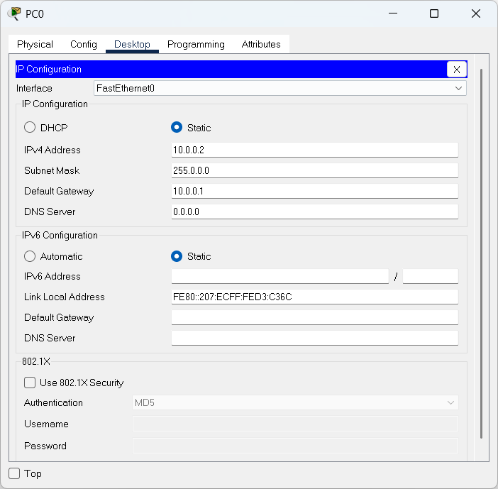

PC1:-
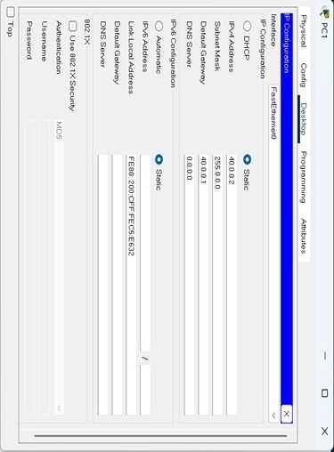
Conclusion :- The program was executed successfully.

Practical No. 2
Study of Network Layer

- Static Routing

Aim :- To study Static routing.

Circuit Diagram :-
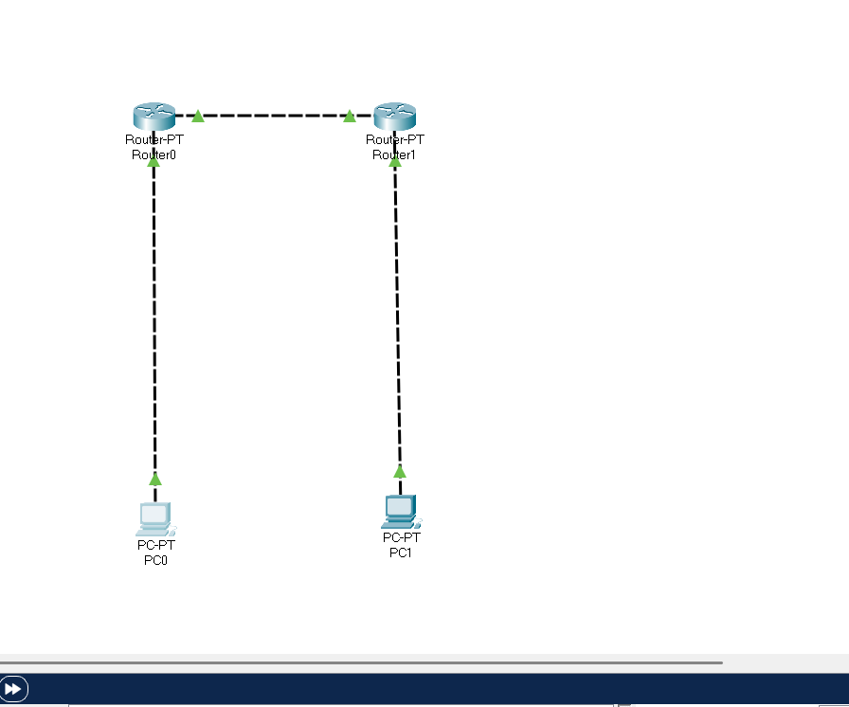
Program :-
Router 0 > cli :-
enable
configure terminal
interface fastethernet 0/0
ip address 10.0.0.1 255.0.0.0
no shutdown
exit
interface fastethernet 0/1
ip address 20.0.0.1 255.0.0.0
no shutdown
exit
ip route 40.0.0.0 255.0.0.0 20.0.0.2

Router 1 > cli :-
enable
configure terminal
interface fastethernet 0/0
ip address 40.0.0.1 255.0.0.0
no shutdown
exit
interface fastethernet 0/1
ip address 20.0.0.2 255.0.0.0
no shutdown
exit
ip route 10.0.0.0 255.0.0.0 20.0.0.1

Pc 0 > Desktop > Ip configuration :-
ipv4 : 10.0.0.2
subnet mask : 255.0.0.0
Default gateway: 10.0.0.1

Pc 1 > Desktop > Ip configuration :-
ipv4 : 40.0.0.2
subnet mask : 255.0.0.0
Default gateway: 40.0.0.1

Output :-
PC0 :-
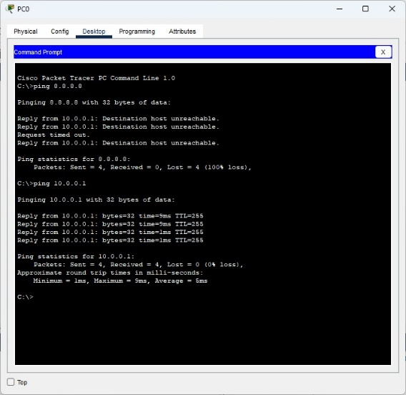
PC1 :-
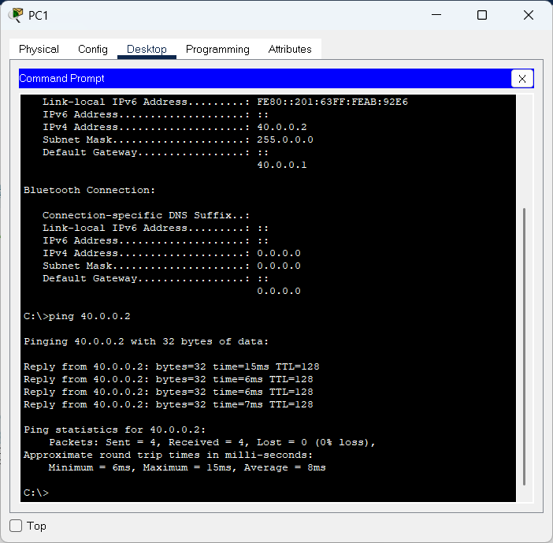

Conclusion :- The program was executed successfully.

- RIP Routing

Aim :- To study RIP routing.

Circuit Diagram :-
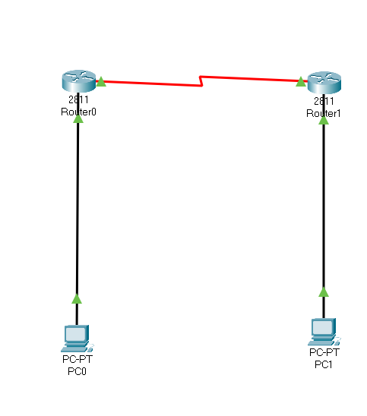
Program :-
Router 0 > cli :-
enable
configure terminal
interface fastethernet 0/0
ip address 10.0.0.1 255.0.0.0
no shutdown
exit
interface fastethernet 0/1
ip address 20.0.0.1 255.0.0.0
no shutdown
exit
router rip
version 2
network 10.0.0.0
network 20.0.0.0
exit

Router 1 > cli :-
enable
configure terminal
interface fastethernet 0/0
ip address 40.0.0.1 255.0.0.0
no shutdown
exit
interface fastethernet 0/1
ip address 20.0.0.2 255.0.0.0
no shutdown
exit
router rip
version 2
network 40.0.0.0
network 20.0.0.0
exit

Pc 0 > Desktop > Ip configuration :-
ipv4 : 10.0.0.2
subnet mask : 255.0.0.0
Default gateway: 10.0.0.1
Pc 1 > Desktop > Ip configuration :-
ipv4 : 40.0.0.2
subnet mask : 255.0.0.0
Default gateway: 40.0.0.1

Output :-
PC0:-
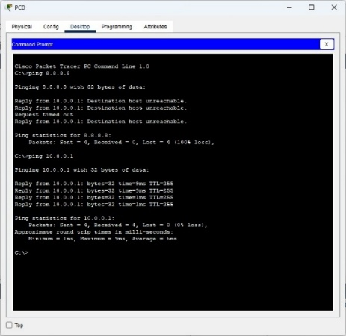

PC1:-
Conclusion :- The program was executed successfully.

- OSPF Routing

Aim :- To study OSPF routing.

Circuit Diagram :-
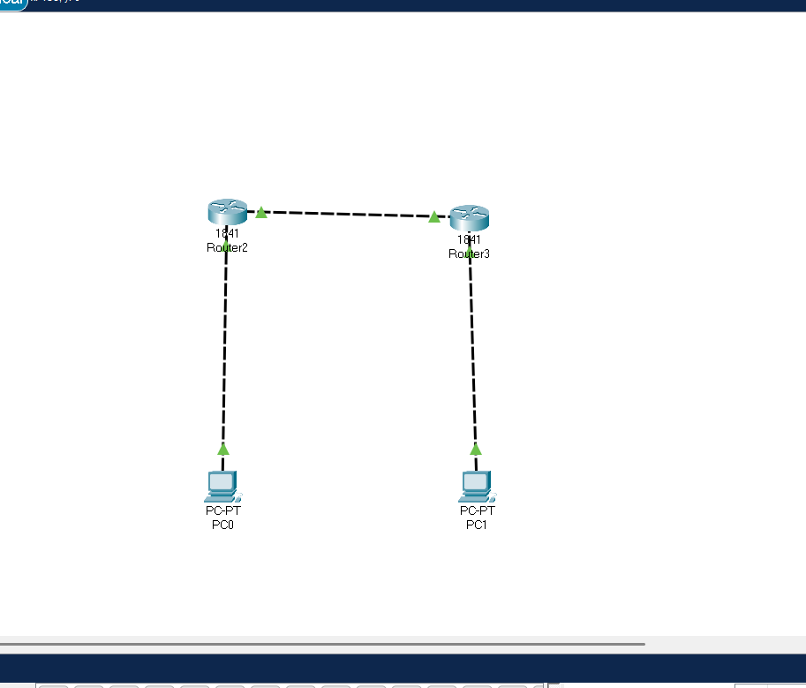
Program :-
Router 0 > cli :-
enable
configure terminal
interface fastethernet 0/0
ip address 10.0.0.1 255.0.0.0
no shutdown
exit
interface fastethernet 0/1
ip address 20.0.0.1 255.0.0.0
no shutdown
exit
router ospf 1
network 10.0.0.0 0.255.255.255 area 0
network 20.0.0.0 0.255.255.255 area 0
exit

Router 1 > cli :-
enable
configure terminal
interface fastethernet 0/0
ip address 40.0.0.1 255.0.0.0
no shutdown
exit
interface fastethernet 0/1
ip address 20.0.0.2 255.0.0.0
no shutdown
exit
router ospf 2
network 40.0.0.0 0.255.255.255 area 0
network 20.0.0.0 0.255.255.255 area 0
exit

Pc 0 > Desktop > Ip configuration :-
ipv4 : 10.0.0.2
subnet mask : 255.0.0.0
Default gateway: 10.0.0.1

Pc 1 > Desktop > Ip configuration :-
ipv4 : 40.0.0.2
subnet mask : 255.0.0.0
Default gateway: 40.0.0.1

Output :-
PC0:-

PC1:-
Conclusion :- The program was executed successfully.

Practical No. 3
Study of Application Layer

- DHCP
Aim :- To study DHCP.

Circuit Diagram :-
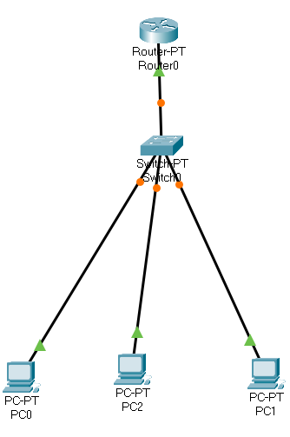

Program :-
Router 0 > cli :-
enable
configure terminal
interface fastethernet 0/0
ip address 10.0.0.1 255.0.0.0
no shutdown
exit
ip dhcp pool syit
network 10.0.0.0 255.0.0.0
default-router 10.0.0.1
ip dhcp excluded-address 10.0.0.2 10.0.0.1
ip dhcp pool syit
network 10.0.0.0 255.0.0.0
default-router 10.0.0.1
ip dhcp excluded-address 10.0.0.2 10.0.0.13
exit

Output:-
Pc0
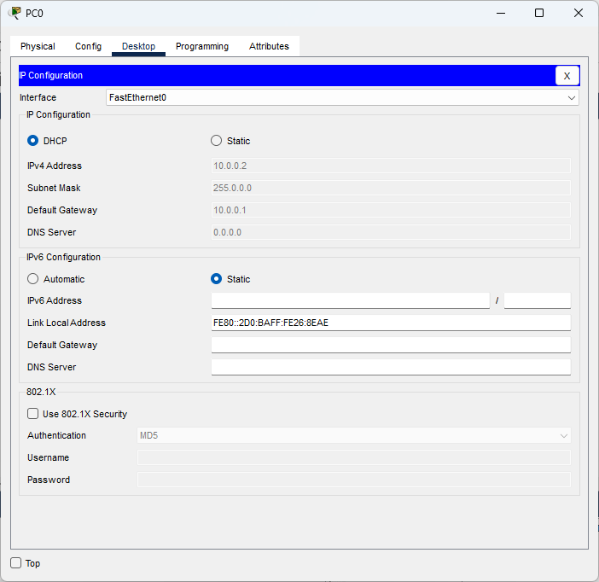
Pc1
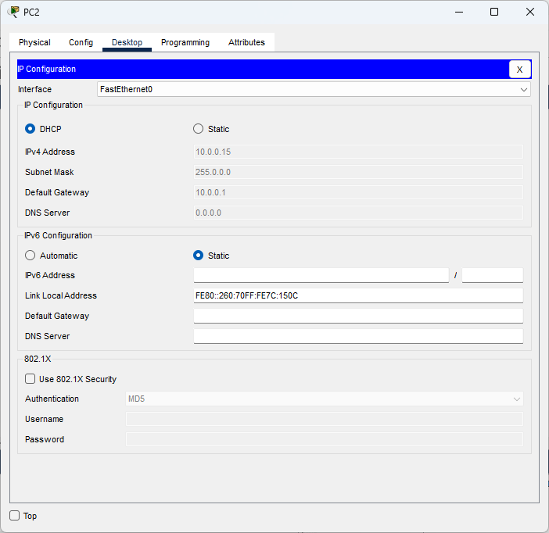

Conclusion :- The program was executed successfully.

- DNS

Aim :- To study DNS.

Circuit Diagram :-
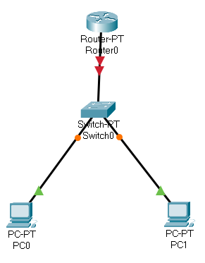
Program :-
Router 0 > cli :-
enable
configure terminal
interface fastethernet 0/0
ip address 10.0.0.1 255.0.0.0
no shutdown
exit
ip dhcp pool syit
network 10.0.0.0 255.0.0.0
default-router 10.0.0.1
dns-server 8.8.8.8
exit
ip host www.syit.com 10.0.0.1
exit

Pc 0 > Desktop > Ip configuration :-
ipv4 : 10.0.0.2
subnet mask : 255.0.0.0
Default gateway: 10.0.0.1

Pc 1 > Desktop > Ip configuration :-
ipv4 : 10.0.0.3
subnet mask : 255.0.0.0
Default gateway: 10.0.0.1

Output:-
PC0
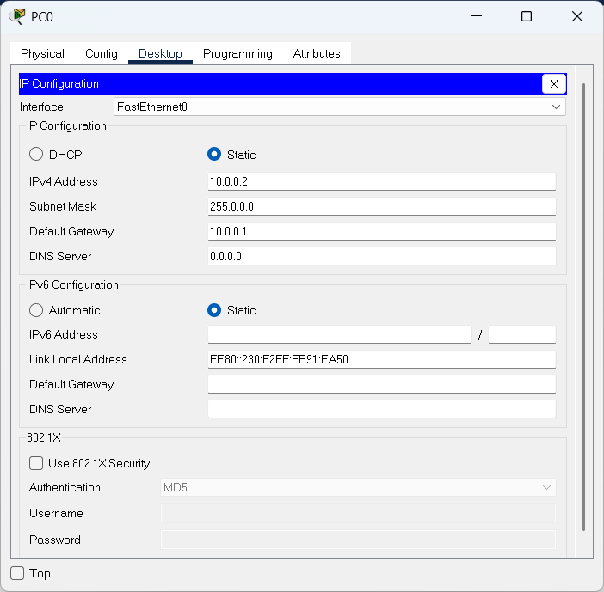
PC1
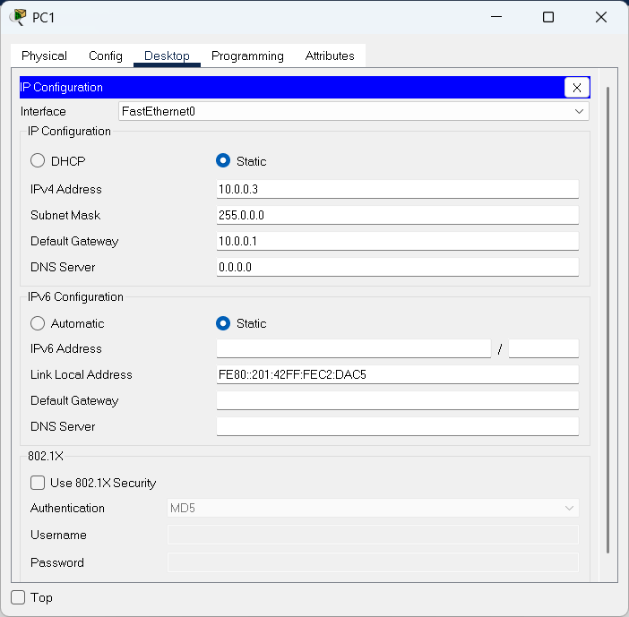

Conclusion:-The program executed Successfully.

- FTP

Aim :- To study FTP.
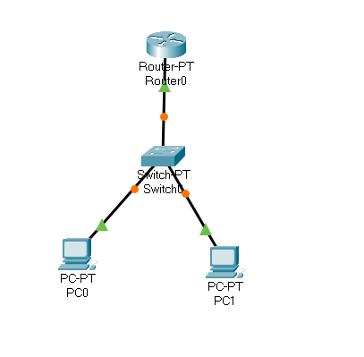
Program :-
Router 0 > cli :-
enable
configure terminal
interface fastethernet 0/0
ip address 10.0.0.1 255.0.0.0
no shutdown
exit
ip ftp username bscit
ip ftp password syit
ip ftp server enable
exit

Pc 0 > Desktop > Ip configuration :-
ipv4 : 10.0.0.2
subnet mask : 255.0.0.0
Default gateway: 10.0.0.1

Pc 1 > Desktop > Ip configuration :-
ipv4 : 10.0.0.3
subnet mask : 255.0.0.0
Default gateway: 10.0.0.1

Pc 0 > Desktop > Text Editor :-
This is from PC0

Pc 0 > Desktop > Command Prompt :-
ftp 10.0.0.1
username : bscit
password : syit
put testfile.txt

Pc 1 > Desktop > Command Prompt :-
ftp 10.0.0.1
username : bscit
password : syit
get testfile.txt

Output:-
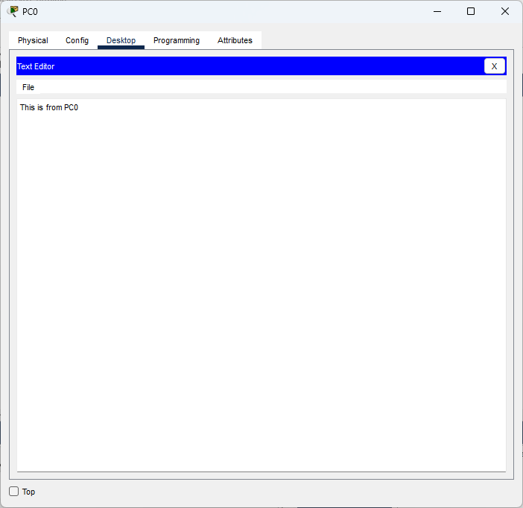

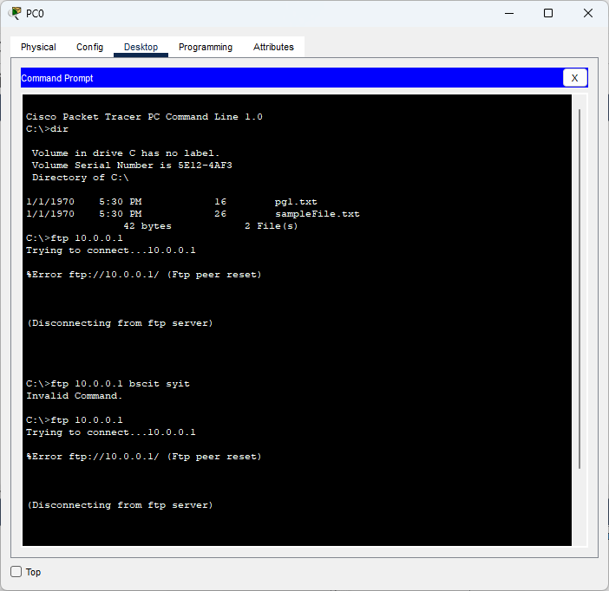

Conclusion:-The program executed Successfully.

- HTTP

Aim :- To study HTTP.
Circuit Diagram:-
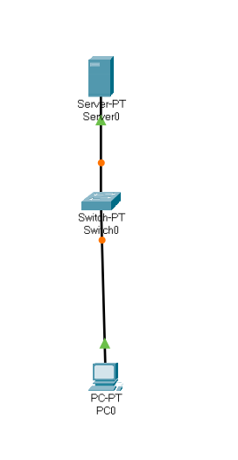
Program :-
Server 0 > Desktop > Ip configuration :-
ipv4 : 10.0.0.2
subnet mask : 255.0.0.0
Default gateway: 0.0.0.0

Server 0 > Services > HTTP :-
HTTP : on
HTTPS : on

Server 0 > Services > TFTP :-
service: off

Server 0 > Services > HTTP > index.html > Edit :-
<html>
<head>
<title>SYIT</title>
</head>
<body>
<h1>I am SYIT</h1>
</body>
</html>

Pc 0 > Desktop > Ip Configuration :-
ipv4 : 10.0.0.3
subnet mask : 255.0.0.0
Default gateway: 10.0.0.2

Output:-
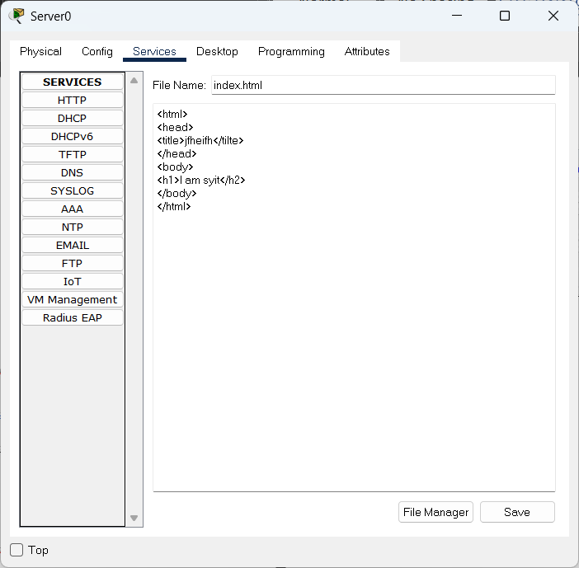

Conclusion:-The program executed Successfully.

- TELNET

Aim :- To study TELNET.
Circuit diagram:-
Program :-
Router 0 > cli :-
enable
configure terminal
interface fastethernet 0/0
ip address 10.0.0.1 255.0.0.0
no shutdown
exit
line vty 0 10
password syit
login
transport input telnet
exit
exit

Pc 0 > Desktop > Ip configuration :-
ipv4 : 10.0.0.2
subnet mask : 255.0.0.0
Default gateway: 10.0.0.1

Pc 1 > Desktop > Ip configuration :-
ipv4 : 10.0.0.3
subnet mask : 255.0.0.0
Default gateway: 10.0.0.1

Output:-
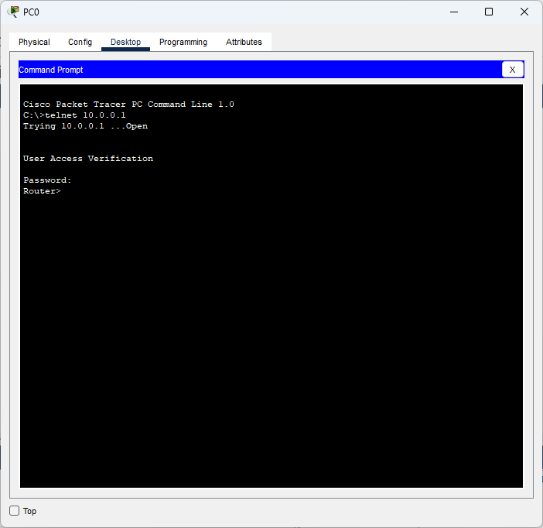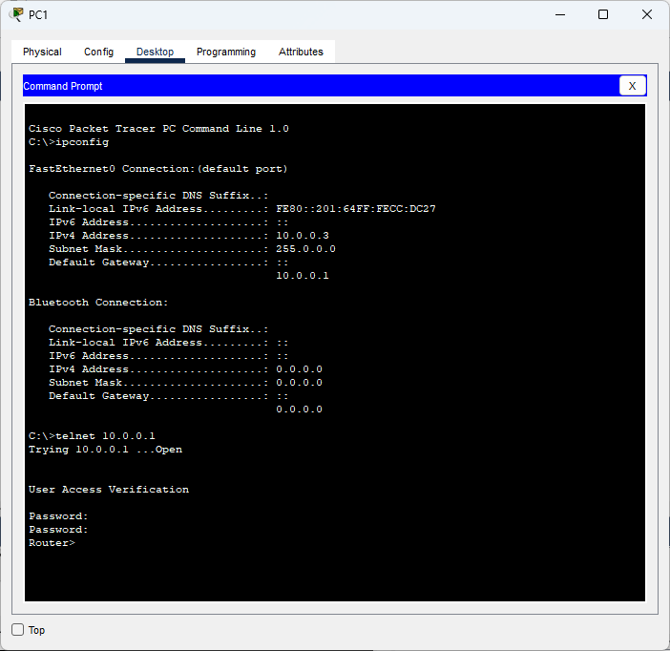

Conclusion:-The program executed Successfully.

