User/Administrator Manual and Deployment Instructions for Split the Bill

CIS4595 Capstone 2019

Team ‘); DROP TABLE Students;--

Team Members: Alex King, Jared Bumgardner, Mel Nichols, Wolf Raynsford

Table of Contents
User/Administrator Manual 3
Deployment Instructions 5

User/Administrator Manual
NOTE: You will need to complete deployment before going through these steps. Please proceed to the second half of this document if you have not set up the environment for deployment yet.

- Make sure you have all required htdocs in the htdocs folder. This consists of everything in the Github repository. These files can simply be copied into the htdocs folder. 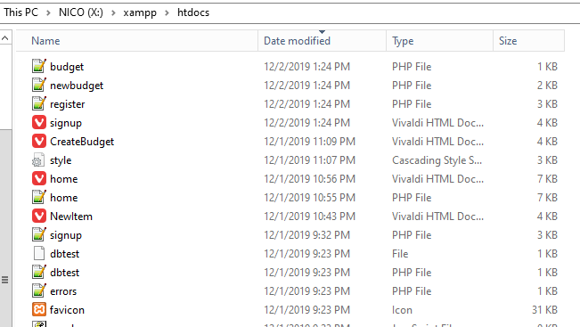
- The start page for our website is currently the registration page. Make sure that the XAMPP Apache and MySQL server are running, then open a web browser.
- Point your web browser towards localhost/signup.html. This will load the registration page.
- Create a new user. You can test various inputs. Notably, the page will not allow you to enter in blank information, and the registration form will check the username and email for duplicates in the DB Users table. The email will also be checked for proper format. If the registration was successful, the page will redirect to localhost/login.html. If registration was not successful, it will return to the registration page. Test different inputs and compare them with what is put into the DB. Passwords will be hashed before they are put into the DB. All inputs are sanitized before being entered into the DB.
- Once you are in the login page, attempt to login with the user you just created. Or, you can try invalid inputs that don’t exist in the DB. If the user does not exist or the password is incorrect, the page will reload back to the login page. If the user exists and the password is correct, the page will redirect to the home page, localhost/home.html.
- The home page contains a lot of static values. Currently, there are two functionalities that can be done using the homepage:
  - Create a new budget by clicking “Create Budget”. This will open a separate page, localhost/CreateBudget.html. You can create a new budget here and add one item to the new budget. The only thing that will currently be created is the Budget, which you can check in the DB. The owner of the budget should be the ID of the currently logged in user. In the finished product, this page would add that new item to the budget, and set up a column in the BudgetMembers table for the currently logged in user. After creating a new budget, it should redirect back to the home page.
  - Log out. Once logged out, you can log back in or register a new user. All session data should be cleared from the previous user.

Deployment Instructions
You will need to install:
XAMPP. The latest version available for download from the website should work. https://www.apachefriends.org/index.html
A copy of the SQL to load the DB into MySQL, located here: https://drive.google.com/file/d/1tg0Pd-3DF_p7Pyn9cb7_N_U8BXLQ-Eot/view?usp=sharing
A copy of all files from the GitHub repository.

Deployment Instructions:
- Install XAMPP on your system. Once installed, no configuration is needed as values were left as default during development.
- Download a copy of the SQL text file to load the DB into MySQL.
- Open the XAMPP control panel. This executable will be in the directory you installed XAMPP in, named xampp-control.exe.
- Start the Apache server and MySQL server by clicking Start for both items. 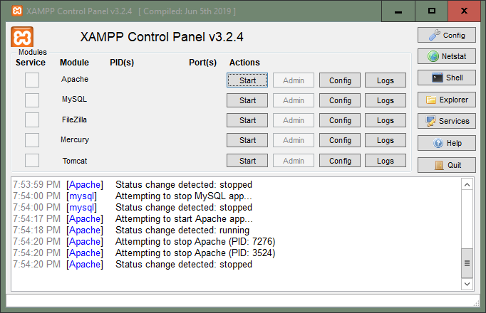
- In the folder you installed XAMPP into, there should be a folder called htdocs. Copy all files from the GitHub repository into this folder. 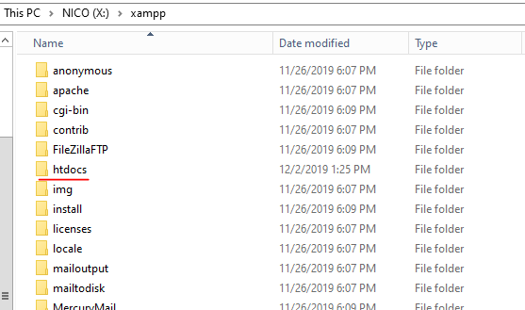
- Return to the XAMPP control panel. Click “Admin” next to the MySQL service. This will open the phpMyAdmin page for the MySQL server.
- On the side panel, click “New” to create a new DB.
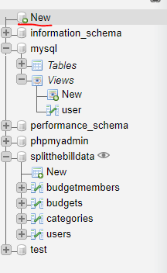
- Create a new DB named “splitthebilldata”. Click “Create.”
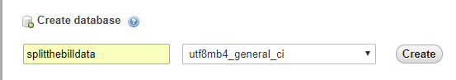
- Make sure you have the newly created DB selected. Then, in phpMyAdmin, click “Import”.
- Click “Choose File” and upload the downloaded MySQL.
- Click Go at the bottom of the page. You can leave all values on this page as default.
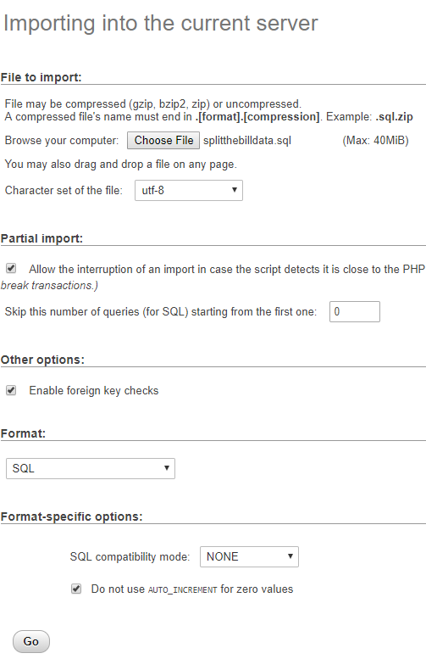
The DB should successfully be uploaded to MySQL.
NOTE: If you have issues uploading the SQL file to the MySQL server, add this line to the end of your SQL text file before importing:
CREATE DATABASE splitthebilldata;

