1.What are the two values of the Boolean data type? How do you write them?

Ans. True and False.

2. What are the three different types of Boolean operators?

* Ans. The AND operator
* The OR operator
* The NOT operator

3. Make a list of each Boolean operator's truth tables (i.e. every possible combination of Boolean values for the operator and what it evaluate ).

* True and True = True
* True and False = False
* False and True = False
* False and False = False
* True or True = True
* True or False = True
* False or True = True
* False or False = False
* not(True) = False
* not(False) = True

4. What are the values of the following expressions?

(5 > 4) and (3 == 5)

Ans. False

not (5 > 4)

Ans. False

(5 > 4) or (3 == 5)

Ans. True

not ((5 > 4) or (3 == 5))

Ans. False

(True and True) and (True == False)

Ans. False

(not False) or (not True)

Ans. True

5. What are the six comparison operators?

Ans. <,>,==,<=,>=,!=

6. How do you tell the difference between the equal to and assignment operators?Describe a condition and when you would use one.

Ans. Equal to is denoted by : ==

Equal to operator is used to check a condition. Like:

if (2==3):

print(‘pass’)

else:

print(‘fail’)

Whereas, assignment operator is denoted by : =

Assignment operator is used to assign a value to a variable like a=2, so 2 is getting assigned to the variable a.

7. Identify the three blocks in this code:

spam = 0 #1st Block

if spam == 10:

print('eggs')

if spam > 5:

print('bacon')

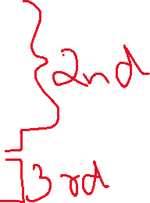

else:

print('ham')

print('spam')

print('spam')

Though it’s not clear because of this writing format which statements are under if and else due to proper indentation in the question itself.

8. Write code that prints Hello if 1 is stored in spam, prints Howdy if 2 is stored in spam, and prints Greetings! if anything else is stored in spam.

Ans. 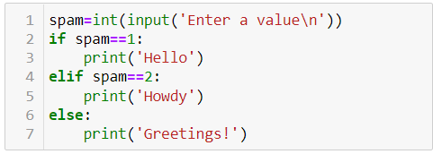

9.If your programme is stuck in an endless loop, what keys you’ll press?

Ans. ctrl+alt+delete

10. How can you tell the difference between break and continue?

Ans. Break, cuts out from the loop or breaks the loop.

Whereas, continue continues the loop but doesn’t execute the code before which the statement continue is used.

11. In a for loop, what is the difference between range(10), range(0, 10), and range(0, 10, 1)?

Ans. There is no difference the output will be the same for all the 3 cases i.e 0,1,2,3,4,5,6,7,8,9.

12. Write a short program that prints the numbers 1 to 10 using a for loop. Then write an equivalent program that prints the numbers 1 to 10 using a while loop.

Ans. for i in range (1,11):



print(i)

i=1

while i<=10:



print(i)

i+=1

13. If you had a function named bacon() inside a module named spam, how would you call it after importing spam?

From spam import bacon