-- create database general;
-- use general;

-- CREATE TABLE customers (
-- customer_id INT PRIMARY KEY,
-- first_name VARCHAR(50) NOT NULL,
-- last_name VARCHAR(50) NOT NULL,
-- email VARCHAR(100) UNIQUE NOT NULL,
-- city VARCHAR(50) NOT NULL,
-- state VARCHAR(50) NOT NULL,
-- join_date DATE NOT NULL,
-- is_premium BOOLEAN DEFAULT FALSE
-- );
-- -- Index for filtering by city/state
-- CREATE INDEX idx_customers_city ON customers(city);
-- CREATE INDEX idx_customers_state ON customers(state);
-- CREATE TABLE products (
-- product_id INT PRIMARY KEY,
-- product_name VARCHAR(100) NOT NULL,
-- category VARCHAR(50) NOT NULL,
-- brand VARCHAR(50) NOT NULL,
-- unit_price DECIMAL(10,2) NOT NULL CHECK (unit_price > 0),
-- stock_qty INT NOT NULL DEFAULT 0 CHECK (stock_qty >= 0)
-- );
-- -- Index for filtering by category
-- CREATE INDEX idx_products_category ON products(category);
-- CREATE TABLE orders (
-- order_id INT PRIMARY KEY,
-- customer_id INT NOT NULL,
-- order_date DATE NOT NULL,
-- status VARCHAR(20) NOT NULL DEFAULT 'Pending'
-- CHECK (status IN ('Pending','Shipped','Delivered','Cancelled')),
-- total_amount DECIMAL(12,2) NOT NULL CHECK (total_amount >= 0),
-- FOREIGN KEY (customer_id) REFERENCES customers(customer_id)
-- );
-- -- Index for date-based filtering and sorting
-- CREATE INDEX idx_orders_date ON orders(order_date);
-- CREATE INDEX idx_orders_status ON orders(status);
-- CREATE TABLE order_items (
-- item_id INT PRIMARY KEY,
-- order_id INT NOT NULL,
-- product_id INT NOT NULL,
-- quantity INT NOT NULL CHECK (quantity > 0),
-- unit_price DECIMAL(10,2) NOT NULL CHECK (unit_price > 0),
-- discount_pct DECIMAL(5,2) DEFAULT 0 CHECK (discount_pct BETWEEN 0 AND 100),
-- FOREIGN KEY (order_id) REFERENCES orders(order_id),
-- FOREIGN KEY (product_id) REFERENCES products(product_id)
-- );
-- INSERT INTO customers VALUES
-- (101, 'Aarav', 'Sharma', 'aarav.s@email.com', 'Mumbai', 'Maharashtra', '2024-01-15', TRUE),
-- (102, 'Priya', 'Patel', 'priya.p@email.com', 'Ahmedabad', 'Gujarat', '2024-02-20', FALSE),
-- (103, 'Rohan', 'Gupta', 'rohan.g@email.com', 'Delhi', 'Delhi', '2024-03-10', TRUE),
-- (104, 'Sneha', 'Reddy', 'sneha.r@email.com', 'Hyderabad', 'Telangana', '2024-04-05', FALSE),
-- (105, 'Vikram', 'Singh', 'vikram.s@email.com', 'Jaipur', 'Rajasthan', '2024-05-12', TRUE),
-- (106, 'Ananya', 'Iyer', 'ananya.i@email.com', 'Chennai', 'Tamil Nadu', '2024-06-18', FALSE),
-- (107, 'Karan', 'Mehta', 'karan.m@email.com', 'Pune', 'Maharashtra', '2024-07-22', TRUE),
-- (108, 'Divya', 'Nair', 'divya.n@email.com', 'Kochi', 'Kerala', '2024-08-30', FALSE);
-- -- ========== INSERT: products ==========
-- INSERT INTO products VALUES
-- (201, 'Wireless Earbuds', 'Electronics', 'BoAt', 1499.00, 250),
-- (202, 'Cotton T-Shirt', 'Clothing', 'Levis', 799.00, 500),
-- (203, 'Smart Watch', 'Electronics', 'Noise', 2999.00, 150),
-- (204, 'Running Shoes', 'Clothing', 'Nike', 4599.00, 120),
-- (205, 'Bluetooth Speaker', 'Electronics', 'JBL', 3499.00, 200),
-- (206, 'Bedsheet Set', 'Home', 'Spaces', 1299.00, 300),
-- (207, 'Laptop Stand', 'Electronics', 'AmazonBasics', 899.00, 180),
-- (208, 'Cushion Covers (Set)', 'Home', 'HomeCenter', 599.00, 400);

-- -- ========== INSERT: orders ==========
-- INSERT INTO orders VALUES
-- (1001, 101, '2024-08-01', 'Delivered', 4498.00),
-- (1002, 102, '2024-08-03', 'Delivered', 799.00),
-- (1003, 103, '2024-08-05', 'Shipped', 7498.00),
-- (1004, 101, '2024-08-10', 'Delivered', 3499.00),
-- (1005, 104, '2024-08-12', 'Cancelled', 2999.00),
-- (1006, 105, '2024-08-15', 'Delivered', 5898.00),
-- (1007, 106, '2024-08-18', 'Pending', 1299.00),
-- (1008, 103, '2024-08-20', 'Delivered', 899.00),
-- (1009, 107, '2024-08-25', 'Shipped', 6098.00),
-- (1010, 108, '2024-08-28', 'Delivered', 1598.00);

-- -- ========== INSERT: order_items ==========
-- INSERT INTO order_items VALUES
-- (5001, 1001, 201, 2, 1499.00, 0),
-- (5002, 1001, 207, 1, 899.00, 10),
-- (5003, 1002, 202, 1, 799.00, 0),
-- (5004, 1003, 203, 1, 2999.00, 0),
-- (5005, 1003, 204, 1, 4599.00, 5),
-- (5006, 1004, 205, 1, 3499.00, 0),
-- (5007, 1005, 203, 1, 2999.00, 0),
-- (5008, 1006, 201, 1, 1499.00, 10),
-- (5009, 1006, 204, 1, 4599.00, 5),
-- (5010, 1007, 206, 1, 1299.00, 0),
-- (5011, 1008, 207, 1, 899.00, 0),
-- (5012, 1009, 205, 1, 3499.00, 0),
-- (5013, 1009, 208, 2, 599.00, 15),
-- (5014, 1010, 206, 1, 1299.00, 0),
-- (5015, 1010, 208, 1, 599.00, 0);

-- -- q1
-- select * from customers;
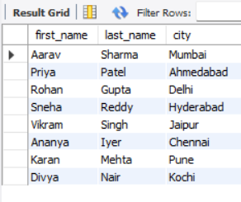
-- -- q2
-- select first_name, last_name, city from customers;
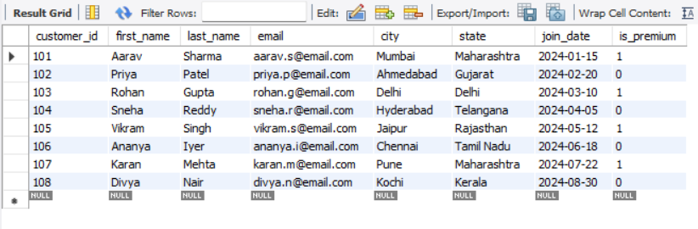
-- -- q3
-- select distinct category from products;
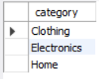

-- -- q4
-- -- primary keys: customer_id (customers), product_id (products),
-- -- order_id (orders), item_id (order_items).
-- -- a primary key must be unique and not null

-- -- q5
-- -- the email has uniqu and not null constraints.
-- -- if you try to insert a duplicate email, the database will throw
-- -- a unique constraint error and block the insert.

-- -- q6
-- insert into products (product_id, product_name, category, brand, unit_price, stock_qty)
-- values (301, 'test earphones', 'Electronics', 'testbrand', -50.00, 10);
-- -- this fails with a check constraint violation error.

-- -- q7
-- select * from orders
-- where status = 'Delivered';
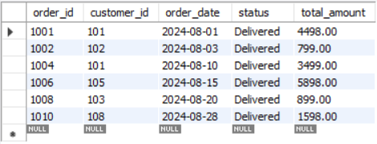
-- -- q8
-- select * from products
-- where category = 'Electronics' and unit_price > 2000;
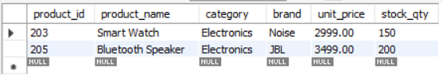
-- -- q9
-- select * from customers
-- where join_date >= '2024-01-01' and join_date <= '2024-12-31'
-- and state = 'Maharashtra';
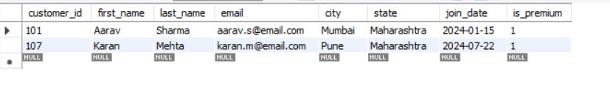
-- -- q10
-- select * from orders
-- where order_date between '2024-08-10' and '2024-08-25'
-- and status != 'Cancelled';
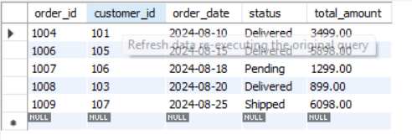
-- -- q11
-- -- the idx_orders_date index creates a sorted lookup structure for dates.
-- -- it vastly improves query speed by jumping straight to the matching date
-- -- instead of scanning every single row in the table.
-- select * from orders where order_date = '2024-08-15';
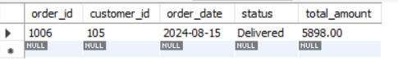

-- -- q12:
-- -- the index on join_date won't be used if we wrap it in year().
-- -- this forces a full table scan
-- select * from customers
-- where join_date >= '2024-01-01' and join_date < '2025-01-01';

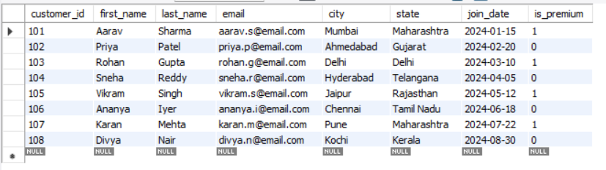

-- -- q13:
-- select count(order_id) as total_orders from orders;
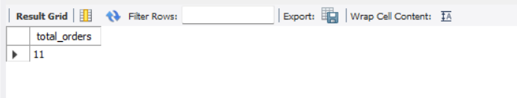
-- -- q14
-- select sum(total_amount) as total_revenue
-- from orders
-- where status = 'Delivered';
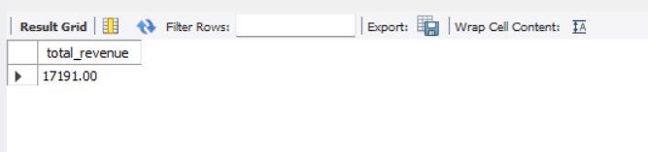
-- -- q15
-- select category, avg(unit_price) as average_price
-- from products
-- group by category;
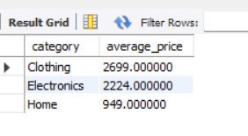
-- -- q16
-- select status, count(order_id) as order_count, sum(total_amount) as total_revenue
-- from orders
-- group by status
-- order by total_revenue desc;
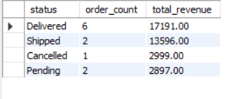
-- -- q17
-- select category, max(unit_price) as most_expensive, min(unit_price) as cheapest
-- from products
-- group by category;
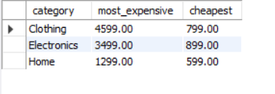
-- -- q18:
-- select category
-- from products
-- group by category
-- having avg(unit_price) > 2000;

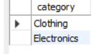
-- -- q19:
-- select o.order_id, o.order_date, c.first_name, c.last_name, o.total_amount
-- from orders o
-- inner join customers c on o.customer_id = c.customer_id;
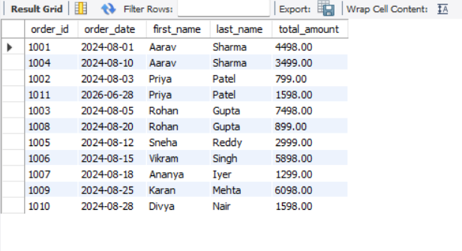
-- -- q20:
-- select c.customer_id, c.first_name, c.last_name, o.order_id, o.order_date, o.total_amount
-- from customers c
-- left join orders o on c.customer_id = o.customer_id;
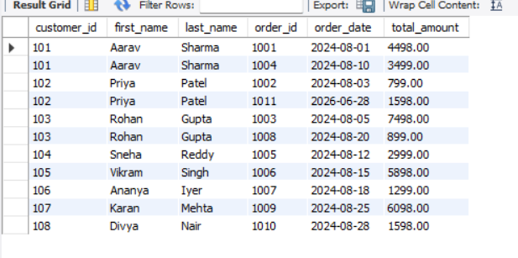
-- -- q21:
-- select o.order_id, p.product_name, oi.quantity, oi.unit_price, oi.discount_pct
-- from orders o
-- join order_items oi on o.order_id = oi.order_id
-- join products p on oi.product_id = p.product_id;
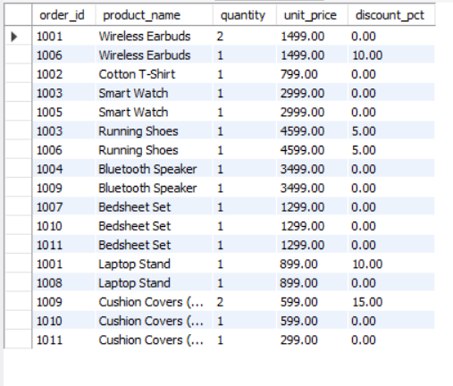
-- -- q22:
-- -- a left join returns all customers
-- -- a right join would return all orders.
-- -- full outer join is used when you want all records from both sides,
-- -- useful for showing data mismatches across two systems.

-- -- q23:
-- -- fkeys: orders.customer_id, order_items.order_id, order_items.product_id.
-- -- inserting an order for customer_id=999 throws a foreign key constraint violation
-- -- because that customer doesn't exist in the parent table.

-- -- q24:
-- select product_name, unit_price,
-- case
-- when unit_price < 1000 then 'Budget'
-- when unit_price between 1000 and 3000 then 'Mid-Range'
-- when unit_price > 3000 then 'Premium'
-- end as price_tier
-- from products;
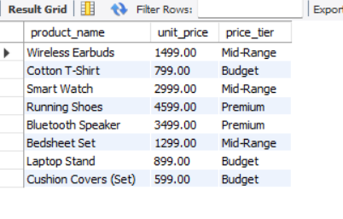
-- -- q25:
-- select
-- sum(case when status = 'Delivered' then 1 else 0 end) as delivered_count,
-- sum(case when status != 'Delivered' then 1 else 0 end) as not_delivered_count
-- from orders;
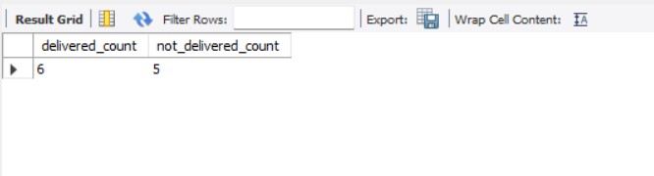
-- q26:
-- a - atomicity: complete execution of a task,either a transaction succeeds or doesn’t affect state of table at all
-- c - consistency: data consistent across all the tables.
-- i - isolation: each transaction is isolates and acts as a unit
-- d - durability: once saved, data survives power outages or crashes.

-- q27

delimiter //

create procedure create_new_order()
begin
-- rolback is done here if sqlexception arrises
declare exit handler for sqlexception
begin
rollback;
end;

start transaction;

insert into orders (order_id, customer_id, order_date, status, total_amount)
values (1011, 102, current_date(), 'Pending', 1598.00);

insert into order_items (item_id, order_id, product_id, quantity, unit_price, discount_pct)
values
(5016, 1011, 206, 1, 1299.00, 0),
(5017, 1011, 208, 1, 599.00, 0);

update products
set stock_qty = stock_qty - 1
where product_id in (206, 208);

commit;
end //

delimiter ;

call create_new_order();

