Style Guidelines for Final Year Project ReportsSmart Bio Floc Monitoring

Final Year Project Proposal

Session 2018-2022

A 4th Year Student

A project submitted in partial fulfilment of the

COMSATS University Degree

of

BSc. (Hons.)BS in Software Engineering (CUI)



Department of Computer Science

COMSATS University Islamabad, Attock Campus

24 February 2021

1. **Project Registration Form**

|  |  |  |  |  |  |  |  |  |
| --- | --- | --- | --- | --- | --- | --- | --- | --- |
| Project ID (for office use) | |  | | | | | | |
| Project Title | | Smart Bio Floc Monitoring | | | | | | |
| Type (Nature of project) | | [ ] Desktop Application [ ] Web Application [**.**]Mobile Application | | | | | | |
| Area of specialization | | Flutter Development & Networking | | | | | | |
| **Project Group Members** | | | | | | | | |
| Sr.# | Registration No | | Student Name | CGPA | Email ID | | Contact No. | Signature |
| 1. | FA18-BSE-024 | | Eqra Khattak | 3.16 | eqra.khattak7@gmail.com | | 03125997916 |  |
| 2. | FA18-BSE-038 | | Laraib Noor | 2.81 | nlaraib87@gmail.com | | 03341553867 |  |
| Name & Signature of Program Coordinator to certify that  Are the students eligible for FYP? [**.**] Yes [ ]No | | | | | |  | | |

# Consent and Plagiarism Certificate from Supervisor

I affirm to accept and supervise the above-mentioned students throughout the project duration. This is to certify that this FYP proposal is checked by me and the similarity index is ________% that is less than 19%, an acceptable limit by HEC. Report is attached herewith.

Name of Supervisor: ____________________ Co-Supervisor (if any): _____________________

Designation: ____________________ Designation: _______________________

Signature: ______________________ Signature: _______________________

**Approval of FYP Management Committee**

Committee Member 1: Name: _____________________

[ ] Accept [ ] *Defer [ ] *Reject Signature: _________________

*Remarks: ________________________________________________________________________

Committee Member 2: Name: ____________________

[ ] Accept [ ] *Defer [ ] *Reject Signature: _________________

*Remarks: ________________________________________________________________________

Convener: Name: _____________________

[ ] Accept [ ] *Defer [ ] *Reject Signature: _________________

*Remarks: ________________________________________________________________________

_________________________________________________________________________________

**Project Abstract**

Smart Bio Floc Monitoring is a project based on a controlled synthetic environment which is highly suitable for survival and growth of a flock. Automated by a mobile application that runs on both Android and iOS with a single codebase Dart. This project is a simple program for a bio-flock fish farmer to help him in doing his job properly and efficiently with minimum efforts.

**Introduction**

Traditional fish farming is not sensitive to aquatic life as the ponds are already made, there’s always more water, more space, more fish and more of about everything but it has its perks. Such as, it can prove too unhealthy and contaminated for the fish to survive. The waste excreted by the fish and the leftover food can cause the formation of ammonia gas which is harmful for fish. In contrast, Bio floc is a symbiotic process that includes confined aquatic animals, heterotypic bacteria and microbial species in the water. Bio floc provides environment that is good for fish growth and survival providing certain parameters are fulfilled. Consumption of bio flocs also provides nutritional value to cultured aquatic species.

*Smart Bio Floc Monitoring* is the monitoring of a bio floc in an artificially generated pond. This project will be an ultimately huge helping guide for bio floc fish farmers to do successful bio floc farming, from seed deployment to selling fish in the market. It will be looking into various factors such as monitoring sensors and their integration in the mobile app to look for any slight change in the properties of water or food. For example, oxygen level detection, temperature, pH, and water level etc. Also, to undergo the survival rate of fish in a pond according to its symmetry and then provide tips for its betterment. The sensors are directly connected to the mobile app and can be used remotely from anywhere to keep an eye on things. It can be used for both natural and artificial ponds.

**Motivation and Scope**

Computer literacy is a major issue in our country for farmers that are either on a small scale or in a large-scale production. They lack critical information about most of their farming practices and are unaware of the upgrade in resources. Numerous fish die in their ponds due to poor consideration.

Specifically, in Pakistan there’s no consultancy for farmers to consult for the growth, fertilization and health issues of fish. Our objective is to provide them with the solutions to their problems so they can become better and successful fisherman of their region.

Considering the farmers must create artificial ponds in order to grow fish in ideal environments, there might be an issue with the area and the design of the pond. The problems can be a rectangular shaped pond which might stop the fish in their paths as fish tend to keep swimming most of the time, to avoid that, we decide to shape it circular.

It’s a fact that fish requires utmost care as their environment is different from land animals, so they need specific conditions like oxygen level, temperature, pH, water level, food etc. Fish feed is deployed according to the pound areas but first these parameters must be satisfied which will ultimately lead to reduction in fish death rate.

Survival area for 1000 fishes in a pond is 1 square meter. If 1 Acre farm is converted in to 1 single tank, a 1000 fish can survive. Parameters that must be met for bio floc are: Temperature, Dissolved Oxygen, pH, Salinity, Solids (total suspended solids and settling solids), Alkalinity, Orthophosphate. So, for its management, a technology called WSN (Wireless Sensor Network) is used in this project. WSN monitors and records the physical conditions of the environment and organize the collect data at a central location.

This project will decrease labour time and increase efficiency as it can be controlled from a mobile phone when installed on an Android or an iPhone. The sensors attached to the ponds will be integrated in the mobile app and the user will continuously examine the situation of the pond such as water quality and environment for better growth. In addition to that our app will advocate the best marketplace and farmers can manage all expenses and stocks record.

**Related Work**

*Smart Bio Floc Monitoring* is related to an existing hardware project *Ultimate Fishing Guide* previously made by *Iqra Sayyal & Muhammad Hamza*. We are trying to automate the project into a mobile application and make it better using WSF for bio floc which will include all the existing features and more with a lot more flexibility and ease.

**System Architecture and Features**

Our system architecture consists of 3 main modules; Frontend, Backend and Hardware. The frontend is an interactive interface that allows our users to visit our application and ease of use. Users can monitor the basic requirements for ideal pond conditions such as Oxygen level, pH of water, temperature and other nutrients crucial for the fishes’ survival. Feed suggestions, latest updates on farming technologies and practices and the nearest Fish Market through Google Map. The results are displayed on the screen. Our project architecture diagram is shown below:

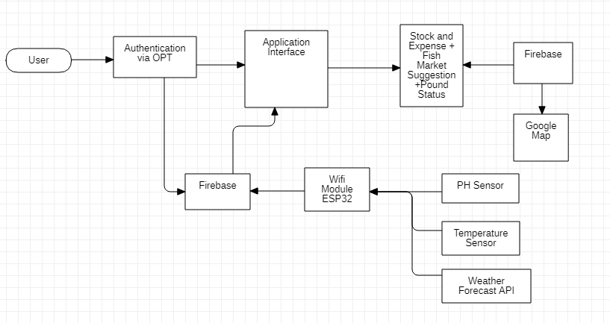

**Goals and Objectives**

The goal of this project is to provide the bio floc fish farmers the ultimate help by making it easy and accessible to them to monitor the ponds under the palm of their hands.

The objectives of the project are to provide the user with the best farming techniques, latest updates on the farming technology, upgraded food and to provide them with the best tools to examine the survival and growth of the fishes in the ponds and guide farmer about selling point for fish to get the best reward in the form of money.

**Individual Tasks**

The project is under the care of two students; Eqra Khattak & Laraib Noor. Both will be gathering requirements for the project. Eqra Khattak will be designing and developing the application and system architecture. Laraib will be doing the system testing and the associated documentation. She will be creating the UML and ERD Diagrams for the project.

**Gantt chart**

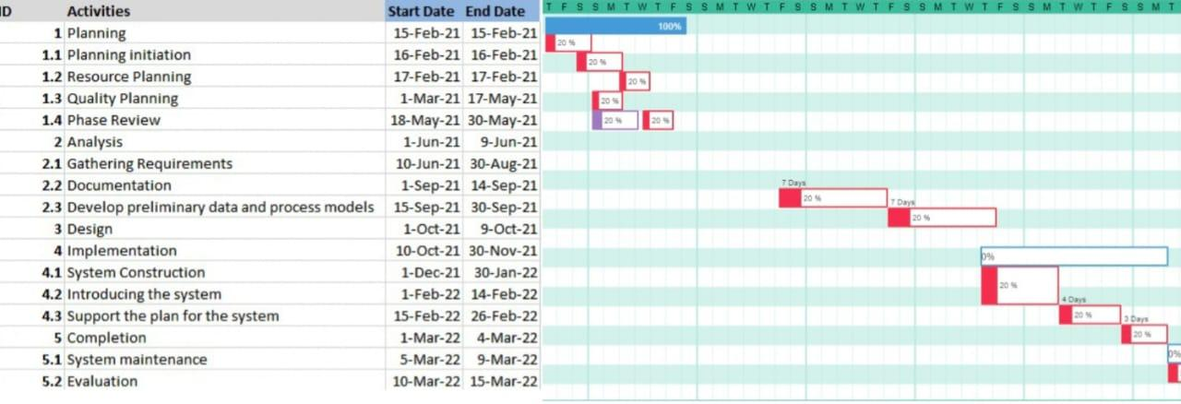

**Tools and Technologies**

This project will be developed on the app developing tool *Android Studio* in a framework called *Flutter* which allows us to build an application in a single codebase *Dart* that can be deployed on both Android and iOS in the same APK. WSN will be used to monitor and record the physical conditions of the environment of the bio floc. We will be using *Firebase Firestore* for our databases and for the system diagrams, Microsoft Visio