# Introduction

The V2M-Musca-S1 board has mounted a 512 Mb QSPI NOR Flash memory from Micron. To successfully program the Flash from µVision, you need to do some distinct steps.

# Steps to download an application

1. Set the on-board **BOOT** switch to **MRAM**.
2. Boot the device by pressing **PBON**.
3. In µVision, flash download (use  or press **F8**) the image to the target.
4. Turn off the device by pressing **PBON** again.
5. Set the on-board **BOOT** switch to **QSPI**.
6. Boot the device by pressing **PBON**.
7. The correct application is in the device and runs from the QSPI Flash.

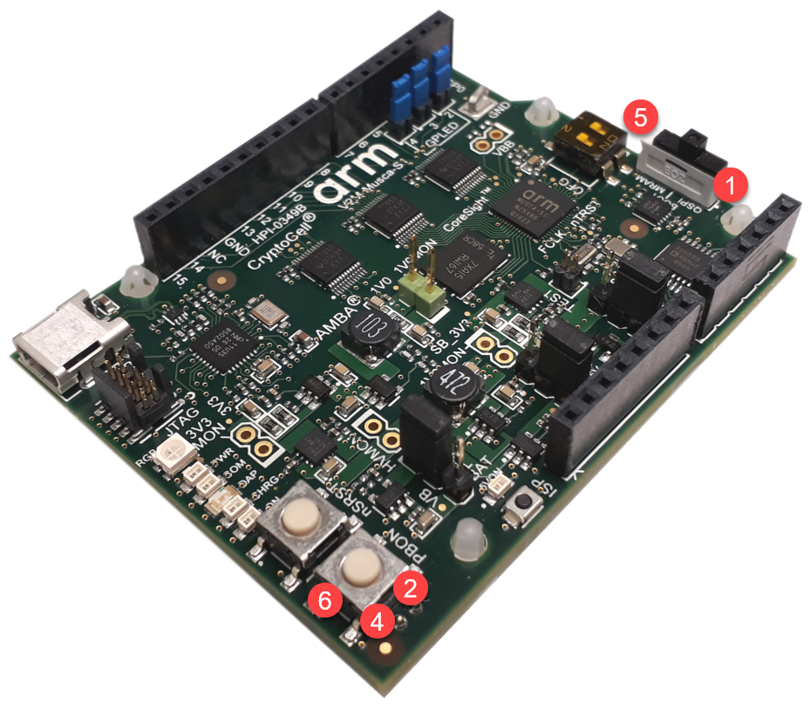

**Note:** Develop and debug your application code for SRAM/eMRAM and retarget for production to QSPI (if required). When debugging, resetting the device after booting from QSPI may experience connectivity problems in the µVision debugger.