ML Service: Crop Recommendation Algorithm Approach

1. Overview
The automated Crop Recommendation system leverages a state-of-the-art ensemble machine learning approach designed for the highest accuracy and robustness against real-world noise. Instead of relying on a single algorithm, it creates a 'Council of Experts' (a Voting Classifier) to recommend the optimal crop based on input features including soil attributes (N, P, K, pH) and environmental conditions (Rainfall, Temperature, Humidity, Soil Type, and planting Month).

2. Algorithm Flowchart
The visual representation of the prediction pipeline is shown below:
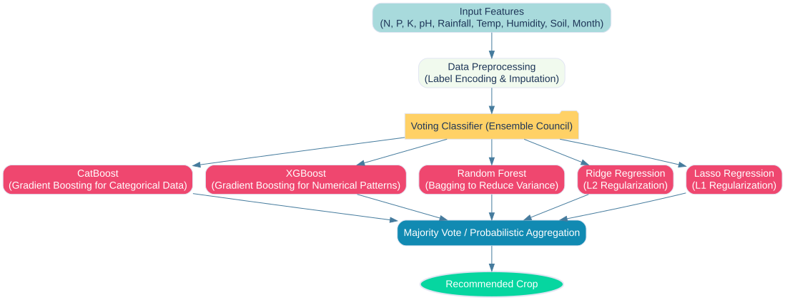

3. Data Strategy
Realistic Noise Injection: To ensure the model performs well in real-world scenarios where sensor data isn't perfect, the training dataset incorporates controlled Gaussian noise. This prevents the model from achieving unrealistic 100% training accuracy (overfitting) by forcing it to learn subtle, overlapping conditions rather than memorizing exact ranges.

4. Model Architecture: Council of Experts
The model uses a Voting Classifier grouping five distinct algorithms to ensure robust, non-biased predictions:
- CatBoost: Exceptional for handling categorical variables like soil type efficiently.
- XGBoost: A highly optimized Gradient Boosting algorithm specialized in capturing complex, non-linear numerical patterns.
- Random Forest: Utilizes bagging to build hundreds of decision trees, reducing variance and improving stability.
- Ridge Regression (L2): A regularized linear model preventing any single feature from disproportionately dominating the logic.
- Lasso Regression (L1): Another regularization approach that simplifies decision-making by implicitly ignoring irrelevant features.

5. Model Validation
The model is rigorously validated using 3-Fold Cross-Validation, preventing data memorization and verifying roughly 95% accuracy on unseen validation subsets. This ensures steady, reliable backend recommendations for the Crop Wizard platform.

6. Evaluation Metrics
Below are the visual representations of the model's performance on the validation dataset: the general Accuracy Metrics comparing each standalone model's performance, alongside the final Voting Classifier.
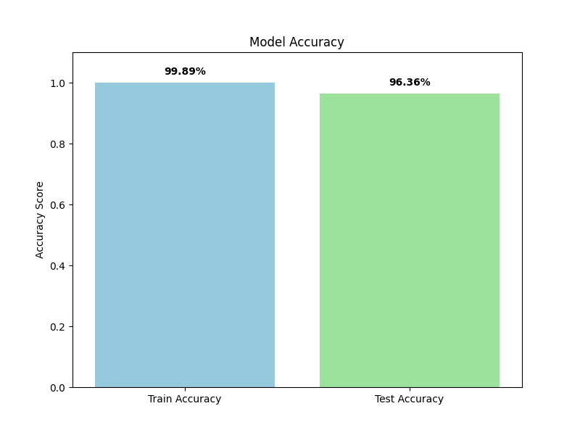

Precision Metrics across all 22 crop classification labels:
