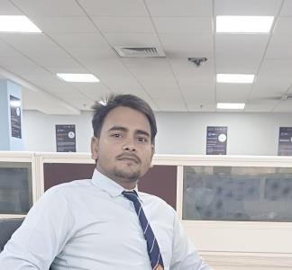

LinkedIn ID :
-

htps://www.linkedin.com/in/Mohd
Arman
-

Emai ID
-
mirajkhan557954199@gmail.com

Mobile No :
8176881886

Mohd Arman

FROM

BARABANKI

,
UTTAR PRADESH

CAREER OBJECTIVE

Looking for a challenging and task oriented position in an organization which demands the best of my professional ability in terms of managerial and analytical skills and helps me in broadening and enhancing my current skill and knowledge and to be involved as a part of a team that dynamically works towards the growth of the organization and reach the top with determination, dedication and hard work.

PROFESSIONAL QUALIFICATION

COURSE | BOARD/ UNIVERSITY | PERCENTAGE and CGPA | YEAR OF  PASSING
B. TECH(CSE-AI) | BIET, Lucknow | 71.10%(Till 6thsem) | 2026

EDUCATIONAL QUALIFICATION

- B.TECH (CSE-AI) from Aktu University, Lucknow, in 2026.
- 12thfrom New Vision Public Inter College Mahmoudabad , Sitapur, UP in 2022. • 10thfrom New Vision Public Inter College, Mahmoudabad ,Sitapur, UP in 2020.

SIGNIFICANT ACCOMPLISHMENT

- Active participation in “Software Development” workshops .
- Active participation in Corporate Summits at BIET Lucknow.
- Was coordinator for Orientation Program2020 at BIET Lucknow.
- Won prizes, participated and co- ordinated in different Photography competition.

SOFTWARE SKILLS

- Programming Languages - C, C++, Python, Java.
- Tools & Platforms - Git/GitHub.
- Office Productivity -MS Office (Word ,Excel, PowerPoint.)
- Wed Development - HTML , CSS , JavaScript , Bootstrap .

STRENGTHS

- Highly confident and innovative in the area of expertise.
- Swift in learning and implementing new topics and techniques.
- Determined to learn with practical approach.
- Good communication skills and managing skills.

PERSONAL INFORMATION

Nationality Indian
Date of Birth 01-01-2003
Gender Male
Marital Status Single
Permanent Address GORAICHA, BARABANKI ,BARABANKI (UTTAR PRADES) Hobbies Reading Book , CODE IMPLEMENT.
FIELDS OF INTEREST  - Market Research.  - Analysis for Investment.  - Software Development.  - Case based Studies. | LIGUISTIC PROFICIENCY  - English  - Hindi

Date: Tuesday, May 20, 2025
Place: Lucknow

Signature
