2026-10-06

应用系统体系架构 — 作业1

学号： 524031910745 姓名： 丁宇轩 得分：

本次作业回答如下：

完整提示词与实现契约
本作业使用真实 DeepSeek API，为知页书城已实现的四个 REST 接口生成 OpenAPI 3.0.3 JSON。角色提示限定架构师职责，任务提示提供实际字段、默认值和错误边界；通过5轮记录与独立校验确认最终规范可用于接口测评。
GET /api/books 获取分页书目与分类过滤
GET /api/books/{id} 查看单本详情
POST /api/books 添加新书
PATCH /api/books/{id}/inventory 仅更新库存
System Prompt
你是一名资深后端架构师，负责把已实现的在线书店 HTTP 接口整理为可执行、可验证的 OpenAPI 契约。
任务：根据用户提供的实现事实，生成完整的 OpenAPI 3.0.3 文档。
只输出一个合法 JSON 对象，第一字符为 {，最后字符为 }。禁止 Markdown 代码围栏、注释、解释、前言或省略号。不得输出 YAML。必须包含 openapi、info、servers、paths、components。
仅描述用户指定的四个操作，遵循 REST 资源语义。每个操作必须有唯一 operationId、中文 summary、所需参数或 requestBody，以及完整 responses。所有 path 参数必须 required:true。所有成功和错误响应统一使用 code/message/data；成功 code 固定为 0，错误 data 为 null。复用 components/schemas 和 components/responses，所有 $ref 必须可解析。
参数的类型、默认值、边界、请求体 required 字段、响应状态码必须与实现一致；不要把示例假设当事实。不要凭空添加认证要求。允许未知分类返回空页。库存仅接受非负 JSON 整数，不接受浮点数、字符串、null 或额外字段；OpenAPI integer 表达数值契约，严格 JSON token 类型限制写在 description 中。
结构稳定：只使用 /api/books、/api/books/{id}、/api/books/{id}/inventory 三条路径；schema 采用 Book、BookCreateRequest、InventoryUpdateRequest、BookPage、BookResponse、BookPageResponse、ErrorResponse；responses 采用 BadRequest、NotFound、Conflict、InternalError。路径顺序固定为列表/新增、详情、库存。
Few-Shot 格式片段：
输入：库存对象只允许 stock，必填，范围为 0 到 2147483647。
输出：{"type":"object","required":["stock"],"additionalProperties":false,"properties":{"stock":{"type":"integer","format":"int32","minimum":0,"maximum":2147483647}}}
此片段只是结构示例，最终必须输出完整 OpenAPI 文档。后续收到审查意见时，在同一对话中修正并重新输出完整 JSON，仍遵守全部格式约束。
User Prompt
为知页在线书店生成完整 OpenAPI 3.0.3 JSON。以下是已经实现并经过真实 MySQL/浏览器验证的契约，不能改写成理想化接口。
服务器：http://localhost:8080，描述为本机课程演示后端。接口不要求认证，部署权限控制不在本次契约内。
四个操作：
1. GET /api/books，operationId=listBooks。query page:integer int32，默认1、最小1；size:integer int32，默认12、范围1～100；category:可选string，去前后空格后精确匹配分类编码；keyword:可选string，去前后空格，书名或作者子串匹配，%和_按字面匹配；sort:string，默认recommended，枚举recommended/price-low/price-high。推荐按id升序，价格排序同价按id升序。先筛选排序后分页，offset=(page-1)*size必须不超过2147483647，否则400。不存在的分类/超过末页返回200空items。成功200 BookPageResponse，非法类型/范围/排序400，内部异常500。
2. GET /api/books/{id}，operationId=getBook。id必填string路径参数。成功200 BookResponse；不存在404，内部异常500。查询id不单独实施创建ID的pattern校验。
3. POST /api/books，operationId=createBook。application/json请求体BookCreateRequest。必填id/title/author/stock/price/image。成功201 BookResponse，响应头Location:string，值如/api/books/example-book；非法输入/错误JSON/缺字段400，重复id409，内部异常500。不会自动生成id。创建请求未知字段由当前Jackson忽略，不应声称全部拒绝。
4. PATCH /api/books/{id}/inventory，operationId=updateBookInventory。id必填string路径参数。application/json请求体InventoryUpdateRequest，仅允许stock，必填integer int32范围0～2147483647；严格拒绝小数token、数字字符串、null、负数、溢出和额外字段。仅修改库存，不改变标题/作者/价格等。成功200 BookResponse；非法请求400，不存在404，内部异常500。
BookCreateRequest字段：
id：string，最大80，pattern ^[A-Za-z0-9][A-Za-z0-9._-]{0,79}$。
title/author：非空白string，最大120。image：非空白string，最大255；允许本地资源路径，不要强制uri格式。
stock：严格JSON整数，int32，0～2147483647。
price：number，最小0。originalPrice：可选nullable number，最小0。
可选nullable string：isbn最大40，publisher最大120，category最大60，categoryName最大80，categoryLabel最大120，rating最大40，badge最大80，description最大255，summary/highlight/audience/review无明确长度上限。
所有必填文本都不接受null；title/author/image可用pattern表达至少一个非空白字符。
Book响应字段都存在，id/title/author/image为string，stock为integer int32，price为number；其他字段originalPrice及所有可选文本可能是null。Book无需套用创建时字段pattern来约束已有旧数据，stock和price非负。BookPage为object，必填items(array<Book>)/page(integer>=1)/size(integer1～100)/totalItems(integer int64>=0)/totalPages(integer>=0)。
BookResponse为object，必填code(integer enum[0])/message(string)/data(Book)。BookPageResponse类似，data为BookPage。ErrorResponse必填code(integer最小1)/message(string)/data(nullable:true，可为null)。错误例子：40001参数无效、40404图书不存在、40901重复ID、50000服务器错误。响应错误示例不作为全部业务码的封闭枚举。
请包含列表、图书和库存示例；示例中的售价/库存仅为课程演示值。不要添加第五个操作、工具接口或旧/api/v1/books接口。

多轮生成与修订记录
服务商 DeepSeek，模型 deepseek-flash，调用端点 https://api.deepseek.com/chat/completions。使用非思考模式、temperature=0 与 JSON 输出模式。完整原始消息、响应 ID、用量和时间保存在 conversation.json；记录不含 API 密钥。
前三轮保存结果通过 OpenAPI 结构检查。响应校验器随后发现错误 data 缺少明确类型，第四轮反馈真实报错并修正；同时修正重复 ID 示例码为40903，并允许历史图书响应 stock 为 null。第五轮根据复核修正创建库存描述和一般参数错误示例码40000。各轮路径、方法及核心请求约束保持一致。低温度参数与 Few-Shot 约束用于减少漂移，不代表模型逐字节确定。
第 2 轮完整 User Prompt
第二轮契约审查：逐项确认只有四个操作、201的Location、404/409错误、query默认值和范围、必填字段、int32库存最大值、库存additionalProperties:false、创建请求允许未知字段、nullable旧数据。非空白文本pattern应为含\S的正确JSON转义；ErrorResponse的data必须允许null，但不能使用OpenAPI不支持的type:null或const。修复发现的问题，输出完整JSON，不加解释。
第 3 轮完整 User Prompt
第三轮稳定性检查：保留路径、operationId、schema名称和全部行为，只修复不符合OpenAPI3.0.3或遗漏的字段。确认所有$ref可以解析，所有响应有description，所有路径参数required:true，schema中不用3.1专有关键字。price/stock的课程演示示例不能冒充真实销售数据。重新输出完整JSON。
第 4 轮完整 User Prompt
第四轮真实校验反馈：前三轮通过Swagger Parser结构校验，但AJV编译ErrorResponse失败，错误为 nullable cannot be used without type。请将ErrorResponse.properties.data明确设为 {"type":"object","nullable":true,"enum":[null]}，以表达错误data只能为null。代码审查确认历史Book响应stock可能为null，请仅为Book.properties.stock增加nullable:true；创建与更新请求stock仍必填且不得null。重复ID真实业务码为40903，请修正所有重复ID响应示例；之前40901仅为误写示例。重新输出完整JSON，其余接口保持一致。
第 5 轮完整 User Prompt
第五轮真实复核反馈，仅修正两处文字：BookCreateRequest.stock的description写不接受额外字段，与创建schema的additionalProperties:true冲突；请删去创建stock描述中的额外字段限制，库存更新对象仍拒绝额外字段。BadRequest响应示例的code仍为40001，而图书接口实际一般参数错误为40000，请将该示例改为40000。其他字段、schema及四个操作保留，输出完整JSON。
第 1 轮真实 API 对话截图
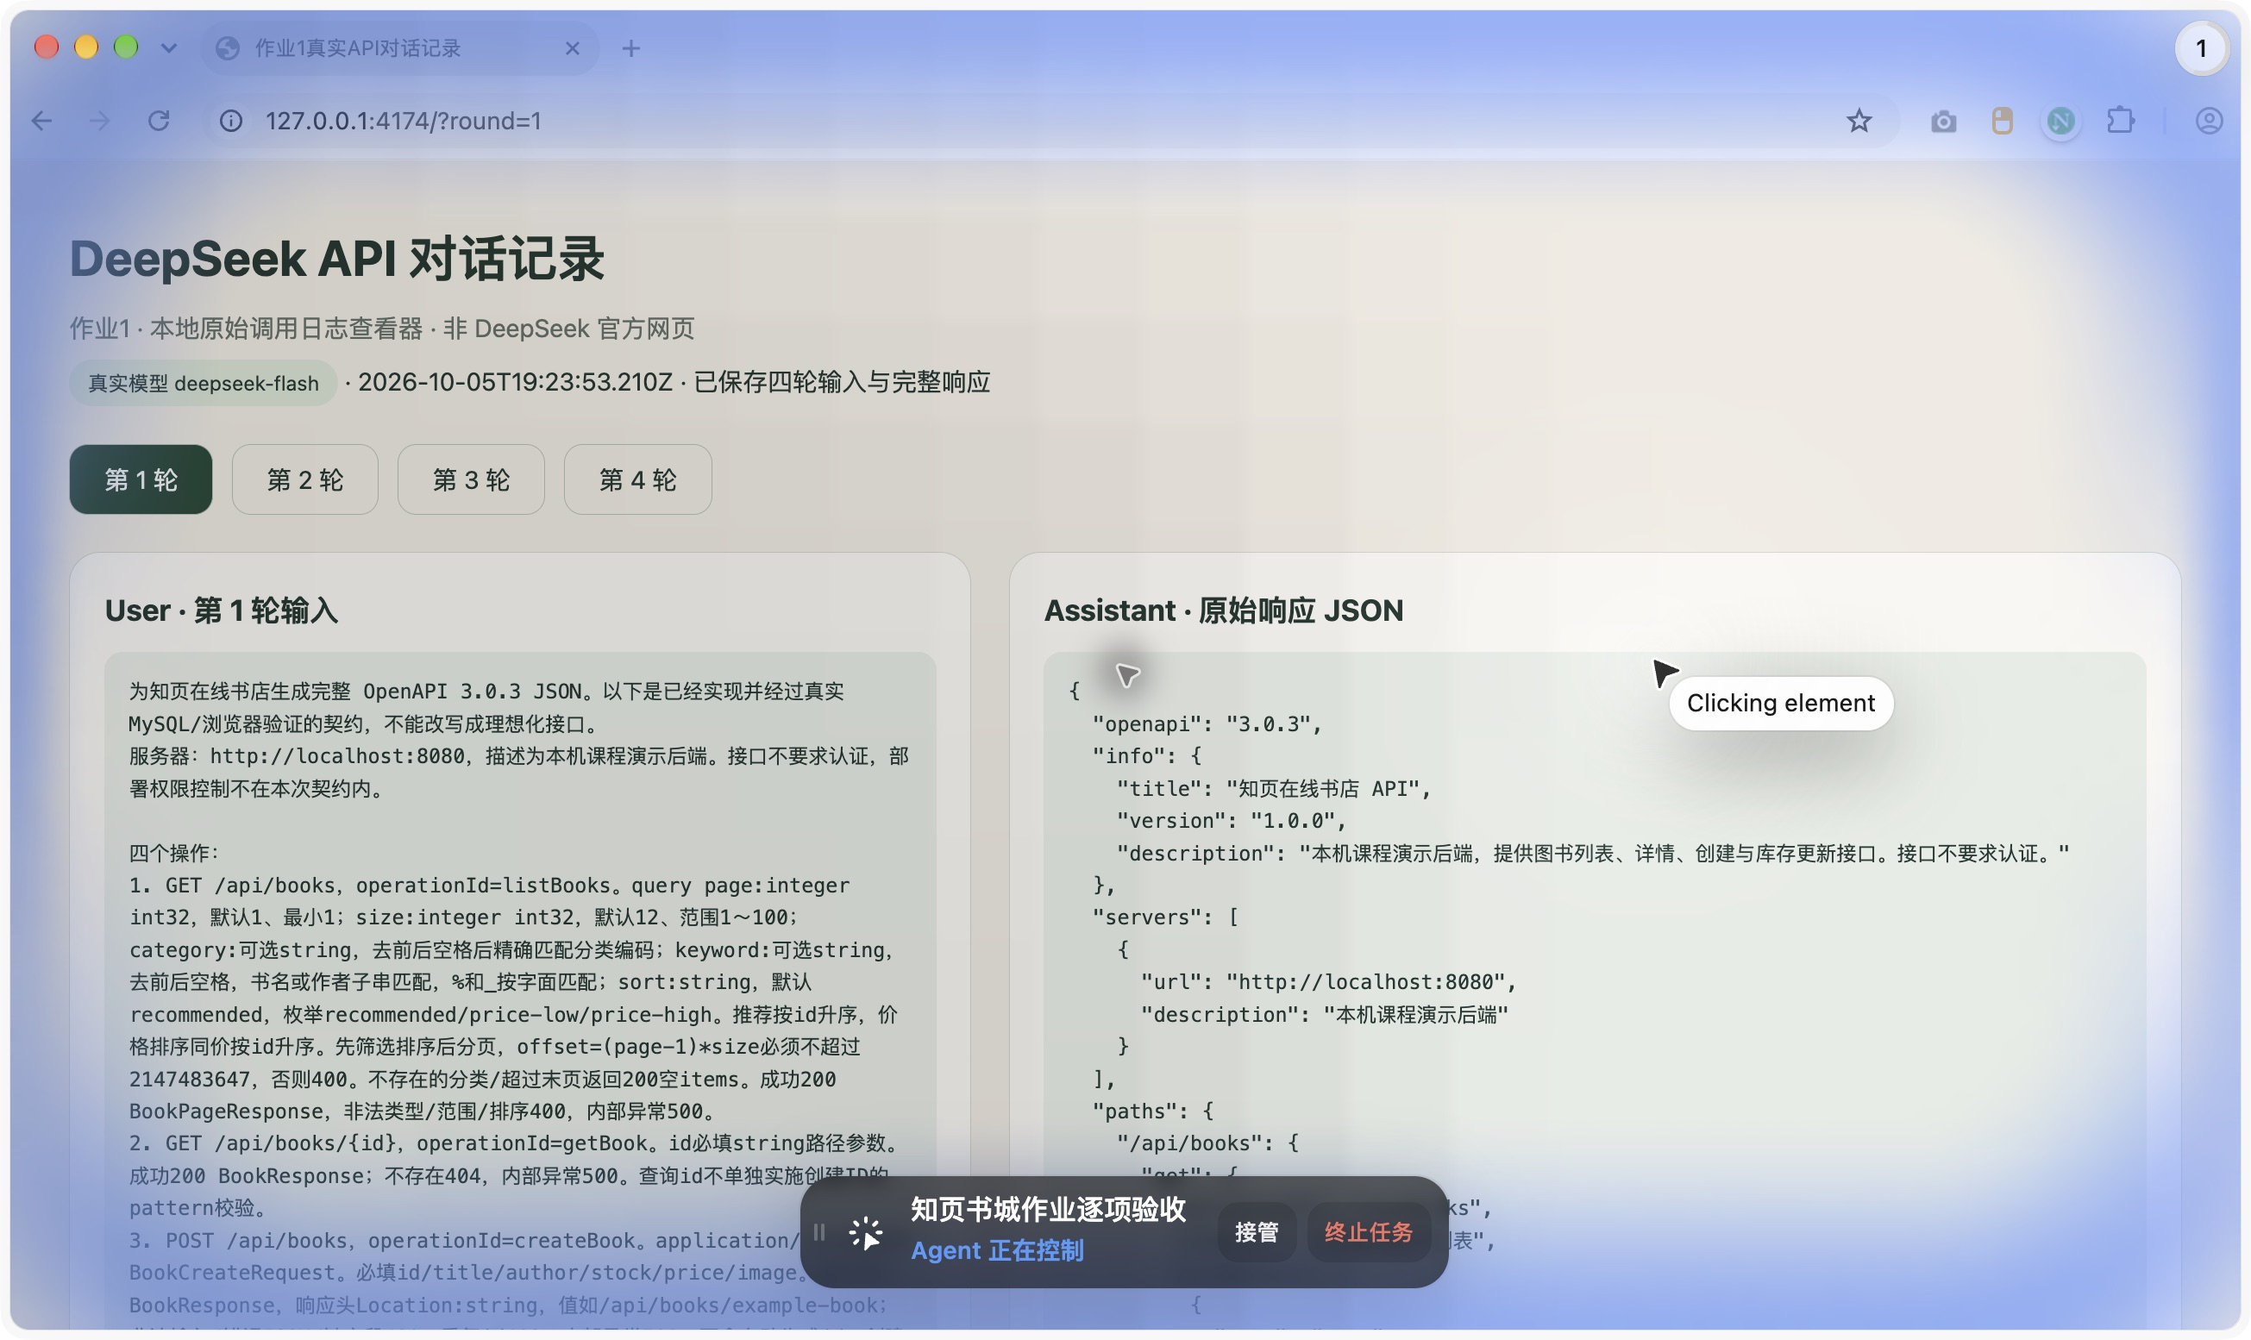
截图由本地原始日志查看器显示，非 DeepSeek 官方网页；为可读性仅添加 JSON 缩进，完整内容见前述提示词及下方最终规范。
第 2 轮真实 API 对话截图
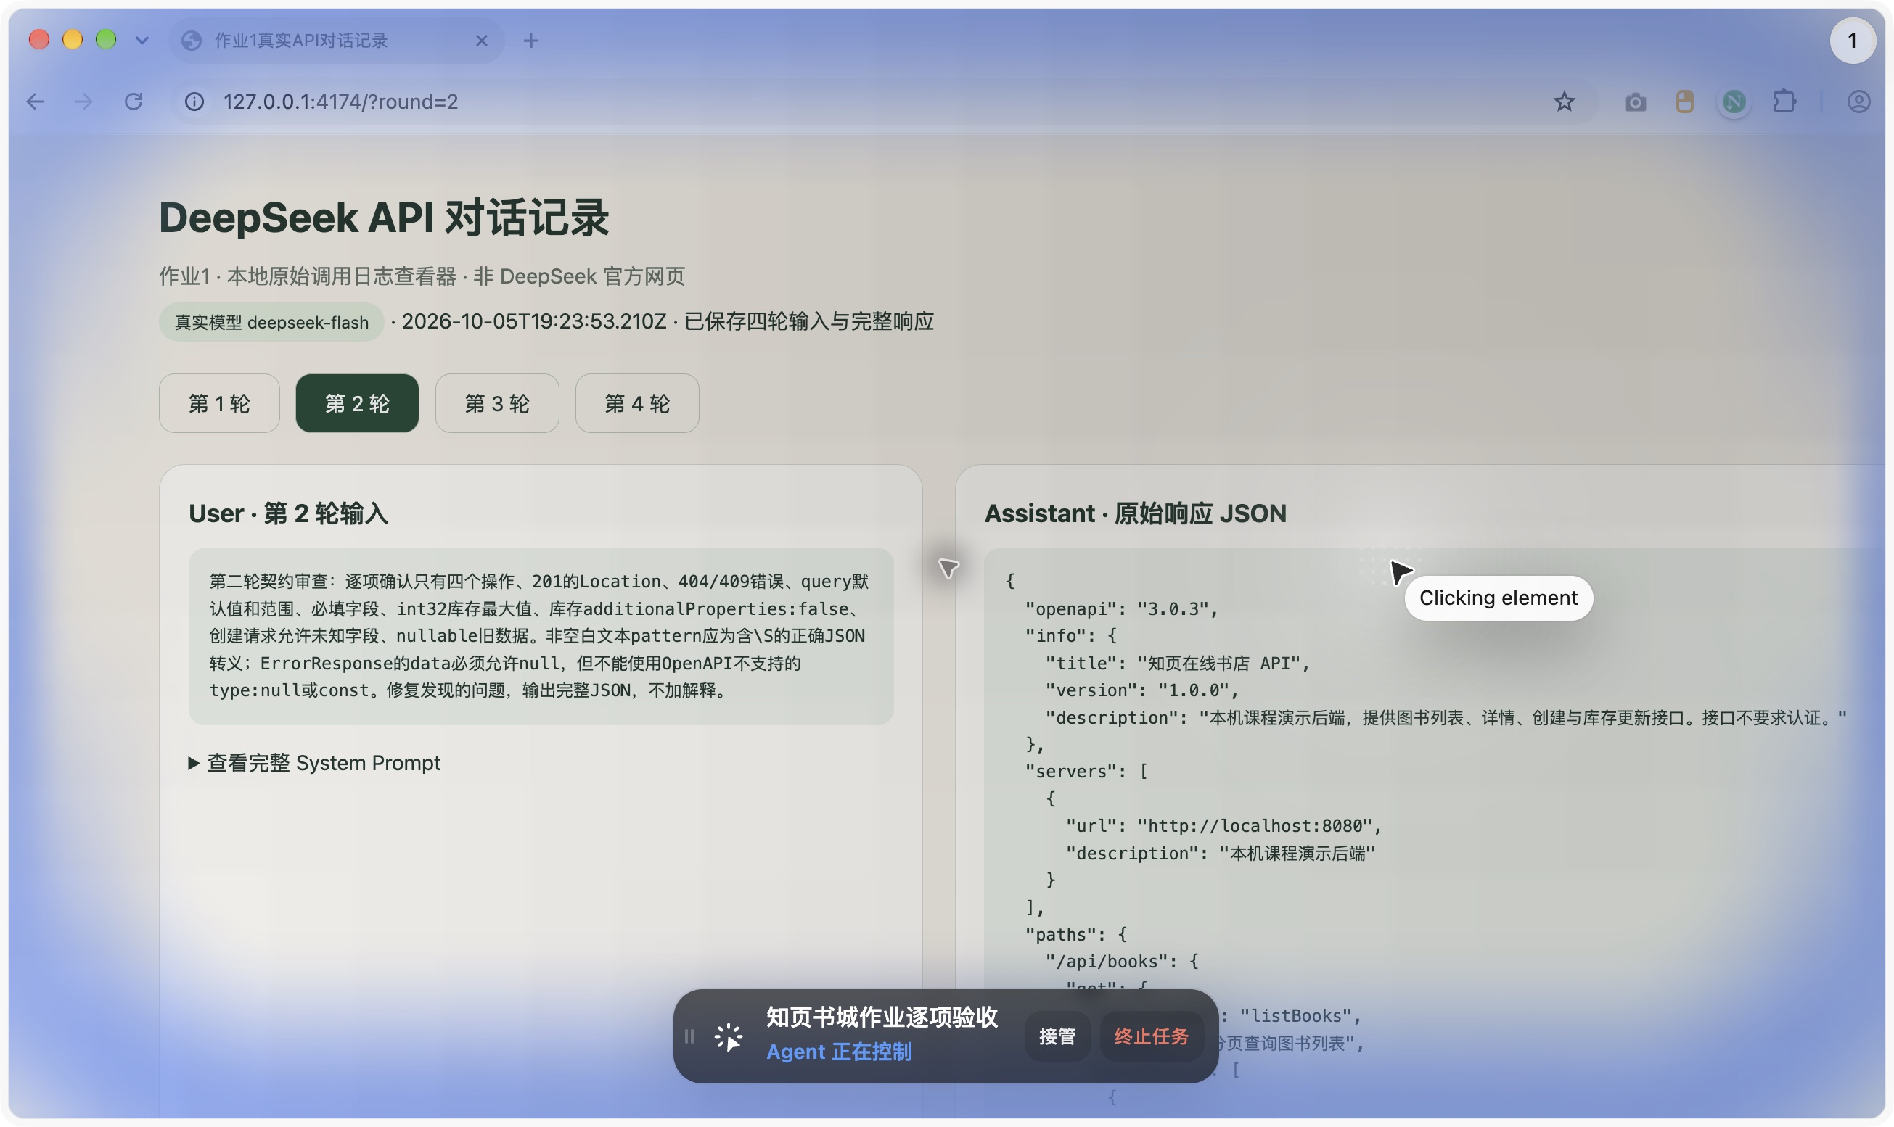
截图由本地原始日志查看器显示，非 DeepSeek 官方网页；为可读性仅添加 JSON 缩进，完整内容见前述提示词及下方最终规范。
第 4 轮真实 API 对话截图
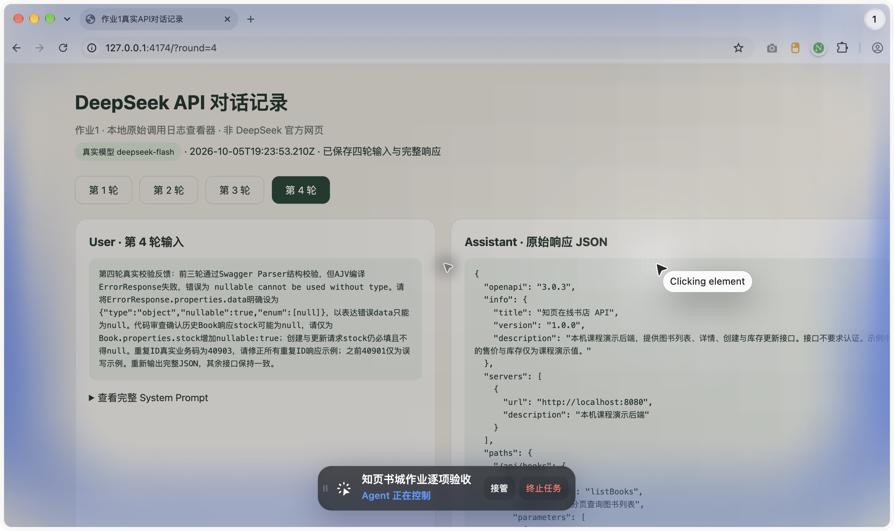
截图由本地原始日志查看器显示，非 DeepSeek 官方网页；为可读性仅添加 JSON 缩进，完整内容见前述提示词及下方最终规范。

前后端测评结果
2026-10-06，本机真实 Spring Boot 与 MySQL 环境下，23 个 HTTP 响应按最终 schema 校验通过，含分页成功及空页、非法参数400、详情404、新增201与Location、重复ID409、库存更新与严格整数拒绝。验收临时图书已清理；线上真实销售库存不在本作业范围内。
后端48个隔离测试全部通过；前端生产构建通过。桌面浏览器此前逐项完成分页/分类/搜索/排序、空结果、断网重试、详情404、新增失败保留输入与新增持久化、库存24→0→24及缺货禁用加购。PATCH来源检查曾发现403，修正CORS并重测后才进入本功能。按用户要求不测试手机比例。
OpenAPI静态地址 /api/v1/openapi.json 与最终文件逐字段一致。未人为制造真实500故障，500是已实现异常处理约定。证据目录为 docs/assignments/evidence；完整测试脚本为 scripts/assignments/verify_openapi.mjs。
最终规范 SHA-256：a2a034c1cecb8111a09da5d9b6197f3e82498091f91ad07c39f5cede6e564a67
参考：OpenAPI 3.0.3规范 https://spec.openapis.org/oas/v3.0.3.html；DeepSeek官方JSON与模型说明 https://api-docs.deepseek.com/guides/json_mode/ 及 https://api-docs.deepseek.com/zh-cn/。

最终 OpenAPI JSON 全文
以下为最终模型生成并通过真实响应校验的完整 JSON。独立规范文件位于 backend/src/main/resources/static/api/v1/openapi.json，可从后端静态地址下载。
{
"openapi": "3.0.3",
"info": {
"title": "知页在线书店 API",
"version": "1.0.0",
"description": "本机课程演示后端，提供图书列表、详情、创建与库存更新接口。接口不要求认证。示例中的售价与库存仅为课程演示值。"
},
"servers": [{"url": "http://localhost:8080","description": "本机课程演示后端"}],
"paths": {
"/api/books": {
"get": {
"operationId": "listBooks",
"summary": "分页查询图书列表",
"parameters": [
{
"name": "page",
"in": "query",
"required": false,
"schema": {"type": "integer","format": "int32","minimum": 1,"default": 1},
"description": "页码，从1开始。offset=(page-1)*size 必须不超过 2147483647，否则返回400。"
},
{
"name": "size",
"in": "query",
"required": false,
"schema": {
"type": "integer",
"format": "int32",
"minimum": 1,
"maximum": 100,
"default": 12
},
"description": "每页条数，范围1～100。"
},
{
"name": "category",
"in": "query",
"required": false,
"schema": {"type": "string"},
"description": "分类编码，去前后空格后精确匹配。不存在的分类返回200空items。"
},
{
"name": "keyword",
"in": "query",
"required": false,
"schema": {"type": "string"},
"description": "关键词，去前后空格后对书名或作者进行子串匹配，%和_按字面匹配。"
},
{
"name": "sort",
"in": "query",
"required": false,
"schema": {
"type": "string",
"enum": ["recommended","price-low","price-high"],
"default": "recommended"
},
"description": "排序方式。recommended按id升序；price-low/price-high按价格排序，同价按id升序。"
}
],
"responses": {
"200": {
"description": "查询成功，返回分页图书列表。不存在的分类或超过末页返回空items。",
"content": {
"application/json": {
"schema": {"$ref": "#/components/schemas/BookPageResponse"},
"example": {
"code": 0,
"message": "success",
"data": {
"items": [
{
"id": "example-book",
"title": "示例图书",
"author": "示例作者",
"image": "/images/example-book.jpg",
"stock": 10,
"price": 39.9,
"originalPrice": 59.9,
"isbn": "978-7-111-11111-1",
"publisher": "示例出版社",
"category": "tech",
"categoryName": "技术",
"categoryLabel": "计算机",
"rating": "4.8",
"badge": "热销",
"description": "课程演示图书",
"summary": "摘要",
"highlight": "亮点",
"audience": "大众",
"review": "好评"
}
],
"page": 1,
"size": 12,
"totalItems": 1,
"totalPages": 1
}
}
}
}
},
"400": {"$ref": "#/components/responses/BadRequest"},
"500": {"$ref": "#/components/responses/InternalError"}
}
},
"post": {
"operationId": "createBook",
"summary": "创建图书",
"requestBody": {
"required": true,
"content": {
"application/json": {
"schema": {"$ref": "#/components/schemas/BookCreateRequest"},
"example": {
"id": "example-book",
"title": "示例图书",
"author": "示例作者",
"image": "/images/example-book.jpg",
"stock": 10,
"price": 39.9,
"originalPrice": 59.9,
"isbn": "978-7-111-11111-1",
"publisher": "示例出版社",
"category": "tech",
"categoryName": "技术",
"categoryLabel": "计算机",
"rating": "4.8",
"badge": "热销",
"description": "课程演示图书",
"summary": "摘要",
"highlight": "亮点",
"audience": "大众",
"review": "好评"
}
}
}
},
"responses": {
"201": {
"description": "创建成功，返回创建的图书。Location响应头指向新资源。",
"headers": {
"Location": {
"description": "新创建图书的资源路径，例如 /api/books/example-book",
"schema": {"type": "string"}
}
},
"content": {
"application/json": {
"schema": {"$ref": "#/components/schemas/BookResponse"},
"example": {
"code": 0,
"message": "success",
"data": {
"id": "example-book",
"title": "示例图书",
"author": "示例作者",
"image": "/images/example-book.jpg",
"stock": 10,
"price": 39.9,
"originalPrice": 59.9,
"isbn": "978-7-111-11111-1",
"publisher": "示例出版社",
"category": "tech",
"categoryName": "技术",
"categoryLabel": "计算机",
"rating": "4.8",
"badge": "热销",
"description": "课程演示图书",
"summary": "摘要",
"highlight": "亮点",
"audience": "大众",
"review": "好评"
}
}
}
}
},
"400": {"$ref": "#/components/responses/BadRequest"},
"409": {"$ref": "#/components/responses/Conflict"},
"500": {"$ref": "#/components/responses/InternalError"}
}
}
},
"/api/books/{id}": {
"get": {
"operationId": "getBook",
"summary": "查询图书详情",
"parameters": [
{
"name": "id",
"in": "path",
"required": true,
"schema": {"type": "string"},
"description": "图书ID。查询时不单独实施创建ID的pattern校验。"
}
],
"responses": {
"200": {
"description": "查询成功，返回图书详情。",
"content": {
"application/json": {
"schema": {"$ref": "#/components/schemas/BookResponse"},
"example": {
"code": 0,
"message": "success",
"data": {
"id": "example-book",
"title": "示例图书",
"author": "示例作者",
"image": "/images/example-book.jpg",
"stock": 10,
"price": 39.9,
"originalPrice": 59.9,
"isbn": "978-7-111-11111-1",
"publisher": "示例出版社",
"category": "tech",
"categoryName": "技术",
"categoryLabel": "计算机",
"rating": "4.8",
"badge": "热销",
"description": "课程演示图书",
"summary": "摘要",
"highlight": "亮点",
"audience": "大众",
"review": "好评"
}
}
}
}
},
"404": {"$ref": "#/components/responses/NotFound"},
"500": {"$ref": "#/components/responses/InternalError"}
}
}
},
"/api/books/{id}/inventory": {
"patch": {
"operationId": "updateBookInventory",
"summary": "更新图书库存",
"parameters": [
{
"name": "id",
"in": "path",
"required": true,
"schema": {"type": "string"},
"description": "图书ID。"
}
],
"requestBody": {
"required": true,
"content": {
"application/json": {
"schema": {"$ref": "#/components/schemas/InventoryUpdateRequest"},
"example": {"stock": 20}
}
}
},
"responses": {
"200": {
"description": "库存更新成功，返回更新后的图书。仅修改库存，不改变标题、作者、价格等。",
"content": {
"application/json": {
"schema": {"$ref": "#/components/schemas/BookResponse"},
"example": {
"code": 0,
"message": "success",
"data": {
"id": "example-book",
"title": "示例图书",
"author": "示例作者",
"image": "/images/example-book.jpg",
"stock": 20,
"price": 39.9,
"originalPrice": 59.9,
"isbn": "978-7-111-11111-1",
"publisher": "示例出版社",
"category": "tech",
"categoryName": "技术",
"categoryLabel": "计算机",
"rating": "4.8",
"badge": "热销",
"description": "课程演示图书",
"summary": "摘要",
"highlight": "亮点",
"audience": "大众",
"review": "好评"
}
}
}
}
},
"400": {"$ref": "#/components/responses/BadRequest"},
"404": {"$ref": "#/components/responses/NotFound"},
"500": {"$ref": "#/components/responses/InternalError"}
}
}
}
},
"components": {
"schemas": {
"Book": {
"type": "object",
"required": ["id","title","author","image","stock","price"],
"properties": {
"id": {"type": "string"},
"title": {"type": "string"},
"author": {"type": "string"},
"image": {"type": "string"},
"stock": {
"type": "integer",
"format": "int32",
"minimum": 0,
"maximum": 2147483647,
"nullable": true
},
"price": {"type": "number","minimum": 0},
"originalPrice": {"type": "number","minimum": 0,"nullable": true},
"isbn": {"type": "string","nullable": true},
"publisher": {"type": "string","nullable": true},
"category": {"type": "string","nullable": true},
"categoryName": {"type": "string","nullable": true},
"categoryLabel": {"type": "string","nullable": true},
"rating": {"type": "string","nullable": true},
"badge": {"type": "string","nullable": true},
"description": {"type": "string","nullable": true},
"summary": {"type": "string","nullable": true},
"highlight": {"type": "string","nullable": true},
"audience": {"type": "string","nullable": true},
"review": {"type": "string","nullable": true}
}
},
"BookCreateRequest": {
"type": "object",
"required": ["id","title","author","stock","price","image"],
"properties": {
"id": {
"type": "string",
"maxLength": 80,
"pattern": "^[A-Za-z0-9][A-Za-z0-9._-]{0,79}$"
},
"title": {"type": "string","maxLength": 120,"pattern": "\\S"},
"author": {"type": "string","maxLength": 120,"pattern": "\\S"},
"image": {
"type": "string",
"maxLength": 255,
"pattern": "\\S",
"description": "非空白字符串，允许本地资源路径，不强制uri格式。"
},
"stock": {
"type": "integer",
"format": "int32",
"minimum": 0,
"maximum": 2147483647,
"description": "严格JSON整数，不接受浮点数、数字字符串或null。"
},
"price": {"type": "number","minimum": 0},
"originalPrice": {"type": "number","minimum": 0,"nullable": true},
"isbn": {"type": "string","maxLength": 40,"nullable": true},
"publisher": {"type": "string","maxLength": 120,"nullable": true},
"category": {"type": "string","maxLength": 60,"nullable": true},
"categoryName": {"type": "string","maxLength": 80,"nullable": true},
"categoryLabel": {"type": "string","maxLength": 120,"nullable": true},
"rating": {"type": "string","maxLength": 40,"nullable": true},
"badge": {"type": "string","maxLength": 80,"nullable": true},
"description": {"type": "string","maxLength": 255,"nullable": true},
"summary": {"type": "string","nullable": true},
"highlight": {"type": "string","nullable": true},
"audience": {"type": "string","nullable": true},
"review": {"type": "string","nullable": true}
},
"additionalProperties": true,
"description": "创建请求中的未知字段由当前Jackson忽略，不声称全部拒绝。"
},
"InventoryUpdateRequest": {
"type": "object",
"required": ["stock"],
"additionalProperties": false,
"properties": {
"stock": {
"type": "integer",
"format": "int32",
"minimum": 0,
"maximum": 2147483647,
"description": "严格JSON整数，不接受小数token、数字字符串、null、负数、溢出或额外字段。"
}
}
},
"BookPage": {
"type": "object",
"required": ["items","page","size","totalItems","totalPages"],
"properties": {
"items": {"type": "array","items": {"$ref": "#/components/schemas/Book"}},
"page": {"type": "integer","format": "int32","minimum": 1},
"size": {"type": "integer","format": "int32","minimum": 1,"maximum": 100},
"totalItems": {"type": "integer","format": "int64","minimum": 0},
"totalPages": {"type": "integer","format": "int32","minimum": 0}
}
},
"BookResponse": {
"type": "object",
"required": ["code","message","data"],
"properties": {
"code": {"type": "integer","enum": [0]},
"message": {"type": "string"},
"data": {"$ref": "#/components/schemas/Book"}
}
},
"BookPageResponse": {
"type": "object",
"required": ["code","message","data"],
"properties": {
"code": {"type": "integer","enum": [0]},
"message": {"type": "string"},
"data": {"$ref": "#/components/schemas/BookPage"}
}
},
"ErrorResponse": {
"type": "object",
"required": ["code","message","data"],
"properties": {
"code": {"type": "integer","minimum": 1},
"message": {"type": "string"},
"data": {"type": "object","nullable": true,"enum": [null]}
}
}
},
"responses": {
"BadRequest": {
"description": "请求参数无效或请求体格式错误。",
"content": {
"application/json": {
"schema": {"$ref": "#/components/schemas/ErrorResponse"},
"example": {"code": 40000,"message": "参数无效","data": null}
}
}
},
"NotFound": {
"description": "请求的图书不存在。",
"content": {
"application/json": {
"schema": {"$ref": "#/components/schemas/ErrorResponse"},
"example": {"code": 40404,"message": "图书不存在","data": null}
}
}
},
"Conflict": {
"description": "创建图书时ID重复。",
"content": {
"application/json": {
"schema": {"$ref": "#/components/schemas/ErrorResponse"},
"example": {"code": 40903,"message": "重复ID","data": null}
}
}
},
"InternalError": {
"description": "服务器内部错误。",
"content": {
"application/json": {
"schema": {"$ref": "#/components/schemas/ErrorResponse"},
"example": {"code": 50000,"message": "服务器错误","data": null}
}
}
}
}
}
}

