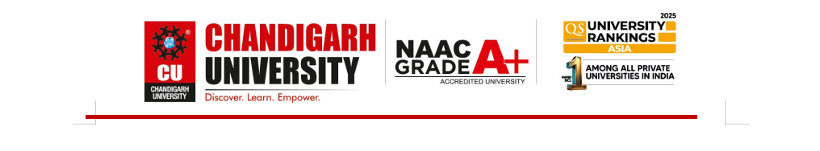

UNIVERSITY INSTITUTE OF COMPUTING
PROJECT REPORT ON :

GRAPH VISUALIZER TOOL
(Visual Representation of BFS, DFS, and Dijkstra’s Algorithm)
A Project Report Submitted in Partial Fulfillment of the Requirements for the Course
OBJECT-ORIENTED PROGRAMMING (OOP)/24CAH-201
Submitted By:
SEKA ARMEL YANNICK
24-BCA / Semester III
UID : 24BCA10005
Under the Guidance of: RAVINDER SINGH
Course Instructor
Department of Computer Applications
Chandigarh University

ABSTRACT
Graphs are a fundamental data structure in computer science, forming the foundation of various applications like social networks, navigation systems, and network routing. However, understanding the internal working of graph algorithms such as Breadth-First Search (BFS), Depth-First Search (DFS), and Dijkstra’s Algorithm can be challenging for beginners. This project, titled 'Graph Visualizer Tool', aims to provide a console-based visualization that demonstrates how these algorithms traverse nodes and calculate shortest paths step by step. Developed in C++ using Object-Oriented Programming (OOP) principles, it serves as an educational tool to make learning graph algorithms more intuitive and interactive.

INTRODUCTION

Graphs are powerful data structures that represent relationships between entities. They consist of nodes (vertices) and connections (edges) and are widely used in computer science fields such as AI, networking, and data analysis. The Graph Visualizer Tool demonstrates three major algorithms — BFS, DFS, and Dijkstra’s Algorithm — to show how graphs are traversed and how the shortest paths are calculated. The program is implemented in C++ using object-oriented design for modularity, encapsulation, and reusability.

PROBLEM STATEMENT

Understanding how graph traversal algorithms work internally is often challenging. Students struggle to visualize the traversal order, queue or recursion stack behavior, and distance updates. Hence, there is a need for a console-based tool that clearly displays step-by-step algorithm execution, helping learners develop a deeper understanding of te algorithms.

OBJECTIVES

- To implement BFS, DFS, and Dijkstra’s algorithms using C++.
- To provide a text-based visualization of traversal and shortest-path computation.
- To enhance conceptual understanding of graph theory.
- To demonstrate Object-Oriented Programming principles in algorithm implementation.
- To create a reusable and extendable code-base.

TOOLS & TECHNOLOGIES USED

- C++ 20: Core language used for implementation.
- STL: Used for data structures such as vectors, queues, and priority queues.
- OnlineGDB Compiler: Online IDE used for compiling and testing the program.
- Console I/O: Used for displaying the step-by-step traversal process.
- Object-Oriented Programming: For modularity and encapsulation.

5. SYSTEM DESIGN AND CLASS DIAGRAM
The system is designed using an object-oriented approach with a single class 'Graph' that encapsulates all functionalities related to graph creation, traversal, and pathfinding. The following is the class diagram:
Class Name | Graph
Attributes (Private) | Type
V | int
adj | vector<vector<pair<int, int>>>
Methods (Public) | Description
Graph(int vertices) | Constructor to initialize the graph with a given number of vertices.
addEdge(int u, int v, int w) | Adds an edge between vertices u and v with weight w.
displayGraph() | Displays the adjacency list of the graph.
BFS(int start) | Performs Breadth-First Search starting from the given node.
DFS(int start) | Performs Depth-First Search starting from the given node.
Dijkstra(int start) | Finds the shortest paths from the start node using Dijkstra’s Algorithm.
Helper Methods (Private) | Description
DFSUtil(int node, vector<bool>& visited) | A recursive utility function used internally by DFS.

ALGORITHMIC DETAILS

The project implements three fundamental algorithms: BFS, DFS, and Dijkstra’s. Each algorithm uses different traversal strategies and data structures to achieve its goal.
Breadth-First Search (BFS): Visits all nodes level by level using a queue.
Depth-First Search (DFS): Explores nodes deeply using recursion or a stack.
Dijkstra’s Algorithm: Finds the shortest path from a source node using a priority queue.

- FLOWCHART & PSEUDOCODE
The following pseudo-code represents the general logic of BFS:
BFS(Graph, Start):
Initialize queue Q
Mark Start as visited and en-queue it
While Q is not empty:
Node = Q.dequeue()
For each neighbor of Node:
If neighbor not visited:
Mark as visited
En-queue(neighbor)

- IMPLEMENTATION
The Graph Visualizer Tool was implemented in C++ using the OnlineGDB compiler. It allows users to enter the number of vertices and edges, specify weighted connections, and select a starting node for traversal.

- SAMPLE INPUT/OUTPUT
Sample Input:
Vertices: 5
Edges: 6
Edges:
0 1 2
0 2 4
1 2 1
1 3 7
2 4 3
3 4 2
Start Node: 0
Sample Output:
BFS: 0 1 2 3 4
DFS: 0 1 2 4 3
Dijkstra Distances: 0->0=0, 1=2, 2=3, 3=9, 4=6
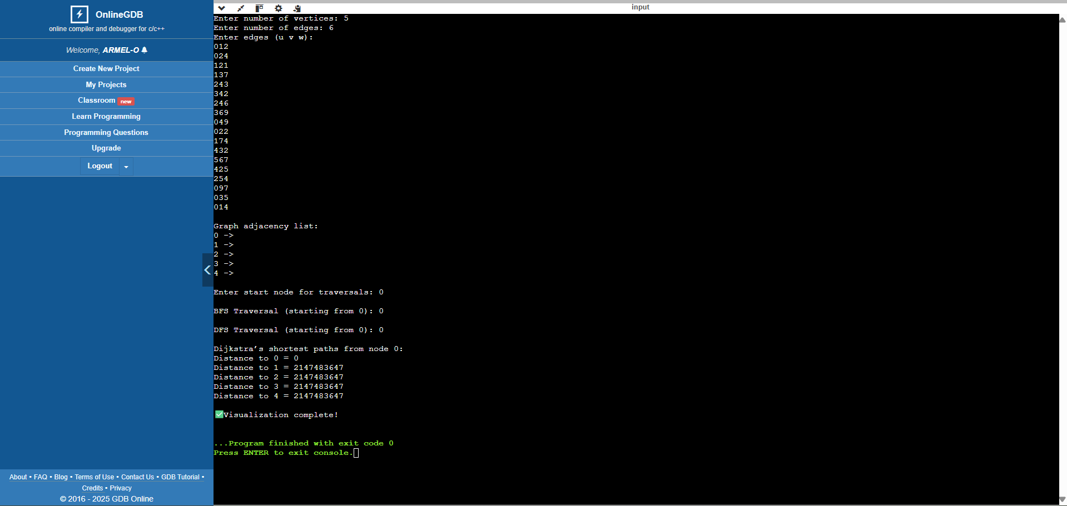

APPLICATIONS

- Used in computer networks for routing and packet transfer.
- In AI for pathfinding (e.g., in games).
- In GPS systems for shortest route computation.
- In social networks to suggest connections.

CONCLUSION
The Graph Visualizer Tool provides an educational demonstration of BFS, DFS, and Dijkstra’s algorithms. It emphasizes how OOP principles can simplify algorithm design and visualization. This tool makes learning graph theory interactive, bridging the gap between theoretical knowledge and practical understanding.

REFERENCES

- GeeksforGeeks – Graph Algorithms in C++
- TutorialsPoint – Data Structures and Algorithms
- Programiz – Graph Representation and Algorithms
- cppreference.com – C++ STL Documentation
- Abdul Bari – Graph Algorithm Lectures (YouTube)

