

**In the Name of God**

**Communication Systems**

Computer Homework_1 Report

Multi-Path Channels &

Signal Reconstruction

Armin Panjehpour – 98101288

1. Multi-Path Channels:

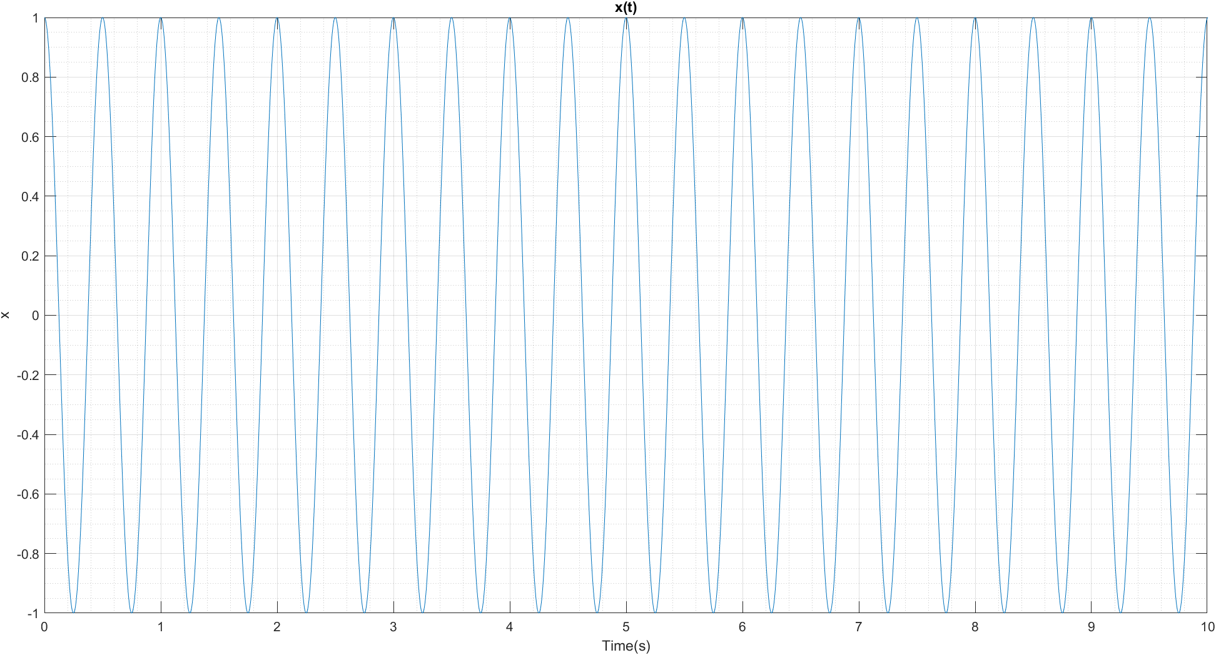1.1 -

1.2 –

paramters:

mu = 0;

sigma = 0.5;

Tm = 0.01;

n = [1 10]; % length of a

a = normrnd(mu,sigma,n); % coeffiecients of impulses

tau = unifrnd(0,Tm,n); % shiftings of impulses

Hc is defined using a syms function and then using abs and angle, the magnitude and phase of the channel is drawn:

syms f;

syms HcF(f);

HcF(f) = sum(a.*exp(-1i*2*pi*f.*tau));

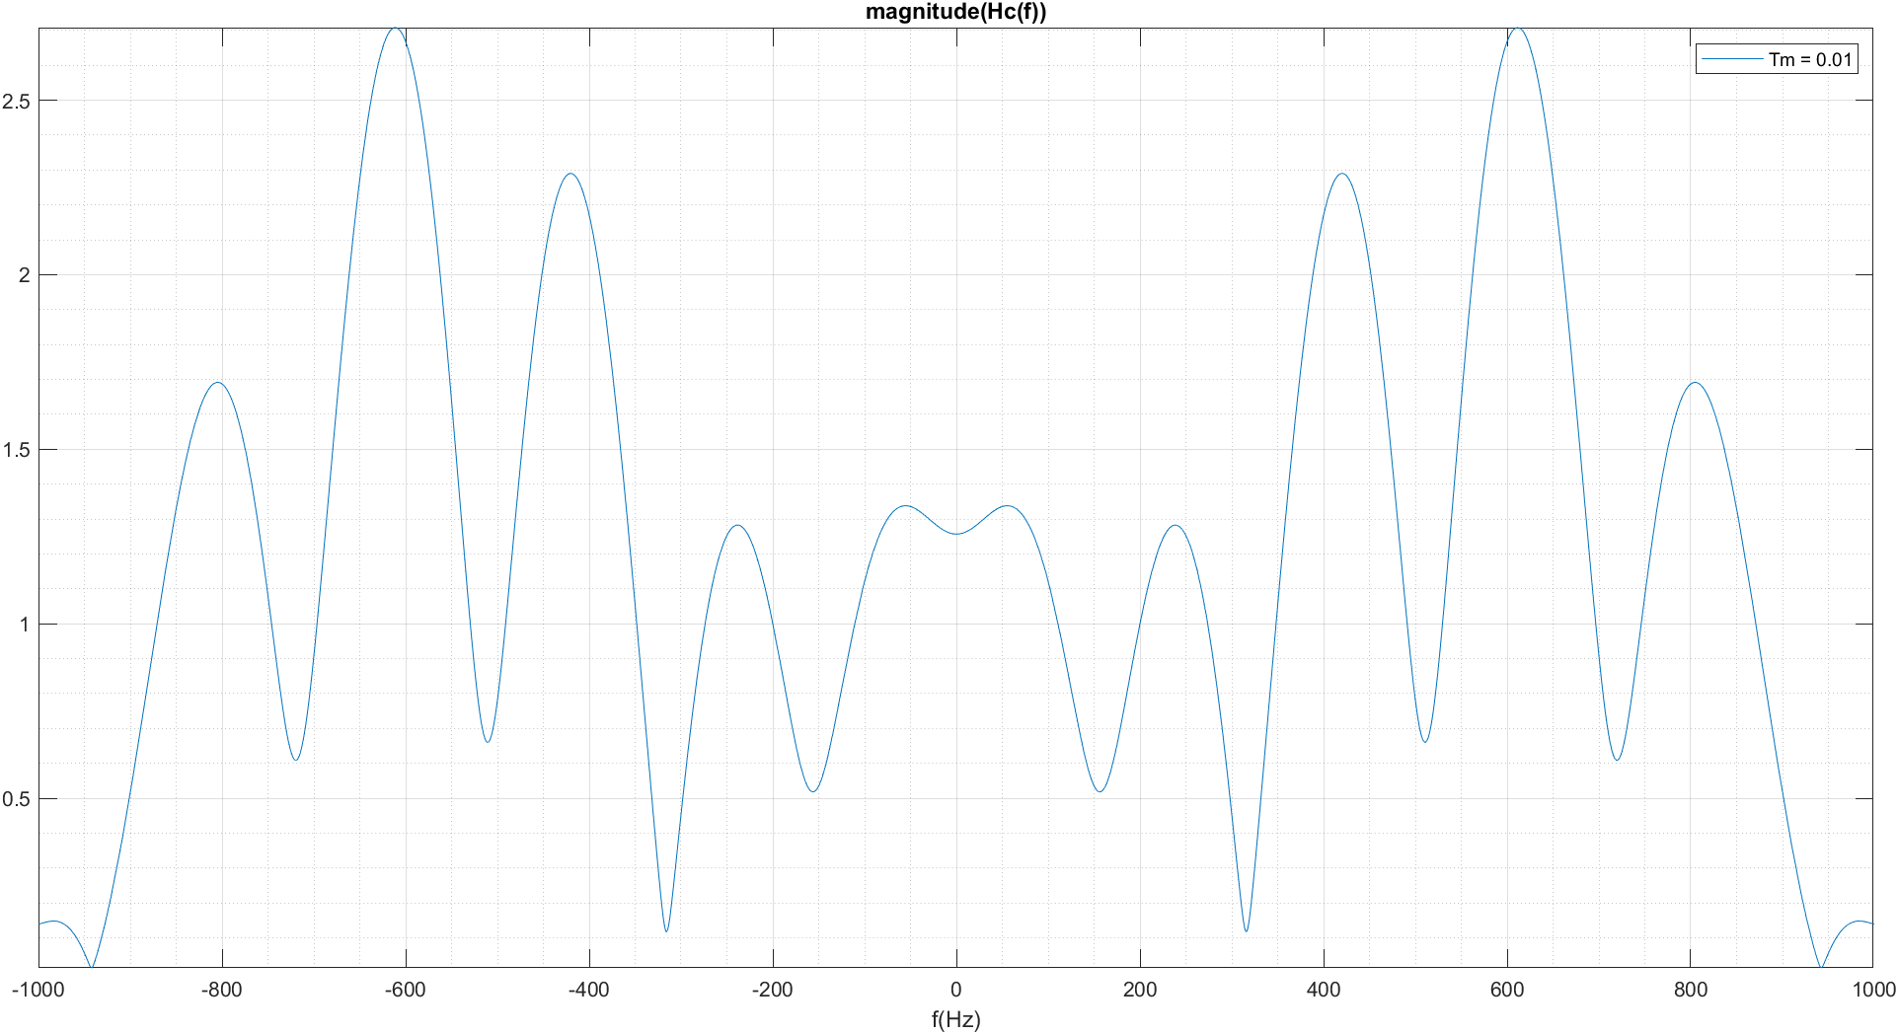

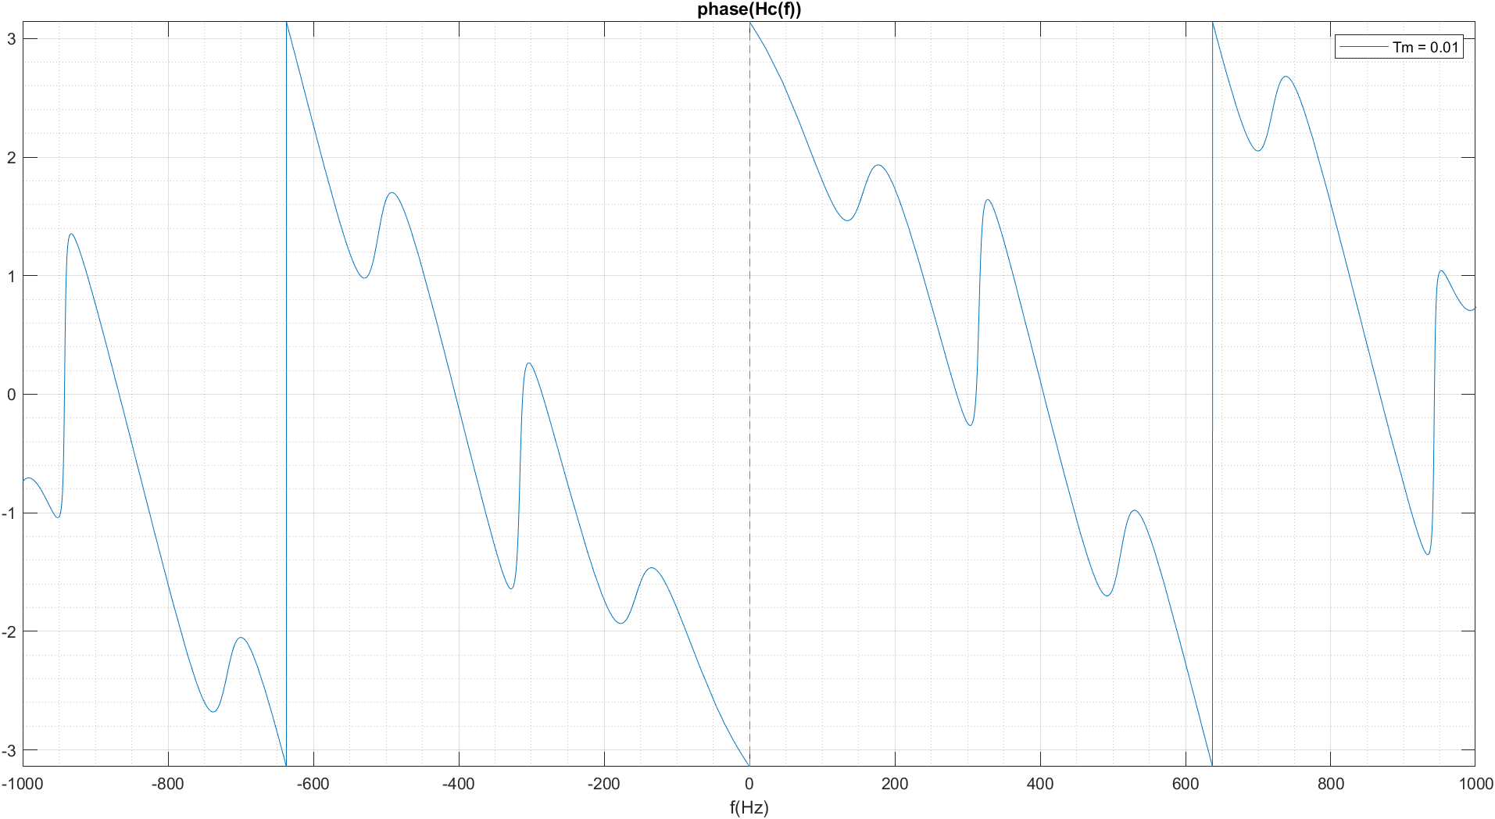

1.3 – By testing different Tm values, we find out that the distance between each two local minimums has a inverse relationship with Tm.

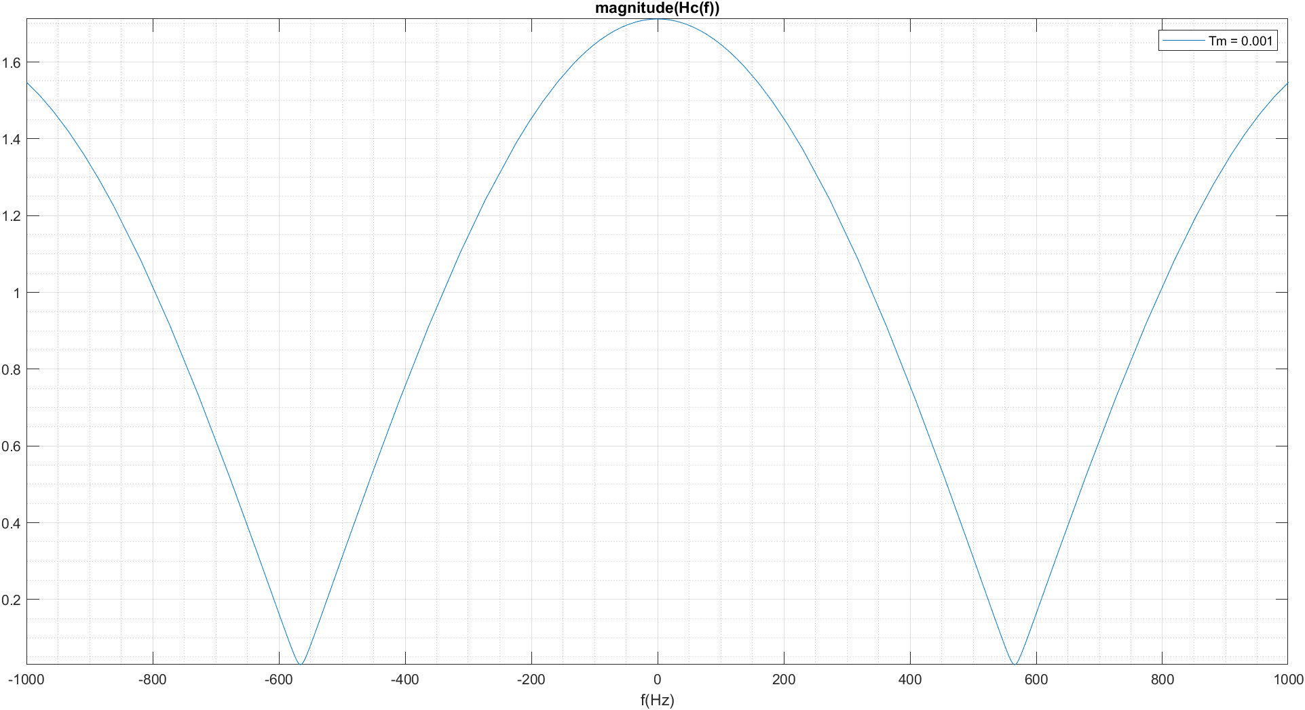

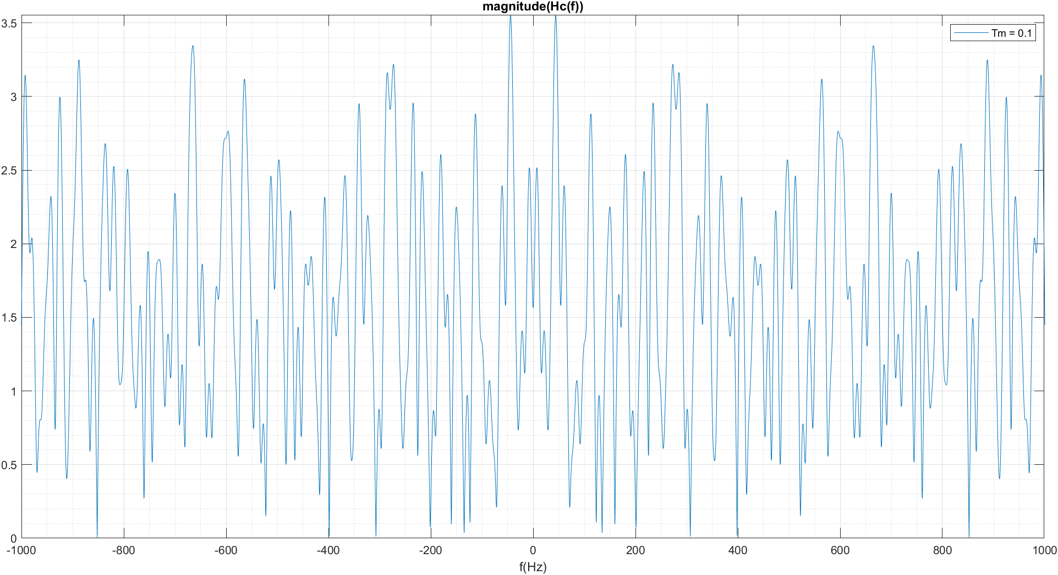

1.4 –

tau = (1/fs).*randi([0 floor(Tm*fs)],n); % samples

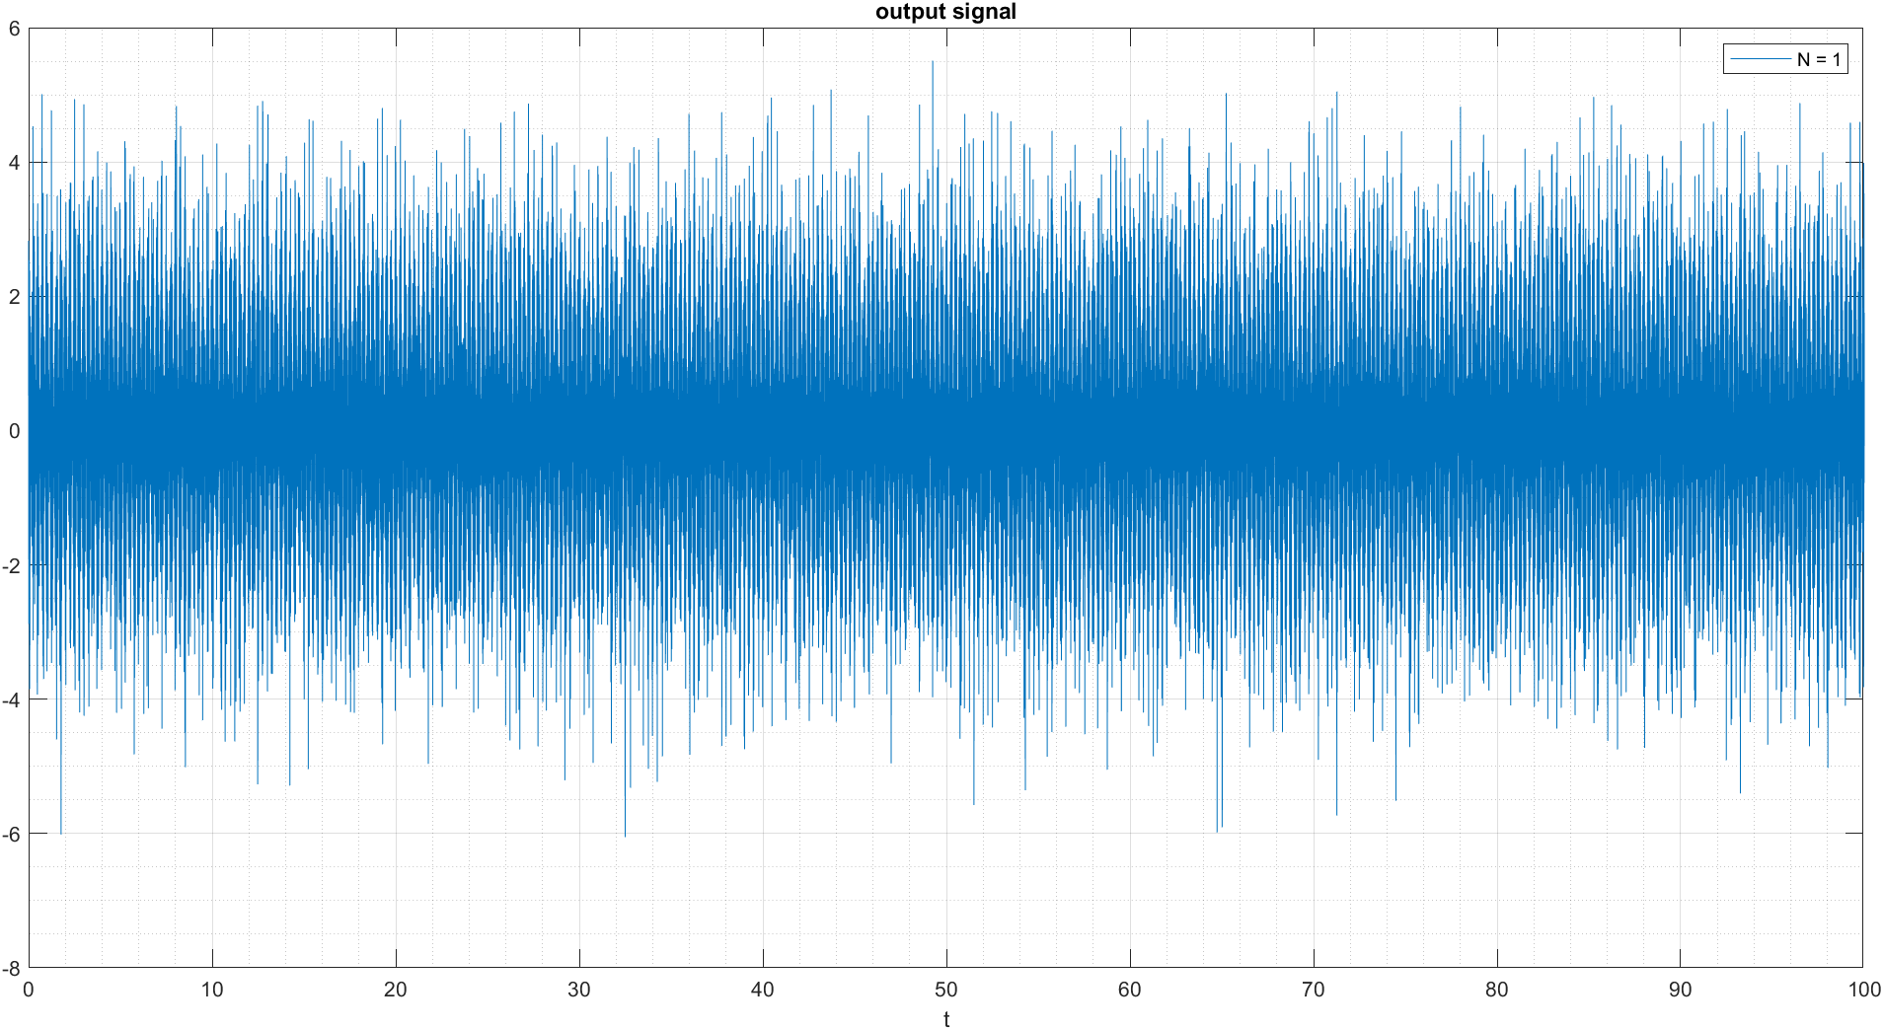

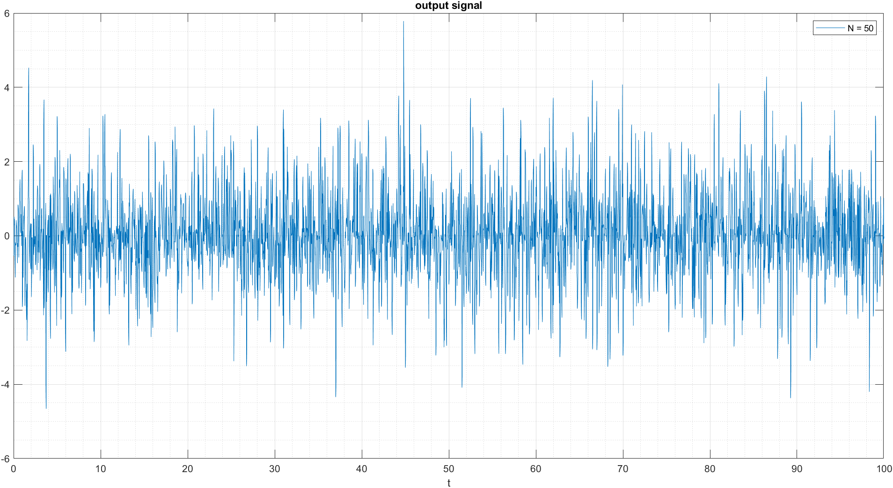

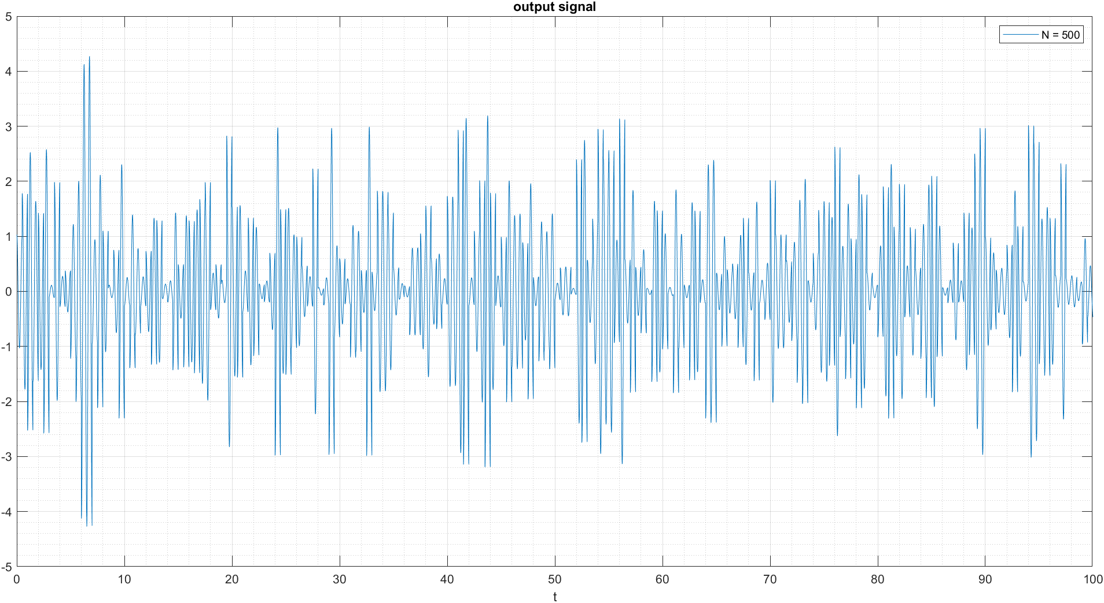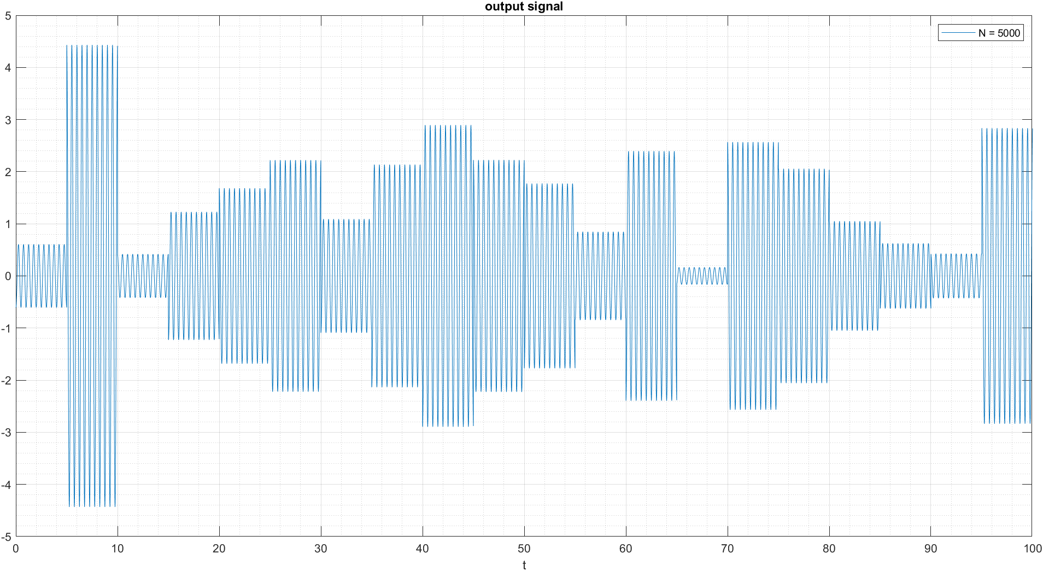

1. Signal Reconstruction in multi path channels:

Using M-Tapped-Delay Line Equalizer, the output signal of the multi-path channel will be reconstructed:

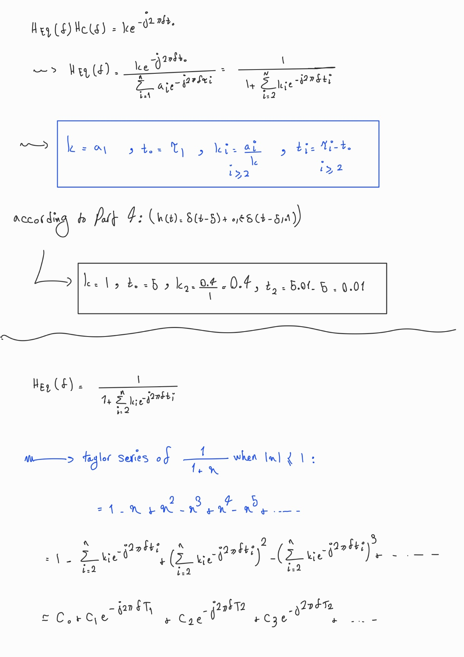2.1 –



2.2 –



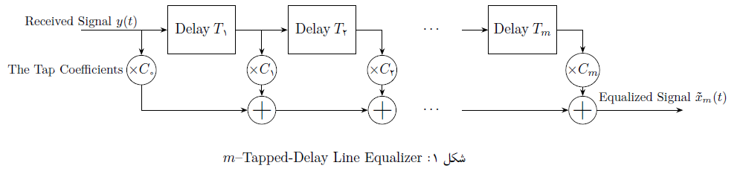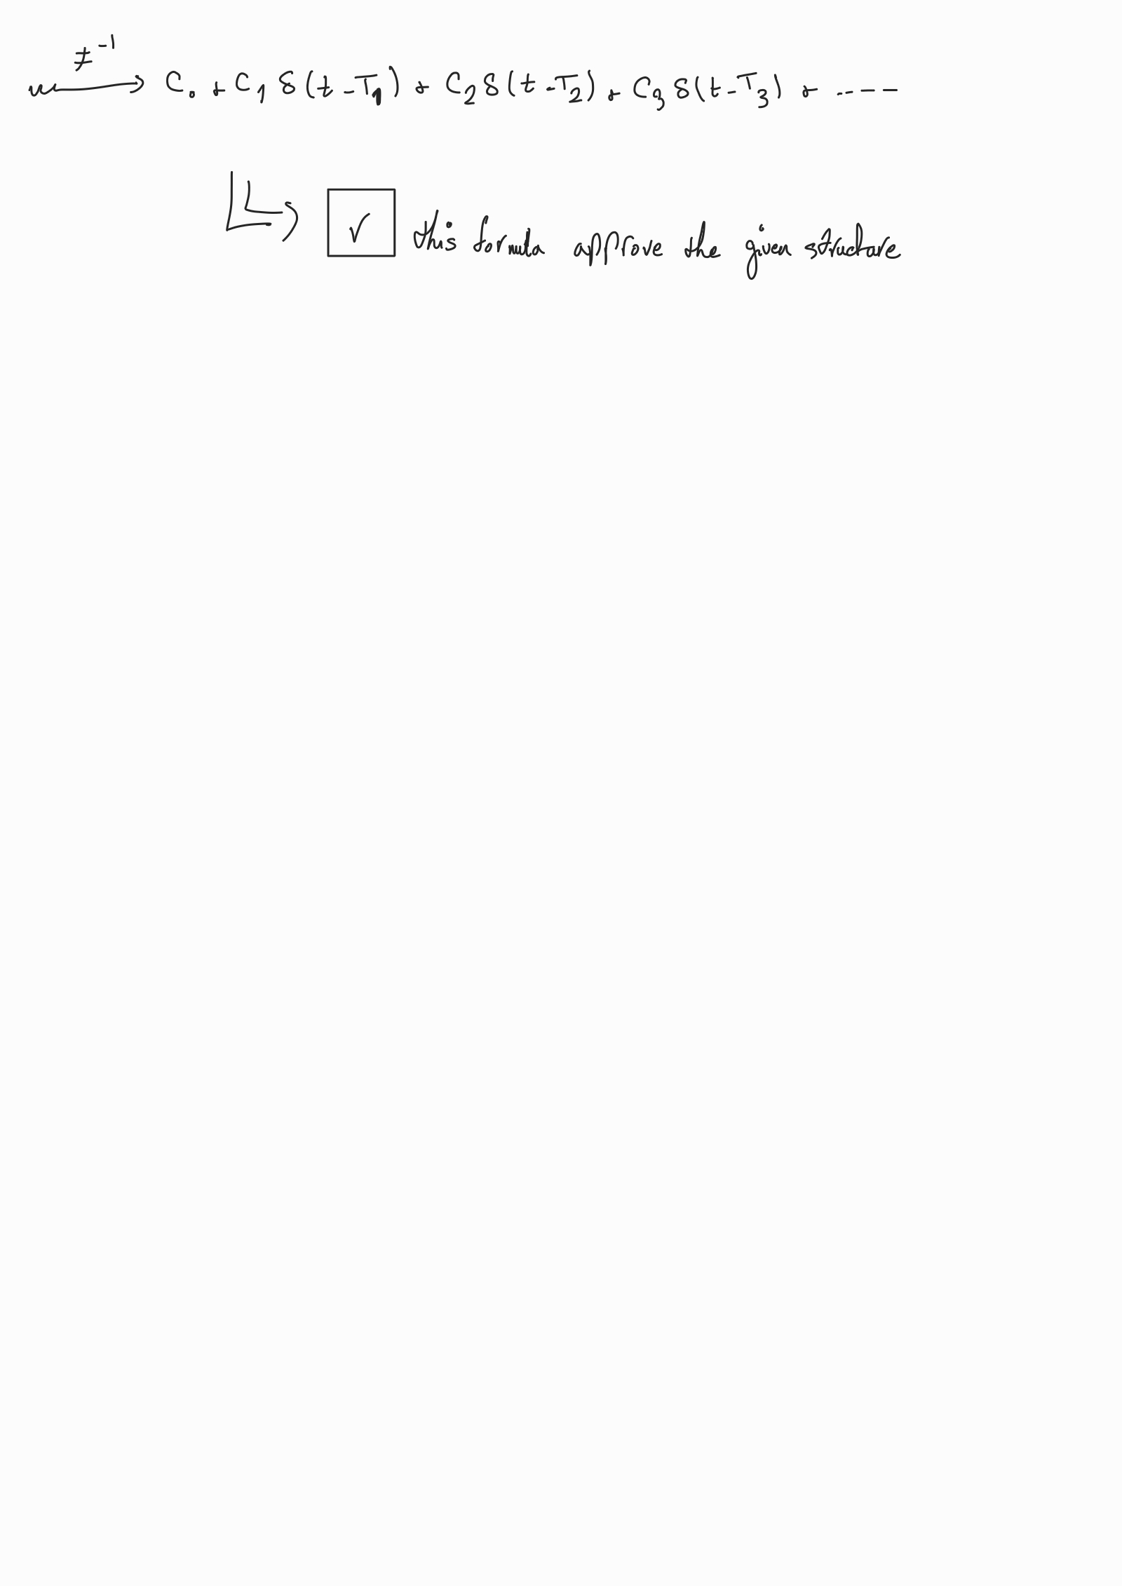

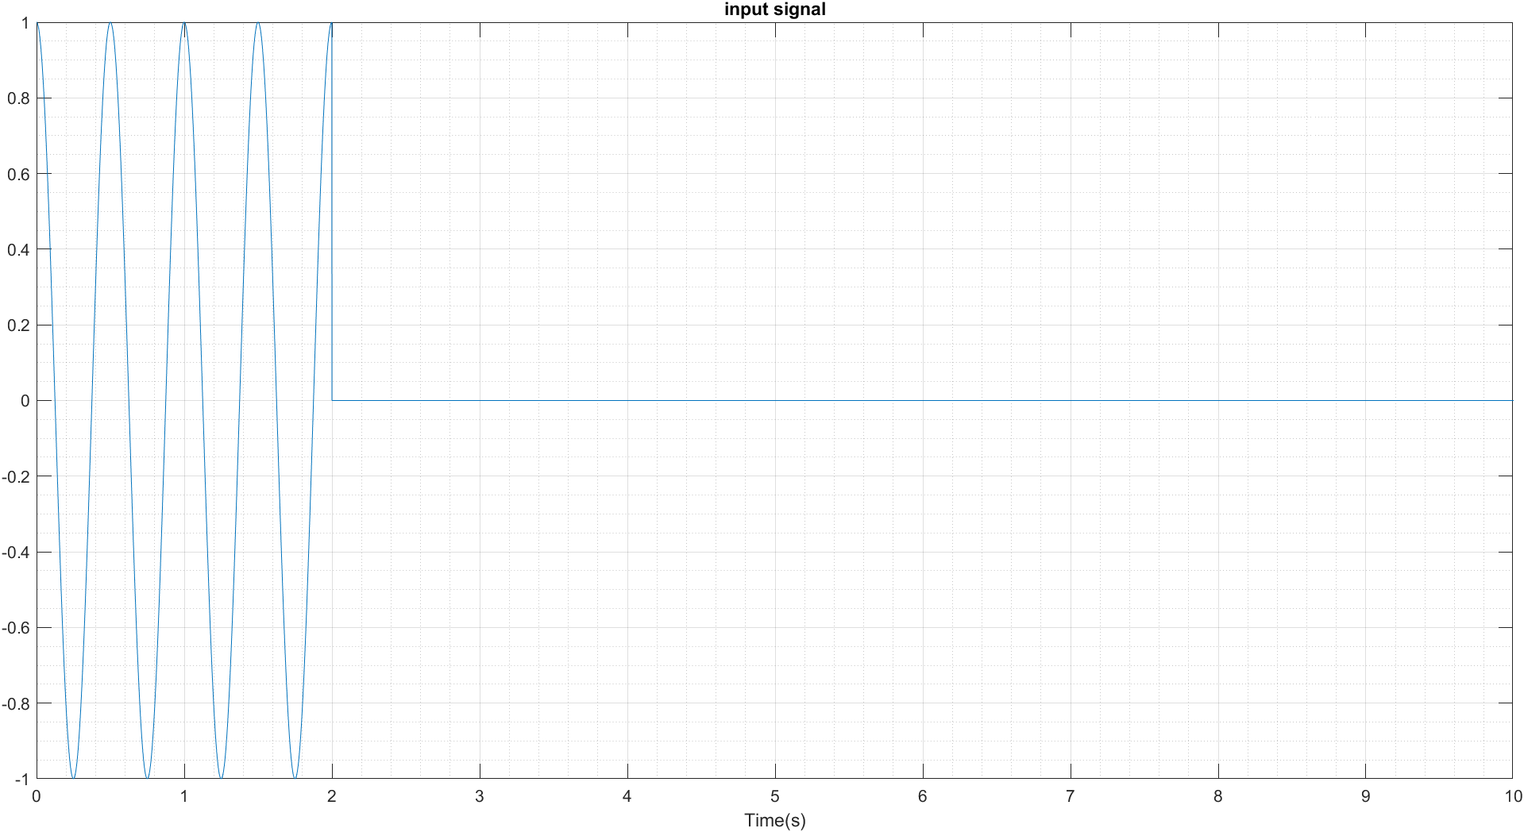2.3 –

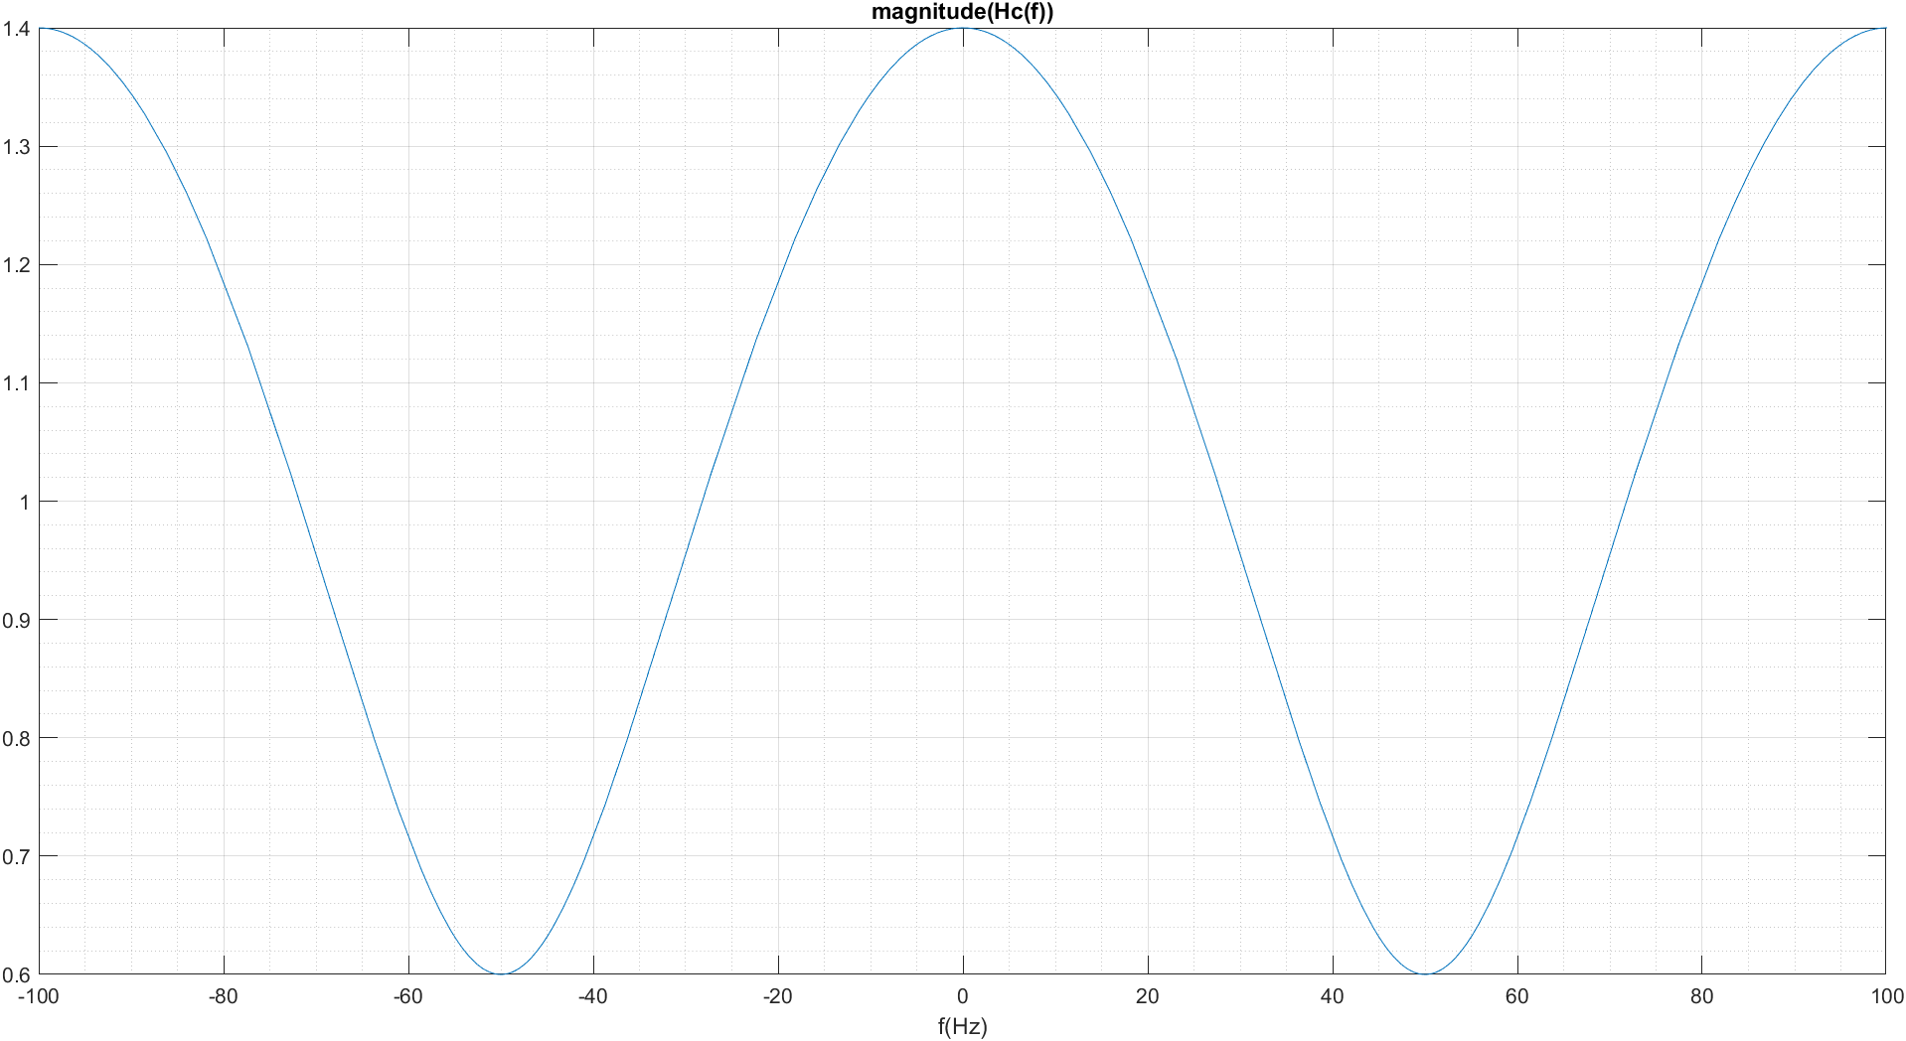2.4 –

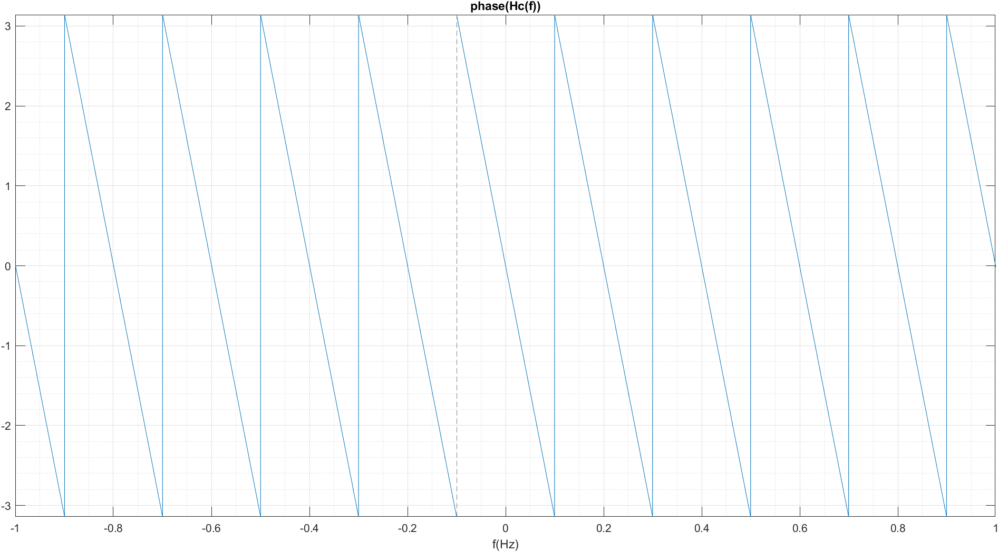

2.5 –

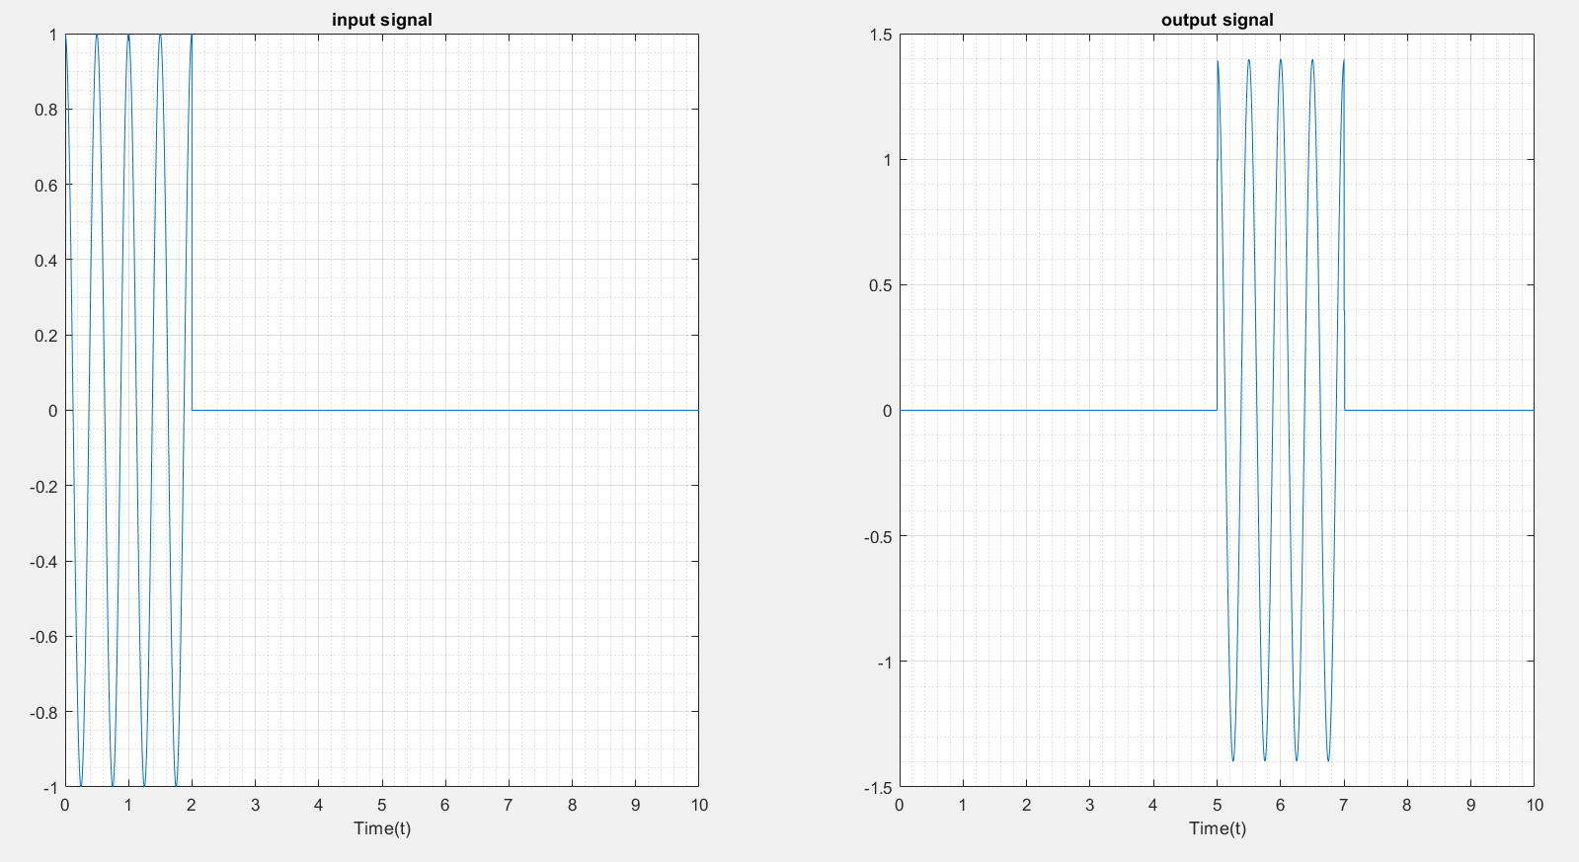

2.6 –

According to part 2.1, Ti and Ci are:

C(i+1) = ((-1)^i)*((k2)^i);

T(i) = t2*i;

Ci: 

Ti:



As you can see in RMS plots, by increasing m, a better signal would be reconstructed:

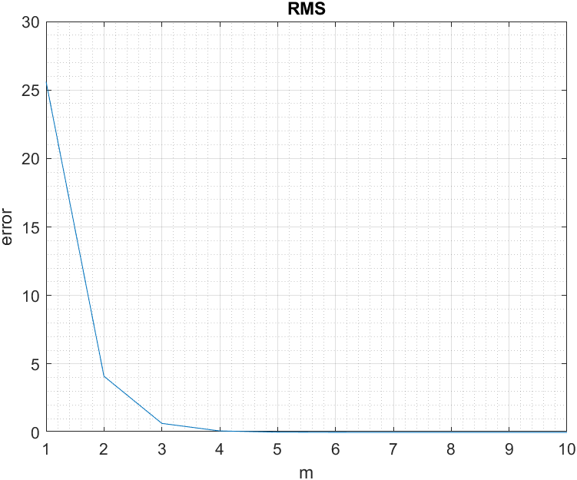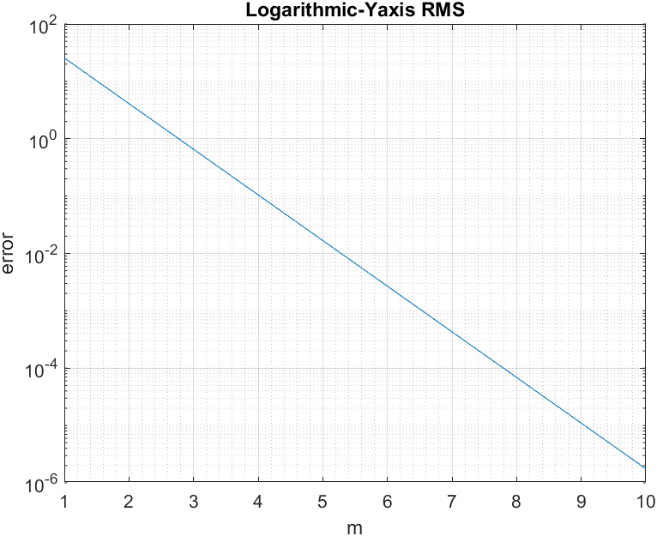

2.7 – 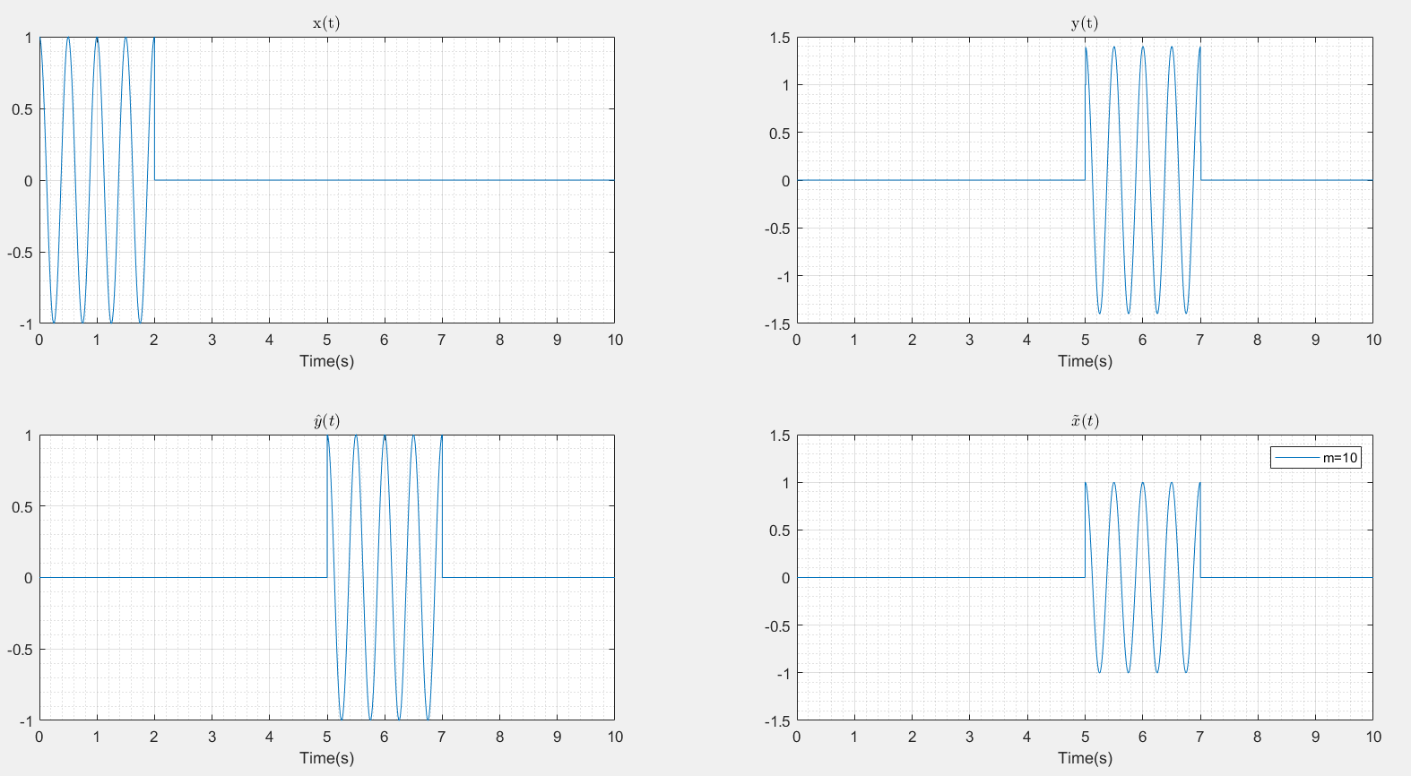

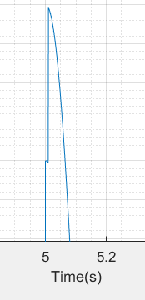As we see, y(t) which is the output of the multipath channel is destroyed because the domain is changed and if we zoom, there are some impulses on the signal:

but and which are in order, the output of the ideal channel and reconstructed signal are the same and has a low RMS as we saw.