**Autonomous Tractor Safety System**

**Objective 1.2** To demonstrate turning ON LEDs when switches are pressed in ATSS PCB board

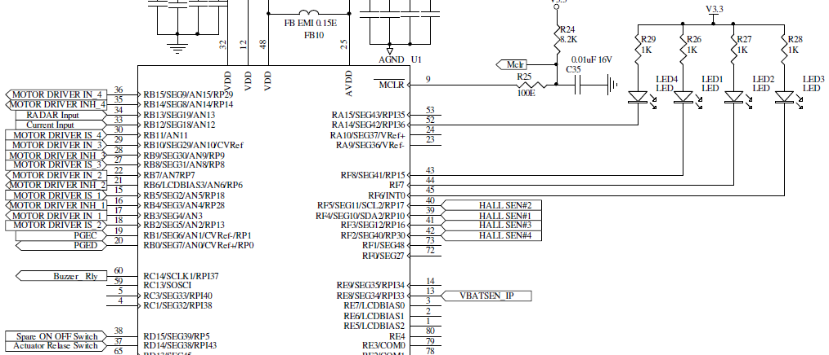

**TRISF** DATA DIRECTION REGISTER F: 0x0000

|  |  |  |  |  |  |  |  |
| --- | --- | --- | --- | --- | --- | --- | --- |
| TRISF15 | TRISF14 | TRISF13 | TRISF12 | TRISF11 | TRISF10 | TRISF9 | TRISF8 |
| I/O | I/O | I/O | I/O | I/O | I/O | I/O | I/O |
|  |  |  |  |  |  |  |  |
|  |  |  |  |  |  |  |  |

|  |  |  |  |  |  |  |  |
| --- | --- | --- | --- | --- | --- | --- | --- |
| TRISF7 | TRISF6 | TRISF5 | TRISF4 | TRISF3 | TRISF2 | TRISF1 | TRISF0 |
| I/O | I/O | I/O | I/O | I/O | I/O | I/O | I/O |
| 0 | 0 |  |  |  |  |  |  |
| Output | Output |  |  |  |  |  |  |

**TRISD** DATA DIRECTION REGISTER D: 0xC000

|  |  |  |  |  |  |  |  |
| --- | --- | --- | --- | --- | --- | --- | --- |
| TRISD15 | TRISD14 | TRISD13 | TRISD12 | TRISD11 | TRISD10 | TRISD9 | TRISD8 |
| I/O | I/O | I/O | I/O | I/O | I/O | I/O | I/O |
| 1 | 1 |  |  |  |  |  |  |
| Input | Input |  |  |  |  |  |  |

|  |  |  |  |  |  |  |  |
| --- | --- | --- | --- | --- | --- | --- | --- |
| TRISD7 | TRISD6 | TRISD5 | TRISD4 | TRISD3 | TRISD2 | TRISD1 | TRISD0 |
| I/O | I/O | I/O | I/O | I/O | I/O | I/O | I/O |
|  |  |  |  |  |  |  |  |
|  |  |  |  |  |  |  |  |

**LATF** OUTPUT LATCH REGISTER F: 0x00C0

|  |  |  |  |  |  |  |  |
| --- | --- | --- | --- | --- | --- | --- | --- |
| LATF15 | LATF14 | LATF13 | LATF12 | LATF11 | LATF10 | LATF9 | LATF8 |
| I/O | I/O | I/O | I/O | I/O | I/O | I/O | I/O |
|  |  |  |  |  |  |  |  |
|  |  |  |  |  |  |  |  |

|  |  |  |  |  |  |  |  |
| --- | --- | --- | --- | --- | --- | --- | --- |
| LATF7 | LATF6 | LATF5 | LATF4 | LATF3 | LATF2 | LATF1 | LATF0 |
| I/O | I/O | I/O | I/O | I/O | I/O | I/O | I/O |
| 1 | 1 |  |  |  |  |  |  |
| LED2 off | LED3 off |  |  |  |  |  |  |

**LATD** OUPUT LATCH REGISTER D:

|  |  |  |  |  |  |  |  |
| --- | --- | --- | --- | --- | --- | --- | --- |
| LATD15 | LATD14 | LATD13 | LATD12 | LATD11 | LATD10 | LATD9 | LATD8 |
| I/O | I/O | I/O | I/O | I/O | I/O | I/O | I/O |
| 1 | 0 |  |  |  |  |  |  |
| Switch is ON | Switch is OFF |  |  |  |  |  |  |

|  |  |  |  |  |  |  |  |
| --- | --- | --- | --- | --- | --- | --- | --- |
| LATD7 | LATD6 | LATD5 | LATD4 | LATD3 | LATD2 | LATD1 | LATD0 |
| I/O | I/O | I/O | I/O | I/O | I/O | I/O | I/O |
|  |  |  |  |  |  |  |  |
|  |  |  |  |  |  |  |  |

**Code Prg01a.c**

/*************************************************************************************

Source code file: Prg01a.c

Author, version, date: PSS ver 1.0 01.11.24

Program function: Turn ON LEDs using switches

RD15 spareOnOffSwitch RD14 actuatorReleaseSwitch RF8 LED1 RF7 LED2 RF6 LED3 RA14 LED4

Simulation: PIC24FJ128GA308 MCU, MPLAB X IDE ver 6.05, XC16 ver 2.10

*************************************************************************************/

**#include <xc.h>**

#include <libpic30.h>

void initializeLeds **(**void**);**

void turnOnLeds **(**void**);**

int main**()**

**{**

initializeLeds**();**

**while** **(**1**)** turnOnLeds**();**

**}**

void initializeLeds **(**void**)**

**{**

TRISF **=** 0x0000**;** // RF6 is set in output mode

TRISD **=** 0xC000**;** // RD15, RD14 are set in input mode

LATF **=** 0x00C0**;** // Set LED2, LED3 LOW initially

**}**

void turnOnLeds **(**void**)**

**{**

**if** **(**LATD **&** 0x8000**)**

LATF **=** **~**0x0040**;** // Turn ON LED3 RF6

**else**

LATF **=** 0x0040**;**

**if** **(**LATD **&** 0x4000**)**

LATF **=** **~**0x0080**;** // Turn ON LED2 RF5

**else**

LATF **=** 0x0080**;**

**}**