**Autonomous Tractor Safety System**

**Objective 1.2** To demonstrate turning ON buzzer when switch is pressed in ATSS PCB board

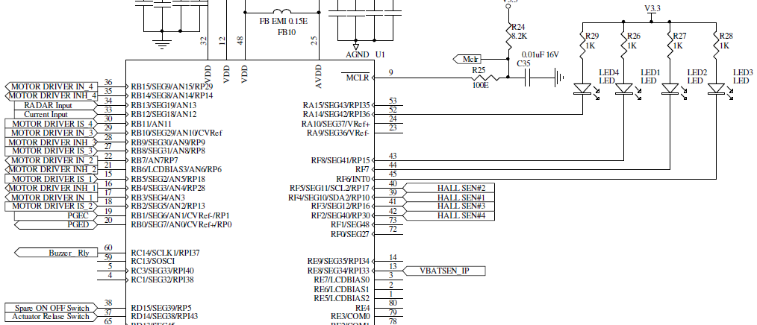

**TRISC** DATA DIRECTION REGISTER C: 0x0000

|  |  |  |  |  |  |  |  |
| --- | --- | --- | --- | --- | --- | --- | --- |
| TRISC15 | TRISC14 | TRISC3 | TRISC12 | TRISC11 | TRISC10 | TRISC9 | TRISC8 |
| I/O | I/O | I/O | I/O | I/O | I/O | I/O | I/O |
|  | 0 |  |  |  |  |  |  |
|  | Output |  |  |  |  |  |  |

|  |  |  |  |  |  |  |  |
| --- | --- | --- | --- | --- | --- | --- | --- |
| TRISC7 | TRISC6 | TRISC5 | TRISC4 | TRISC3 | TRISC2 | TRISC1 | TRISC0 |
| I/O | I/O | I/O | I/O | I/O | I/O | I/O | I/O |
|  |  |  |  |  |  |  |  |
|  |  |  |  |  |  |  |  |

**TRISD** DATA DIRECTION REGISTER D: 0x8000

|  |  |  |  |  |  |  |  |
| --- | --- | --- | --- | --- | --- | --- | --- |
| TRISD15 | TRISD14 | TRISD13 | TRISD12 | TRISD11 | TRISD10 | TRISD9 | TRISD8 |
| I/O | I/O | I/O | I/O | I/O | I/O | I/O | I/O |
| 1 |  |  |  |  |  |  |  |
| Input |  |  |  |  |  |  |  |

|  |  |  |  |  |  |  |  |
| --- | --- | --- | --- | --- | --- | --- | --- |
| TRISD7 | TRISD6 | TRISD5 | TRISD4 | TRISD3 | TRISD2 | TRISD1 | TRISD0 |
| I/O | I/O | I/O | I/O | I/O | I/O | I/O | I/O |
|  |  |  |  |  |  |  |  |
|  |  |  |  |  |  |  |  |

**LATC** OUTPUT LATCH REGISTER C: 0x4000

|  |  |  |  |  |  |  |  |
| --- | --- | --- | --- | --- | --- | --- | --- |
| LATC15 | LATC14 | LATC13 | LATC12 | LATC11 | LATC10 | LATC9 | LATC8 |
| I/O | I/O | I/O | I/O | I/O | I/O | I/O | I/O |
|  | 1 |  |  |  |  |  |  |
|  | Buzzer ON |  |  |  |  |  |  |

|  |  |  |  |  |  |  |  |
| --- | --- | --- | --- | --- | --- | --- | --- |
| LATC7 | LATC6 | LATC5 | LATC4 | LATC3 | LATC2 | LATC1 | LATC0 |
| I/O | I/O | I/O | I/O | I/O | I/O | I/O | I/O |
|  |  |  |  |  |  |  |  |
|  |  |  |  |  |  |  |  |

**LATD** OUTPUT LATCH REGISTER D: 0x8000

|  |  |  |  |  |  |  |  |
| --- | --- | --- | --- | --- | --- | --- | --- |
| LATD15 | LATD14 | LATD13 | LATD12 | LATD11 | LATD10 | LATD9 | LATD8 |
| I/O | I/O | I/O | I/O | I/O | I/O | I/O | I/O |
| 1 |  |  |  |  |  |  |  |
| Switch is ON |  |  |  |  |  |  |  |

|  |  |  |  |  |  |  |  |
| --- | --- | --- | --- | --- | --- | --- | --- |
| LATD7 | LATD6 | LATD5 | LATD4 | LATD3 | LATD2 | LATD1 | LATD0 |
| I/O | I/O | I/O | I/O | I/O | I/O | I/O | I/O |
|  |  |  |  |  |  |  |  |
|  |  |  |  |  |  |  |  |

**Code Prg01b.c**

/*************************************************************************************

Source code file: Prg01b.c

Author, version, date: PSS ver 1.0 01.11.24

Program function: Turn ON buzzer using switches

RD15 spareOnOffSwitch RD14 actuatorReleaseSwitch RF8 LED1 RF7 LED2 RF6 LED3 RA14 LED4

RC14 buzzerRelay RG8 powerOnRelay RE8 vBatSensorInput

Simulation: PIC24FJ128GA308 MCU, MPLAB X IDE ver 6.05, XC16 ver 2.10

*************************************************************************************/

#include <xc.h>

#include <libpic30.h>

void initializeBuzzer **(**void**);**

void turnOnBuzzer **(**void**);**

int main**()**

**{**

initializeBuzzer**();**

**while** **(**1**)** turnOnBuzzer**();**

**}**

void initializeBuzzer **(**void**)**

**{**

TRISC **=** 0x0000**;** // RC14 is set in output mode

TRISD **=** 0x8000**;** // RD15 is set as input

**}**

void turnOnBuzzer **(**void**)**

**{**

**if** **(**LATD **&** 0x8000**)**

LATC **=** 0x4000**;** // Turn ON Buzzer

**else**

LATC **=** **~**0x4000**;**

**}**