**Autonomous Tractor Safety System**

**Objective 6.0** To find and display the DC motor position using LEDs in ATSS PCB board

**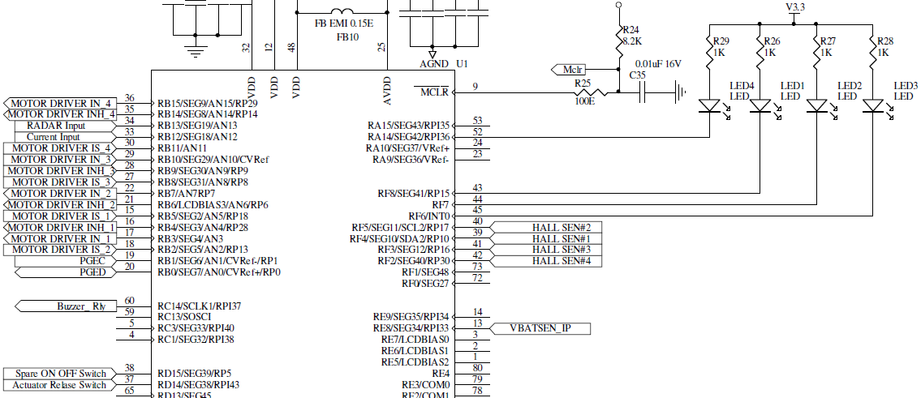**

**TRISF** DATA DIRECTION REGISTER F: 0x0000

|  |  |  |  |  |  |  |  |
| --- | --- | --- | --- | --- | --- | --- | --- |
| TRISF15 | TRISF14 | TRISF13 | TRISF12 | TRISF11 | TRISF10 | TRISF9 | TRISF8 |
| I/O | I/O | I/O | I/O | I/O | I/O | I/O | I/O |
|  |  |  |  |  |  |  | 0 |
|  |  |  |  |  |  |  | Output |

|  |  |  |  |  |  |  |  |
| --- | --- | --- | --- | --- | --- | --- | --- |
| TRISF7 | TRISF6 | TRISF5 | TRISF4 | TRISF3 | TRISF2 | TRISF1 | TRISF0 |
| I/O | I/O | I/O | I/O | I/O | I/O | I/O | I/O |
| 0 | 0 |  |  |  |  |  |  |
| Output | Output |  |  |  |  |  |  |

**TRISA** DATA DIRECTION REGISTER A: 0x0000

|  |  |  |  |  |  |  |  |
| --- | --- | --- | --- | --- | --- | --- | --- |
| TRISA15 | TRISA14 | TRISA13 | TRISA12 | TRISA11 | TRISA10 | TRISA9 | TRISA8 |
| I/O | I/O | I/O | I/O | I/O | I/O | I/O | I/O |
|  | 0 |  |  |  |  |  |  |
|  | Output |  |  |  |  |  |  |

|  |  |  |  |  |  |  |  |
| --- | --- | --- | --- | --- | --- | --- | --- |
| TRISA7 | TRISA6 | TRISA5 | TRISA4 | TRISA3 | TRISA2 | TRISA1 | TRISA0 |
| I/O | I/O | I/O | I/O | I/O | I/O | I/O | I/O |
|  |  |  |  |  |  |  |  |
|  |  |  |  |  |  |  |  |

**TRISB** DATA DIRECTION REGISTER B: 0x3927

|  |  |  |  |  |  |  |  |
| --- | --- | --- | --- | --- | --- | --- | --- |
| TRISB15 | TRISB14 | TRISB13 | TRISB12 | TRISB11 | TRISB10 | TRISB9 | TRISB8 |
| I/O | I/O | I/O | I/O | I/O | I/O | I/O | I/O |
| 0 | 0 | 1 | 1 | 1 | 0 | 0 | 1 |
| OUTPUT | OUTPUT | INPUT | INPUT | INPUT | OUTPUT | OUTPUT | INPUT |

|  |  |  |  |  |  |  |  |
| --- | --- | --- | --- | --- | --- | --- | --- |
| TRISB7 | TRISB6 | TRISB5 | TRISB4 | TRISB3 | TRISB2 | TRISB1 | TRISB0 |
| I/O | I/O | I/O | I/O | I/O | I/O | I/O | I/O |
| 0 | 0 | 1 | 0 | 0 | 1 | 1 | 1 |
| OUTPUT | OUTPUT | INPUT | OUTPUT | OUTPUT | INPUT | INPUT | INPUT |

**ANSB** DATA DIRECTION REGISTER B: 0x0000

|  |  |  |  |  |  |  |  |
| --- | --- | --- | --- | --- | --- | --- | --- |
| ANSB15 | ANSB14 | ANSB13 | ANSB12 | ANSB11 | ANSB10 | ANSB9 | ANSB8 |
| I/O | I/O | I/O | I/O | I/O | I/O | I/O | I/O |
| 0 | 0 | 0 | 0 | 0 | 0 | 0 | 0 |
| DIGITAL | DIGITAL | DIGITAL | DIGITAL | DIGITAL | DIGITAL | DIGITAL | DIGITAL |

|  |  |  |  |  |  |  |  |
| --- | --- | --- | --- | --- | --- | --- | --- |
| ANSB7 | ANSB6 | ANSB5 | ANSB4 | ANSB3 | ANSB2 | ANSB1 | ANSB0 |
| I/O | I/O | I/O | I/O | I/O | I/O | I/O | I/O |
| 0 | 0 | 0 | 0 | 0 | 0 | 0 | 0 |
| DIGITAL | DIGITAL | DIGITAL | DIGITAL | DIGITAL | DIGITAL | DIGITAL | DIGITAL |

**LATF** OUTPUT LATCH REGISTER F: 0x01C0

|  |  |  |  |  |  |  |  |
| --- | --- | --- | --- | --- | --- | --- | --- |
| LATF15 | LATF14 | LATF13 | LATF12 | LATF11 | LATF10 | LATF9 | LATF8 |
| I/O | I/O | I/O | I/O | I/O | I/O | I/O | I/O |
|  |  |  |  |  |  |  | 1 |
|  |  |  |  |  |  |  | LED1 off |

|  |  |  |  |  |  |  |  |
| --- | --- | --- | --- | --- | --- | --- | --- |
| LATF7 | LATF6 | LATF5 | LATF4 | LATF3 | LATF2 | LATF1 | LATF0 |
| I/O | I/O | I/O | I/O | I/O | I/O | I/O | I/O |
| 1 | 1 |  |  |  |  |  |  |
| LED2 off | LED3 off |  |  |  |  |  |  |

**LATA** OUTPUT LATCH REGISTER A: 0x4000

|  |  |  |  |  |  |  |  |
| --- | --- | --- | --- | --- | --- | --- | --- |
| LATAF15 | LATA14 | LATA13 | LATA12 | LATA11 | LATA10 | LATA9 | LATA8 |
| I/O | I/O | I/O | I/O | I/O | I/O | I/O | I/O |
|  | 1 |  |  |  |  |  |  |
|  | LED4 off |  |  |  |  |  |  |

|  |  |  |  |  |  |  |  |
| --- | --- | --- | --- | --- | --- | --- | --- |
| LATA7 | LATA6 | LATA5 | LATA4 | LATA3 | LATA2 | LATA1 | LATA0 |
| I/O | I/O | I/O | I/O | I/O | I/O | I/O | I/O |
|  |  |  |  |  |  |  |  |
|  |  |  |  |  |  |  |  |

**INTCON2** INTERRUPT CONTROL REGISTER 2: 0x0000

|  |  |  |  |  |  |  |  |
| --- | --- | --- | --- | --- | --- | --- | --- |
| ALTIVT | DISI | - | - | - | - | - | - |
| ALT INT VECTOR TABLE EN | DISI INSTR STATUS |  |  |  |  |  |  |
|  |  |  |  |  |  |  |  |
|  |  |  |  |  |  |  |  |

|  |  |  |  |  |  |  |  |
| --- | --- | --- | --- | --- | --- | --- | --- |
| - | - | - | INT4EP | INT3EP | INT2EP | INT1EP | INT0EP |
|  |  |  | EXT INT4 POLARITY | EXT INT3 POLARITY | EXT INT2 POLARITY | EXT INT1 POLARITY |  |
|  |  |  | 0 | 0 | 0 | 0 |  |
|  |  |  | +VE EDGE | +VE EDGE | +VE EDGE | +VE EDGE |  |

**IFS1 INTERRUPT FLAG STATUS REGISTER 1**: 0x0000

|  |  |  |  |  |  |  |  |
| --- | --- | --- | --- | --- | --- | --- | --- |
| U2TXIF | U2RXIF | INT2IF | T5IF | T4IF | OC4IF | OC3IF | DMA2IF |
| UART2 Tx REQUEST | UART2 Rx REQUEST | EXT INT2 REQUEST | TMR4 INT REQUEST | TMR4 INT REQUEST | O/P CMP CH4 INT | O/P CMP CH3 INT | DMA CH2 INT |
|  |  | 0 |  |  |  |  |  |
|  |  | NO INT |  |  |  |  |  |

|  |  |  |  |  |  |  |  |
| --- | --- | --- | --- | --- | --- | --- | --- |
| - | IC7IF | - | INT1IF | CNIF | CMIF | MI2C1IF | S12C1IF |
|  | I/P CH 7 CAPTURE |  | EXT INT1 REQUEST | I/P CHNG NOTIF INT | CMP INT | MASTER I2C1 INT | SLAVE I2C1 INT |
|  |  |  | 0 |  |  |  |  |
|  |  |  | NO INT |  |  |  |  |

**IFS3 INTERRUPT FLAG STATUS REGISTER 3**: 0x0000

|  |  |  |  |  |  |  |  |
| --- | --- | --- | --- | --- | --- | --- | --- |
| - | RTCIF | DMA5IF | - | - | - | - | - |
|  | RTC INT REQ | DMA CH5 INT |  |  |  |  |  |
|  |  |  |  |  |  |  |  |
|  |  |  |  |  |  |  |  |

|  |  |  |  |  |  |  |  |
| --- | --- | --- | --- | --- | --- | --- | --- |
| - | INT4IF | INT3IF | - | - | MI2C2IF | SI2C2IF | - |
|  | EXT INT4 REQUEST | EXT INT3 REQUEST |  |  | MASTER I2C2 INT | SLAVE I2C2 INT |  |
|  | 0 | 0 |  |  |  |  |  |
|  | NO INT | NO INT |  |  |  |  |  |

**IEC1** INTERRUPT ENABLE CONTROL REGISTER 1: 0x2010

|  |  |  |  |  |  |  |  |
| --- | --- | --- | --- | --- | --- | --- | --- |
| U2TXIE | U2RXIE | INT2IE | T5IE | T4IE | OC4IE | OC3IE | DMA2IE |
| UART2 Tx REQUEST | UART2 Rx REQUEST | EXT INT2 REQUEST | TMR4 INT REQUEST | TMR4 INT REQUEST | O/P CMP CH4 INT | O/P CMP CH3 INT | DMA CH2 INT |
|  |  | 1 |  |  |  |  |  |
|  |  | ENABLE |  |  |  |  |  |

|  |  |  |  |  |  |  |  |
| --- | --- | --- | --- | --- | --- | --- | --- |
| - | IC7IE | - | INT1IE | CNIE | CMIE | MI2C1IE | S12C1IE |
|  | I/P CH 7 CAPTURE |  | EXT INT1 REQUEST | I/P CHNG NOTIF INT | CMP INT | MASTER I2C1 INT | SLAVE I2C1 INT |
|  |  |  | 1 |  |  |  |  |
|  |  |  | ENABLE |  |  |  |  |

**IEC3** INTERRUPT ENABLE CONTROL REGISTER 3: 0x0060

|  |  |  |  |  |  |  |  |
| --- | --- | --- | --- | --- | --- | --- | --- |
| - | RTCIE | DMA5IE | - | - | - | - | - |
|  | RTC INT REQ | DMA CH5 INT |  |  |  |  |  |
|  |  |  |  |  |  |  |  |
|  |  |  |  |  |  |  |  |

|  |  |  |  |  |  |  |  |
| --- | --- | --- | --- | --- | --- | --- | --- |
| - | INT4IE | INT3IE | - | - | MI2C2IE | SI2C2IE | - |
|  | EXT INT4 REQUEST | EXT INT3 REQUEST |  |  | MASTER I2C2 INT | SLAVE I2C2 INT |  |
|  | 1 | 1 |  |  |  |  |  |
|  | ENABLE | ENABLE |  |  |  |  |  |

**IPC5** INTERRUPT PRIORITY CONTROL REGISTER 5: 0x0004

|  |  |  |  |  |  |  |  |
| --- | --- | --- | --- | --- | --- | --- | --- |
| - | - | - | - | - | IC7IP2 | IC7IP1 | IC7IP0 |
|  |  |  |  |  | I/P CAPTURE CH7 PRIORITY | | |
|  |  |  |  |  |  |  |  |
|  |  |  |  |  |  |  |  |

|  |  |  |  |  |  |  |  |
| --- | --- | --- | --- | --- | --- | --- | --- |
| - | - | - | - | - | INT1IP2 | INT1IP1 | INT1IP0 |
|  |  |  |  |  | EXT INT1 PRIORITY | | |
|  |  |  |  |  | 1 | 0 | 0 |
|  |  |  |  |  | 4 | | |

**IPC7** INTERRUPT PRIORITY CONTROL REGISTER 7: 0x0040

|  |  |  |  |  |  |  |  |
| --- | --- | --- | --- | --- | --- | --- | --- |
| - | U2TXIP2 | U2TXIP1 | U2TXIP0 | - | U2RXIP2 | U2RXIP1 | U2RXIP0 |
|  | UART2 TX PRIORITY | | |  | UART2 RX PRIORITY | | |
|  |  |  |  |  |  |  |  |
|  |  | | |  |  |  |  |

|  |  |  |  |  |  |  |  |
| --- | --- | --- | --- | --- | --- | --- | --- |
| - | INT2IP2 | INT2IP1 | INT2IP0 | - | T5IP2 | T5IP1 | T5IP0 |
|  | EXT INT2 PRIORITY | | |  | TMR5 INT PRIORITY | | |
|  | 1 | 0 | 0 |  |  |  |  |
|  | 4 | | |  |  |  |  |

**IPC13** INTERRUPT PRIORITY CONTROL REGISTER 13: 0x0440

|  |  |  |  |  |  |  |  |
| --- | --- | --- | --- | --- | --- | --- | --- |
| - | - | - | - | - | INT4IP2 | INT4IP1 | INT4IP0 |
|  |  |  |  |  | EXT INT4 PRIORITY | | |
|  |  |  |  |  | 1 | 0 | 0 |
|  |  | | |  | 4 | | |

|  |  |  |  |  |  |  |  |
| --- | --- | --- | --- | --- | --- | --- | --- |
| - | INT3IP2 | INT3IP1 | INT3IP0 | - | - | - | - |
|  | EXT INT3 PRIORITY | | |  |  |  |  |
|  | 1 | 0 | 0 |  |  |  |  |
|  | 4 | | |  |  |  |  |

**RPINR0** PERIPHERAL PIN SELECT INPUT REGISTER 0: 0x2700

|  |  |  |  |  |  |  |  |
| --- | --- | --- | --- | --- | --- | --- | --- |
| - | - | INT1R5 | INT1R4 | INT1R3 | INT1R2 | INT1R1 | INT1R0 |
|  |  | ASSIGN EXT INT1 CORRESPONDING TO PINS IN RP0 | | | | | |
|  |  | 1 | 0 | 0 | 1 | 1 | 1 |
|  |  | PIN 39 IS HALL SENSOR1 | | | | | |

|  |  |  |  |  |  |  |  |
| --- | --- | --- | --- | --- | --- | --- | --- |
| - | - | - | - | - | - | - | - |
|  |  |  |  |  |  |  |  |
|  |  |  |  |  |  |  |  |
|  |  |  |  |  |  |  |  |

**RPINR1** PERIPHERAL PIN SELECT INPUT REGISTER 1: 0x2928

|  |  |  |  |  |  |  |  |
| --- | --- | --- | --- | --- | --- | --- | --- |
| - | - | INT3R5 | INT3R4 | INT3R3 | INT3R2 | INT3R1 | INT3R0 |
|  |  | ASSIGN EXT INT3 CORRESPONDING TO PINS IN RP1 | | | | | |
|  |  | 1 | 0 | 1 | 0 | 0 | 1 |
|  |  | PIN 41 IS HALL SENSOR3 | | | | | |

|  |  |  |  |  |  |  |  |
| --- | --- | --- | --- | --- | --- | --- | --- |
| - | - | INT2R5 | INT2R4 | INT2R3 | INT2R2 | INT2R1 | INT2R0 |
|  |  | ASSIGN EXT INT2 CORRESPONDING TO PINS IN RP1 | | | | | |
|  |  | 1 | 0 | 1 | 0 | 0 | 0 |
|  |  | PIN 40 IS HALL SENSOR2 | | | | | |

**RPINR2** PERIPHERAL PIN SELECT INPUT REGISTER 2: 0x002A

|  |  |  |  |  |  |  |  |
| --- | --- | --- | --- | --- | --- | --- | --- |
| - | - | - | - | - | - | - | - |
|  |  |  |  |  |  |  |  |
|  |  |  |  |  |  |  |  |
|  |  |  |  |  |  |  |  |

|  |  |  |  |  |  |  |  |
| --- | --- | --- | --- | --- | --- | --- | --- |
| - | - | INT4R5 | INT4R4 | INT4R3 | INT4R2 | INT4R1 | INT4R0 |
|  |  | ASSIGN EXT INT2 CORRESPONDING TO PINS IN RP1 | | | | | |
|  |  | 1 | 0 | 1 | 0 | 1 | 0 |
|  |  | PIN 42 IS HALL SENSOR4 | | | | | |

**BTN8982A** Motor driver

**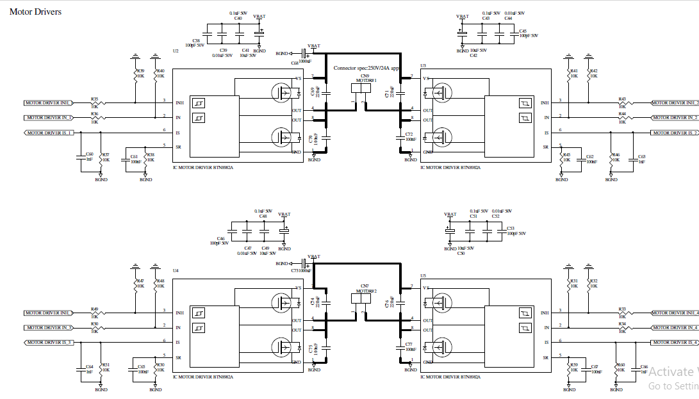**



Rotary encoder output of a DC motor rotating clockwise

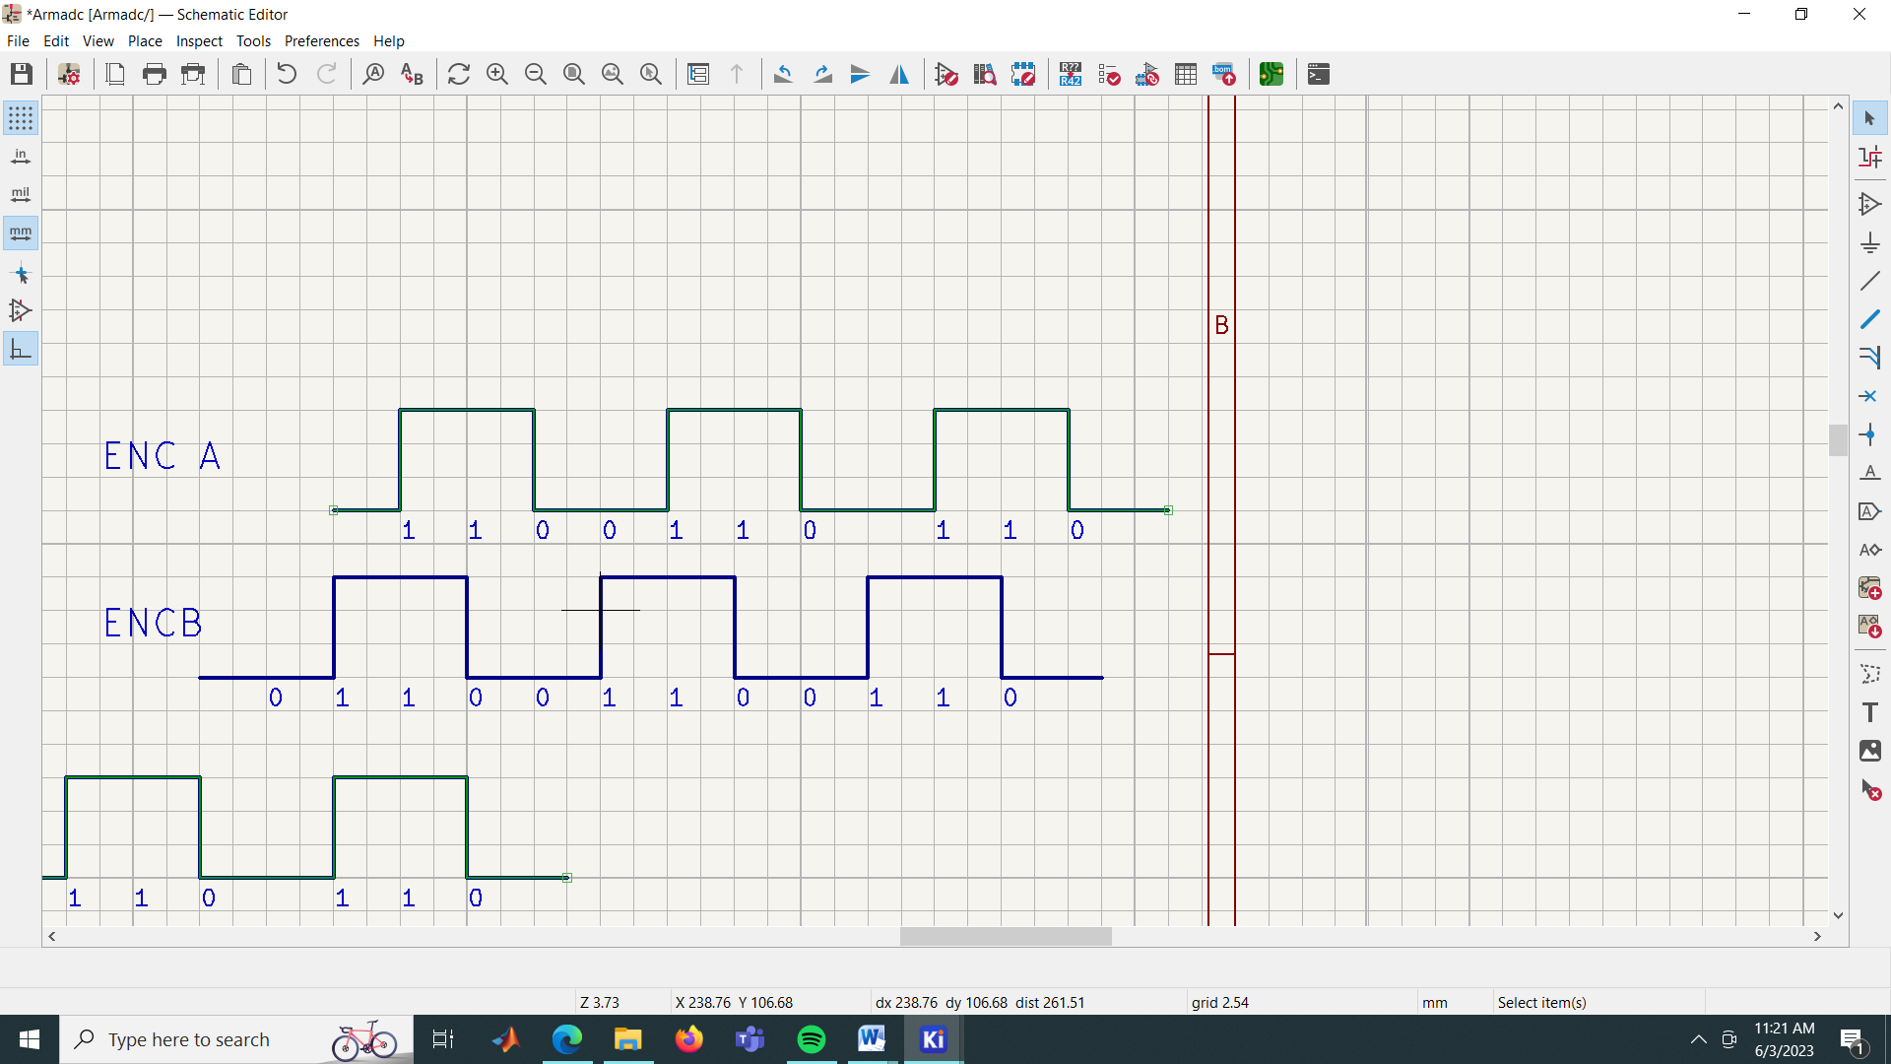

Tabulate the voltage levels of A and B alternatively every qardature starting with the first rising edge in ENC A, to get five distinct patterns that repeat themselves – 1110, 1000, 0111, 0111.

Rotary encoder output of a DC motor rotating anticlockwise

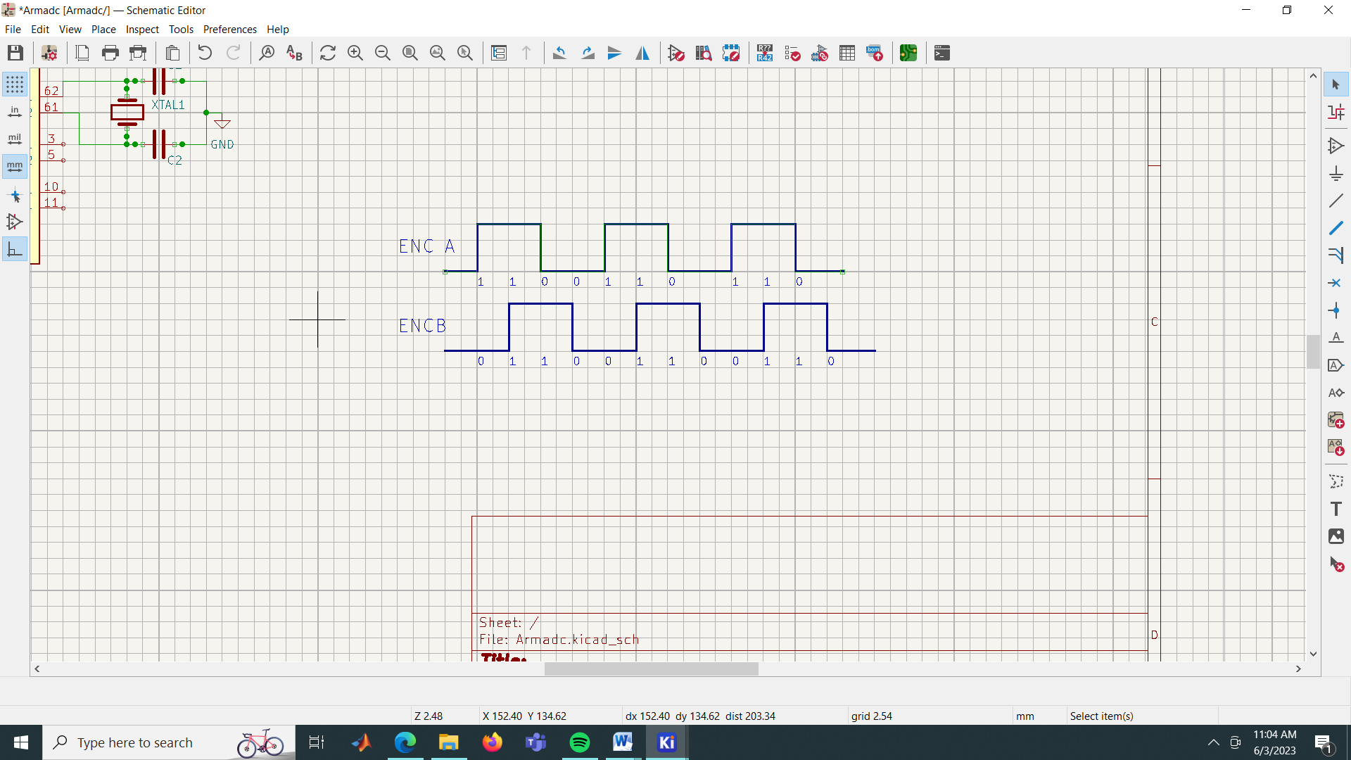

Tabulate the voltage levels of A and B alternatively every qardature starting with the first rising edge in ENC A, to get five distinct patterns that repeat themselves – 10111, 1101, 0100, 0010.

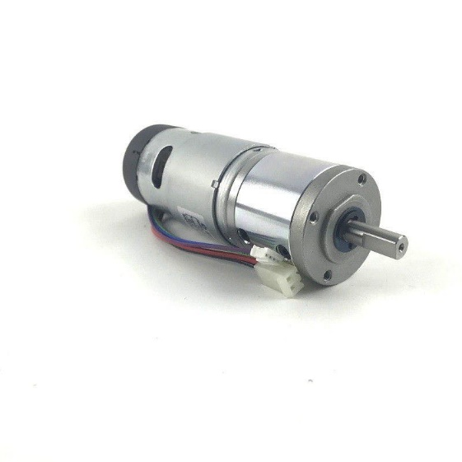Molex 09-50-3021 
3.96-2P 
JST PHR-4 
P=2 -4P 
UL 1007 AWG24 
UL 1007 AWG18 
100mm 
Specifications 
Motor Specification 
Voltage 
Speed (RPM) 
Torque (kgf.cm) 
Gear Ratio 
Current 
Diameter Motor 
Encoder 
12VDC 
301 - 500 
5.01 - 10.00 
5.5A 
42mm/45mm 
Yes IG42E - 
Two Channel Hall Effect Encoder 
Two Channel Encoder Connection 
Black 
Red 
Brown 
Green 
Blue 
Purple 
Motor Terminal 
Motor Terminal 
Hall Sensor Vcc 
Hall Sensor GND 
Hall Sensor A output 
Hall Sensor B output Specifications: 
• 
Voltage: 12VDC 
Rated Torque: 6.526kgf.cm (640mN.m) 
Rated Speed: 405 RPM 
Rated Current: 5.5A 
Rated Power output: 41.3W 
Weight: 609g 
Shaft: 8mm diameter x 20mm length 
Compatible motor driver: 
o Arduino - 
Shield MDIO 
o MD IOC 
o MDI) IOA 
o MDS40B 
Gear ratio: 14:1 
Encoder Output: 70 pulses per rotation, single-channel output 
Brushed motor type 
Power Wires are terminated by 
MOLEX 09-50-3021, Pitch= 3.96- 
the mating connector is 
KK-963 
Encoder Wires are terminated by 
JST-PHR-4, Pitch=2-4P 
, the 
mating connector is 

Hall Effect sensor

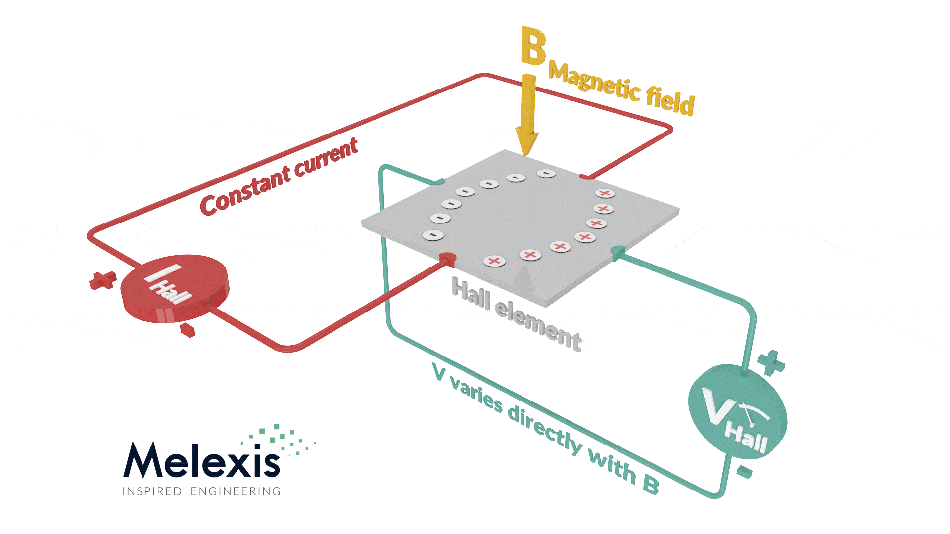

A rotary encoder, also called a shaft encoder, is an electro-mechanical device that converts the angular position or motion of a shaft or axle to analog or digital output signals.

Rotary encoders measure rotation of a shaft, while linear encoders measure distance traveled. For both types of encoder, the position measurement can be either incremental or absolute. An incremental encoder measures change in position, but does not keep track of actual position. When power is interrupted, incremental encoders lose their position reference and must start over via a re-homing sequence to a reference point.

Incremental encoders work by producing a specific number of equally spaced pulses per revolution (PPR) or per distance (PPM—pulses per millimeter, or PPI—pulses per inch). When one set of pulses, or output channel, is used, the encoder can determine position only.  But most incremental encoders use quadrature output, which consists of two channels, typically referred to as channel A and channel B, that are out of phase by 90 degrees. Quadrature output allows the encoder to also sense direction, by determining which channel is leading and which is following.

With quadrature output, three types of encoding can be used: X1, X2, or X4. The difference between these encoding types is simply which edges of which channel are counted during movement, but their influence on encoder resolution is significant.

With X1 encoding, either the rising (aka leading) or the falling (aka following) edge of channel A is counted. If channel A leads channel B, the rising edge is counted, and the movement is forward, or clockwise. Conversely, if channel B leads channel A, the falling edge is counted, and the movement is backwards, or counterclockwise.

01 A_CHANGE C 
digitalRead(encoderB) 
if ( digitalRead(encoderA) 
// A fell, B is low 
moving reverse 
pulses-•; 
else { 
// A rose, B is low 
pulses••; moving forward 
pulsesChanged • I; x-ı-n-n m-n-m 
g-u-ı-ru-ı-n 
Count 
Value 

In this function,we can see that if encoder B/channel B is 0 and the encoder A also 0.The pulses will count in negative, that’s mean the motor is moving counter clockwise.The encoder B is lagging the encoder A. To conclude, when the channel B is leading the channel A means the motor/encoder is moving counter clockwise.When the channel A is leading the channel B means the motor/encoder is moving clockwise.And the pulses will count when channel A is trigger to 1.

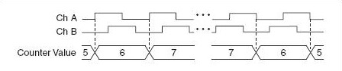

X1 encoding, in which either the rising or the falling edge of channel A is counted. Notice that when channel B is leading, the movement is considered counterclockwise or reverse, and the count is decreased. For rotary encoders, position is calculated by dividing the number of edges counted by the product of the number of pulses per revolution and the encoding type described above (1, 2, or 4), and then multiplying the result by 360 in order to get degrees of motion.

degrees = edgeCount \* 360 /(x \* N), x = type of encoding (X1, X2, X4)

The encoder has a disk with evenly spaced contact zones that are connected to the common pin C and two other separate contact pins A and B, as illustrated below.

When the disk will start rotating step by step, the pins A and B will start making contact with the common pin and the two square wave output signals will be generated accordingly.

In a simple DC motor there are two main components, the “stator” and the “armature”. The stator is a permanent magnet and provides a constant magnetic field. The armature, which is the rotating part, is a simple coil.

The armature is connected to a DC power source using a 2-piece ring installed around the motor shaft, these ring sections are called “commutator rings”. The two pieces of the commutator rings are connected to each end of the armature coil. Direct Current of a suitable voltage is applied to the commutator rings via two “brushes” that rub against the rings.

When DC is applied to the commutator rings it flows through the armature coil, producing a magnetic field. This field is attracted to the stator magnet (remember, opposite magnetic polarities attract, similar ones repel) and the motor shaft begins to spin.

The motor shaft rotates until it arrives at the junction between the two halves of the commutator. At that point the brushes come into contact with the other half of the commutator rings, reversing the polarity of the armature coil (or coils, most modern DC motors have several). This is great because at this point the motor shaft has rotated 180 degrees and the magnetic field polarities need to be reversed for the motor to continue rotating. This process repeats itself indefinitely until the current is removed from the armature coils.

To reverse the direction in which the DC motor rotates you simply reverse the polarity of the DC current that you apply to it. One method of changing the speed of a DC motor is to simply reduce its supply voltage. While this will work to some degree it is actually not a very good method of controlling motor speed as lowering the voltage will also lower the torque that the motor is capable of producing. Also, once the voltage drops below a certain point the motor will not rotate at all.

With PWM the motor is sent a series of pulses. Each pulse is of the full voltage that the motor can handle so a 6-volt motor will be sent 6-volt pulses while a 12-volt motor will be sent 12 volt pulses. The width of the pulses are varied to control the motor speed, pulses with a narrow width will cause the motor to spin quite slowly. Increasing the pulse width will increase the speed of the motor, as illustrated below.

Slow 
Faster 
Even Faster!  Stop 
Full Speed 
htÄi: / I 

In order to stop the motor completely you just stop pulsing it, essentially sending it zero volts. To run it at full speed you send it the full voltage, again without pulsing it.

An “H-Bridge” is simply an arrangement of switching the polarity of the voltage applied to a DC motor, thus controlling its direction of rotation.

In the first diagram we can see four switches which are all in the open or “off” position. In the center of the circuit is a DC motor. If you look at the circuit as it is drawn here you can distinctly see a letter “H”, with the motor attached in the center or “bridge” section – thus the term “H-Bridge”.

Motor 
Negative Motor 
Clockwise 
- Negative 

Now we’ll open those switches and close the other two. As you can see this causes the polarity of the voltage applied to the motor to be reversed, resulting in our motor spinning counterclockwise.

Motor 
Counter-Clockwise 
Negative INPUT 1 
Ground (O) 
5 Volts (1) 
Ground (O) 
5 Volts (1) 
INPUT 2 
Ground (O) 
Ground (O) 
5 Volts (1) 
5 Volts (1) 
DIRECTION 
Motor Off 
Forward 
Reverse 
Not Used 

The BTN8982A actually contains two complete H-Bridge circuits, so it is capable of driving a pair of DC motors.

The board has four input terminals plus two enable terminals. You will use these terminals to control both direction and speed or each motor. They are as follows:

* **IN1** – Input 1 for Motor A
* **IN2** – Input 2 for Motor A
* **IN3** – Input 3 for Motor B
* **IN4** – Input 4 for Motor B
* **INH1** – Inhibit line for Motor A (SLEEP MODE)
* **INH2** – Inhibit Line for Motor B (SLEEP MODE)

The INHIBIT line can be used to turn the motor on, to turn it off and to control its speed. When the Enable line is at 5 Volts (1) the motor will be on. Grounding the INHIBIT line (0) will turn the motor off. To control the speed of the motor you apply a Pulse Width Modulation (PWM) signal to the INHIBIT line. The shorter the pulse width, the slower the motor will spin.

**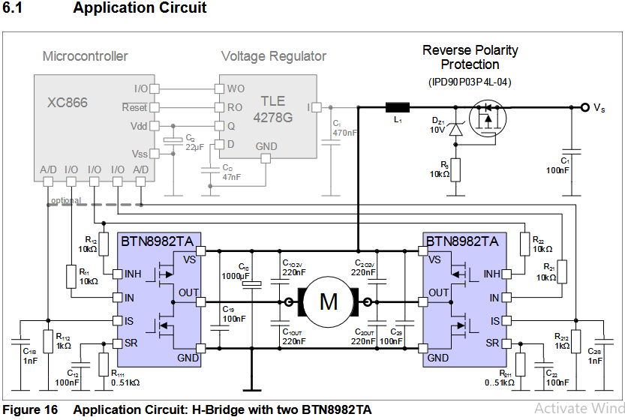**

**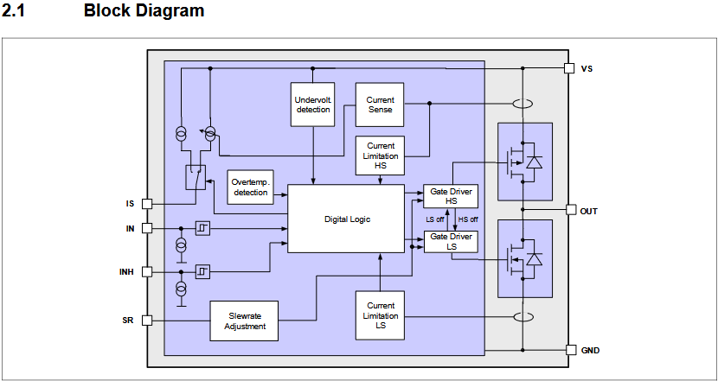**

**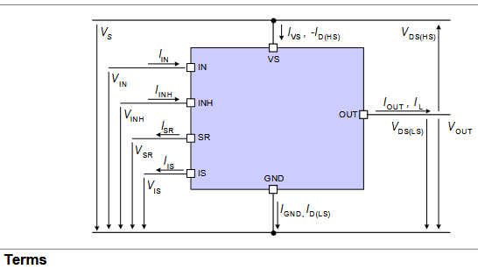**

**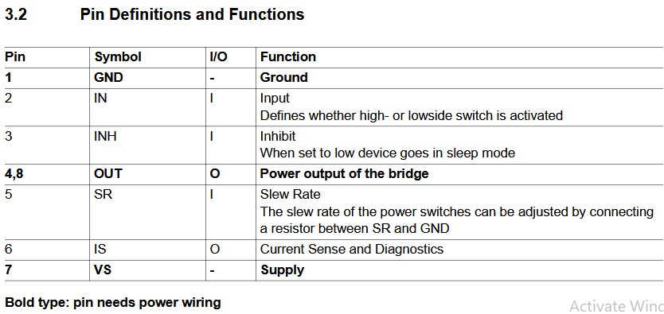**

**Truth table**

**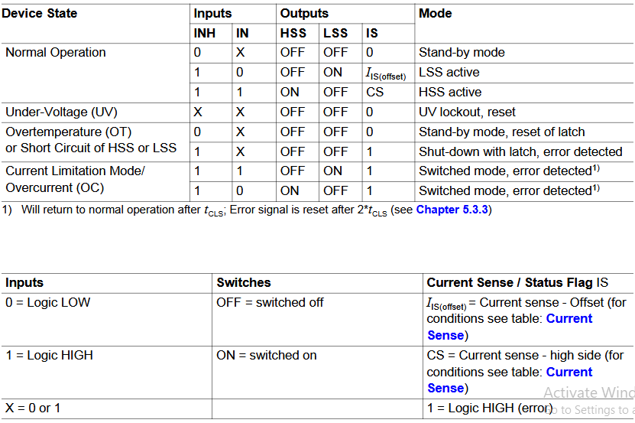**

**Code Prg06.c**

/\*\*\*\*\*\*\*\*\*\*\*\*\*\*\*\*\*\*\*\*\*\*\*\*\*\*\*\*\*\*\*\*\*\*\*\*\*\*\*\*\*\*\*\*\*\*\*\*\*\*\*\*\*\*\*\*\*\*\*\*\*\*\*\*\*\*\*\*\*\*\*\*\*\*\*\*\*\*\*\*\*\*\*\*\*

Source code file: Prg06.c

Author, version, date: PSS ver 1.0 01.11.24

Program function: Motor position

Simulation: PIC24FJ128GA308 MCU, MPLAB X IDE ver 6.05, XC16 ver 2.10

\*\*\*\*\*\*\*\*\*\*\*\*\*\*\*\*\*\*\*\*\*\*\*\*\*\*\*\*\*\*\*\*\*\*\*\*\*\*\*\*\*\*\*\*\*\*\*\*\*\*\*\*\*\*\*\*\*\*\*\*\*\*\*\*\*\*\*\*\*\*\*\*\*\*\*\*\*\*\*\*\*\*\*\*\*/

/\*

SW1 switch on safety box for running (LED ON) the clutch (LED1) and brake (LED3) motors or stopping the motors (LED OFF)

SW2 switch near driver for running the clutch (LED2) and brake (LED4) motors in a clockwise (LED ON) or anticlockwise direction (LED OFF)

LED1: ON - clutch motor is running, OFF - clutch motor is not running

LED2: ON - clutch motor is fully engaged, OFF - clutch motor is fully disengaged

LED3: ON - brake motor is running, OFF - brake motor is not running

LED4: ON - brake motor is fully engaged, OFF - brake motor is fully disengaged

\*/

#include <xc.h>

#include <libpic30.h>

#define LED1 LATFbits.LATF8

#define LED2 LATFbits.LATF7

#define LED3 LATFbits.LATF6

#define LED4 LATAbits.LATA14

#define spareOnOffSwitch LATDbits.LATD15

#define actuatorReleaseSwitch LATDbits.LATD14

#define INH1 LATBbits.LATB4 // Motor driver inhibit pins

#define INH2 LATBbits.LATB6

#define INH3 LATBbits.LATB9

#define INH4 LATBbits.LATB14

#define IN1 LATBbits.LATB3 // Motor input pins

#define IN2 LATBbits.LATB7

#define IN3 LATBbits.LATB10

#define IN4 LATBbits.LATB15

#define IS1 LATBbits.LATB5 // Motor current sensor pins

#define IS2 LATBbits.LATB2

#define IS3 LATBbits.LATB8

#define IS4 LATBbits.LATB11

#define ON 1

#define OFF 0

#define BEGINNING 0 // Fully disengaged

#define MIDDLE -1 // Fifty percent engaged

#define END 1 // Fully engaged

#define hallSensor1 LATFbits.LATF4

#define hallSensor2 LATFbits.LATF5

#define hallSensor3 LATFbits.LATF3

#define hallSensor4 LATFbits.LATF2

uint8\_t spareOnOffSwitchNow**;**

uint8\_t actuatorReleaseSwitchNow**;**

uint8\_t motorsState**;**

uint8\_t motorsStateNow**;**

uint8\_t clutchMotorState**;**

uint8\_t clutchMotorStateNow**;**

uint8\_t clutchMotorPositionNow**;**

uint8\_t bit0**;**

uint8\_t bit1**;**

uint8\_t bits10**;**

uint8\_t bits32**;**

uint8\_t bits3210**;**

uint8\_t brakeMotorState**;**

uint8\_t brakeMotorStateNow**;**

uint8\_t brakeMotorPositionNow**;**

uint8\_t motorPosition**;**

uint16\_t motorDegrees**;**

uint8\_t motorPulsesCount**;**

uint8\_t motorPulsesPerRevolution **=** 280**;**

uint8\_t INH1Now**;**

uint8\_t INH2Now**;**

uint8\_t INH3Now**;**

uint8\_t INH4Now**;**

uint8\_t IN1Now**;**

uint8\_t IN2Now**;**

uint8\_t IN3Now**;**

uint8\_t IN4Now**;**

uint8\_t extInt1**;**

uint8\_t extInt2**;**

uint8\_t extInt3**;**

uint8\_t extInt4**;**

void initializeMotors**(**void**);**

uint8\_t turnOnMotors**(**void**);**

uint8\_t getClutchMotorState**(**void**);**

uint8\_t getBrakeMotorState**(**void**);**

uint8\_t getMotorPosition**();**

void engageClutchMotor**(**void**);**

void disEngageClutchMotor**(**void**);**

void engageBrakeMotor**(**void**);**

void disEngageBrakeMotor**(**void**);**

int main**()**

**{**

initializeMotors**();**

turnOnMotors**();**

**while** **(**1**)**

**{**

clutchMotorStateNow **=** getClutchMotorState**();**

**if** **(**clutchMotorStateNow**)**

**if** (!IS1 & !IS2) // No current sensor error

clutchMotorPositionNow **=** getMotorPosition**();**

brakeMotorStateNow **=** getBrakeMotorState**();**

**if** **(**brakeMotorStateNow**)**

**if** (!IS3 & !IS4)

brakeMotorPositionNow **=** getMotorPosition**();**

**if** **(**clutchMotorStateNow**)**

LATFbits**.**LATF6 **=** 0**;** // LED3 RF6 ON, clutch motor is running

**else**

LATFbits**.**LATF6 **=** 1**;** // LED3 RF6 OFF, clutch motor is not running

**if** **(**clutchMotorPositionNow**)**

LATFbits**.**LATF7 **=** 0**;** // LED2 RF7 ON, clutch motor is fully engaged

**else**

LATFbits**.**LATF7 **=** 1**;** // LED2 RF7 OFF, clutch motor is fully disengaged

**if** **(**brakeMotorStateNow**)**

LATFbits**.**LATF8 **=** 0**;** // LED1 RF8 ON, brake motor is running

**else**

LATFbits**.**LATF8 **=** 1**;** // LED1 RF8 OFF, brake motor is not running

**if** **(**brakeMotorPositionNow**)**

LATAbits**.**LATA14 **=** 0**;** // LED4 RA14 ON, brake motor is fully engaged

**else**

LATAbits**.**LATA14 **=** 1**;** // LED4 RA14 OFF, brake motor is fully disengaged

**}**

**}**

void initializeMotors**(**void**)**

**{**

ANSB **=** 0x0000**;** // Digital mode

TRISA **=** 0x0000**;** // Output mode(O):0, Input mode(I):1, RA14:LED4(O)

TRISB **=** 0x3927**;** // RB0:PGEC(I), RB1:PGED(I), RB2:IS2(I), RB3:IN1(O),

// RB4:INH1(O), RB5:IS1(I), RB6:INH2(O), RB7:IN2(O), RB8:IS3(I), RB9:INH3(O),

// RB10:IN3(O), RB11:IS4(I), RB12:CurrentSensorInput(I), RB13:RadarSensorInput(I),

// RB14:INH4(O), RB15:IN4(O)

TRISF **=** 0x003C**;** // RF2:HallSensor4(I), RF3:HallSensor3(I),

// RF4:HallSensor1(I), RF5:HallSensor2(I)

TRISD **=** 0xC110**;** // RD0:CAN CS(O), RD4:JetsonXavierTx(I),

// RD5:JetsonXavierRx(O), RD8:CAN SDI(I), RD9:CAN SDO(O), RD10:CAN SCL(I), RD11:CAN

// INT(O), RD14:spareOnOffSwitch(I), RD15:actuatorReleaseSwitch(I)

LATF **=** 0x01C0**;** // Set all LEDs LOW initially

LATA **=** 0x4000**;** // All the LEDS are in common cathode configuration

PORTA **=** PORTB **=** PORTD **=** 0x0000**;**

LATA **=** LATB **=** LATD **=** 0x0000**;**

RPINR0 **=** 0x2700**;**// PPS Peripheral Pin Select INT1(39:0x27)-hallSensor1(39)

RPINR1 **=** 0x2928**;**// INT3(41:0x29)-hallSensor3(41) INT2(40:0x28)-hallSensor2(40)

RPINR2 **=** 0x002A**;**// INT4(42:0x2A)-hallSensor4(42)

INTCON2 **=** 0x0000**;** // INT1-4 are +ve edge triggered

IFS1 **=** 0x0000**;** // Clear INT1,2 flags

IFS3 **=** 0x0000**;** // Clear INT3,4 flags

IEC1 **=** 0x2010**;** // Enable INT1,2

IEC3 **=** 0x0060**;** // Enable INT3,4

IPC5 **=** 0x0004**;** // Set INT1 priority as 4 (default)

IPC7 **=** 0x0040**;** // Set INT2 priority as 4 (default)

IPC13 **=** 0x0440**;** // Set INT3,4 priority as 4 (default)

LED1 **=** 1**;** // Set all LED OFF initially

LED2 **=** 1**;**

LED3 **=** 1**;**

LED4 **=** 1**;**

clutchMotorPositionNow **=** BEGINNING**;**

brakeMotorPositionNow **=** BEGINNING**;**

**}**

uint8\_t turnOnMotors**(**void**)**

**{**

spareOnOffSwitchNow **=** spareOnOffSwitch**;**

actuatorReleaseSwitchNow **=** actuatorReleaseSwitch**;**

**if** **(**spareOnOffSwitchNow**)** // RD15 Spare ON/OFF switch

**{**

**if** **(**actuatorReleaseSwitchNow**)** // RD14 actuatorReleaseSwitch

**{**

**while** **(**clutchMotorPositionNow **!=** END**)**

**{**

engageClutchMotor**();** // Motors run in clockwise direction

**if** (!IS1 & !IS2)

clutchMotorPositionNow **=** getMotorPosition**();**

**}**

**while** **(**brakeMotorPositionNow **!=** END**)**

**{**

engageBrakeMotor**();**

**if** (!IS3 & !IS4)

brakeMotorPositionNow **=** getMotorPosition**();**

**}**

**}**

**else**

**{**

**while** **(**clutchMotorPositionNow **!=** BEGINNING**)**

**{**

disEngageClutchMotor**();** // Motors run in anticlockwise direction

**if** (!IS1 & !IS2)

clutchMotorPositionNow **=** getMotorPosition**();**

**}**

**while** **(**brakeMotorPositionNow **!=** BEGINNING**)**

**{**

disEngageBrakeMotor**();**

**if** (!IS3 & !IS4)

brakeMotorPositionNow **=** getMotorPosition**();**

**}**

**}**

**}**

**else**

**{**

INH1 **=** 0**;** // Clutch motor in SLEEP inactive mode

INH2 **=** 0**;**

INH3 **=** 0**;** // Brake motor in SLEEP inactive mode

INH4 **=** 0**;**

clutchMotorStateNow **=** OFF**;**

brakeMotorStateNow **=** OFF**;**

**}**

**}**

uint8\_t getClutchMotorState**(**void**)**

**{**

INH1Now **=** INH1**;**

INH2Now **=** INH2**;** // RB4 is INH1, RB6 is INH2

IN1Now **=** IN1**;** // RB3 is IN1, RB7 is IN2

IN2Now **=** IN2**;**

**if** **((**INH1Now**)** **&** **(**INH2Now**))** // Low INHIBIT puts BT8982A in SLEEP mode, clutch

// motor is in an OFF state

**{**

**if** **(((**IN1Now **&** **(!**IN2Now**))** **|** **((!**IN1Now**)** **&** IN2Now**)))** // (IN1, IN2) = (0, 1) is

// CLOCKWISE, (IN1, IN2) = (1, 0) is ANTICLOCKWISE

clutchMotorState **=** ON**;**

**else**

clutchMotorState **=** OFF**;**

**}**

**return** clutchMotorState**;**

**}**

uint8\_t getBrakeMotorState**(**void**)**

**{**

INH3Now **=** INH3**;** // RB10 is INH3, RB15 is INH4

INH4Now **=** INH4**;**

IN3Now **=** IN3**;** // RB9 is IN3, RB14 is IN4

IN4Now **=** IN4**;**

**if** **((**INH3Now**)** **&** **(**INH4Now**))** // Low INHIBIT puts BT8982A in SLEEP mode, brake

// motor is in an OFF state

**{**

**if** **(((**IN3 **&** **(!**IN4**))** **|** **((!**IN3**)** **&** IN4**)))** // (IN3, IN4) = (0, 1) is CLOCKWISE,

// (IN3, IN4) = (1, 0) is ANTICLOCKWISE

brakeMotorState **=** ON**;**

**else**

brakeMotorState **=** OFF**;**

**}**

**return** brakeMotorState**;**

**}**

uint8\_t getMotorPosition**()**

**{**

**if** **((**extInt1 **&** extInt2**)** **|** **(**extInt3 **&** extInt4**))**

**{**

bit1 **=** hallSensor3**;**

bit0 **=** hallSensor4**;**

bits10 **=** **(**bit1 **<<** 1**)** **|** bit0**;**

bits3210 **=** **(**bits32 **<<** 2**)** **|** bits10**;**

**if** **(**bits3210 **==** 0b1101 **||** bits3210 **==** 0b0100 **||** bits3210 **==** 0b0010 **||**

bits3210 **==** 0b1011**)** motorPulsesCount**--;**

**if** **(**bits3210 **==** 0b1110 **||** bits3210 **==** 0b0111 **||** bits3210 **==** 0b0001 **||**

bits3210 **==** 0b1000**)** motorPulsesCount**++;**

bits32 **=** bits10**;**

motorDegrees **=** motorPulsesCount **\*** 360 **/** motorPulsesPerRevolution**;** // degrees =

// edgeCount \* 360 /(x \* N), x = type of encoding (X1, X2, X4), x = 1 for X1

**switch** **(**motorDegrees**)** // N is the pulse count for one revolution

**{**

**case** 0**:**

motorPosition **=** BEGINNING**;**

**break;**

**case** 180**:**

motorPosition **=** MIDDLE**;**

**break;**

**case** 360**:**

motorPosition **=** END**;**

**break;**

**}**

**}**

**return** motorPosition**;**

**}**

void engageClutchMotor**(**void**)**

**{**

INH1 **=** 1**;**

INH2 **=** 1**;**

IN1 **=** 1**;**

IN2 **=** 0**;** // Clockwise motor

**}**

void disEngageClutchMotor**(**void**)**

**{**

INH1 **=** 1**;**

INH2 **=** 1**;** // Counterclockwise motor

IN1 **=** 0**;**

IN2 **=** 1**;**

**}**

void engageBrakeMotor**(**void**)**

**{**

INH3 **=** 1**;**

INH4 **=** 1**;**

IN3 **=** 1**;**

IN4 **=** 0**;**

**}**

void disEngageBrakeMotor**(**void**)**

**{**

INH3 **=** 1**;**

INH4 **=** 1**;**

IN3 **=** 0**;**

IN4 **=** 1**;**

**}**

void \_\_attribute\_\_**((**interrupt**,** no\_auto\_psv**))** \_INT1Interrupt**(**void**)**

// External Interrupt 1 service sub routine

**{**

IFS1bits**.**INT1IF **=** 0**;** // Clear External Interrupt Flag INT1IF(0)

extInt1 **=** 1**;**

**}**

void \_\_attribute\_\_**((**interrupt**,** no\_auto\_psv**))** \_INT2Interrupt**(**void**)**

// External Interrupt 2 service sub routine

**{**

IFS1bits**.**INT2IF **=** 0**;** // Clear External Interrupt Flag INT2IF(0)

extInt2 **=** 1**;**

**}**

void \_\_attribute\_\_**((**interrupt**,** no\_auto\_psv**))** \_INT3Interrupt**(**void**)**

// External Interrupt 3 service sub routine

**{**

IFS3bits**.**INT3IF **=** 0**;** // Clear External Interrupt Flag INT3IF(0)

extInt3 **=** 1**;**

**}**

void \_\_attribute\_\_**((**interrupt**,** no\_auto\_psv**))** \_INT4Interrupt**(**void**)**

// External Interrupt 4 service sub routine

**{**

IFS3bits**.**INT4IF **=** 0**;** // Clear External Interrupt Flag INT4IF(0)

extInt4 **=** 1**;**

**}**