Hey, Faisal.

Jae, Finn & myself need access to a few Azure services. This is in relation to the DB3 project that we’re working on, as we’ve currently hit a bit of a brick wall in progress in regards to the limitations of what we can do.

As you know, we’re currently designing a system for getting Databases Three & Two onto Azure services. A major consideration during this is making sure there’s access to MySQL and SQL servers both remotely and locally. Currently, for both Databases Three and Two a combination of Linux servers and SQL Server Management Studio, running a SQL server via a Docker container, which can then be accessed via port forwarding and tunnelling off of campus.

The suggestion has been made to look into a serverless architecture, which requires us to have access to Azure Functions. We’ve already done a ‘lift and shift’, where the current structure for Databases Three & Two is replicated on a standalone virtual machine.

Our client, Rob, has requested that we have alternatives to our current solution.

Finally, both Databases classes will require their own SQL server, as this is what students will be connecting to in order to access their databases required for all class work. Normally, this would be done with Docker SQL, however, our client requested an alternative. Since this is required to largely be an Azure focused solution, we do need access to the Azure SQL functions in order to go about this efficiently.

Both Azure Functions & SQL Database server are essentially free of cost. Please see the screenshots attatched.

Kind regards,

Ops team

**Azure Functions**

First 400,000GB of execution and 1,000,000 executions are free.

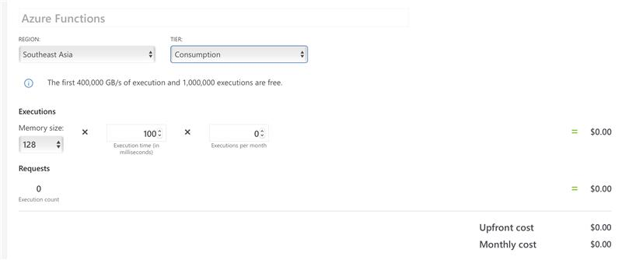

**Azure SQL Database Server**

Has no additional costs.

