  - DETERMINING THE NEED FOR PERMIT LIMITS WITHOUT EFFWENT MONITORING DATA FOR A SPECIFIC FACILITY
If the regulatory authority so chooses, or if the circumstances dictate, the authority may decide to develop and impose a permit limit for whole effluent toxicity or for individual toxicants without facility-specific effluent monitoring data, or prior to the generation of effluent data. Water quality-based permit limits can be set for a single toxkant or for whole effluent toxicity based on the available dilution and the water quality criterion or the State standard in the absence of facility specific effluent monitor-ing data. However, in doing so, the regulatory authority must satisfy all the requirements of 40 CFR 122.44(d)(l )(ii).

When determining whether or not a discharge causes, has the reasonable potential to cause, or contributes to an excursion of a numeric or narrative water quality criterion for individual toxi-cants or for toxicity, the regulatory authority can use a variety of factors and information where facility-specific effluent monitor-ing data are unavailable. These factors also should be considered with available effluent monitoring data. Some of these factors are the following:

- Dilution-Toxic impact is directly related to available dilu-tion for the effluent. Dilution is related to the receiving stream flow and the size of the discharge. The lower the available dilution, the higher the potential for toxic effect. If an effluent's concentration at the edge of a mixing zone in a receiving water is expected to reach 1 percent or higher during critical or worst-case design periods, then such an effluent may require a toxicity limit (see discussion in Section 3.3.3). Assessment of the amount of stream dilution available should be made at the conditions re-quired by the water quality standards or, if not specified in the standards, at the harmonic mean flow and the 7Q1O
flow. Figure 3-3 (Pg. 57) shows that, whereas a majority of
NPDES permittees nationwide discharge to areas during annual mean flow ranging in dilution from 100 to 1,000, the majority of dischargers fall into the 1 to 1O dilution range during low-flow conditions.

- Type of industry-Although dischargers should be indi-vidually characterized because toxicity problems are site-specific, the primary industrial categories should be of principal toxicity concern. EPA's treatment technology data base generally suggests that secondary industrial cat-
�gories_ may have less potential for toxicity than primary
�ndustn_es. However, based on experier,ce, it is virtually 1mpornble to generalize the toxicity of effluents with any certainty. If two plants produce the same type of product, one effluent may be toxic while the other may not be toxic due to the type and efficiency of the treatment applied, general materials handling practices, and the functional target of the compound(s) being produced.

- Type of POTW-POTWs with loadings from indirect dis-chargers (particularly primary industries) may be candi-dates for toxicity limits. However, absence of industrial input does not guarantee an absence of POTW discharge toxicity problems. For example, commercial pesticide ap-

plicators often discharge to POTWs, resulting in pesticide concentrations in the POTW's effluent. Household disposal of pesticides, detergents, or other toxics may have a similar effect. The types of industrial users, their product lines, their raw materials, their potential and actual discharges, and their control equipment should be evaluated. POTWs should also be characterized for the possibility of chlorine and ammonia problems.

- Existing data on toxic pollutants-Discharge monitoring reports (DMRs) and data from NPDES permit application forms 2C and 2A may provide some indication of the pres-ence of toxicants. The presence or absence of the 126 "priority pollutants" may or may not be an indication of the presence or absence of toxicity. There are thousands of "nonpriority" toxicant5 that may cause effluent toxicity. Also, combinations of several toxicants can produce ambi-ent toxicity where the individual toxicants would not. EPA regulations at 40 CFR 122.21(j) require POTWs with design flows equal to or greater than 1 MGD and POTWs with approved pretreatment programs, or POTWs required to develop a pretreatment program, to submit the results of whole effluent toxicity tests with their permit applications. These regulations also provide discretion to the permitting authority to request such data from other POTWs at the time of permit application.

- History of compliance problems and toxic impact-Regu-latory authorities may consider particular dischargers that have had difficulty complying with limits on toxicants or that have a history of known toxicity impacts as probable priority candidates for effluent toxicity limits.

- Type of receiving water and designated use-Regulatory authorities may compile data on water quality. Examples of available data include fish advisories or bans, reports of fish kills, State lists of priority waterbodies, and State lists of waters that are not meeting water quality standards. Regu-latory authorities should use this information as a means of identifying point sources that discharge to impaired waterbodies and that thus may be contributing to this impairment. One source of this information is the lists of waters generated by states to comply with Section 304(1) regulations at 40 CFR 130.10(d)(6); 50 FR 23897-98, June 2,
1989:

  - Waters where fishing or shellfish bans and/or advisories are currently in effect or are antici-pated;

  - Waters where there have been repeated fish kills or where abnormalities (cancers, lesions, tumors, etc.) have been observed in fish or other aquatic life during the last ten years;

  - Waters where there are restrictions on water sports or recreational contact;

  - Waters identified by the state in its most re-cent state section 305(b) report as either "par-tially achieving" or "not achieving" designated uses;

  - Waters identified by the states under section 303(d} of the Clean Water Act as waters need-ing water quality-based controls;

  - Waters identified by the state as priority water bodies;

  - Waters where ambient data indicate potential or actual excursions of water quality criteria due to toxic pollutants from an industry classi-fied as a primary industry in Appendix A of 40 CFR Part 122;

  - Waters for which effluent toxicity test results indicate possible or actual excursions of state water quality standards, including narrative "free from" water quality criteria or EPA water quality criteria where state criteria are not avail-able;

  - Waters with primary industrial major discharg-ers where dilution analyses indicate exceedances of state narrative or numeric wa-ter quality criteria (or EPA water quality criteria where state standards are not available) fortoxic pollutants, ammonia, or chlorine;
  - Waters with POlW dischargers requiring local pretreatment programs where dilution analy-ses indicate exceedances of state water quality criteria (or EPA water quality criteria where state water quality criteria are not available) for toxic pollutants, ammonia, or chlorine;

  - Waters with facilities not included in the previ-ous two categories such as major PO1Ws, and industrial minor dischargers where dilution analyses indicate exceedances of numeric or narrative state water quality criteria (or EPA water quality criteria where state water quality criteria are not available) for toxic pollutants, ammonia, or chlorine;

  - Water classified for uses that will not support the "fishable/swimmable" goals of the Clean Water Act;

  - Waters where ambient toxicity or adverse wa-ter quality conditions have been reported by local, state, EPA or other Federal Agencies, the private sector, public interest groups, or uni-versities;

  - Waters identified by the state as impaired in its most recent Clean lake Assessments conducted under 314 of the Clean Water Act; and

  - Surface waters impaired by pollutants from hazardous waste sites on the National Priority List prepared under section 105(8)(A) of CERCLA.

  - Waters judged to be impaired as a result of a bioassessment/biosurvey.
The presence of a combination of these factors, such as low available dilution, high-quality receiving water, poor compli-ance record, and clustered industrial and municipal discharges, could constitute a high priority for effluent limits.

Regardless, the regulatory authority, if it chooses to impose an effluent limit after conducting an effluent assessment without facility-specific monitoring data, will need to provide adequate justification for the limit in its permit development rationale or in its permit fact sheet. A clear and logical rationale for the need for the limit covering all of the regulatory points will be neces-sary to defend the limit should it be challenged. In justification of a limit, EPA recommends that the more information the authority can acquire to support the limit, the better a position the authority will be in to defend the limit if neces-sary. In such a case, the regulatory authority may well benefit from the collection of effluent monitoring data prior to estab-lishing the limit.

If the regulatory authority, after evaluating all available informa-tion on the effluent, in the absence of effluent monitoring data, is not able to decide whether the discharge causes, has the reasonable potential to cause, or contributes to, an excursion above a numeric or narrative criterion for whole effluent toxicity or for individual toxicants, the authority should require whole effluent toxicity or chemical-specific testing to gather further evidence. In such a case, the regulatory authority can require the monitoring prior to permit issuance, if sufficient time exists, or it may require the testing as a condition of the issued/ reissued permit.

Under these circumstances, the regulatory authority may find it protective of water quality to include a permit reopener for the imposition of an effluent limit should the effluent testing estab-lish that the discharge causes, has the reasonable potential to cause, or contributes to excursion above a water quality criteria. A discussion of these options is provided later in this chapter.

DETERMINING THE NEED FOR PERMIT LIMITS WITH EFFWENT MONITORING DATA

General Considerations
When characterizing an effluent for the need for a whole efflu-ent toxicity limit, and/or an individual toxicant limit, the regula-tory authority should use any available effluent monitoring data, together with any information like that discussed under Section 3.2 above, as the basis for a decision. The regulatory authority may already have effluent toxicity data available from previous monitoring, or it may decide to require the permittee to generate effluent monitoring data prior to permit issuance or as a condition of the issued permit. EPA regulations at 40 CFR 122.21(j) require PO1Ws with design flows equal to or greater than 1 MGD and POlWs with approved pretreatment pro-grams, or POlWs required to develop a pretreatment program, to submit the results of whole effluent toxicity tests with their permit applications. These regulations also provide discretion to the permitting authority to request such data from additional PO1Ws at the time of permit application.

In the instance where the permittee is required to generate data in advance, data collection should begin 12 to 18 months in advance of permit development to allow adequate time for conducting toxicity tests and chemical analyses. The type of data, including toxicity testing data, should be specified by the regulatory author-ity at the outset so that decisions on permit actions will not be delayed. EPA recommends monitoring data be generated on effluent toxicity prior to permit limit development for the following reasons: (1) the presence or absence of effluent toxicity can be more clearly established or refuted and (2) where toxicity is shown, effluent variability can be more clearty defined. Several basic factors that should be considered in gener-ating effluent monitoring data are discussed below.

Adllresslng Uncertainty In EffluBIII Characterization
by Generating Effluent Monitoring Data
All toxic effects testing and exposure assessment parameters, for both effluent toxicity and individual chemicals, have some degree of uncertainty associated with them. The more limited the amount of test data available, the larger the uncertainty. The least amount of uncertainty of an effluent's impact on the receiving water exists where ( 1) a complete data base is available on the effects of acute and chronic toxicity on many indigenous species, (2) there is a clear understanding of ecosystem species composition and func-tional processes, and (3) actual measured exposure concentrations are available for all chemicals during seasonal changes and dilution situations. The uncertainty associated with such an ideal situation would be minimal. However, generation of these data can be very resource intensive.

An example of uncertainty that results from limited monitoring data is if a regulatory authority has only one piece of effluent data (e.g., an LC50 of 50 percent) for a facility. Effluent variability in such a case, given the range of effluent toxicity variability seen in other effluents, may range between 20 percent and 100 percent (see Appendix A). It is impossible to determine from one piece of monitoring data where in this range the effluent variability really falls. More monitoring data would need to be generated to determine the actual variability of this effluent and reduce this source of uncertainty.

To better characterize the effects of effluent variability and reduce uncertainty in the process of deciding whether to require an effluent limit, EPA has developed the statistical approach described below and in Box 3-2. This approach combines knowledge of effluent variability as estimated by a coefficient of variation with the uncertainty due to a limited number of data to project an estimated maximum concentration for the effluent. The estimated maximum concentration is calculated as the upper bound of the expected lognorrnal distribution of effluent concentrations at a high confidence level. The projected effluent concentration after
consideration of dilution can then be compared to an appropriate water quality criterion to determine the potential for exceeding that criterion and the need for an effluent limit.

The statistical approach has two parts. The first is a characteriza-tion of the highest measured effluent concentration based on the desired confidence level. The relationship that describes this is the following:
Pn = (1 - confidence level)1/n
where Pn is the percentile represented by the highest con-centration in the data and n is the number of samples. The following are some examples of this relationship at a 99 percent confidence level:

- The largest value of 5 samples is greater than the 40 percentile

- The largest value of 10 samples is greater than the 63 percentile

- The largest value of 20 samples is greater than the 79 percentile

- The largest value of 100 samples is greater than the 96 percentile.

The second part of the statistical approach is a relationship between the percentile described above and the selected upper bound of the lognormal effluent distribution. EPA's effluent data base suggests that the lognormal distribution well characterizes effluent concentrations (see Appendix E). For example, if five samples were collected (which repre-sents a 40th percentile), the coefficient of variation is 0.6, and the desired upper bound of the effluent distribution is the 99th percentile, then the two percentiles can be related using the coefficient of variation (CV) as shown below:
C99 exp(2.326o - o.so2)
= =4.2
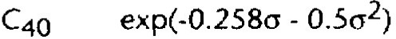

where o:! = In (CV2+1) and 2.326 and -0.258 are the normal distribution values for the 99th and 40th percentiles, respec-tively. The use of the 99th percentile is for illustrative purposes here. Although it does represent a measure of the upper bound of an effluent distribution, other percentiles could be selected by a regulatory agency. The relationship shown above can be calculated for other percentiles and CVs by replacing the values in the equation.

Tables 3-1 and 3-2 show the combined effects of both parts for a 99-percent confidence level and upper bounds of the 99th and 95th percentiles, respectively. The factors shown in the tables are multiplied by the highest concentration in an effluent sample to estimate the maximum expected con-centration.

This procedure can be used for both single and multiple discharges to the same receiving waterbody. This is accom-plished for multiple dischargers by summing the projected RWCs for the pollutant or pollutant parameter of concern from each individual discharger, and comparing it to the water quality standard. This involves an assumption of conservative additivity of the pollutant after discharge, which may not accurately reflect the true behavior of the toxicant. To overcome this, and to further refine the proportional contribution of each discharger and the resultant limits, the permitting authority should supplement this evaluation with multiple source WLA modeling and/or ambient water con-centration monitoring.

==================---= -_ =-=============-=-=-=-=-=-=-=-=-=-=-=-=-=-=-=-=-=-=-=-=-=-=-=-=-=-=-=-=-=-=-=-=-=-=-=-=-=-=-=-=-=-=-=-=-=-=-=-=-=-=-=-=

Box 3-2. Determining "Reasonable Potential" for Excursions Above Ambient Criteria Using Effluent Data Only

EPA recommends finding that a permittee has "reasonable potential" to exceed a receiving water quality standard if it cannot be demonstrated with a high confidence level that the upper bound of the lognormal distribution of effluent concentrations is below the receiving water criteria at specified low-flow conditions.

Step 1 Determine the number of total observations ("n") for a particular set of effluent data (concentrations or toxic units [TUs)), and determine the highest value from that data set.

Step 2 Determine the coefficient of variation for the data set. For a data set where n<l 0, the coefficient of variation (OI) is estimated to equal 0.6, or the 0/ is calculated from data obtained from a discharger. For a data set where n>l 0, the 0/ is calculated as standard deviation/mean (see Figure 3-1). For less than 10 items of data, the uncertainty in the 0/ is too large to calculate a standard deviation or mean with sufficient confidence.

Step 3 Determine the appropriate ratio from Table 3-1 or 3-2.

Step 4 Multiply the highest value from a data set by the value from Table 3-1 or 3-2. Use this value with the appropriate dilution to project a maximum receiving water concentration (RWC).

Step 5 Compare the projected maximum RWC to the applicable standard (criteria maximum concentration, criteria continuous concentration [CCC], or reference ambient concentration). EPA recommends that permitting authorities find reasonable potential when the projected RWC is greater than an ambient criterion.

Example

Consider the following results of toxicity measurements of an effluent that is being characterized: 5 TU,, 2 TUc, 9 TU,, and 6 TU,. Assume that the effluent is diluted to 2 percent at the edge of the mixing zone. Further assume that the 0/ is 0.6, the upper bound of the effluent distribution is the 99th percentile, and the confidence level is 99 percent.

Step 1 There are four samples, and the maximum value of the sample results is 9 TUc.

Step 2 The value of the 0/ is 0.6.

Step 3 The value of the ratio for four pieces of data and a 0/ of 0.6 is 4.7.

Step 4 The value that exceeds the 99th percentile of the distribution (ratio times Xmax) after dilution is calcu-lated as:

[9 TUc x 4.7 X 0.02) = 0.85 TU,.

Step 5 0.85 TUc is less than the ambient criteria concentration of 1.0 TU,. There is no reasonable potential for this effluent to cause an excursion above the CCC.

Effluent Characterization tor Whole Effluent Toxicity
Once an effluent has been selected for whole effluent toxicity characterization after consideration of the factors discussed above, the regulatory authority should require toxicity testing in accor-dance with appropriate site-specific considerations and the rec-ommendations discussed below. In the past 5 years, significant additional experience has been gained in generating effluent toxicity data upon which to make decisions as to whether or not an effluent will cause toxic effects in the receiving water in both freshwater and marine environments.

General Considerations and Assumptions

EPA has revised its initial effluent toxicity data generation recom-mendations based on three observations made over the last 5 years:

- Only rarely have effluents discharged by NPDES permittees been observed to have LC5os less than 1.0 percent or no observed effect concentrations (NOECs) less than 0.1 per-cent. However, there is always a chance that an effluent could be toxic at such low effluent concentrations.

-..

Table 3-1. Reasonable Potential Multiplying Factors: 99% Confidence Level and 99% Probability Basis

I
Number of Samples |  | Coefficient of Variation
 |  | 0.1 | 0.2 | 0.3 | 0.4 | 0.5 |  | 0.6 | 0.7 | 0.8 | 0,9 | 1.0 | 1.1 | 1.2 | 1.3 1.4 | 1.5 | 1.6 | 1.7 | 1.8 | 1.9 | 2.0
1  2  3  4  5 |  | 1.6 | 2.5 | 3.9 | 6.0 | 9.0 | 113_2 |  | 18.9 | 26.5 | 36.2 | 48.3 1633 |  | 81.4 | 102.8128.0 | 157.1 | 90.3  58.4  33.5  23.6  18.4 | 227.8  67.2  37.7  26.3  20.4 | 269.9  76.6  42.3  29.l  22.4 | 316.7  86.7  47.0  32.1  24.5 | 368.3  97.5  52.0  35.l  26.6
 |  | 1.4  1.4  1,3  1.3 | 2.0  1.9  1.7  1.7 | 2.9  2.5  2.3  2.1 | 4.0  3.3  2.9  2.7 | 5.5  4.4  3.8  3.4 |  | 7.4  5.6  4.7  4.2 | 9.8  7.2  5,9  5.1 | 12.7  8.9  7,2  6.2 | 16.1  11.0  8.7  7.3 | 20.2  13.4  l 0.3  8.6 | 24.9  16.0  12.2  10.0 | 30.3  19.0  14.2  11.5 | 36.3 43.0  22.2 25.7  16.3 18.6  13.1 14.8 | 50.4  29.4  21.0  16.6
6  7  8  9  10 |  | 1.3  1.3  1.2  1.2  1.2 | 1.6  1.6  1.5  1.5  1.5 | 2.0  2.0  1.9  1.8  1.8 | 2.5  2.4  2.3  2.2  2.2 | 3.1  2.9  2.8  2.7  2.6 |  | 3.8 | 4.6 | 5.5 | 6.4 | 7.5 | 8.6 | 9.8 | 11.1 12.4 | 13.8 | 15. 3 | 16.8 | 18.3 | 19.9 | 21.5
 |  |  |  |  |  |  |  | 3.6 | 4.2 | 5.0 | 5.8 | 6.7 i 7.7 |  | 8.7 | 9.7 10.8 | 12.0 | 13.1 | 14.4 | 15.6 | 16.9 | 18.2
 |  |  |  |  |  |  |  | 3.3  3.2  3.0 | 3.9  3,7  3.5 | 4.6  4.3  4.1 | 5.3  5.0  4.7 | 6.1 I 6.9  5.7 l 6.4  5.3 : 5.9 |  | 7.8  7.1  6.6 | 8.7 9.6  7.9 8.7  7.3 8.0 | 10.6  9.6  8.8 | 11.6 | 12.6 | 13.6 | 14.7 | 15.8
 |  |  |  |  |  |  |  |  |  |  |  |  |  |  |  |  | 10.4  9.5 | 11.3  10.3 | 12.2  17 .0 | 13.1  11.8 | 14.0  12.6
I  I  I | 11  12  13  14  15 | 1.2  1.2  1.2  1.2  1.2 | 1.5  1.4  1.4  1.4  1.4 | 1.8  1.7  1.7  1.7  1.6 | 2.1  2.0  2.0  2.0  1.9 | 2.5  2.4  2.3  2.3  2.2 |  | 2.9  2.8  2.7  2,6  2.6 | 3.4  3.2  3.1  3.0  2.9 | 3.9  3.7  3.6  3.4  3.3 | 4.4  4.2  4.0  3.9  3.7 | 5.0 5.6  \  4.7 5.2  4.5 ' 5.0  4.3 l 4.8  4.1 I 4.6 |  | 6.2  5.8  5.5  5.2  5.0 | 6.8 7.4  6.4 7.0  6.0 6.5  5.7 6.2  5.4 5.9 | 8.1  7.5  7.1  6.7  6.4 | 8.8  8.1  7.6  7.2  6,8 | 9.4  8.8  8.2  7.7  7.3 | 10.1  9.4  8.7  8.2  7.7 | 10.8  10.0  9.3  8.7  8.2 | 11.5  10.6  9.9  9.2  8.7
16  ' 17  18  I 19  I 20 |  | 1.2  1.2  1.2  1.2  1.2 | 1.4  1.4  1.4  1.4  1. 3 | 1.6  1.6  1.6  1.6  1.6 | 1.9  1.9  1.8  1.8  1.8 | 2.2  2.1  2.1  2.1  2.0 |  | 2.5  2.5  2.4  2.4  2.3 | 2.9  2.8  2.7  2.7  2.6 | 3.2  3.1  3.0  3.0  2.9 | 3.6  3.5  3.4  3.3  3.2 | 4.0 I 4.4  3.8 I 4.2  3.7 ^{I} 4.1  I  3.6 4.0  3.5 I 3.8 |  | 4.8  4.6  4.4  4.3  4.2 | 5.2 5.6  5.0 5.4  4.8 5.2  4.6 5.0  4.5 4.8 | 6.1  5.8  5.6  5.3  5.2 | 6.5  6.2  5.9  5.7  5.5 | 6.9  6.6  6.3  6.0  5.8 | 7.3  7.0  6.7  6.4  6.1 | 7.8  7.4  7.0  6.7  6.5 | 8.2  7.8  7.4  7.1  6.8

I
I
I

I
I

I
I
i

I

I I
I

I

Table 3-2. Reasonable Potential Multiplying Factors: 95% Confidence Level and 95% Probability Basis

I Number of Coefficient of Variation

�
Samples 0.1 0.2 0.3 0.4 0.5 0.6 0.7 0.8 0.9 1.0 1.1 1.2 1.3 1.4 1.5 1.6 1.7 1.8 1.9 2.0
-� \
1 I 1.4 1,9 2.6 3.6 4.7 6.2 8.o 10.1 12.6 15.5 118.7 22.3 26.4 30.8 35.6 40.7 46.2 52.1 58.4 64.9
2 \ 1.3 1.6 2.0 2.5 3.1 3.8 4.6 5.4 6.4 7.4 8.5 9.7 10.9 12.2 13.6 15.0 16,4 17.9 19.5 21.J I
I
3 1.2 1.5 1.8 2.1 2.5 3.0 3.5 4.0 4.6 5.2 5.8 6.5 7.2 7.9 8.61 9.3 10.0 10.8 1 u 12.3
4 Ii 1.2 1.4 1.7 1.9 2.2 2.6 2.9 3.3 3.7 4.2 4.6 5.0 5.5 6.0 6.4 6.9 7,4 7.8 8.3 8.8 I
5 I 1.2 1.4 1.6 1.8 2.1 2.3 2.6 2.9 3.2 3.6 3.9 4.2 4.5 4.9 5.2 I 5.6 5.9 6.2 6.6 6.9 I
6 |  | I  1 | 1.1 | 1.3 | 1.5 | 1.7 | 1.9 |  | 2.1 | 2.4 | 2.6 | 2.9 | 3.1 | 3.4 | 3.7 | 3.9 | 4.2 | 4.5 I | 4.7 | 5.0 | 5.2 | 5.5 | 5.7 | I
7 |  | I | 1.1 | 1.3 | 1.4 | 1.6 | 1.8 |  | 2.0 | 2.2 | 2.4 | 2.6 | 2.8 | 3.1 | 3.3 | 3.5 | 3.7 | 3.91 | 4.1 | 4.3 | 4.5 | 4.7 | 4.9 | I
8 |  | \ | 1.1 | 1.3 | 1.4 | 1.6 | 1.7 |  | 1.9 | 2.1 | 2.3 | 2.4 | 2.6 | 2.8 | 3.0 | 3.2 | 3.3 | 3.5 I | 3.7 | 3.9 | 4.0 | 4.2 | 4.3 | I
9  10 |  | I  1 | 1.1  1.1 | 1.2  1.2 | 1.4  1.3 | 1.5  1.5 | 1.7  1.6 |  | 1.8  1,7 | 2.0  1.9 | 2.1  2.0 | 2.3  2.2 | 2.4  2.3 | 2.6  2.4 | 2.8  2.6 | 2.9  2.7 | 3.1  2.8 | 3.2  3.o I | 3.4  3.1 | 3.5  3.2 | 3.6  3.3 | 3.8  3.4 | 3.9  3.6
11 |  | l  I  I | 1.1 | 1.2 | 1.3 | 1.4 | 1.6 |  | 1.1 | 1.8 | 1.9 | 2.1 | 2.2 | 2.3 | 2.4 | 2.5 | 2.7 | 2.8 ,' | 2.9 | 3.0 | 3.1 | 3.2 | 3.3
12 |  | l  I  I | 1.1 | 1.2 | 1.3 | 1.4 | 1.5 |  | 1.6 | 1.7 | 1.9 | 2.0 | 2.1 | 2.2 | 2.3 | 2.4 | 2.5 | 2.61 | 2.7 | 2.8 | 2.9 | 3.0 | 3.0
 |  |  | 1.1 |  |  |  |  |  |  |  |  |  | 1.9 i  1.8 I
14  15 |  | I  \ | 1.1  1.1 | 1.2  1.2 | 1.3  1.2 | 1.4  1.3 | 1.4  1.4 |  | 1.5  1.5 | 1.6  l.6 | 1.7  1.7 | 1.8  1.8 | 1.9 i  1.8 I | 2.0  1.9 | 2.1  2.0 | 2.2  2.1 | 2.3  2 2 | 2.3 I  2.2 1 | 2.4  2.3 | 2.5  2.4 | 2.6  2.4 | 2.6  2.5 | 2.7  2.5
16  17  18 |  | I  I  I | 1.1  1.1  1.1 | I.I  1.1  1.1 | 1.2  1.2  1.2 | 1.3  1.3  1.3 | l.4  1.4  1.3 |  | 1.5  1.4  1.4 | 1.6  1.5  1.5 | 1.6  1.6  1.6 | 1.7  1.7  1.6 | 1.8 I  l 1.71  1.7 | 1.9  1.8  1.7 | 1.9  1.9  1.8 | 2.0  1.9  1.9 | 2.1  2.0  1.9 | 2.1 I  2.0 I  2.0 | 2.2  2.1  2.0 | 2.3  2.2  2.1 | 2.3  2.2  21 | 2.4  2.3  2.2 | 2.4  2.3  2.2
19  20 |  | I'  I | 1.1  i.1 | 1.1  u | 1.2  1.2 | 1.3  1.2 | 1.3  u | I | 1.4  1 .4 | 1.5  1.4 | 1.5  1.5 | 1.6  1.5 | 1.6 I  1.6 I | 1.7  1.1 | 1.8  1.7 | 1.8  1.8 | 1.9  1.8 | 1.9  1.81 | 2.0  1.9 | 2.0  1.9 | 2.0  2.0 | 2.1  2.0 | 2.1  2.0

l

I
I

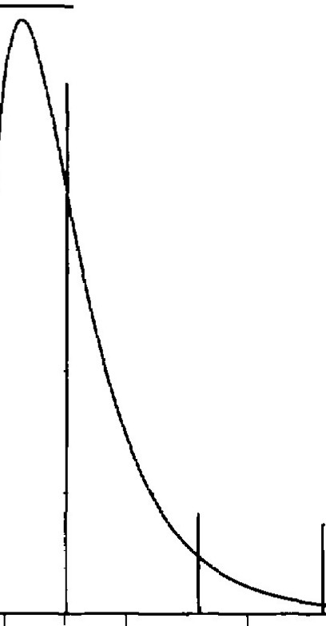

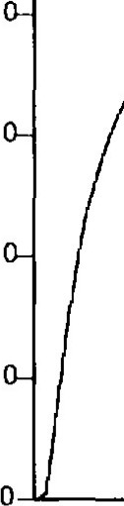
0 0.5 1.5 2 2.5 3 3.5 4 4.5 5
>u,
C:
Q)
::>
CT
�
u.
8
1in
Q)
>
�c 6
Percentile = (1 - 0.99)
Q)
� Qi a:
�
Q)
c.. 4
2
0
50
100

/ Long-term average

95th percentile
/
99th percentile
/
Value

Number of Samples

Figure 3-1a. Frequency Distribution of Values for a Lognormal Distribution with a Mean of 1.0 and a Coefficient of Variation of 0.6
Figure 3-lc. Relationship Between the Largest Value of n Samples and the Percentile It Exceeds
with 99 Percent Confidence

>,
(.J
C:
Q)
::>
CT
�
u.
<I)
>

�
aQ:i
<D
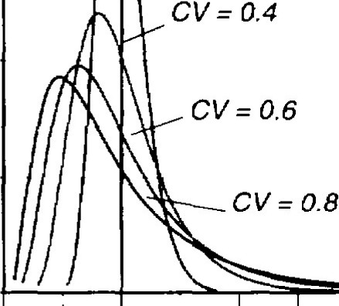
c:i
/
/
Long-term average
CV =0.2
0 (>)
Q)
.=::i
"O
C:
e::i
<t'.
m
.�s
Q)
(.)
C:
Q)
"O
"E
0
()

1.

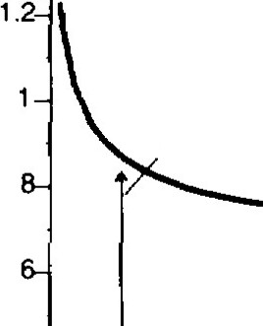
0

:,r
0

Range of CVs for nc10. 90th percentile confidence mterval

0 0.5 1.5 2 2.5 3 3.5 4 4.5 5
Value
,f?.
0
0)
0-+----.-----,�---.--""T"--,----.,.....--,
0 20 40 60 80 100
Number of Samples

Figure 3-lb. Comparison of Relative Frequencies of Lognormal Distributions with a Mean of 1.0 for Different Coefficients of Variation

- With the exception of a small number of "outliers" for which confirmation is not possible, acute-to-chronic ratios (ACRs) above 20 for effluents discharged by NPDES per-mittees have not been observed by EPA. The majority of observed ACRs are very seldom above 10. However, higher ACRs may be found for selected facilities.

- The use of the three commonly used freshwater species and of three of the five commonly used marine organisms has generally been sufficient to measure any effluent's toxicity for the purposes of projecting effluent toxicity impact and making regulatory decisions.

Figure 3-1d. Example of 90 Percent Confidence Intervals Around Coefficient of Variation Estimates for Numbers of Samples

Figure 3-2 is a flow chart of EPA's recommendations for data generation for three different dilution scenarios. It is divided into three basic steps: determining initial dilution, develop-ing toxicity testing procedures, and developing decision criteria for permit limit. There are certain basic assumptions built into this flow chart. The basic principle used in making decisions is to compare available dilution to known or pro-jected toxic effect concentrations in order to place an efflu-ent into one of three categories:

NO |  | NO
 | Require monitoring at reissuance

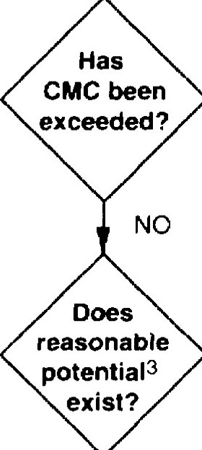
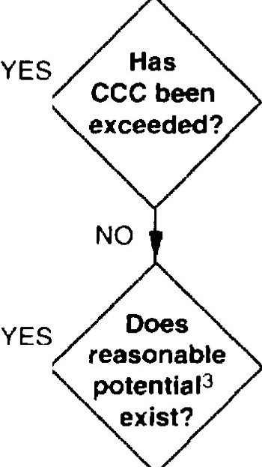
Notes:
·- ··-····- -· -·· -··

STEP 1
STEP2
Acute toxicity data or estimate based on ACA
Chronic toxicity data or estimate based on ACR
STEP 3
YES
YES
Develop permit limits

Develop permit limits
Conduct toxicity testing2 based on dilution determination (3 species at a minimum of quarterly for 1 year)
Dilution determination1
1Dilution determinations should be performed for critical flows and any applicable mixing zones. 2Toxicity testing recommendations
- Dilution > l 000:1: acute testing, check CMC only.
- 100:l < Dilution< 1000: 1: acute or chronic testing, check CMC and CCC with data or ACR.
- Dilution< 100:1: conduct chronic testing, check CCC with data and CMC using acute data or ACR. 3Reamnable potential: Use procedures in Box 3-3.

Figure 3-2. Effluent Characterization for Whole Effluent Toxicity

- The effluent causes or contributes to an excursion of a numeric or narrative water quality criterion and the permit requires a limit on toxicity.

- The effluent has a reasonable potential of causing or con-tributing to an excursion of a numeric or narrative water quality criterion and a limit is required.

- The effluent has a very low probability of causing or con-tributing to an excursion of a water quality standard and no limit is required.
This categorization is accomplished by using dilution esti-mates in the first step and the results of the toxicity tests in the next steps. In addition, all these impact estimates assume discharge at critical conditions and imposition of any applicable mixing zone requirements. Therefore, a conservative assumption is used to determine whether or not an impact is projected to occur. Estimates of possible toxic impact are made assuming that the effluent is most toxic to the most sensitive species or lifestage at the time of lowest available dilution.

�
<1J
e>
."c'
l;l

8000

6000
15,863 (3.159 Majors)
dilution toxicity tests are much more variable than multiple dilu-tion tests. Therefore, the use of single concentration toxicity tests is strongly discouraged for this data generation process.

Since the new data generation requirements are much less expen-sive than the previous requirements, tiered testing (less expensive, single-concentration, initial screening followed by increasingly expensive definitive data generation, using multiconcentration


i5 4000
0
�
E::,
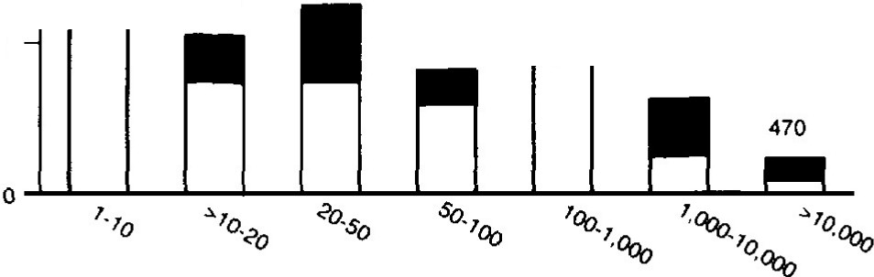
z
2000
1.628
1,241

2,0B4

2,467 2,771

Dilution (stream/effluent)

- At Low Flow (7010)

7,908
tests, as described in the September 1985 version of the technical support document) is unnecessary. However, elimination of the requirement to conduct toxicity testing on the basis of projec-tions using dilution alone is not recommended. Although EPA's data review suggests that an LC50 of 1 percent and an NOEC of
0.1 percent are the lower bounds on effluent toxicity, there may be other effluents that are presently unmeasured that are more toxic. Testing data are always desirable for fully characterizing discharges of concern.

Steps in Whole Effluent Characterization Process

The following is a detailed description of the major steps pre-sented in Figure 3-2 and the rationale behind each.

8000 |  |  |  |  |  |  |  |  |  | Step 1: Dilution Determination
 |  |  |  |  |  |  |  |  |  | The initial step is to determine the dilution of the effluent at the
6000 |  |  |  |  |  |  |  |  |  | edge of the mixing zone, assuming the State allows mixing zones.
�  <1l  �  �  �  iS 4000  0  �  E::,  z | 5 | .006 | 1,771 | 3,450 | 2,477 |  |  |   3,849 | 2.065 | Figure 3-4 shows a schematic representation of typical mixing  zone requirements for both acute and chronic toxicity. Calculat-ing the dilution at the edges of mixing zones for site-specific situations can be complicated. Modeling can be employed using either steady-state or dynamic approaches to calculate the dilu-tion (see Chapter 4). However, for complex situations, such as  marine and estuarine waters or lakes, dye studies (or other tech-
2000 |  |  |  |  |  |  |  |  |  | niques used to assess mixing zones) may still be required.

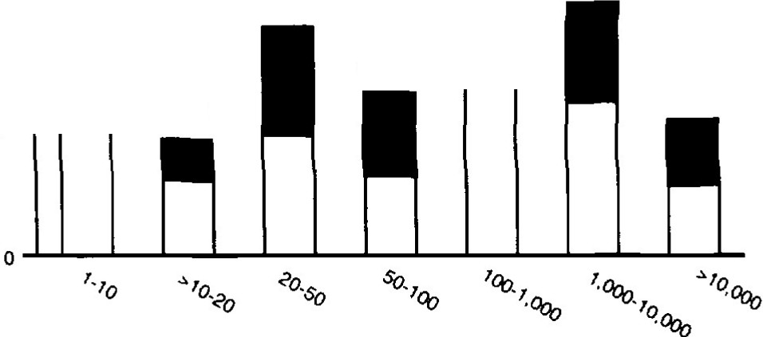
Dilution (stream/effluent)
- At Annual Mean Flow

figure 3-3. National Distribution of NPDES Dilution Conditions at 7Q10 and at Annual Mean Flow

The changes to the EPA's data generation recommendations eliminate the application of multiple sets of safety margins that was proposed in the 1985 version of this document. Rather, general observations on effluent toxicity described above now allow regulatory authorities to tighten the bounds
of the initial dilution categorization, eliminate the species sensitivity uncertainty factor and target lC50s of 1 percent and NOECs of 0.1 percent as the most extreme toxicity
measurements that can normally be expected for the vast majority of effluents discharged by NPDES permittees for acute and chronic toxicity, respectively. The observation of toxicity was based on multiple dilution tests. The same observation may not hold for toxicity measured with single dilution tests (pass/fail). As reflected in Chapter 1, single
Some State water quality standards do not allow the use of mixing in the control of acute toxicity. For these States, acute toxicity is often limited at the end of the pipe. Permit limits derived to enforce such requirements would be considered "wa-ter quality-based" because they would be based upon an ambient criterion (as opposed to an arbitrary test endpoint). Regardless, both chronic and acute toxicity must be assessed in these situa-tions.

Step 2: Toxicity Testing Procedures

Where toxicity tests are required in order to make decisions regarding appropriate next steps in a screening protocol, EPA recommends as a minimum that three species (for example, a vertebrate, an invertebrate, and a plant) be tested quarterly for a minimum of 1 year. As discussed in Chapter 1, the use of three species is strongly recommended. Experience indicates that marine algae can be a highly sensitive test species for some effluents. Using a surrogate species of the plant kingdom adds another trophic level to the testing regimen. For both freshwater and marine situations, the use of three species is more protective than two species since a wider range of species sensitivity can be measured. EPA is continuing to develop toxicity test methods using additional organisms including plants. In addition, EPA has revised the test for Selenostnum, which has improved the test precision.

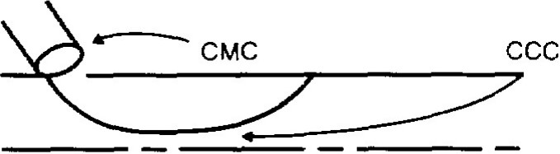
No initial mixing allowed

flow +

Initial mixing allowed:
'0 �
CMG C:::: CCC

I
mixing zon�
+--

river width

ability. If less frequent testing is required in the permit, it is preferable to use three species tested less frequently than to test the effluent more frequently with only a single species whose sensitivity to the effluent is not well characterized.

EPA recommends that a discharger conduct acute toxicity testing if the dilution of the effluent is greater than 1000:1 at the edge of the mixing zone [3]. Such a discharger would be considered a low priority for chronic toxicity testing. The rationale for this is that the effluent concentration would be below 0.1 percent at the edge of the mixing zone and thus incapable of causing an excursion above the CCC. A worst case NOEC of 0.1 percent translates into 1,000 TUc, which would result in a concen-tration of less than 1.0 TUc at the edge of the mixing zone for this dilution category. The test results would be compared to the CMC
after consideration of any allowable mixing.

�---------�- _:ixing zone

flow +

where
CMG= 0.3 TUa
CCC= 1.0 TUc

river width
I
l

EPA recommends that a discharger conduct either acute or chronic toxicity testing if the dilution of the effluent falls between 100:1 and 1,000:1 at the edge of the mixing zone. Effluents have been shown to be both acutely and chronically toxic within this range of receiving water dilution. Under worst-case scenarios, LCsos of 1.0 percent and ACRs of 10 will result in excursions above both the CCC and CMC at the edge of the regulatory mixing zone.
Although either acute or chronic testing can be required within this dilution range, acute testing would be more appropriate at the higher end of this dilution range (1,000:1 or 0.1 percent). At the lower end of this dilution range (100:1 or 1.0 percent), chronic

Figure 3-4. Schematic Representation of Mixing Zone Areas
Where the CMC and CCC Apply

EPA recommends against selecting a "most sensitive" species for toxicity testing. For one organism to consistently be the most sensitive in a battery of toxicity tests, two conditions must occur: (1) the toxicants causing toxicity must remain the same, and (2) the ratios of the toxicants in the effluent (if more than one) must remain the same. Based on EPA's experience at the Duluth research laboratory, neither of these conditions is likely to occur. For example, the causes of effluent toxicity in POTWs can vary on a seasonal basis. Toxicity in the summer can be caused by pesticides to which invertebrates are most sensitive. However, the winter toxicity could be caused by ammonia to which fathead minnows will respond most sensitively. The most sensitive spe-cies for an effluent actually may not exist and at best is difficult to identify.

Conducting toxicity tests using three species quarterly for 1 year is recommended to adequately assess the variability of toxicity observed in effluents. Below this minimum, the chances of missing toxic events increase. The toxicity test result for the most sensitive of the tested species is considered to be the measured toxicity for a particular effluent sample.

The data generation recommendations in Figure 3-2 represent minimum testing requirements. Since uncertainty regarding whether or not an effluent causes toxic impact is reduced with more data, EPA recommends that this test frequency be in-creased where necessary to adequately assess effluent vari-
tests may be more appropriate. Where other factors are equal, chronic testing may be preferable since the interim results in a chronic test gives data on acute toxicity as well. The acute endpoint data can then be used to compare directly to the CMC without the need for an ACR.

Whichever type of toxicity test (either acute or chronic) is speci-fied, the results from that test should be compared to the criterion associated with that type of test. For example, a chronic test would be compared to the CCC. Comparisons to the other criteria can be made by using the ACR or additional data generated to convert a chronic test result to an acute endpoint and vice versa. For example, a chronic NOEC of 5 percent effluent (or 20 TUc) represents an acute LC50 of 50 percent (or 2 TUa) at an ACR of 10.

EPA recommends that a discharger conduct chronic toxicity testing if the dilution of the effluent falls below 100:1 at the edge of the mixing zone. The rationale for this recommendation is that chronic toxicity has been observed in some effluents down to the 1.0 percent effect concentration. Therefore, chronic toxicity tests, although somewhat more expensive to conduct, should be used directly in order to make decisions about toxic impact.

There is a potential for acute toxicity within this dilution range, although this is less likely as the 100:1 dilution level is approached. Thus, the recommended screening protocol shown in Figure 3-2 includes a determination of whether excursions above the CMC are projected (4]. This analysis may be performed by assuming an ACR, applying this value to the chronic toxicity testing data, and allowing for any allowable initial mixing. Alternatively, the regula-tory authority may use the interim results in the chronic test to calculate the acute toxicity.

Both the chronic and acute toxicity test data would be compared to their respective criterion. The chronic test results would be compared to the CCC, and the acute results, regardless of how calculated, would be compared to the CMC.

Step 3: Deci1ion Criteria for Permit Limit Development

Once the toxicity data have been generated for a discharger, the regulatory authority must decide whether or not the results show that the permittee causes, has the reasonable potential to cause, or contributes to an excursion of an applicable numeric or narrative water quality criterion and therefore needs to limit effluent toxic-ity. To do this, these data should be used to project receiving water concentrations, which are then compared to the CCC and CMC. One of four outcomes will be reached when following the screening protocol shown in Figure 3-2:

- Excursion Above CMC or CCC-Where any one data point shows an excursion above the State's numeric or narrative criterion for the parameter toxicity, EPA regulations require a permit limit be set for whole effluent toxicity (40 CFR 122.44(d)(l )(iv or v)), unless limits on a specific chemical will allow the narrative water quality criterion to be attained or maintained. In the absence of a State numeric criterion for the parameter toxicity, EPA recommends that 1.0 TU, and 0.3 TUa be used as the CCC and CMC,.respectively. The decision to develop permit limits based upon an excur-sion above either the CMC or CCC will lead to protection against both acute and chronic toxicity if the permit deriva-tion procedures in Chapter 5 are used to set effluent limits.

- Reasonable Potential for Excursion Above CMC or CCC-EPA believes that "reasonable potential" is shown where an effluent is projected to cause an excursion above the CCC or CMC. This projection is based upon a statistical analysis of available data that accounts for limited sample size and effluent variability. EPA's detailed recommenda-tions for making a statistical determination based upon effluent monitoring data alone are shown in Box 3-2. Where a regulatory authority finds that test results alone indicate a "reasonable potential" to cause an excursion above a State water quality criterion in accordance with 40 CFR 122.44(d)(l )(ii), a permit limit must be developed.

A regulatory authority may select an alternative approach for assessing reasonable potential. For example, an author-ity may opt to use a stochastic dilution model that incorpo-rates both ambient dilution and effluent variability for deter-mining reasonable potential. Such an approach is analo-gous to the statistical approach shown in Box 3-2. Whatever approach selected by the authority, it must use all the factors that account for all the factors listed in 40 CFR 122.44(d)(l )(ii).

In some cases the statistical analysis of the effluent data may not actually project an excursion above the CMC or CCC but may be close. Under such conditions, reasonable poten-tial determinations will include an element of judgment on the part of the regulatory authority. Other factors will need to be considered and given appropriate weight in the decisionmaking process, including value of waterbody (e.g., high-use fishery), relative proximity to the CCC or CMC, existing controls on point and nonpoint sources, informa-
lion on effluent variability, compliance history of the facil-ity, and type of treatment facility. These factors are summarized in Box 3-2 and are discussed in detail in Section 3.1. EPA recommends regulatory authorities establish a written policy and procedure for making determinations of "reasonable potential" under these circumstances.

- No Reasonable Potential for Excursions Above CMC or CCC-In these situations, EPA recommends that the toxicity tests recommended above be repeated at a frequency of at least once every 5 years as a part of the permit application. Such testing is required for certain POlWs under 40 CFR 122.21(j).

- Inadequate Information-Where a regulatory authority has inadequate information to determine reasonable po-tential for an excursion of a numeric or narrative water quality criterion, there may still be a basis for concern on the part of the authority. The permit should contain whole effluent toxicity monitoring requirements and a reopener clause. This clause would require reopening of the permit and establishment of a limit based upon any test results, or other new factors, which substantiate that the effluent causes, has the reasonable potential of caus-ing, or contributes to an excursion above the CCC or CMC.

Use of Toxicity Testing In Multiple-source Discharge Situations
Where more than one discharge to the same receiving waterbody contributes, or has the reasonable potential to contribute to an excursion of water quality standards, permit limits must be developed for each individual discharger on that waterbody. For the regulatory authority to make this assessment, additional testing may be needed to provide the authority with the infor-mation necessary to assess the relative impact of each source. For purposes of this discussion, a multiple-source discharge situation is defined as a situation where impact zones overlap, or where ambient receiving water concentrations of a pollutant are elevated due to upstream discharges. In multiple-source discharge situations, additivity, antagonism, and persistence of toxicity can be of concern. To collect additional data, the permit authority should employ the toxicity testing procedures for multiple dischargers described in Box 3-3. In addition, ambient toxicity testing, as described below, could be used.

Assuming that screening has been conducted that reveals the need for permit limits, two options for controlling the dis-charges exist. The first option is for the permit authority to regulate each source separately using the procedures for indi-vidual point sources. In this option, the permitting authority would require use of upstream ambient water as a diluent in the toxicity test so as to be able to evaluate the contributions of upstream sources of toxicity. A second option is to treat each discharge as an interactive component of a whole system. In this option, the permit writer would determine a total maxi-mum daily load for the receiving waterbody and develop indi-vidual wasteload allocations for each discharger using the pro-cedures discussed in Chapter 4.

Box 3-3. Recommend Multiple-source Toxicity Testing Procedures

Tests

Where the combined effluents make up 1 percent or greater of the receiving waters, conduct chronic toxicity tests following the testing procedures described in Section 3.3.3.

Where the combined effluents make up less than 1 percent of the receiving waters, conduct acute toxicity tests following the testing procedures described in Section 3.3.3 (see Figure 3-2) to determine if any of the effluents are exhibiting toxicity.

An additional data requirement is the assessment of relative and absolute toxicity of each source so that appropriate permit conditions can be set for individual dischargers. The following procedure is suggested.

      - Conduct one set of toxicity tests on the effluents using a control of reconstituted or uncontaminated dilution water. The set of tests will give an absolute toxicity measurement of the effluent.

      - Run a parallel set of toxicity tests on the effluent using dilution water taken directly upstream from the point of discharge or, for estuarine waters, from an area outside of the immediate discharge impact zone (this will have to be determined by a dye study). This dilution water may be contaminated with upstream effluents or other toxicant sources. The purpose of this test is to project toxic impact of the effluent after it is mixed at its point of discharge. This is a relative effluent toxicity measurement. The relative testing procedure could result in a change in the standard concentration-effect curve generated by the testing. The dilution water for the relative toxicity test may cause significant mortality, growth, or reproductive effects at the lower effluent concentra-tions (including the 100 percent diluent control concentration) if the diluent from the receiving water is toxic (from an upstream discharge). Such mortality does not invalidate the test. Instead, analysis of toxicity trends resulting from the relative toxicity tests can be used to assess the effluent's toxicity in relation to other sources and ambient receiving water conditions. However, a control dilution water with no toxicity must be used for quality assurance and determination of absolute toxicity of the effluent.

      - Conduct ambient toxicity tests to (a) determine whether or not the effluent has a measurable toxicity after mixing, (b) measure persistence of toxicity from all sources contributing to receiving water toxicity, and (c) determine combined toxicity resulting from the mixing of multiple, point, and nonpoint sources of toxicity. See Appendix C for a discussion of ambient toxicity testing procedures.

The ambient testing can be required of each discharger and conducted during low-flow or worst-case design periods.

Frequency for Ambient Testing

All testing should be conducted simultaneously by each discharger, if possible. At a minimum, the tests should be conducted concurrently starting within a short time period (1 to 2 days). Repeated ambient toxicity analyses will be desirable when variable effluents are involved. Effluent toxicity data showing variability can be used to assess what frequency will be most applicable. The level of repetition for variability analysis should be similar to that used in effluent variability analyses.

Other Considerations

Dye studies of effluent dispersion for rivers, lakes, reservoirs, and estuaries are strongly recommended. This allows analysis of effluent concentration at the selected sampling stations above and below the discharge points.

The procedures suggested in this multiple source section are based on actual multiple source site investigations conducted under the Complex Effluent Toxicity Testing Program. Site reports from that study can be used to obtain further description of the toxicity testing procedures used to analyze multiple source toxic impact [1, 2).

Ambient Toxicity Testing
Ambient toxicity testing also is useful in screening receiving water bodies for existing toxic conditions. The procedure de-scribed in Appendix C uses short-term chronic toxicity tests to measure the toxicity of samples of receiving water taken above, at, and below outfalls. It can be used in freshwater, marine, and estuarine systems. The procedure must be conducted during an appropriate low-flow or worst-case design period.

The utility of the ambient toxicity screening approach is that actual receiving water toxicity is directly measured. No extrapo-lation from exposure or ACR is needed. Further, impact from multiple source discharge situations, which may not be apparent from individual discharger data, is identified. Finally, the tech-nique can provide an assessment of the persistence of effluent toxicity.

Spec/al Considerations for Discharges to Marine and Estuarine Environments
Special problems are encountered when assessing and control-ling impacts of toxic pollutants discharged to marine and estua-rine waterbodies. These special problems include the following:

- Determining the physical characteristics of estuaries and the complex mixing and effluent dilution situations for RWCs of effluents.

- Generating toxicity data on nonsaline effluents that dis-charge to brackish or saline waters and establishing cause-effect relationships on that basis.

- Assessing exposure and controlling impacts from persis-tent toxicants accumulating in fish and shellfish tissues and in sediments. These factors are particularly important in estuaries and near coastal waters because of high use of estuaries as breeding and fishing areas for important com-mercial seafood supplies and recreational fishing, and be-cause many estuaries and near coastal waters act as sinks for pollutants that accumulate in sediments.

Where these special problems are encountered, additional infor-mation may need to be gathered to better quantify dilution, to determine metals partitioning, and to identify potential interfer-ences in whole effluent toxicity tests.

To characterize the type of whole effluent toxicity that is most relevant for a particular discharge to marine and estuarine wa-ters, the following questions should be considered [5]:

- What is the salinity of the receiving water, and is this important in terms of the State standards?

- What is the appropriate test organism to require for toxic-ity testing under differing salinity conditions?

The answers to these questions will enable the permitting au-thority to determine what type of toxicity testing is most suitable for effluent characterization and whole effluent toxicity control.

For most marine and estuarine discharges the choice of test species and dilution water should be made based on the charac-teristics of the receiving water at the critical conditions for flow,

mixing, and salinity. Foremost in this determination should be the salinity of the receiving water and, to a lesser extent, the salinity of the effluent itself.

The primary objective of whole effluent toxicity tests is to identify sources of toxicity that can potentially cause an excursion of a State's narrative or numeric water quality criteria. For this reason, the toxicity tests should reflect the natural conditions of the receiving water so to be able to measure any effluent characteris-tic that could contribute to ambient toxicity. The marine toxicity test methods identify 1,000 mg/I as the point at which salinity begins to exert an effect on freshwater species. As a general rule, EPA recommends that freshwater organisms be used when the receiving water salinity is less than 1,000 mg/I, and that marine organisms be used when the receiving water salinity equals or exceeds 1,000 mg/I.

Saline Effluent Discharges to Saltwater

The dissolved salts in the effluent are pollutants. These salts may or may not be the same as those present in the receiving water. Also, the proportion of dissolved salts in the effluent may be different from that of the salts in the receiving water. In this case, the toxicity test needs to be able to determine if these salts contribute to ambient toxicity. For this reason, marine organ-isms are needed.

Saline Effluent Discharged to Freshwater

In this case, the dissolved salts in the effluent is a pollutant that does not exist in the receiving water. The toxicity test needs to determine whether the dissolved salts can be one of the toxicants that contribute to ambient toxicity. For this reason, freshwater organisms are needed.

Freshwater Effluent Discharged to Saltwater

In this instance, the lack of dissolved salts in the effluent can cause an apparent toxic effect to the marine organisms in the toxicity test. However, in contrast to the instances presented above, the toxicity test does not need to be able to measure this effect because a lack of salts is not a pollutant. The marine toxicity test methods account for this by requiring that the salinity of the effluent be adjusted to approximate the salinity of the receiving water. As an alternative to using a marine organism, a freshwater organism can be used if the test is being conducted only on a 100-percent effluent sample and if State water quality standards do not require that a marine organism be used.

Using a Chemical-specific Limit to Control Toxicity
EPA regulations at 40 CFR 122.44(d)(1)(v) provide that limits on whole effluent toxicity are not necessary where the permitting authority demonstrates in the fact sheet or statement of basis of the NPDES permit that chemical-specific limits for the effluent are sufficient to attain and maintain applicable numeric and narrative State water quality criteria. To make this demonstration that chemical-specific limits are sufficient, additional effluent informa-tion will be needed. EPA recommends that the discharger conduct a toxicity identification evaluation to identify the causative agent(s) in the effluent. Where the permitting au-thority determines that the demonstration required by 40 CFR 122.44(d)(1)(v) has been made, limits on whole effluent toxicity

need not be imposed. Effluent limits on the controlling chemical with concurrent whole effluent monitoring will be sufficient. Where subsequent whole effluent toxicity testing reveals the presence of toxicity in the effluent, the above process will need to be repeated, or alternatively a whole effluent toxicity limit will be needed. If continued toxicity testing shows that additional chemical-specific effluent limits are insufficient to control whole effluent toxicity, then toxicity limits may be the only practical way to control toxicity.

3.3.B Effluent Characterization for Specific Ch11111lcals
The previous section discussed effluent characterization for whole effluent toxicity. This section will describe EPA's recommendations for data generation to determine whether or not permit limits are needed to control specific chemical pollutants in effluents. While many of the same principles apply when developing chemical-specific limits, there are some differences based upon regulatory and analytical considerations.

Characterization of impacts due to specific chemicals do not re-quire a determination of the type of testing as is required for whole effluent toxicity because there is generally only one type of test for specific chemicals. However, there are some antecedent steps that are unique to effluent characterization for specific chemicals: de-termination of the chemicals of concern and determination of acceptable ambient levels (RAC, CMC, or CCC) for these pollut-ants.

Steps for Chemical-specific Effluent Characterization Process

Figure 3-5 illustrates EPA's recommendations for determining whether or not permit limits need to be developed according to an evaluation of a limited data set. The following discussion corresponds to the various activities shown in Figure 3-5. (Refer to the human health discussion in Section 3.3.9 for additional details on procedures to characterize the bioconcentration potential of effluents.)

Step 1: Identify the Pollutants of Concern

This process should begin with an examination of existing data to determine the presence of specific toxicants for which criteria, standards, or other toxicity data are available. Sources of data include the following:

- Permit application forms, DMRs, permit compliance systems (PCS), and permit files

- Pretreatment industrial surveys

- STORET for ambient monitoring data

- SARA Title Ill Toxic Chemical Release Inventory

- Industrial effluent guidelines development documents

- The Treatability Manual (6]

- Effluent bioconcentration assessment (see Section 3.3.9).

Data on specific chemicals that are typically submitted with NPDES application forms will consist of a limited number of analytical test
results for many of the reported parameters. Where the regula-tory authority has reason to believe that additional data for key parameters of concern are needed in order to adequately charac-terize the effluent, this information should be requested as a part of the application or, in some cases, through the use of Section 308 letters. It is recommended that 8 to 12 samples be ana-lyzed for key parameters of concern. In some cases, special analytical protocols will need to be specified in order to gather all appropriate information.

Step 2: Determine the Basis for Establishing RACs, CMCs, and CCCs for the Pollutants of Concern

The second step is to identify the appropriate water quality stan-dard, including designated or existing use, and criteria for use. Ideally, the State water quality standards include aquatic life and human health criteria for the pollutants of concern. If a State does not have a numeric water quality criterion for the pollutant of concern, then one of three options for using the narrative crite-rion may be used (40 CFR 122.44(d)(l )(vi)) to determine whether a discharge causes, has the reasonable potential to cause, or contributes to an excursion above a narrative criteria because of an individual pollutant. Although the provisions of 40 CFR l 22.44(d)(l )(vi) are presented in the regulation in the context of permit limit development, these same considerations should be applied in characterizing effluents in order to determine whether limits are necessary. The options available are as follows:

- Option A allows the regulatory authority to establish limits using a "calculated numeric water quality criterion" that the regulatory authority demonstrates will attain and main-tain applicable narrative water quality criteria and fully protect the designated use. This option allows the regula-tory authority to use any criterion that protects aquatic life and human health. This option also allows the use of site-specific factors, including local human consumption rates of aquatic foods, the State's determination of an appropri-ate risk level, and any other current data that may be available.

- Option B allows the regulatory authority to establish efflu-ent limits using EPA's Water Quality Criteria guidance docu-ments, if EPA has published a criteria document for the pollutant supplemented where necessary by other relevant information. As discussed earlier, EPA criteria documents provide a comprehensive summary of available data on the effects of a pollutant.

- Option C may be used to develop limits for a pollutant of concern based on an indicator parameter under limited circumstances. An example of an indicator parameter is total toxic organics (TTO); effluent limits on TTO are useful where an effluent contains organic compounds. However, use of this option must be justified to show that controls on one pollutant control one or more other pollutants to a level that will attain and maintain applicable State narrative water quality criteria and will protect aquatic life and hu-man health (see 40 CFR l 22.44(d)(l )(vi)(C)). Use of this option is restricted by regulation to those instances where it can be demonstrated that controls on indicator pollutants serve to control the toxicant of concern. Using Option A or Option B is a more direct and perhaps more defensible approach.

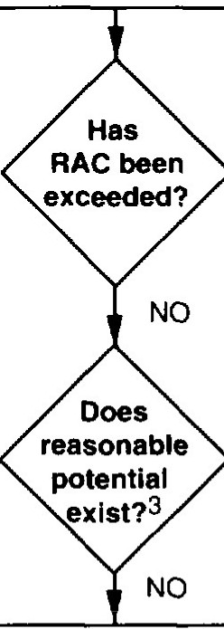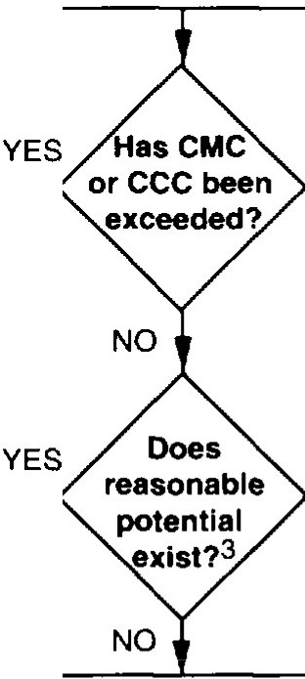
STEP 1
STEP2
RAC available
CMC and/or CCC available
STEP3
YES
YES
Develop permit limits

Select the most restrictive
Require monitoring at reissuance
Require monitoring at relssuance
Dilution determination for aquatic life impacts2
DIiution determination for human health lmpacts2
Determine RAC and/or CMCICCC for pollutants of concernl

Identify pollutants of concern

Notes:
  - RAC and/or CMC/CCC: Use State numeric criterion or interpret State narrative criterion using one of three options specified under 40 CFR
122.44(d).
  - Dilution determination: Perform for critical flow and for any applicable mixing zones for aquatic life and human health protection procedures, respectively.
  - Reasonable potential: Use procedures in Boxes 3-2 and 3-4.

Figure 3-5. Effluent Characterization for Specific Chemicals

Step 3: Dilution Determination

The third step is to calculate the effluent dilution at the edge of the mixing zone. The pertinent factors for consideration here are the same as were previously presented for whole effluent toxicity with one difference: there are two levels of dilution analysis for chemical data. The first level is to use simple fate models based on a dilution analysis and comparison with the RAC, CMC, or CCC. The second level of analysis is to use more complex fate models, including dynamic models to estimate persistence, and may be applied to lakes, rivers, estuaries, and coastal systems using a desktop calculator or microcomputer. EPA has sup-ported development of a second level of analysis that estimates point source wasteload allocations and nonpoint source alloca-tions and predicts the resulting pollutant concentrations in re-ceiving waters [7].
Step 4: Decision Criteria for Permit Limit Development

After this dilution analysis has been performed, the projected RWC is compared to the RAC, CMC, or CCC (either the State numeric criteria or an interpretation of the narrative criteria as described earlier). Whereas analysis of aquatic impacts should include evalu-ations with respect to both the CCC and the CMC, analysis of human health impacts will only involve comparisons with the RAC. The four possible outcomes discussed above in the triggers for permit limit development discussion in Section 3.3.3 also apply here:

- Excursion above the RAC, CMC, or CCC

- Reasonable potential for excursion above the RAC, CMC, or CCC

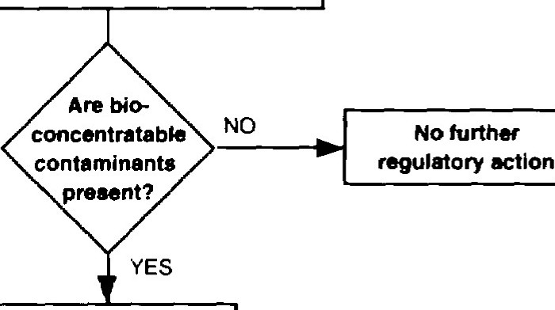
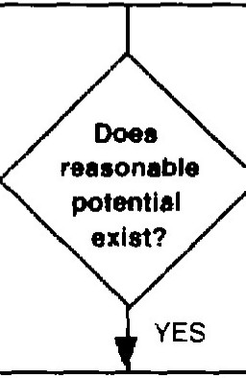
- No reasonable potential for excursion above the RAC, CMC, CCC
- Inadequate information.

If these evaluations project excursions or the reasonable potential to cause or contribute to an excursion above the RAC, CMC, or CCC, then a permit limit is required (40 CFR l 22.44(d)(1)(iii)). The statistical approach shown in Box 3-2 or an analogous ap-proach developed by a regulatory authority can be used to deter-
mine the reasonable potential. Effluents that are shown not to

Effluent

Select diacharg..-1 and/or
receiving water■
I
Select asse■sment alternative
+

I
TiHUe

cause or that have a reasonable potential to cause or contribute to an excursion above an RAC, CMC, or CCC should be reevaluated at permit reissuance.

Where chemical-specific test results do not show a reasonable potential but indicate a basis for concern after consideration of the other factors discussed in Section 3.2, or if there were inadequate information to make a decision, the permit should contain chemi-cal testing requirements and a reopener clause. This clause would require reopening of the permit and establishment of a limit based upon any test results that show effluent toxicity at levels that cause or have a reasonable potential to cause or contribute to an excur-sion above the RAC, CCC, or CMC.

Effluent Characterization tor Blocoacentratabltl Pollutants
The previous section discussed how to characterize effects of specific chemicals, including those that may threaten human health, to determine whether or not a discharge causes, has the reason-able potential to cause, or contributes to excursions above an
water quality criterion. The primary disadvantage of this approach
bioconcentration alternative
rHidue
alt..-natlve
Develop
RAC/RTC

NO ►I No futthar
Develop wa■teload allocation

is that it does not identify all effluent chemicals of potential con-cern for human health. To help address this gap, EPA is develop-ing a procedure for identifying pollutants with the propensity to bioconcentrate in fish tissue. This procedure is presently in draft form and should not be used for establishing NPDES permit limits until EPA releases the final document on the procedure. This section describes the outline of this procedure.

The overall approach illustrated in Figure 3-6 is a seven-step proce-dure that starts with collecting samples and ends with developing permit effluent limits. The effluent characterization step unique to
this approach lies in Step 3. There are two alternatives under this
step: fish tissue residue and effluent assessment. An analytical chemistry laboratory with residue chemistry and gas chromato-graph/mass spectometer (GC/MS) capability is needed to conduct the analytical methods for both alternatives. A summary of the alternatives follows:
- Tissue Residue Alternative: This alternative measures the con-centrations of organic bioconcentratable chemicals in tissue samples of indigenous organisms from the receiving water. This analysis involves the collection of fish or shellfish samples, the extraction of the organic chemicals from the tissue and the analysis of these extracts with GC/MS to identify and quantify the bioconcentratable contaminants. The procedure provides recommendations to sort the results of this screening analysis in order to determine which of the contaminants pose a hazard and require regulatory action. The approach recom-mends that the identity of those contaminants then be con-firmed prior to taking subsequent action.
>----. regulatory action

Develop permit limits
Conduct
monitOf'lng

Figure 3-6. Procedure for Assessment and Control of Bloconcentratable Contaminants in Surface Waters

- Effluent Alternative: This alternative measures the concen-trations of organic bioconcentratable chemicals in effluent samples from point source dischargers. This analysis in-volves the collection of effluent samples, the extraction of the organic chemicals from the effluent sample, and the separation of the chemicals that have characteristics known to result in bioconcentration from the other chemical com-ponents of the effluent sample. This separation is achieved by way of an analytical chemistry methodology called high-

pressure liquid chromotography (HPLC). The HPLC also separates (fractionates) an effluent sample into three subsamples or "fractions." These three fractions contain chemicals with increasing potential to bioconcentrate, with the third fraction containing those chemicals with the highest bioconcentration rates. Following HPLC fractionation, each fraction is then analyzed with GC/MS to identify and quantify the bioconcentratable contaminants. The effluent proce-dure also provides recommendations to sort the re-sults of the initial screening analysis to determine which of the contaminants pose a hazard and require subsequent regulatory action. The approach then recommends that the identity of those contaminants then be confirmed prior to taking further regulatory action.

While both of the assessment alternatives described above may be used for a given discharger, generally one of these alternatives may be preferred by the regulatory authority. The regulatory authority would select the assessment ap-proach based on the available site- and facility-specific infor-mation and the objectives of the application.
Although the approach provides a means to identify chemicals that can bioconcentrate, it does not identify all bioconcentratable chemicals. Chemicals that bioconcentrate include many organic compounds, and a small number of metals (e.g., mercury and selenium) and organometals (e.g., tributyltin). The new approach is limited to nonpolar organic chemicals that produce measurable chemical residues in aquatic organisms or that have log octanol-water partition coefficients greater than 3.5.

Analytical Considerations for Chemicals
Analysis of discharges for toxic substances requires special quality control procedures beyond those necessary for conventional pa-rameters. Toxicants can occur in trace concentrations and are frequently volatile or otherwise unstable. An EPA publication en-titled, Test Methods-Technical Additions to Methods for Chemical Analysis of Water and Wastes [8], contains sampling and handling procedures recommended by EPA for a number of toxic and conventional parameters. Additional methods for analyses for toxicants are described in Standard Methods of Water and Waste-water Analyses (ASTM, 17th edition, 1989, or most recent edition) and 40 CFR Part 136. Chapter 5 discusses detection limits and sampling requirements.

